The investigation of pollution levels in aquaculture product
Amy Sansby BVMedSci (Hons)

Submitted to The University of Nottingham for the degree of Master of Research

April 2019

Summary
Aquaculture is currently the fastest growing food sector worldwide, particularly in developing countries such as Kenya and Vietnam. Not only do these countries rely on aquaculture to provide food to their own populations but they also rely on the sector for income through exportation to more developed regions such as the European Union. Therefore, it is crucial that the sector grows in a sustainable way that limits environmental impact and ensures the food is safe for all consumers; helping meet nutritional needs. Therefore, the aims of this study were to assess the quality of aquaculture product from Kenya and aquaculture product that was farmed in Vietnam but purchased in leading UK supermarkets. The study investigated heavy metal and essential element content, microplastic burden, presence of antibiotic residues and the presence of bacteria containing antimicrobial and heavy metal resistance genes. The study found significant differences between both heavy metals and essential elements in wild and farmed fish, different types of fish and between fish farmed in different locations. The study found presence of antibiotic residues in both fish sampled from Kenya and aquaculture product from Vietnam. A number of bacteria were also identified within the aquaculture samples by PCR with the presence of genes for both antibiotic and heavy metal resistance confirmed. The study highlights the need for further work to be carried out in these areas and the importance of monitoring the development of aquaculture.

Acknowledgments
The author would like to thank Dr Tracey Coffey for her continuous support and guidance throughout the project. I would also like to thank Dr Andy Marriot, Dr Sharon Egan, Dr Allie Pickwell and Dr Leah Goulding for their invaluable help throughout the project and to colleagues at the British Geological Survey and the Kenya Marine and fisheries research institute. I would like to thank my family, friends and colleagues for their support particularly my grandparents, Anna Heslop, Genevieve Barnish and Richard Birnie.

Contents

Summary i
Acknowledgments ii
Contents iii
- Introduction 1
  - What is food security? 1
  - How is this food provided? 1
  - Aquaculture 2
  - Global aquaculture 3
Figure 1.1 5
  - Aquaculture in Africa 5
    - Vulnerable people in society 7
    - Aquaculture in Kenya 8
    - Lake Victoria 9
Figure 1.2 10
  - Aquaculture in Asia 11
    - Aquaculture in Vietnam 12
Figure 1.3 13
    - Mekong River Delta 14
  - What fish are farmed? 14
    - Prawns 15
Figure 1.4 16
    - Tilapia 17
    - Nile perch 19
    - Basa 20
  - Why eat fish? 21
  - How does fish physiology differ from terrestrial animals? 22
  - The threats to aquaculture 24
    - Climate change threatening aquaculture 25
    - Pollution threating aquaculture 25
    - Bacteria as a pollutant 26
    - Disease threatening aquaculture 27
  - Antibiotics as a cure for disease 28
    - Antibiotics in aquaculture 28
    - Does the use of antibiotics threaten wild fish? 29
    - The threat of antibiotic resistance 30
    - Can antibiotic resistance happen without overuse of antibiotics? 31
    - Tetracyclines 32
  - Essential elements 33
  - Bioaccumulation and biomagnification 34
  - Heavy metals polluting the aquatic environment 35
  - Copper, essential or toxic? 36
  - Mercury as a pollutant 37
  - Plastic as a pollutant 38
  - Does consuming fishery products cause a threat to human health? 40
  - Aims of this study 41
  - Methods and materials 43
  - Water collection from Lake Victoria 43
2.1.2 Water elemental analysis 43
  - Sediment collection 43
Figure 2.1 44
  - Sampling of aquaculture products 44
    - Fish from Lake Victoria, Kenya 44
Figure 2.2 45
Figure 2.3 46
    - Aquaculture products purchased in the UK 47
Figure 2.4 47
  - Extraction of genomic DNA 47
    - Purification of genomic DNA 48
    - Assessment of the quality and quantity of DNA 48
  - Polymerase chain reactions 48
    - Primers for PCR 48
Figure 2.5 49
    - PCR with Phusion 49
    - PCR with Taq-polymerase 50
    - PCR with GoTaq hot start master mix 50
    - Gradient PCR with GoTaq hot start master mix 51
    - Nested PCR 51
    - PCR product purification 51
    - Gel extraction of PCR products for cloning 52
    - Cleaning of purified plasmid PCR 52
  - A tailing with Taq polymerase fragment 52
    - Cloning 52
    - Plasmid purification 53
    - PCR with purified plasmids 53
    - Sequencing from PCR products 53
    - Sequencing clean up 53
  - Agarose gel electrophoresis 54
  - Detection of antibiotic residues in aquaculture products 54
    - Bacterial plates for antibiotic residue testing 54
  - Elemental analysis of fish samples 55
    - Analysis of Mercury content 55
  - Microplastic analysis 55
    - Water microplastic analysis 55
    - Sediment microplastic anaylsis 56
    - Analysis of microplastics in the gastrointestinal tract of the Kenyan fish 56
      - Flush with deionised water 56
      - Zinc chloride 56
      - Hydrogen peroxide 56
  - Data analysis 57
Results 58
Water sediment and fish collection 58
3.1 Water data 58
3.1.1 Temperature 58
Table 3.1 59
Table 3.2 60
3.1.2 pH 61
Table 3.3 61
Table 3.4 62
    - Elements analysis of water samples 63
Table 3.5 64
Table 3.6 65
Table 3.7 67
Table 3.8 69
    - Water microplastic anaylsis 69
  - Sediment 70
  - Sampling of aquaculture product 70
    - Tilapia 70
Table 3.9 72
    - Nile perch 72
Table 3.10 73
3.3.4 Cross-site comparison of Tilapia weights and lengths 73
Table 3.11 74
3.3.3 Comparison of wild and caged Tilapia 74
Table 3.12 74
  - Genomic DNA 74
Table 3.13 76
Table 3.14 77
  - Polymerase chain reactions 77
    - Gradient PCRS 77
Table 3.15 77
Figure 3.16 78
3.5.2 V3/V6 78
    - CopA 79
    - CopAU 79
    - DMerA 79
    - TetB 79
    - TetD 79
2.5.8 TetDo 80
3.5.9 Results for PCR 80
Table 3.17 81
Table 3.18 82
  - Clonning 82
  - Did any of the fish have antibiotic residues present? 82
Table 3.19 83
Table 3.20 84
  - Element concentrations from ICP analysis Fish 84
    - Heavy metals 85
Figure 3.21 86
      - Aluminium 87
Figure 3.22 88
        - Cross site comparison of Aluminium content 88
Figure 3.23 89
Figure 3.24 90
      - Arsenic 91
Figure 3.25 92
        - Cross site comparison of Arsenic content 92
Figure 3.26 93
Figure 3.27 94
      - Barium 95
Figure 3.28 96
        - Cross site comparison of Barium content 96
Figure 3.30 98
      - Caesium 99
Figure 3.31 100
        - Cross site comparison of Caesium content 100
Figure 3.32 101
Figure 3.33 103
      - Chromium 104
Figure 3.34 105
        - Cross comparison of Chromium content 105
Figure 3.35 106
Figure 3.36 107
      - Cobalt 108
Figure 3.37 109
        - Cross site comparison of Cobalt content 109
Figure 3.38 110
Figure 3.39 111
      - Nickel 112
Figure 3.40 113
        - Cross site comparison of Nickel content 113
Figure 3.41 114
Figure 3.42 115
      - Rubidium 116
Figure 3.43 117
        - Cross site comparison of Rubidium content 117
Figure 3.44 118
Figure 3.45 120
      - Strontium 120
Figure 3.46 121
        - Cross site comparison of Strontium content 121
Figure 3.47 122
Figure 3.48 123
      - Titanium 124
Figure 3.49 125
        - Cross site comparison of Titanium content 125
Figure 3.50 126
Figure 3.51 127
3.8.1.11 Tin 128
Figure 3.52 129
3.8.1.11.1 Cross site comparison of Tin content 129
Figure 3.53 130
Figure 3.54 131
3.8.1.12 Mercury 132
Figure 3.55 133
3.8.1.12.1 Cross site comparison of Mercury content 133
Figure 3.56 134
Figure 3.57 136
    - Essential elements 137
Figure 3.58 138
      - Calcium 139
Figure 3.59 140
        - Cross site comparison of Calcium content 140
Figure 3.60 141
Figure 3.61 142
      - Copper 143
Figure 3.62 144
        - Cross site comparison of Copper content 144
Figure 3.63 145
Figure 3.64 146
3.8.2.3 Iron 147
Figure 3.65 148
3.8.2.3.1 Cross site comparison of Iron content 148
Figure 3.66 149
Figure 3.67 150
3.8.2.4 Magnesium 151
Figure 3.68 152
3.8.2.4.1 Cross site comparison of Magnesium content 152
Figure 3.69 153
Figure 3.70 154
3.8.2.5 Potassium 155
Figure 3.71 156
3.8.2.5.1 Cross site comparison of Potassium content 156
Figure 3.72 157
Figure 3.73 158
3.8.2.6 Selenium 159
Figure 3.74 160
3.8.2.6.1 Cross site comparison of Selenium 160
Figure 3.75 161
Figure 3.76 162
3.8.2.7 Sodium 163
Figure 3.77 164
3.8.2.7.1 Cross site comparison of Sodium content 164
Figure 3.79 166
3.8.2.8 Zinc 167
Figure 3.80 168
3.8.2.8.1 Cross site comparison of zinc concentrations 168
Figure 3.81 169
Figure 3.82 170
3.8.3 Vietnamese aquaculture ICP 171
Table 3.83 171
Table 3.84 172
3.8.3.1 Were there any differences in the nutritional content of the prawns? 172
Figure 3.85 173
Figure 3.86 174
Figure 3.87 175
    - Fish food 175
Table 3.88 176
    - Do elemental concentrations vary between seasons? 176
Figure 3.89 177
Figure 3.90 178
Figure 3.91 179
Figure 3.92 180
Figure 3.93 181
Figure 3.94 182
Figure 3.95 183
Figure 3.96 184
    - Does the fish weight impact on the elemental concentration? 184
      - Aluminium 185
      - Arsenic 186
Figure 3.98 186
      - Rubidium 187
Figure 3.99 187
      - Titanium 188
Figure 3.100 188
3.8.6.6 Iron 189
Figure 3.101 189
3.8.6.5 Zinc 190
Figure 3.102 190
- Discussion 191
4.1 How does the environment impact on fish? 191
4.1.1 How does water temperature effect fish size? 192
4.1.1.2 Does water temperature affect the elemental concentrations in the fish? 193
    - How do changes in pH affect the fish? 194
    - Does water elemental concentration have an effect on the fish? 196
    - Does water quality have an effect on antibiotic concentrations? 198
    - Do the water conditions affect the fish quality? 199
  - Variability in fish size 200
    - Does fish size have an impact on the elemental levels? 200
    - Are some sizes of fish healthier than others? 204
  - What effects does seasonality have on fish quality? 205
    - Does seasonality impact growth? 206
    - Does seasonality affect elemental concentrations in fish? 206
    - Does seasonality affect antibiotic contamination in the fish? 208
    - Does the season impact on trace element content of fish? 209
  - Does the type of fish have any effect on the fish quality? 210
    - Does the aquatic environment affect fish quality? 210
    - Variation among identical aquaculture products originating from the same country 212
    - Are wild fish healthier? 212
    - Do sites make a difference? 213
    - Comparison of fish quality from the two aquaculture producers 215
  - Microplastics in fish 216
  - Interaction between elements 216
  - How does cooking the fish affect element content? 217
    - Mercury can be unaffected by cooking 217
    - Cooking can cause calcium increase 218
  - What effect could the heavy metals in these fish have on humans? 219
    - Would any of the heavy metals in this study cause toxicity? 222
  - The importance of trace elements 222
    - Trace element content of the fish 224
  - Potential for co-resistance to antibiotics 225
  - Conclusions 227
- Bibliography 228

Introduction

What is food security?

Food security can be defined as a ‘‘situation that exists when all people, at all times, have physical, social, and economic access to sufficient, safe, and nutritious food that meets their dietary needs and food preferences for an active and healthy life’’ (FAO, 2014c). This definition is important as it includes not only physical access to food but also that the food is of nutritional benefit, is safe to eat and is accessible to everyone, regardless of economic status.
The challenge is not only to produce vast quantities of food that is nutritious, safe and available to those living in poverty, but to produce it in a way that is sustainable, with minimal environmental impact (Godfray et al., 2010). Climate change, pollution and disease can all impact food security and therefore it is important that these factors are also considered.

How is this food provided?

The demand is met by the different farming sectors; agriculture, which is the farming on land including pastoral (farming of livestock), arable (farming of plants) and aquaculture, which is the farming of aquatic animals and plants. Livestock production is globally the largest user of land resources and although it uses 80% of the agricultural land it only contributes 40% of the agricultural output globally (FAO, 2018a).
The fastest growing food sector globally is aquaculture (Bostock et al., 2010). In 2010, the weight of fish produced globally was twice that of poultry and three

times that of cattle production. With one third of the population across 30 countries utilising fish as their only animal protein supply, this highlights the importance of aquaculture, especially in developing lower income countries (Kawarazuka and Béné, 2011).
One study investigating the trends of meat and fish consumption around the world and found that there was a very weak correlation between fish and meat consumption, highlighting that they need to be looked at as two separate dietary trends (York and Gossard, 2004).

Aquaculture

Aquaculture is the fastest growing food sector globally. In the past 50 years there has been huge growth in aquaculture and a decline in capture fisheries, with aquaculture now producing 45% of the world’s fish for human consumption with the rest being produced by capture fisheries (Subasinghe et al., 2009). This increase in aquaculture is due to the quantity of produce being more reliable than wild fisheries (Hannesson, 2003), together with wild stock being overexploiteed; in 2011 the Food and Agricultural Organisation (FAO) reported that ~29% of fish stocks were at biologically unsustainable levels (FAO, 2014).When carried out responsibly aquaculture can restore habitats, help replenish wild fish stocks and help conservation of endangered species (NOAA, 2017). The different types of aquaculture include finfish, molluscs, crustaceans and aquatic plants, with finfisn the largest sector contributing 67.8% of the total aquaculture output (FAO, 2017).
Although aquaculture provides an opportunity to provide a food source while still maintaining wild fish stocks it needs to be noted that there must be strategies in place to make sure it is sustainable. Native local species should be harvested and there should be limited use of antibiotics and fertilizers (Msangi and Batka, 2015).

In recent years in developed countries, there has been an increased in demand for “luxury” high priced seafood including salmonids, flatfish, seabreams, lobsters, freshwater prawns and marine shrimps (Konikoff, 2017). Consumer tastes have also contributed to problems with wild fish stocks as there has been an increasing demand for top predator fish such as swordfish and tuna. The long-line fishing required to catch these fish has effected populations of certain shark species, due to their slow reproductive rates (Tidwell and Allan, 2001). Studies have also indicated that consumers perceive fish to be healthier than meat products, (Luten et al., 2003), which could be contributing to the increase in demand.
In contrast, in developing countries aquatic products are seen as less of a “luxury”, providing essential and relatively cheap non-plant protein, this is essential to these populations in order to avoid malnutrition and starvation. With warm climates providing an excellent potential for a high production of fish and shellfish production, many developing countries are looking to increase their aquaculture production (Konikoff, 2017).

Global aquaculture

In 2016, the global production of fishery products (crustaceans, fish and molluscs etc.) was 170,900,000 tons. Of this, 90, 900,000 tons was from capture production of wild fish, with the other 80 million tons produced by aquaculture; this was an increase of 5.2% from 2015 (FAO, 2018b).
In terms of consumption, >151,000,000 tons of fishery products were used directly for human consumption. In 2013, global consumption of fish per capita was estimated at 19.8kg, with 17% of global animal protein intake being fish. The sector was also estimated to contribute almost 20% of per capita outcome to about 3.2 billion people (FAO, 2018b).

As well as being important from a food security perspective, aquaculture also contributes to economic development by providing incomes and employment. In 2016, the sector was estimated to provide 59, 600,000 people with jobs in both aquaculture and wild capture fisheries, with 32% employed directly in aquaculture (FAO, 2018b) and women contributing to 14% of the workforce.
Developing countries play a major role in the export of aquatic products, with 76% of the top 10 global exporters being in developing countries. In 2016, their total fisheries exports were 53% by value and 59% by quantity. In developing countries, the fishery net exports continue to rise from the value of 17 billion USD in 1996, to 37 billion USD in 2016. This is significantly higher than exports for other commodities such as coffee, rice and tea (FAO, 2018b).
This shows that aquaculture is growing faster in developing countries in contrast to developed countries, and thus highlights the need for education in these countries to make sure the practices are sustainable. In these countries, the majority of aquaculture practices are based on local family run businesses, with plans and funding in place for larger aquaculture developments that could be more export-orientated (FAO, 2008).

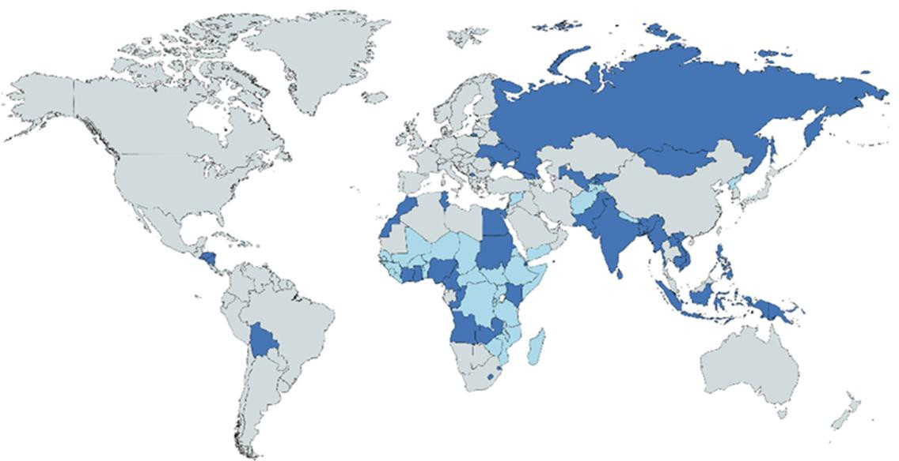

Figure 1.1- A map of the world highlighting the low income countries and the low-middle income countries. In light blue are the low income countries as classified by a gross national income (GNI) of under
$995 per capita, and in dark blue are the low-middle income countries that are earning $995-$3895 per capita, as classified by world bank (The World Bank, 2019b).

Despite the massive growth in aquaculture over the past 50 years, the only 2 continents to increase their aquaculture growth were Africa and Asia, 3.6% and 4.4% respectively (FAO, 2017).

Aquaculture in Africa

Fish are an important source of income and food in Africa with 5% of its population depending fully or partially on the sector for their livelihood. Fish provide 17.4% of the total non-plant protein consumed in Africa, with some African countries consuming >30% of the dietary animal protein from fish sources. Of the 4,000,000 tons produced on average annually, only 10% of the fish is exported. Africans currently consume an average of 7.7 kg/person/yr, which results in the need to

import 4, 200,000 tons of fishery products annually resulting in a net financial loss (Brummett et al., 2008). It is estimated that by 2050, Africa will have to increase its food production by 300% (Gabriel et al., 2007), as its population is expected to double (DeSA, 2013). Therefore it is important that the aquaculture sector not only grows, but grows in a way that is sustainable and suitable for long term developments.
Despite this increasing demand for fish there is reducing production in sub- Saharan Africa due to limited access to knowledge and inefficient technological advances (Lazard et al., 2010). Other limitations include poor or slow growth rates of cultured species, poor management of brood stock and loss of genetic diversity leading the fish to be more susceptible to disease (Changadeya et al., 2003). Another major hindrance to the growth of aquaculture in Africa is the limited supply of locally produced high quality fish feed. The use of high quality fish feed is important as without this the fish will take a lot longer to reach market size and hindering the growth of the aquaculture business. Importing fish feed is expensive and therefore provides a limitation for business expansion (Gabriel et al., 2007). However, there is massive potential for aquaculture development due to a large supply of natural resources available in Africa (Brummett et al., 2008). It is predicted that Africa could, if full potential was reached, produce 300x the amount of fish produced globally (Lazard, 2002).
Although as previously stated, only a small amount of the fish produced and harvest in Africa is exported, several African countries do export aquaculture products. The major markets for export are Europe, Asia, other African countries and North America, accounting for 70%, 15%, 11% and 2% respectively.

The continent is also responsible for 11% of the world’s imports, However, this only related to 3.48% of the global aquaculture value in 2010 (FAO, 2019a). This global aquaculture market demonstrates the importance of monitoring the quality and nutritional content of the aquaculture products produced in these countries.

Vulnerable people in society

Aquaculture has a lot of benefits to rural communities in Africa, especially to people who would not usually bring any income or food into the community. In sub-Saharan Africa aquaculture provides a way for women in single parent households to provide food and income. This is because in west and southern Africa small-scale trading and processing do not require strong physical strength and require little skill. This combined with the fact little investment is needed, means that small scale aquaculture can provide opportunities for women who may have little education and finical resources. In Zambia, three quarters of the women involved in aquaculture live in single parent households (Béné and Heck, 2005).
More than 30% of working adults in southern Africa live with HIV, this not only affects them directly, but also affects communities and families that once relied on these individuals for income and food. The effects of individuals with HIV not been able to work can sometimes affect entire regions. Due to the minimal physical output required, aquaculture can provide a means for these individuals to work. The outcome of this not only provides food of high nutritional value but can lead to cash incomes which can subsequently be used to buy medicines and other foods (Béné and Heck, 2005).
Furthermore, the increase of fishing activities in rural communities not only brings in food and income to these communities, but also increases the availability of fish

in local markets, which can lead to the price of fish being reduced and thus fish being more accessible (Edwards, 2000).

Aquaculture in Kenya

In Kenya, the fisheries and aquaculture sector provides 0.8% of the country’s gross domestic product (GDP), and provides employment to over 500,000 people directly and over 2,000,000 people indirectly. Kenya is the 4th major producer in aquaculture in Africa and has massive potential for development with over 1,400,000 hectares potentially available for aquaculture. There is also potential for development as the two main species farmed (Tilapia and African catfish) are very fast growing fish, resulting in less time needed for them to reach market size (KMFRI, 2017).
The Kenyan government have realised the potential of the aquaculture sector and have set up government initiatives to help the sector grow, including deploying technically trained staff, providing information, development of Tilapia feed with 30% protein and developments in collaborations with higher education institutes to develop knowledge (Mwangi, 2008). The Kenyan government have several facilities around the country to help with the development including the national aquaculture research development and training centre which is located in Sagana, the Lake basin development authority in Kisumu and the Kenyan Marine Fisheries Research Institute (KMFRI); KMFRI are collaborators in this project. These centres aim to encourage the growth of aquaculture and aid further developments however, they lack some equipment and human capacities which slows development (Munguti et al., 2014).
In Kenya, aquaculture can be divided into three broad divisions; warm freshwater, dominated by species of Tilapia and African catfish, cold fresh water, growing

rainbow trout, and marine water, which is currently underdeveloped. The majority of the aquaculture production is made of Tilapia which contributes 90% of Kenya’s aquaculture production (Mbugua, 2008). Freshwater aquaculture is mainly practiced at semi-intensive levels; the pond size aquaculture farms are usually small and can only cater for local markets or the families that own them. There are a few large-scale commercial fish farms but smaller family run farms dominate. Due to this many farmers produce their own feed, However, there are some companies that supply feeds and materials (Rothuis et al., 2011).
Despite Kenya being a coastal state, the majority of fishing is done in Lake Victoria which accounts for approximately 85% of the captured fish volume (Rothuis et al., 2011).

Lake Victoria

Lake Victoria is the most important source of inland fishery production in Africa and is the largest tropical lake in the world (68,000 Km2). The water of Lake Victoria is shared between Tanzania, Uganda and Kenya with each country owning 53%, 43% and 6% respectively (Balirwa et al., 2003) (Figure 1.2). The major fish species in Lake Victoria that are fished commercially are exotic Nile perch (Lates niloticus), native cyprinid (Rastrineobola argentea (Pellegrin)) and introduced Nile Tilapia (Oreochromis niloticus) (Njiru et al., 2007).

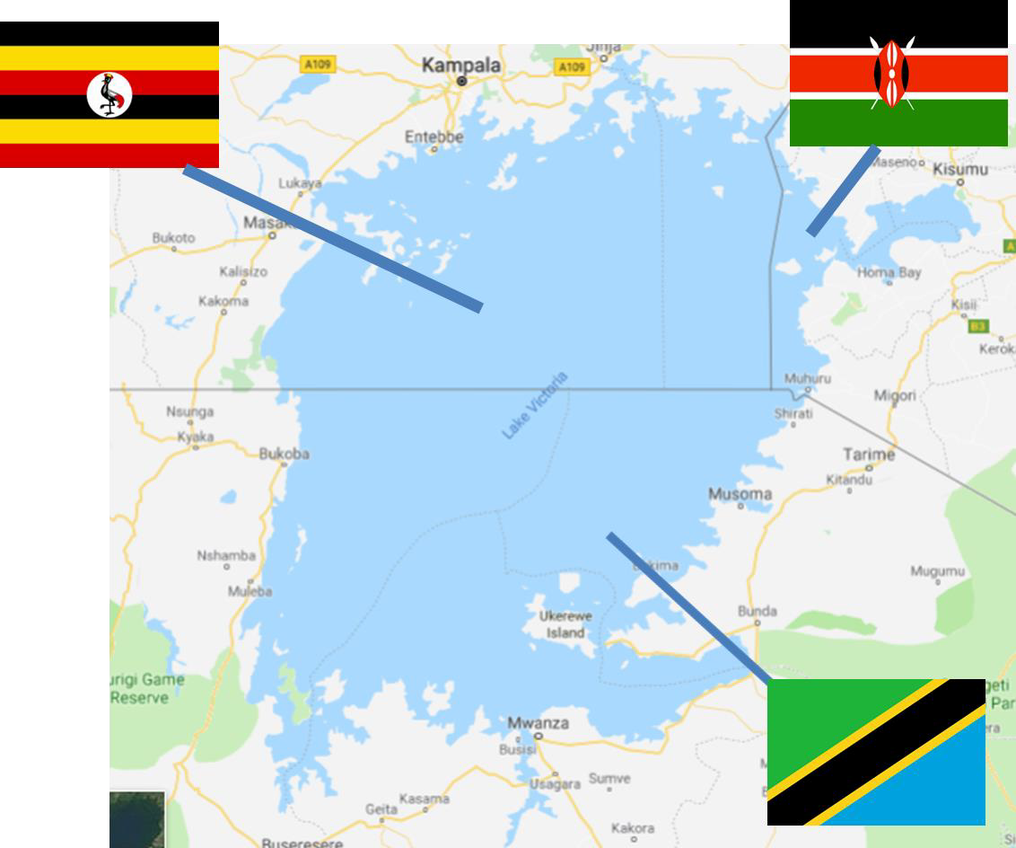

Figure 1.2- Lake Victoria and the parts owned by the different countries. This image is adapted from google maps and shows the different parts of the lake owned by Kenya (top right), Uganda (top left) and Tanzania (bottom).

There are several factors posing a threat to the success of aquaculture and wild caught fishing in Lake Victoria, including environmental degradation, introduction of exotic species and increasing fishing pressures, which have all led to a decline in wild fish catches and caused changes to the lakes biodiversity (Njiru et al., 2008). Due to a mean depth of only 40m, the lake is very susceptible to pollution (Rothuis et al., 2011) which results from increased human activities. This has led to massive eutrophication and decreases in dissolved oxygen levels (Scheren et al., 2000).

Aquaculture in Asia

Over the past few decades there have been some changes in trends in the aquaculture sector in Asia. There has been a shift from meeting the demand of the local communities to supplying products for global trade. Initially in Asia shrimp production had dominated, However, now the trends are shifting towards lower-value fish such as Basa (Pangasius bocourti). The international trade of seafood has now exceeded the trade of pork and poultry combined (Asche et al., 2015). Crustacean production has also grown massively and is mainly focused around shrimp and prawn production, with giant tiger prawns and whiteleg shrimp being the two most prominent species. The top 3 aquaculture producing countries in the south Asia-pacific region were Thailand, Vietnam and Indonesia with 623,660 tons513,100 tons and 387,698 tons, respectively (Commission, 2014); by 2018 these three countries were in the top five countries globally for aquaculture production.
Consumption data across Asia shows that there is a high dependence on fish as a source of non-plant protein in lower income households. In the Philippines, India and Vietnam it has been reported that the lower income households consume larger quantities of fish (Briones et al., 2004), suggesting that if there were any problems in the aquaculture industry, these communities would be most affected. For example, if there were toxins (e.g. heavy metals), these would bioaccummulate more in people of lower household incomes as they are more dependent on fish as a source of dietary proteins.
Vietnam has one of the greatest increases of aquaculture production in the Asia- pacific region, with an increase of 18% in-between 2002-2012.

Aquaculture in Vietnam

In 2016, a total of 6,420,471 metric tons was produced by all fisheries of which 56% was aquaculture products. This is massive growth from 1960 when total fisheries production was 473,160 with only 8% produced by aquaculture (The world Bank, 2019a). In Vietnam, the fisheries sector is the third most important sector in terms of economics. In 2004, the turnover was USD 2,397 million which was an 8.9% increase compared to the previous year, with 4 million people employed in the fisheries sector, with 16.75% of them working in the aquaculture sector (FAO, 2019b).
The aquaculture sector has been ranked 3rd in the league of key economic sectors in the country (Nguyen, 2005). Currently, Catfish and Shrimp are the two main aquaculture products for Vietnam; these are both mostly produced in the Mekong River Delta. In 2004, shrimp represented 56.8% of the coastline aquaculture production and catfish made up 51.3% (Nguyen, 2005).
Vietnam’s aquaculture industry has a high potential for development, due to the favourable conditions of the natural habitats including ponds, rice paddies, rivers estuaries, lakes and coastal areas. The Vietnamese government estimated the total area of water bodies that could be used for aquaculture to be 1.6mha (Phoung et al., Phuong et al., 2006), providing great potential for expansion. In Vietnam, a typical farm is made up of traditional cages made from wood with dimensions (3x3x3m3) similar to those found in Kenya (Figure 1.3). These are usually connected to each other and anchored to some form of floating raft; these rafts have accommodation where the owner can live and monitor the fish (Boerlage et al., 2017).

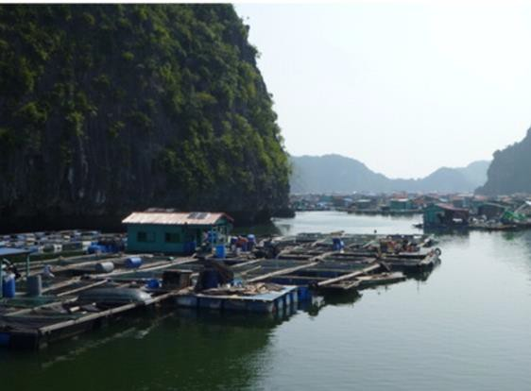

Figure 1.3 – Typical aquaculture pens in Vietnam. This image (Boerlage et al., 2017) is of a typical aquaculture farm in Vitenam, they are made from wood with dimensions 3x3x3m3.

Another popular aquaculture system is integrated agriculture-aquaculture systems (IAAS), where the production of fish is integrated with farming practices such as crop or livestock production. These IAAS recycle the different nutrients between the different farming systems, with emphasis on the recycling of livestock waste such as manure for fish production (Lucas et al., 2004, Kluts et al., 2012). These IAAS are very dependent on the climate and have a high risk of failure from natural hazards such as floods typhoons and droughts, which in Vietnam have increased in number and intensity over the past 20 years (Nghia and Jepsen, 2017). Another advantage of IAAS farming, especially in developing countries, is that the farmer has more than one source of income (Nhan et al., 2007).

The two main sites for aquaculture in Vietnam are the Mekong River Delta in the south and the Red River Delta in the north, which have both been important areas for wild caught fishing as well as the more intensive farming. Approximately 70% of the country’s total aquaculture production is in the Mekong Delta, making it an extremely important river for the country’s food security and economy (Nguyen et al., 2016).

Mekong River Delta

Flowing a distance of 4800km with an area of nearly 800,000 Km2, the Mekong Delta is the longest river in South East Asia, flowing from China to Vietnam, going through Myanmar, Thailand, Laos and Cambodia (Minh et al., 2007). There has been massive growth in the aquaculture sector in the Delta; in 1999 it contributed 29% of the total fish produced in the Delta and then in 5 years it rose to 47% (Nhan et al., 2007). The Mekong Delta is particularly important with regards to food security, as it accounted for nearly half of the national food volume, 55% of the nation’s fruit and fishery outputs and for 61% of the nation’s food export value (Phan et al., 2009).
In the early 1990s, only 5% of the Mekong which was available for use was used, however by 2004 this had increased to 22%. As seen in Kenya this growth has been encouraged by the government and they have promoted the reduction of land used for rice fields and an increase in land used for aquaculture (Nhan et al., 2007).

What fish are farmed?

Globally over the last two decades finfish have dominated the aquaculture sector accounting for 63-68% of total volume, followed by molluscs (21%) and then

Crustacean farming (including prawns), which has accounted for 10% in the past decade (Zhou, 2017).

Prawns

The farming of prawns is currently one of the most important agricultural sectors. Over the last three decades, it has increased in development and has caused particular interest due to the export potential in the global market. It is of particular interest in the European Union (EU) and the United States of America (USA), due to the high price for prawns (Ahmed, 2013). There are three main species of prawns farmed commercially in the world; the oriental river prawn M. nipponense, the monsoon river prawn M. malcolmosonii and the giant ricer prawn
M. rosenbergii (Kutty, 2005). The top producers of prawns in 2001 was China (>128,000 tonnes) and Vietnam (28,000 tonnes) (New, 2005). The major species of farmed prawns were M. rosenbergii (Figure 1.4) which made up 57% in 2009, followed by M. nipponense which are reared in China and contribute 47.2% (New and Nair, 2012).

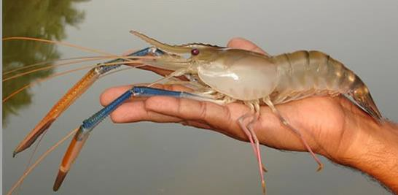

Figure 1.4 – Image of M. rosenbergii. This shows M.rosenbergii which is one of the most commercially farmed prawns globally (http://www.fao.org/fishery/affris/species-profiles/giant-river-prawn/giant-river-prawn- home/en/).

Freshwater prawns are reared in captivity either by catching wild juveniles or trapping them, along with other crustaceans and fish, in wild ponds or rice fields (New, 2009). They are usually farmed inland in comparison to other aquaculture systems therefore there is less competition at the coastline and less damage to the coastlines natural resources (New, 2002). Freshwater prawns are also omnivores, which mean they have a greater range of feed products for selection, so it is easier to source low cost local feed for these animals and still have high growth conversion rates (New, 2002).
For the last two decades prawn farming has played an important economic role in Vietnam. The aquaculture sector for prawns in Vietnam is continually expanding in the Mekong Delta River. However, data has shown that >30% of prawn farms in this area are experiencing some form of economic loss (Den et al., 2007).

Tilapia

Tilapia has been described as the most important aquaculture species of the 21st century due to increasing commercialization and continued expansion of the Tilapia industry (Shelton, 2002). It is the sixth most farmed fish species worldwide and third most important with regards to international trade (Kumar and Engle, 2016). The Tilapia industry entered a rapid increase in growth from 2001, following the development of genetically improved farm Tilapia, which lead to increase growth rates, disease resistance and age at maturation (Kumar and Engle, 2016). Consequently the Tilapia industry worldwide continues to grow, and therefore it is essential that this is done in a sustainable manor that takes into consideration the welfare of the fish and making sure it is of nutritional value to the consumers.
Tilapia are freshwater fish native to Africa and the Middle East (Eknath et al., 1998). They are omnivores and feed on algae and debris (Azim et al., 2003), and are particularly attractive from a farming perspective as they convert low quality feed into high quality protein. They also reproduce easily and have a fast growth rate, reaching a suitable size to go to market within just one growing season (Wang and Lu, 2016). Feeding of farmed Tilapia is dependent on industrially manufactured pelleted feed in the more intensive systems. Alternatively rice bran, wheat bran and mustard oil cakes are used in smaller farming systems and these are usually available on farm or can be sourced from local markets. Usually feed is given both morning and evening, in order to maximise growth. Fertilisers are also used in farming of Tilapia usually cow-dung, urea and triple super phosphate (Ahmed and Ahmed, 2009).

Tilapia farming relies on using males over females as the males have faster growth rates and are therefore more profitable. There is also a need to have no females within the males as this leads to undesirable reproduction which can lead to inbreeding problems and over stocking. In the early stages of Tilapia farming, the success was due to manual techniques of removing the females and hybridisation with species that sexually matured later (Kumar and Engle, 2016). More recently sex reversal technology is being used to produce an all-male population, which led to a 12% increase in Tilapia production from 1991 to 2000 (Phelps and Popma, 2000). Tilapia is mainly farmed in peak season which is between April and December giving 9 months for the fish to grow. However, farmers usually harvest the fish after four months resulting in them being able to harvest two crops of fish per year (Alam et al., 2012).
Currently Tilapia is farmed in ~85 countries worldwide, including those in Africa and Asia. There are several species of the Tilapia with 9 being commonly used in Tilapia aquaculture practices; Nile Tilapia (Oreochromis niloticus) is the main species. In 2000, Tilapia contributed 1.27 million metric tons (3.57%) of the global aquaculture production (Gupta and Acosta, 2004).
The increase in popularity of farming Tilapia is mirrored with an increased demand on the international market. During the first half of 2017, ~150,000 tons of Tilapia, entered the international market (FAO, 2019d). Africa in particular has an increasing demand for Tilapia, especially in sub-Saharan Africa as it is a traditional and favoured dish that offers high quantities of protein with a high nutritional benefit. It is particularly important to those in poorer rural communities as it is one of very few protein sources available to these communities (FAO, 2019e).

Nile perch

Nile perch are large piscivorous fish, and can grow up to 2m in length (Pringle, 2005). Nile perch along with Tilapia were introduced into Lake Victoria in the 1950s, and although this led to a decline in native species it did boost the Lake’s overall productivity. Nile perch development in Lake Victoria led to an increase in fishing and capture of Nile perch, and subsequently an increase in the export industry (Downing et al., 2013).
There have been suggestions that Nile perch are being over-fished due to fluctuations in population size. However, it has been argued (Silsbe and Hecky, 2008) that changes in the size of the populations cannot only be explained by overfishing pressures, but other factors, such as eutrophication may be influencing these population changes.
26,100 tons of Nile perch products were imported into the EU in 2013; the main exporters were Tanzania, Kenya and Uganda with these countries having a 47.5%, 41% and 11% market share respectively. Globally there are currently 27 processing plants that are authorised to export Nile perch internationally, all of which are located in these three countries (FAO, 2014a).
In Kenya, the Lake Victoria Fisheries Organisation (LVFO) had mandated the legal size of Nile perch when harvested to be in-between 50-85cm in total length; however this has been proven quite hard to implement. There is also a lot of ongoing management due to the LVFO is involved with a variety of stakeholders and are trying to move towards a more sustainable co-management approach. Monitoring and surveillance teams have been implemented at a national level and there is a Nile perch fishery management plan that is currently in place (FAO, 2014a).

Basa

There has been a rapid growth of Basa (Pangasius bocourti) production throughout the last decade particularly in Asian countries such as Bangladesh, and Vietnam, with Vietnam producing >1,000,000 tons per annum for exportation (Ali et al., 2013). Basa production in Vietnam has grown at a rate not been seen before with any other food crop or in any other location. Within the European seafood market it has previously been readily available, However, in 2010 it was placed on the World Wide Fund for natures ‘red list’, which effectively means that its production has a highly negative impact on the environment and therefore resulted in environmentally conscientious consumers avoiding it. This was emphasized further by a member of the European parliament, who spoke negatively of the fish from an environment, social and safety perspective (Little et al., 2012). This negative publicity caused a decline in the popularity of the fish. Before this, Russia and the EU were the biggest importers of Basa during 2006 and imported ~60% of the total exported by Vietnam (Orban et al., 2008).
Basa are a fast-growing omnivorous species feeding on algae and insects, and require very little fishmeal and oil supplementation in their diets. Although a major aquaculture species, they have not been the subject of extensive research to improve nutrition genetics and management (Little et al., 2012). These fish have the potential to be even more successful and have a bigger economic value to farmers. Research could also lead to the fish being farmed in a more sustainable manner, which would allow them to become more popular again with environmentally conscious consumers. However, the market for Basa has returned, and it is readily available in the supermarkets here in the UK.

Why eat fish?

Fish have a high nutritional benefit, containing high-quality protein, essential nutrients and vitamins, and unlike other meat products, do not contain a high amount of saturated fat. They are a very important source of vitamin D and perhaps most importantly fish, especially fatty fish, are high in docosahexaenoic acid (DHA) and ecicospentaenoic acid (EPA), which are omega-3 polyunsaturated fatty acids (Domingo et al., 2007). The intake of omega-3 from fatty fish has been shown to be beneficial in patients that have coronary heart disease (CHD) and has led to decreased mortality rates (Kris-Etherton et al., 2002). However, a study in fish farmed in Vietnam found the concentrations of DHA and EPA were not significant for CHD prevention (Usydus et al., 2011). This shows consumers may not be benefiting from some of the health benefits associated with eating fish.
However, there have been wide variations of mineral content much like fatty acid content even in the same species of fish (Lall, 1995, Alasalvar et al., 2002). This could result in misleading guidelines when consumers are purchasing fish as there could be variability in the mineral and vitamin content of fish even of the same species (Domingo et al., 2007). Therefore, it is important to monitor and regulate the nutritional content of major fish species.
One of the barriers to frequent dietary intake of fish could be the potential safety risks associated with eating fish, with the chance of adverse implications due to fish being contaminated with pollutants (Verbeke et al., 2005). One of the pollutants that is well documented is Methylmercury (MeHg), with regards to prenatal exposure. MeHg at high levels is a neurotoxicant and when it crosses the placenta the accumulation is higher in the foetus than in the mother, causing neuotoxicant effects in the foetus and resulting in stinted cognitive development

in the child (Daniels et al., 2004). However, one study in children from in utero to 9 years of age, whose mothers consumed a wide variety of fish while pregnant, found that there were no adverse implications to the their cognitive development (Myers et al., 2003). However, the impact is likely to be different in vulnerable populations such as those with malnourishment or disease or in areas where the aquatic environments contain potentially higher levels of pollutants. In Africa, 27.4% of the population is classed as severely food insecure which would lead to malnourishment to some degree (Kennard, 2018).
The potential benefits of modest fish consumption (1-2 servings per week) are thought to outweigh the negative implications in most fish species and in populations of healthy adults (Mozaffarian and Rimm, 2006). However, this is in with regards to 1-2 servings per week; in developing countries the consumption of fish is much higher and therefore this could expose these populations to greater risks. Furthermore, a high percentage of these populations are malnourished and therefore this could cause further problems with exposure to pollutants in the fish.

How does fish physiology differ from terrestrial animals?

The aquatic environment typically has lower oxygen content than the terrestrial environment and therefore it is important for fish to have an efficient gas exchange system, whereby oxygen is taken in to the body and carbon dioxide, a waste gas, is eliminated. In order to maintain oxygen levels in this environment a counter- current system is used to extract maximum amounts of oxygen from the environment. Gills are the organs that play a vital role in this gas exchange, as well as playing a part in osmo-regulation and excretion of nitrogenous metabolic waste (Fernandes, 2016). A fish has to move approximately 20 litres (L) of water across the gills to obtain the same amount of oxygen that a terrestrial animal can

from 1L of air. This therefore means that fish are potentially exposed to more environmental pollutants (Jezierska and Witeska, 2006). Pollution from poorly treated sewage waste entering waterways has increased nitrogenous waste in aquatic environments and thus lead to eutrophication, which reduces the oxygen content in the water (Kennish, 2002). This can lead to fish suffering from hypoxia, which can cause changes to respiratory rate and the gill structures (Richards, 2011).
The gills also provide a platform for fish to take up pollutants such as heavy metals; these metals are then distributed around the body via the circulatory system. Some metals absorbed can be essential for the fish physiology However, some, such as those leaching from pollution, can be toxic. Due to fish having to pass large amounts of water over there gills to get enough oxygen there is the potential to be exposed to larger amounts of metals than their terrestrial counterparts (Olsson et al., 1998).
In fish, the liver and the kidney are the primary elimination organs (Kohno, 2003, Liu et al., 2018) and are target organs of bioaccumulation but metals can also be found, usually at lower concentrations in other tissues such as the muscle (Chen et al., 2018, Liu et al., 2018). As the muscle is primarily the part of the fish that is consumed, this may cause food safety issues.
The excretion of drugs such as antibiotics, in aquatic animals includes both cellular excretion and excretion from the organism. The cellular excretion for neutral lipophilic compounds can occur by diffusion, however for metal ions it has to occur through ion transporters. Organic compounds are mostly excreted through ABC transporters which are ATP binding cassette transporters. The gills mainly excrete hydrophilic compounds, the kidney mainly small organic ions and larger organic

compounds are excreted via the intestine through bile. Xenobiotics, which are chemical substances that do not naturally occur in nature (e.g. antibiotics), are usually excreted in the bile as conjugates (Nikinmaa, 2014).

The threats to aquaculture

There are many threats to the growth of the global aquaculture sector, which include climate change, pollution, disease, limited resources and education.
One of the reasons climate change, pollution and disease are such a threat is because there is a close relationship in aquaculture between the immediate environmental conditions and the success of the farming. This is mainly due to the fish (both finfish and shellfish) being highly dependent on stable environmental conditions, such as temperature, oxygen solubility and the amount of dissolved waste products (Abollo et al., 2008), any changes in these conditions can cause adverse effects to fish health. Changes to these environmental conditions can also affect the amount of pathogens and parasites in the environment (Karvonen et al., 2010), which can lead to disease outbreaks among the fish population.
An example of how limited resources and education combined affect aquaculture can be seen in Africa. There are limited roads and transportation methods in rural areas where a lot of small aquaculture business are run, which means they lack the resources available for purchasing high quality feed. This therefore means it is essential for the farmers to locally produce the food themselves, However, lack of nutritional education and lack of resources for making the food limits the success (Gabriel et al., 2007). Collectively, this limits the growth and sustainability of the business.

Climate change threatening aquaculture

Climate change has resulted in increasing water temperatures, which causes a decrease in dissolved oxygen, resulting in reduced water quality. As atmospheric CO2 increases it results in an increase in CO2 in the world’s oceans (FAO, 2018) causing a decrease in pH, which can affect fish directly and indirectly. Decreases in pH can increase ion losses from the fish directly and cause elements to leach from soils and rocks which may also impact the fish indirectly (Kwong et al., 2014). The smaller scale fisheries are more vulnerable to the effects of climate change in comparison to the larger commercial fisheries, due to geographic location and the financial input as there is a lot less money behind smaller fisheries that are often found in developing countries (FAO, 2018).
In the Mekong river it is estimated that the water will have risen by 0.7-0.8o C by 2030 (Eastham et al., 2008). This could massively impact the amount of dissolved oxygen in the river and therefore impact aquatic life.
Direct rainfall contributes to 80% of water flowing into Lake Victoria’s and only 20% of it comes from basin discharge (Awange et al., 2008). Climate change, especially with regard to rainfall and changes in seasonality, could have a massive impact not only on the Lake but on the people relying on the lake for their livelihoods.

Pollution threating aquaculture

Pharmaceutical and personal care products (PPCPs), including antibiotics, are one of the major pollutants in water systems, due to their physical properties which make them water soluble (Snyder et al., 2003). Most PPCPs are continually discharged into the water systems through anthropogenic activities and many seem to be persistent in the environment (Ternes et al., 2002). However, the most

prominent contaminants in aquatic environments are trace metals from both anthropogenic sources and natural sources (Rainbow, 2002, de Souza Machado et al., 2016).
In Vietnam, 70% of the country’s aquaculture production is in the Mekong Delta, meaning that any pollution in the river could have a massive impact on the welfare of the fish and potentially cause contamination into the human food chain. One study estimated that 0.5-1 million people in the Delta are at risk of chronic arsenic poisoning from drinking the water (Berg et al., 2007). This indicates that the fish living in these areas could also be at risk, threatening their welfare and the welfare of any potential consumers.
Increased human activity has coincided with increases in pollution in Lake Victoria. One example of the source of pollution into the Lake is domestic sewage which is discharged into the Lake by sewage trenches. There are also small scale mining activities happening in the lake zone which could be a source of heavy metals. In addition during the rainy season some agricultural chemicals that are used in crop production enter the Lake through water run-off, being another source of pollution (Makundi, 2001).

Bacteria as a pollutant

Bacteria pose a threat through not only through causing disease but also for the development of antibiotic resistance. Disease outbreaks are a significant constraint to the development of aquaculture, the global estimate of loses caused by bacterial disease is several billion USD a year (Subasinghe et al., 2001). Antibiotic resistance genes could be transferred from resistant bacteria into bacteria present in the aquatic environment leading to the spread of resistance (Hoa et al., 2011).

Disease threatening aquaculture

In comparison to the terrestrial environment, the aquatic environment is more supportive to pathogenic bacteria, leading to higher pathogen densities and consequently higher prevalence of disease (Verschuere et al., 2000).
Diseases can be classified as infectious, meaning they can spread between individuals, or non-infectious; examples of non-infectious diseases in aquaculture would be tumours (Walker and Winton, 2010). Fish can be subject to many infectious diseases such as those caused by viruses, parasites and bacteria. The intensification of aquaculture, increased globalisation of trade, introduction of new species, poor or ineffective biosecurity measures, lack of awareness, climate change and human mediated movements have all aided the spread of disease through the aquaculture sector (The Fish site, 2010). Several disease outbreaks have had massive economic effects on aquaculture; a Salmon anaemia epidemic in 1998/1999 was estimated to cost approximately 32 million USD (Murray et al., 2002).
In order to combat bacterial disease antibiotics are given, however the legislation on the use of antibiotics in aquaculture varies. In Europe, Japan and North America in particular the regulations are strict and there are only a few products licensed, However, in developing countries the regulations are a lot less strict (Watts et al., 2017). As a result, many farmed fish can be subject to high levels of antibiotics. Vaccination is an alternative to antibiotics; however, the efficacy is limited especially in juvenile fish which are less immunocompetent. Vaccination are not be used on farmed molluscs and crustaceans due to them not having the capacity to develop long-term acquired immunity (Falaise et al., 2016).

Antibiotics as a cure for disease

Antibiotics are used to treat diseases in humans and in animals, as prophylactic and metaphylaxis treatment. They have also been used as growth promoters in livestock (Sarmah et al., 2006). Metaphylaxis is when a limited number of animals are identified as infected and all the animals in that group receive rapid treatment to prevent further spread of the infection. Prophylaxis is a preventive measure, which is given to prevent disease usually in periods when animals are more susceptible to infections for example when they are young (Schwarz and Chaslus- Dancla, 2001). Using antibiotics as growth promoters was banned in 2006 across the EU, although they are still used in some countries. In Kenya traditional antibiotics such as glycopeptides (avoparcin, vancomycin) used for growth promotion are not sold as growth promoters (Mitema et al., 2001), however, they are commonly used in Vietnam (Kim et al., 2013). It is thought that the risk to human health from using antibiotics as growth promoters is very small or even zero (Phillips et al., 2004).
Wastewater that enters aquatic environments can be contaminated with antibiotics as well as pathogenic and commensal bacteria. The presence of antibiotics in an environment can also result in the development of resistance in bacteria which were previously susceptible (Swift et al., 2019).

Antibiotics in aquaculture

Aquaculture is more intense than most types of terrestrial farming resulting in animals been subject to more stressors, such as overcrowding and increased handling. These stressors can negatively impact the animal’s immune system, making them more susceptible to disease (Barton and Iwama, 1991). Combining high stocking densities, typical of many aquaculture practices, with the increased

disease rate results in an increase of need for prophylactic antibiotics (Naylor and Burke, 2005). Aquatic environments have higher pathogenic loads, consequently leading to a higher rate of disease in comparison to terrestrial farming (Verschuere et al., 2000, Defoirdt et al., 2011). In addition, marine waters contain more salts which also leads to the need for higher doses of antibiotics to be administered into the water (Sørum, 2006).
In aquaculture there are two main routes for delivery of antibiotics, incorporation into food pellets (Lützhøft et al., 1999, Wollenberger et al., 2000) or adding them directly to the water (Hirsch et al., 1999). In more expensive fish, topical administration can be used for things such as skin ulcers, and injections are utilised (Park et al., 2012). However, when fish are suffering from disease they often exhibit reduced feeding (Björklund et al., 1990), this therefore reduces the efficacy of incorporating antibiotics into food for diseased fish.
In aquaculture, approximately 70-80% of the antibiotics administered are excreted into the environment by faeces or urine (Christensen et al., 2006). The elimination rate of antibiotics varies greatly with temperature, size and species of fish (Noga, 2011). Variations could lead to antibiotics still being present in fish tissue at the time of harvest, even after recommended withdrawal periods, as well as the antibiotics being excreted into the environment.

Does the use of antibiotics threaten wild fish?

Aquaculture can impact wild fish by habitat modification, food web interactions, introduction of pathogens that infest wild fish and nutrient pollution which could lead to decreased water quality (Naylor et al., 2000). It is also concerning that a lot of food intended for farmed fish is eaten by wild fish, resulting in wild fish been exposed to varying levels of antibiotics (Björklund et al., 1990). Escaping farmed

fish also present a threat to the wild fish population as they compete with the wild fish for food, facilitate the spread of pathogens and can result in interbreeding (Naylor et al., 2005). One example of this can be seen in farmed salmon as the rise in salmon farming has coincided with the emergence of native sea lice infestations in their wild counterparts (Krkošek et al., 2005).
Antibiotics also destroy environmental microflora, which in aquatic environments degrade the waste produced by the fish (Surendran, 2005). This destruction of microflora not only threatens the farmed fish, as higher concentrations of waste product are likely to be harmful to them, but also threatens the wild fish population in the near vicinity.
Wild fish grow a lot slower than farmed fish due to them growing in less intense conditions. This means that any pollutants the wild fish are exposed to pose more of a threat to their welfare as they are exposed to the pollutants for a longer period of time, potentially resulting in more bioaccumulation of these chemicals, including heavy metals and antibiotics (Li et al., 2015, Liu et al., 2016).

The threat of antibiotic resistance

There is growing concern about the use of antibiotics and the potential resistance. Since the resolution on Antimicrobial Resistance (AMR) in 1998 (Heymann and Dzenowagis, 1998) the World Health Organisation (WHO) have worked to develop the WHO global strategy for containment of AMR. The aim is to provide member states with guidance on prevention of infection, slow the development of resistance and reduce the spread of already resistant microorganisms. It also improves access to existing agents and promotes the development of new agents (WHO, 2001).

There are four main mechanisms that can be implemented by bacteria in order to become resistant to antibiotics including; reduction in membrane permeability, inactivation of the drug, efflux mechanisms and mutation in drug targets (Baker- Austin et al., 2006c). Bacteria can have one mechanism or a combination of these mechanisms for one drug. For example tetracycline resistance can be acquired by acquisition of tetracycline resistance (Tet) genes, which can either encode for a mechanism of efflux or can cause ribosomal changes resulting in resistance (Chopra and Roberts, 2001).
It is not only the direct use of antibiotics that can lead to antibiotic resistance. Pharmaceuticals products, such as antibiotics, have been shown to withstand wastewater treatment and be released into the aquatic environment (Kümmerer, 2001). Another indirect source is that from the manure of agricultural animals that have been treated with antibiotics. These faeces are commonly used for fertilisers, which can ultimately lead to antibiotics leaching into the ground and the ground water (Kümmerer, 2003). The use of manure is a particular problem in IAAS, as in these systems animal manure is directly added as a source of feed. One study has shown that the addition of manure into these fish farming systems is likely to be associated with higher levels of AMR (Petersen et al., 2002). These indirect sources of antibiotics in the environment could subsequently lead to the development of antibiotic resistance in an environment even though these particular antibiotics have not been used.

Can antibiotic resistance happen without overuse of antibiotics?
AMR can also occur due to co-resistance and cross-resistance, which can lead to antibiotic resistance developing in the absence of antibiotic exposure. Cross

resistance happens when different antibiotic agents use the same target, are involved in a common pathway or have a common route of entry into their targets. Co-resistance occurs when the selection for resistance through exposure to one compound can result in resistance to another (Chapman, 2003).
There is growing concern with the links between metal and antibiotic resistance. This is of particular concern as the levels of anthropogenic sources of heavy metals in the environment may be greater than the antibiotic load (Stepanauskas et al., 2005). The main source of AMR in the environment may not be due to over exposure of organisms to antibiotics but in fact over exposure to heavy metals. In addition to metals, other pollutants are responsible in co-selection of resistance including anti-fouling agents, detergents and quaternary ammonium compounds that are used in disinfectants, shampoos and fabric softeners (Chapman, 2003, Sidhu et al., 2001).

Tetracyclines

Tetracyclines were first discovered over 60 years ago and are classed as broad spectrum antibiotics with a relatively large therapeutic index. They are readily used in both clinical and agricultural settings; their wide use ultimate leads to more resistance mechanisms (Thaker et al., 2010). As a consequence of their wide spectrum and therapeutic index, Tetracyclines are one of the most used groups of antibiotics both in Veterinary and human medicine; resistance to these antibiotics could pose a large threat. There are three mechanisms in which tetracycline resistance occurs, development of efflux mechanisms so that the drug is pumped out of the cell before having an effect, ribosomal changes causing the tetracycline to be unable to bind to its target site (Thaker et al., 2010) and enzymes been produce to degrade the drug (Yang et al., 2004).

Antibiotics such as β-lactams and aminoglycosides have been found to be naturally occurring in soils, However, no studies that have found this to be the case for Tetracyclines (Kümmerer, 2009b), indicating that tetracyclines are only present due to anthropogenic sources.
Oxytetracycline is the most commonly used tetracycline and one of the most commonly used antibiotics to treat bacterial infections in aquaculture (Abedini et al., 1998, Rigos and Smith, 2015). Oxytetracycline binds to the 30S subunit of the bacterial 70S ribosomes which causing inhibition of protein synthesis (Miranda and Zemelman, 2002). In fish, oxytetracycline is absorbed through the intestinal tract, However, the bioavailability of it is poor due to it forming complexes with Calcium (Ca) and Magnesium (Mg) ions (Park et al., 2012) and therefore it has to be administered at high dosage rates, increasing potential for development of resistance.

Essential elements

Essential elements are vital for everyday normal life processes in all animals including fish. Fish derive these elements from their diet and ambient water, with studies showing that commercial fish feed has variable compositions (Lall, 1995, Alasalvar et al., 2002). The concentrations of these elements and minerals need to be maintained within narrow limits for metabolic activity in cells and tissues. In fish these minerals are important for maintenance of regulation of acid base, skeletal formation and the formation of compounds such as hormones (Watanabe et al., 1997), which is similar to their terrestrial counterparts however, minerals are also required for osmotic regulation due to fish living in an aquatic environment. The minerals used for osmotic balance are Ca, Chlorine (Cl), Mg Phosphorous (P) and Sodium (Na) (Craig et al., 2017). Trace elements of particular importance in fish are

Copper (Cu), Cobalt (Co), Chromium (Cr), Iron (Fe), Selenium (Se) and Zinc (Zn) (Watanabe et al., 1997).
Limited literature is available for species-specific mineral requirements, which can lead to certain species being subject to malnourishment or toxicity of certain elements. In certain species of fish, mineral interaction can be complex. For example, Phytic acid which makes up the majority of the phosphorous in feeds of plant origin, can form complexes that limit the absorption of Ca, Cu, Fe, Mg and Zn in some species. High concentrations of Phytic acid and Ca combined can lead to reduced Zn absorption which causes clinical signs of Zn deficiency (Wildgoose and Association, 2001).
Nutritional deficiencies or toxicities can result in a range of clinical signs including growth abnormalities, chronic illness and increased susceptibility to disease (Wildgoose and Association, 2001). Therefore, it is in the best interest of the farmers, from welfare and economic perspectives, to ensure the fish have an adequate diet. Another barrier in fish nutrition is that a certain pathological presentation can be caused by multiple mineral deficiencies or toxicities. For example vertebral deformity can be due to a vitamin deficiency where there is lack of vitamin C in the diet, or can be from a lack of Ca, Mg or P in the diet (Wildgoose and Association, 2001). However, it can be due to heavy metal toxicity from Lead (Pb) or Cadmium (Cd). This highlights the difficulty in determining what is causing clinical signs without extensive laboratory tests, which may not be available or economically viable.

Bioaccumulation and biomagnification

Bioaccumulation is when a substance is deposited inside an organism and leads to an increase in the concentration of the substance, this usually happens in the

target organs, the liver and the kidneys (Sedki et al., 2003). Biomagnification is the act of a substance increasing in concentration as you move along the food chain (Dallago et al., 2016). Bioaccumulation and biomagnification are concerns for any animal entering the food chain, as this could have a negative impact on human health. With regards to fish, this not only poses a threat to human consumers but could cause problems higher up the food chain.
It has been reported that Ca, Cu, Fe, Mg, Pb and Zn exhibit bioaccumulation in fish from the surrounding water environment (Kalfakakon and Akrida-Demertzi, 2000). Therefore, fish could be used as bio-markers to assess the levels of these elements in the surrounding water environment overtime. Wild fish in these environments could also be subject to higher bioaccumulation than their farmed counterparts due to wild fish potentially living longer and taking longer to grow. This could mean that wild fish are more likely to exhibit toxic side effects if there is a high concentration of certain elements in the environment.
Fish are often used to indicate the conditions of the aquatic environment, in particular with regards to heavy metals. Heavy metals are particularly a problem with regards to bioaccumulation as they cannot be broken down and are therefore deposited or incorporated into the environment or into the animals (Linnik and Zubenko, 2000).

Heavy metals polluting the aquatic environment

Fish living in polluted waters can bioaccumulate chemical pollutants in particular heavy metals in their tissues. Different metals show different affinities to the different tissues in fish with most of them accumulating in the liver, kidney and gills with the muscle of the fish containing the lowest concentration of metals (Jezierska and Witeska, 2006). Several factors can influence the prevalence of

metals and their toxicities such as oxygen concentrations, water hardness, pH, and temperatures. In fish, toxicities can also be influenced by their size (Malik et al., 2010).
Studies have shown that exposing fish to even very low concentrations of these metals can disrupt there olfactory sense (Tierney et al., 2010). This is very important as fish use there olfactory system to control a lot of their behaviours for example searching for food, migration, avoiding predators and mating (Lari et al., 2018), which all have implications on fish growth, health and welfare and ultimately on the suitability of the aquaculture product.
Cd, Mercury (Hg), Pb, Zn and Cu are heavy metals that are of serious threat in an aquatic environment due to their persistence, their toxicity and their ability to be incorporated into the food chains (Kishe and Machiwa, 2003).

Copper, essential or toxic?

Cu is an essential trace element that is vital at low levels for the normal biochemistry of fish (Grosell et al., 2003), However, at higher levels it can become toxic. In the aquatic environment sources of Cu include antibacterial and antiviral agents, surface run off from fields and Cu is present in antifouling paint which can leach from boats and into the environment.
Cu ions (Cu2+) are toxic to freshwater organisms even when present at low levels in the environment. They are known to cause histo-morphological alterations in target organs such as the gill (Griffitt et al., 2009). This can lead to the impairment of gas exchange and decreased excretion of nitrogenous waste, both of which negatively impact the fish (Farrell et al., 2012). The effects of Cu toxicity can vary between species; one study investigated Cu toxicity in dwarf cichlid and in cardinal

tetra with the dwarf cichlid exhibiting more alterations with oxidative stress and the cardinal tetra showing more alterations in metabolism (Braz-Mota et al., 2018).
One study concluded that increased levels of Cu in the aquatic environment could, in the short term, increase the concentrations of fluoroquinolone bioaccumulation in zebrafish (Zhao et al., 2018). This shows that heavy metals do interact and have effects on the levels of antibiotics bioaccumulation in the aquatic environment.
A study into the dietary Cu requirement of juvenile Tilapia (Shiau and Ning, 2003) demonstrated that weight gain was highest in those supplemented with lower concentrations (1-2mg/kg) and lowest in those supplemented with higher concentrations (20mg/kg). This indicates it is important to feed optimal levels of essential elements.

Mercury as a pollutant

The main source of Hg in the oceans is from atmospheric deposition (Mason and Sheu, 2002), from both natural and anthropogenic sources. Natural sources include emission from volcanoes, with soils, vegetation and water bases taking up the Hg from the atmosphere (Gustin et al., 2008). Anthropogenic sources of Hg can be split into primary and secondary anthropogenic sources. Primary sources are those where naturally occurring Hg is mobilized and released into the environment; the two main sources of this are mining and the extraction and burning of fossil fuels containing traces of Hg. Secondary is the release of Hg, emissions from the direct use of Hg for example using Hg in industrial processes, in dental fillings and in gold mining (Pacyna et al., 2010). Hg has a potential for long range transport through the atmosphere and can be deposited in ecosystems

far away from the original source. Hg sources which can stay in the atmosphere for >104 years (Gustin et al., 2000).

Methylmercury (MeHg) is a more toxic form of Hg which bioaccumulates in fish and other seafood (Obeid et al., 2017). It bioaccumulates through food chains (Wiener et al., 2003), which results in predatory fish, having higher levels. MeHg is efficiently absorbed from the diet and can distribute across many organs throughout the body. The biological effects of MeHg can involve numerous body systems including neurological, hormonal, reproductive and behavioural (Scheuhammer et al., 2012).
Some bacteria have developed genes for Hg resistance, enabling them to reduce the ionic form of Hg into is volatile form via enzymatic reduction (Summers et al., 1993). It has been noted that bacteria that are Hg resistant can also become resistant to a variety of antibiotics even if they have not been exposed to these antibiotics. This is due to heavy metal resistance genes and antibiotic resistance genes been located on the same mobile genetic element (Baker-Austin et al., 2006a).

Plastic as a pollutant

In 2014, global plastic production reached 311,000,000 metric tons, a 670% increase since the 1975. Plastics are the fastest growing component of waste, due to limited options for reuse and recycling, particularly in low income countries. In 2010, it was estimated that 4,800,000-12,700,000 tons of plastic entered the oceans (Lusher et al., 2017). With the global production of plastic continuing to grow, the expected ratio of mass of plastic to fish in oceans in 2025 is estimated

to reach 1:3. If the plastic output continues to grow by 2050 it is estimated that the weight of plastic will be equal or larger than the fish stocks (Jovanović, 2017).
The waste should theoretically reach landfill disposal sites or recycling plants However, much is deposited as litter, often contaminating the aquatic environment. This can result in a number of problems including entanglement of marine life and killing them through drowning or suffocation, ingestion of plastic items by marine life as they often mimic the movement of food and destruction of nursery environments impacting their life cycles (Moore, 2008). In addition, there are also direct inputs of plastic into the sea by fishing activities (Morét-Ferguson et al., 2010).
It is thought that microplastics (pieces of plastics smaller than 5mm), can have both chemical and physical effects on the organism that is ingesting them. They can pass through the digestive tract or be retained and clump together causing impactions. It is also thought that ingestion of plastic debris could facilitate the transportation of chemical contaminants (Lusher et al., 2013). The plastic debris that are present in marine environments can carry small chemicals (MW>1000), which can enter cells and interact with important biological molecules, potentially leading to disruption in endocrine systems (Teuten et al., 2009). Plastics can biomagnify when organisms from higher trophic levels ingest organisms from lower trophic levels that are contaminated with plastics (Teuten et al., 2009).
Microbial biofilms are a concern on plastics, especially with regards to transportation (Lobelle and Cunliffe, 2011), they can transport species longer distances than they usually would be able to go. This can lead to increasing natural ranges and can allow them to become non-native or invasive species and possibly vectors of disease (Reisser et al., 2014).

Although a lot of literature states the ingestion of microplastics is harmful to fish, this may not be the case. It is thought that the micro-plastic themselves cause minimal harm as fish have been ingesting indigestible materials for millions of years such as sand and have evolved ways to rid these materials so that they do not cause impactions. The threat is from associated chemicals that are combined in with the plastics such as colorants, stabilisers and flame retardants among others, as these chemicals have the potential to leach out when ingested. Furthermore, when plastics are in the aquatic environment they are efficient in absorbing pollutants that are already present in the aquatic environment (Jovanović, 2017).

Does consuming fishery products cause a threat to human health?
The risk to human health from antibiotic residues is generally due to two mechanisms, adverse drug reactions, which includes allergic reactions (Bousquet et al., 2009) and chronic toxicity which is when antibiotics bio-accumulate over time, which can result in clinical signs, and the potential of AMR (Liu et al., 2017). Furthermore, some antibiotics can be metabolised in the human body; these metabolites can be more toxic than the original compounds (Kümmerer, 2009a).
The risk to human health is amplified by the fact that a lot of fishery product processors do not have the facilities to detect very low levels of antibiotics in the tissue, particularly in developing countries. This therefore results in processors relying on the famers and suppliers to guarantee no antibiotics are present in the product (Surendran, 2003).
There is also a risk to human health when ingested fish that are contaminated with heavy metals such as Hg. The general population is not thought to face a

significant risk from MeHg exposure from fish although it does pose a threat to groups that eat a lot of fish, where it can be associated with a low risk of neurological damage. There is also an increased risk to pregnant women and the unborn foetus, resulting in advice that fish should not be eaten or should only be eaten in certain quantities (Järup, 2003).
There is also a risk to human health from ingesting microplastic contaminated food, However, further work needs to be done to assess the implications (Barboza et al., 2018). With some countries, such as those in Sub-Saharan Africa, relying on fish for >30% of their animal dietary protein (Brummett et al., 2008), this could suggest that these populations are more at risk to adverse reactions from contaminated aquaculture products.

Aims of this study

The overall aim of this study was to investigate the presence of key pollutants in fish from two fish producing countries, Kenya and Vietnam, which was achieved by:
- Assessing the elemental content of the aquculture products and the impacts this may have on both the animal and the consumer
- Asses the presents of antibiotic residues
- Asses antibiotic and heavy metal resistance genes by extracting bacterial DNA from the samples
- Asses how seasonality and site of farming affects the aquaculture product

Methods and materials

The part of this project around Lake Victoria was a collaboration with colleagues from the British Geological Survey (BGS) and the University of Birmingham, with our Kenyan colleagues from KMFRI and the University of Eldoret, without whom none of this work would have been possible. Sample collection was a team effort over two separate field trips on the Lake.

Water collection from Lake Victoria

Water was collected (Niskin water sampler) from various sites in May 2018 and in November 2018; then decanted into glass containers (VWR) for transport back to the UK. Water parameters, including pH, temperature - (degrees centigrade, OC) and depth (meters, m) were measured at several sites by a Multi probe (Hanna).

2.1.2 Water elemental analysis

All elemental analysis was carried out using Inductively coupled plasma mass spectrometry (ICP) (Agilent 7500) by the BGS.

Sediment collection

Sediment was collected (Vanveen, sediment grabber) (Figure 2.1), and was then put into glass containers for transport back to the UK.

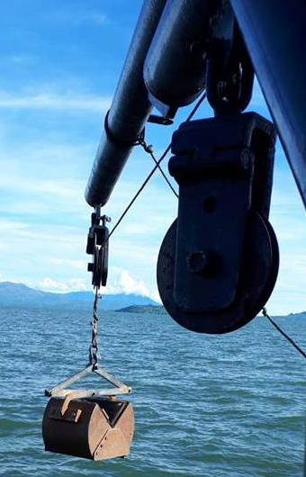

Figure 2.1 – Vanveen sediment grabber used to collect sediment samples. This is an image of the Vanveen sediment grabber that was used to collect sediment samples from the Lake bed in Lake Victoria.

Sampling of aquaculture retail products

All fish analysed as part of this study were purchased at point of sale, either from the farmers (Kenya) or directly from supermarkets (UK) (Table s 2.2, 2.3, 2.4).

Fish from Lake Victoria, Kenya

Fish samples, from both farmed and wild fish, were collected from Kenya during May 2018 (n=34) and November 2018 (n=33). The fish included wild, farmed and pond Tilapia (WT, FT, PT) (Oreochromis niloticus) and wild Nile Perch (WNP) (Lates niloticus) at different sites (Table 2.2 and 2.3); all fish were purchased from fish farmers at point of harvest/sale. The lengths (Centimetres, cm), weights (grams,

g) and sex (male, ♂ and female ♀) were recorded, (Table s 3.9 and 3.10) for Tilapia and Nile perch data respectively. Three fish food samples were also collected from Lake Victoria.

Site | Location | Fish samples
1 | Dunga | 1, 2, 3, 4, 5, 6, 7 S1WN3, S1WN4 S1WN5
2 | Maboko Island | NFS
3 | Asat Cages | 8, 9, 10, 11
4 | Uyoma Point | NFS
5a | Naya Bay | NFS
5b | Naya Cages | 12, 13, 14, 15, 16, 17
6 | off Ngodhe | NFS
7a | Mfangano/Mbeo Cages | NFS
7b | Mbeo cages | NFS
7c | Mbeo cages | 18, 19, 20, 21
8 | Mbita West | NFS
9 | Bridge Island | NFS
10 | Kadimo bay (Anyanga) | 22, 23, 24, 25, 26, 27, 28
11 | Madiany Water Intake | NFS
12 | Achieng' Oneko (Kunya) | NFS
13 | University of Eldorette pond | 29, 30

Figure 2.2 – Fish sampling sites May 2018. This table shows the sites where the fish were sampled from, and where no fish were samples (NFS).
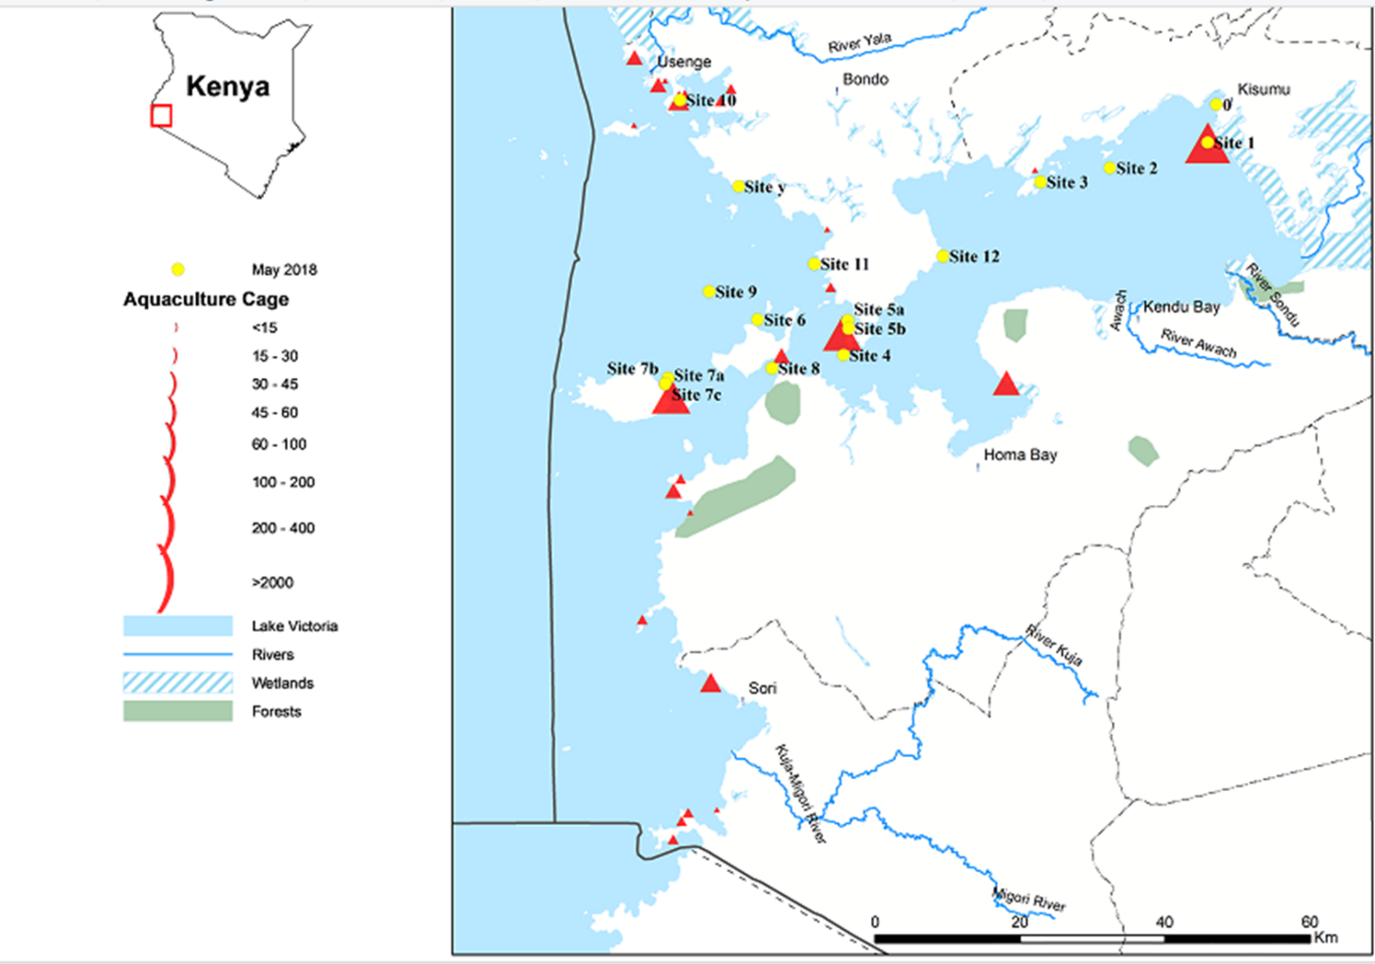

Figure 2.2.1 – A map of the May 2018 sampling sites. This map shows the sampling sites 1-12 where the aquaculture product was sampled from in May 2018 . The red triangles represent the size of the aquaculture cages.
Site | Location | Fish samples
1a | KSM Pier | NFS
1b | KSM Pier | NFS
2a | Dunga | NFS
2b | Dunga | 31, 32, 33, 34, 35, 36, 37, 38
2c | Dunga | NFS
3a | Off Kibos RM | NFS
3b | Off Kibos RM | NFS
3c | Off Kibos RM | 39, 40
4a | Off Nyando RM | NFS
4b | Off Nyando RM | NFS
4c | Off Nyando RM | NFS
5c | Off Nyando RM | 41, 42, 43, 44
6a | Off Awach RM | NFS
6b | Off Awach RM | NFS
6c | Off Awach RM | NFS
6e | Off Awach RM | 46, 47, 48
7a | Gingra | NFS
7b | Gingra | NFS
7c | Gingra | NFS
7d | Gingra | 49, 50, 51, 52
8a | Kowuor Oluch | NFS
8b | Kowuor Oluch | 53, 54, 55, 56
8c | Kowuor Oluch | NFS
9a | Naya bay | NFS
9b | Naya bay | NFS
9c | Naya bay | 57, 58, 59, 60, 61, 62, 63
10a | Luanda Gembe | NFS
10b | Luanda Gembe | NFS
10c | Luanda Gembe | NFS
11a | Achieng Oneko | NFS
11b | Achieng Oneko | NFS
11c | Achieng Oneko | NFS
12a | Asembo bay | NFS
12b | Asembo bay | NFS
12c | Asembo bay | NFS
13a | Ndere Isl. | NFS
13b | Ndere Isl. | NFS
13c | Ndere Isl. | NFS
14a | Maboko Is | NFS
14b | Maboko Is | NFS
14c | Maboko Is | NFS

Figure 2.3 – Fish sampling sites November 2018. This table shows the sites where the fish were sampled from, and where no fish were samples (NFS).
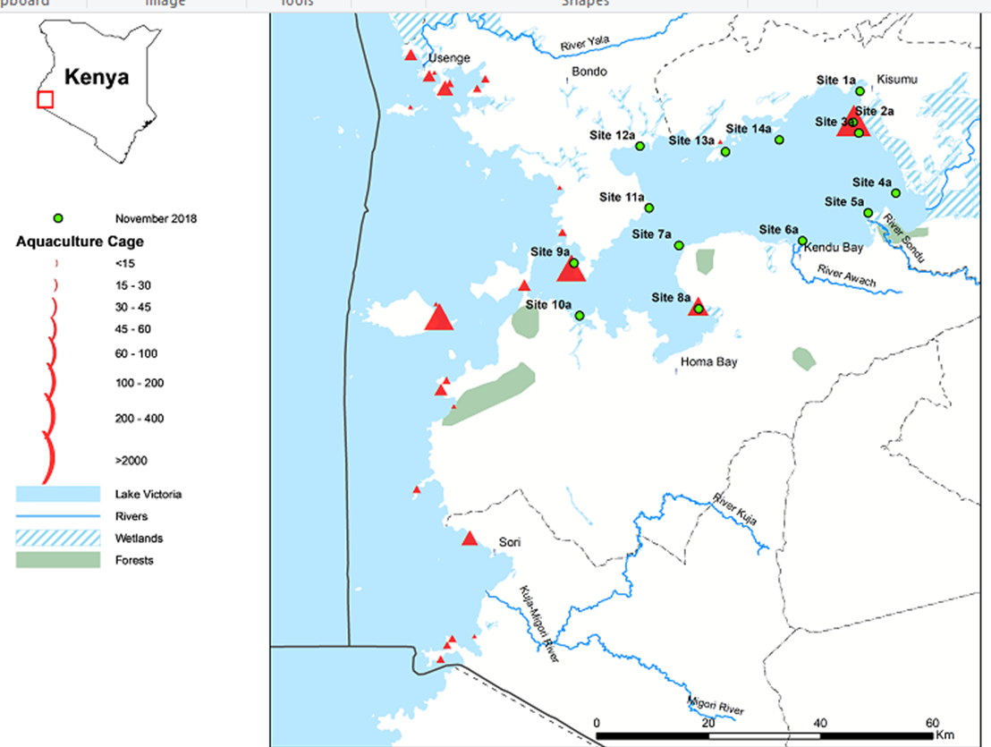

Figure 2.3.1 – A map of the November 2018 sampling sites. This map shows the sampling sites 1-14a where the aquaculture product was sampled from in May 2018 . The red triangles represent the size of the aquaculture cages.

Aquaculture products purchased in the UK

Aquaculture products (n=19) were also collected from two major supermarkets in the United Kingdom (UK); all of which products were farmed in Vietnam, including Jumbo king prawns, Raw king prawns and Basa (Pangasius bocourti) (Table 2.4).

ID | Aquaculture product | Supermarket (A/B)
47 | Jumbo King Prawns raw | A
48 | Jumbo King Prawns raw | A
49 | Jumbo King Prawns raw | A
50 | Jumbo King Prawns raw | A
51 | Jumbo King Prawns raw | A
52 | Raw King Prawns | B
53 | Raw King Prawns | B
54 | Raw King Prawns | B
55 | Raw King Prawns | B
56 | Raw King Prawns | B
57 | Basa | A
58 | Basa | A
59 | Basa | A
60 | Basa | A
61 | Basa | A

Table 2.4 – Vietnamese aquaculture products used in this study purchased from two major UK retailers. This table shows the IDs, the different aquaculture product (Jumbo King Prawns, Raw King Prawns, Basa (Pangasius bocourti)) and the supermarket the product was purchased from (A and B). These fish were bought from major retailers in the UK but were farmed in the Mekong delta river in Vietnam.

Extraction of genomic DNA from aquaculture product

Homogenisation, prior to DNA extraction, of 25mg of fish tissue was carried out using 0.5mm Zirconia silica beads (Biospec) in 180μl of ATL buffer (Qiagen) containing 20μl of Proteinase K (Qiagen). This was incubated (3hrs, 56oC), prior to further homogenisation in a Mini-Beadbeater (Biospec) (1min, 5000rpm) with ice cooling (3mins); this was repeated 4 times. Extraction of genomic DNA from this homogenate was carried out using a DNeasy Blood and Tissue kit (Qiagen) following the manufacturer’s protocol. DNA was eluted from the column with 200μl of

AE buffer (Qiagen) and incubated for (1min, 37oC) prior to centrifugation (1min, 6000g), and stored at -20o C.

Purification of genomic DNA

Some of the DNA samples needed additional purification by ethanol precipitation. To 200μl of DNA, 400μl of ethanol (100%, VWR) was added with 20μl of 3M NaOAc (Ambion) and mixed by inversion. The tube was then incubated (30min, -20oC) to precipitate DNA, and DNA collected following centrifuged (10min, 13,000rpm). The supernatant was removed from the tube and 500μl of ethanol (70%) was then added before further centrifugation (5min, 15,000rpm). The supernatant was removed and the pellet was left to air dry. 100μl of nuclease free water (Invitrogen) was added to the pellet and the sample was incubated (3hrs, 55oC), prior to storage at -20oC.

Assessment of the quality and quantity of DNA

The quality and quantity of the genomic DNA was assessed on a Nanodrop 8000 (Thermo Fisher Scientific) before storage at -20oC.

Polymerase chain reactions

Polymerase chain reaction (PCR) was used to detect a range of genes in the aquaculture samples, using Genetouch (Bioer) and G-storm (Gene Technologies) PCR machines.

Primers for PCR

The primers used in this study (Table 2.5) targeted a range of bacteria specific genes, using primer pairs from published papers. The V3/V6 (Chakravorty et al., 2007) primer pair, which targets the 16S Ribosomal sequence rRNA, was used to highlight the presence of bacterial DNA. The remaining primer pairs (Table 2.5) were then

used to investigate whether resistance genes for two metals (Cu, Hg) and one antibiotic (Tetracycline) could be detected in the bacterial DNA present in each fish tissue; CopA (Altimira et al., 2012), CopAu (De la Iglesia et al., 2010), DMerA (de Luca Rebello et al., 2013), TetB (Van et al., 2008), TetD (Schmidt et al., 2001) and TetDof (Ryu et al., 2012).

Gene name | Forward primer | Reverse primer | Amplicon size (bp) | Annealing temperature (oC) | Reference
CopA | 5’GTCGTTAGCTTGCC AAGATC | 5’CGGAAAGCAAGATGT CGAATCG | 1100 | 58 | (Altimira et al., 2012)
CopA universal primers CopAu | 5’GGTGCTGATCATCG CCTG | 5’GGGCGTCGTTGATAC CGT | 750 | 68 | (De la  Iglesia et al., 2010)
DMerA | 5’TCCGCAAGTNGCVA CBGTNGG | 5’ACCATCGTCAGRTAR GGRAAVA | 285 | 68 | (de Luca Rebello et al., 2013)
TetB | 5’CCTTATCATGCCAGT CTTGC | 5’ACTGCCGTTTTTTCGC C | 773 | 63 | (Van et al., 2008)
TetD | 5’ATTACACTGCTGGA CGCGAT | 5’CTGATCAGCAGACAG ATTGC | 1000 | 67 | (Schmidt et al., 2001)
TetDo | 5’ATGATAAGCAGTTT CATACAACG | 5’CTAGTGCATTGCCTC CAATTC | 336 | 58 | (Ryu et al., 2012)
V3/V6 | 5′ACTYCTACGGRAGG CWGC | 5’CRRCACGAGCTGACG AC | 739 | 56.5 | (Chakravort y et al., 2007)

Figure 2.5 – Table of primers used in this study. This table shows the primer name, sequence, their amplicon size in base pairs (bp) and the annealing temperatures (oC) used. . The V3/V6 (Chakravorty et al., 2007) primer pair, which targets the 16S Ribosomal RNA, was used to highlight the presence of bacterial DNA. The remaining primer pairs were then used to investigate whether resistance genes for two metals (Cu, Hg) and one antibiotic (Tetracycline) could be detected in the bacterial DNA present in each fish tissue; CopA (Altimira et al., 2012), CopAu (De la Iglesia et al., 2010), DMerA (de Luca Rebello et al., 2013), TetB (Van et al., 2008), TetD (Schmidt et al., 2001) and TetDo (Ryu et al., 2012).

PCR with Phusion

The PCRs performed using Phusion (BioLabs) were run according to manufacturer’s instructions. The cycling conditions used for this PCR were as follows:

      - Initial incubation (3min, 94oC) Followed by 40 cycles of:
      - Denaturation (45s, 96oC)

      - Annealing (30s)

      - Extension (30s, 72oC)

Followed by a final extension period (2mins, 72oC)

PCR with Taq-polymerase

The PCRs using LongAmp Taq (BioLabs) were run according to manufacturer’s instructions. The conditions for this PCR were as follows:
      - Initial incubation (3min, 92oC) Followed by 35 cycles of:
      - Denaturation (30s, 94oC)

      - Annealing (60s)

      - Extension (1min 40s, 65oC), Followed by a final extension (10min, 65oC)

PCR with GoTaq hot start master mix

The PCRs were run according to manufacturer’s instructions using GoTaq hot start green master mix (Promega). The conditions were as follows:
      - Initial incubation (3min, 94oC) Followed by 30 cycles of:
      - Denature (45s 94oC)

      - Annealing (30s)

      - Extension (30s,72oC)

Followed by a final extension (5 min,72 oC)

Gradient PCR with GoTaq hot start master mix

Gradient PCRS were carried out using a positive control from a previous study to determine the optimal annealing temperature for the CopA, CopAu and MerA primers using the GoTaq protocol; a GoTaq master mix was used. The gradient temperature range used was 57-63 oC.

Nested PCR

Nested PCRs were performed using Phusion (BioLabs) enzyme following manufacturer’s instructions, and were used to try and further amplify PCR products. The conditions for the PCR were as follows:
      - Initial incubation (10s, 98oC).

Followed by 40 cycles of:

- Denature (30s, 96oC)

- Annealing (30s)

- Extension (30s, 72oC)

With a final extension (2min, 72oC)

10µl of this reaction mixture was then added to 12.5 µl of Phusion master mix, 1.25µl forward primer and 1.25µl reverse primer and the PCR was conducted as detailed above.

PCR product purification

PCR products generated using the CopAU primer pairs with samples 3 and 21 were purified prior to being cloned.

Gel extraction of PCR products for cloning

PCR products (multiple bands present) were excised from an agarose gel and purified using the QIAquick Gel Extraction Kit (Qiagen) following manufacturer’s instructions.

Cleaning of purified plasmid PCR

PCR products (single product on gel) that did not need gel purification were purified using a PCR purification kit (Quiagen), following manufacturer’s instructions.

A tailing with Taq polymerase fragment

Using the purified PCR product (generated using Phusion), 0.2μl Taq polymerase was added to 2.8μl of purified PCR product, 1μl of dATP (10mM), 5μl of 10xPCR buffer with Mg (Promega), and a suitable volume of water was added to make the reaction up to the volume of 50μl. This was then incubated (72oC, 20min) prior to cloning.

Cloning

Cloning was performed using the TA cloning kit (Invitrogen) according to manufacturer’s instructions, using nutrient agar plates (OXOID) with ampicillin (100μg/ml), with 40mg/ml X-gal spread on the plates. Two plates were spread with 50µl and 150µl of the cloning mix respectively, which were then incubated (37oC, overnight). Resulting white colonies were picked, re-suspended in 5ml nutrient broth supplemented with ampicillin (100μg/ml) and incubated overnight on the shaker (37oC, 200rpm).

Plasmid purification

Plasmid DNA was extracted using QIAprep spin Miniprep kit (Qiagen), following manufacturer’s instructions.

PCR with purified plasmids

PCR from the purified plasmids was done with Phusion using M13 and T7 primers. The PCR using the following conditions: initial denature (10s, 98oC), 40 cycles of denature (30s, 96oC), annealing (30s) and elongation (30s, 72oC), with a final elongation step (10min, 72oC).

Sequencing from PCR products

Sequencing reactions contained 5μl of the purified product, 1μl of big dye (Thermos fisher), 1.5μl of 5X sequencing buffer, 1μl of primer (CopAu or MerA) and 1.5μl of water. The sequencing reaction conditions were as follows: incubation (1min, 96˚C), denaturation (10s, 96˚C), annealing (5s, 50˚C), extension (4min, 60˚C), and this was repeated for 25 cycles.

Sequencing purification

The product from the sequencing reaction was briefly centrifuged, then put into a 1.5ml tube and 5μl of water, 2μl of Sodium acetate (3M) and 50μl of cold ethanol (100%) was added. The tube was then left to incubate (45min, room temperature). The tubes were then centrifuged (60min, 4oC, 13000rpm), all liquid was removed and 150μl of cold ethanol (70%) was added. This was then centrifuged (15min, 13000rpm), and after removing all liquid the pellet was left to dry (15min, 37oC). The dried pellets were sent to the Zoology department at the University of Oxford for sequencing.

Agarose gel electrophoresis

PCR products were visualised on a 1% ultrapure agarose (Invitrogen) gel using Tris Borate Ethylenediaminetetraacetic acid (EDTA) (TBE, Gibco), containing Gel Red (Invitrogen) as per manufacturer’s instructions. 10μl of PCR samples were mixed with 3μl of loading dye (manufacture) and loaded onto the gel alongside 4μl of 1kb ladder (Promega), prior to electrophoresis (Biorad, 40min, 70V).

Detection of antibiotic residues in aquaculture products

This was performed using a Premi-Test K3925 (Biopharm) following manufacturer’s instructions. This test is based on the inhibition of the growth of Bacillus Stearothermophilus var. calidolactis which is a themophillic microorganism which is sensitive to antibiotics including β-lactams, Cephalosporins, Macrolides, Tetracyclines, Sulphonamides, Aminoglycosides, Quinolones, Amphenicoles and Polypeptides. Juice extracted from fish/prawn muscle was added to the test and heated to 64oC; the absence of antibiotic residues allows the Bacillus to produce acid turning the test yellow, with the presence of antibiotic residues preventing growth of the spores and the test remains purple. There was no positive control (antibiotic positive) for the test kit, However, samples of chicken meat were used as a negative control.

2.8.1 Bacterial plates for antibiotic residue testing

Bacillus cereus NTC 2599 and B. cereus NCTC 211B (150µl) were streaked onto separate Nutrient agar plates (OXOID) and left to incubate (15 hrs, 37oC). Colonies were resuspended in Nutrient broth (OXOID) and left on a shaker overnight (37oC, 200rpm).
Plates were made from 50ml of nutrient agar with 750µl of bacterial broth added. Once plates were set 2 3x3mm filter papers were placed on the plate with 10µl of

fish juice on one paper and a chunk of fish muscle on the other. Then leave the plates in incubator lid side up (37o C, 3hrs) then turn the plates round and incubate (37oC, 12hrs) and visualise the results.

2.9 Elemental analysis of fish samples

All elemental analysis was carried out using Inductively coupled plasma mass spectrometry (ICP) (Agilent 7500) at the BGS. The samples were freeze dried and then were ran on the ICP (Agilent 7500). This was carried out on water, aquaculture product and fish food samples.

2.9.1 Analysis of Mercury content

The Hg analysis was completed on aquaculture product muscle tissue at the BGS using a direct Mercury analysis system (DMA-80Analitix). The samples were freeze dried and then ran on the Hg analyser. This was carried out on aquaculture product samples.

Microplastic analysis

Water, sediment and gastrointestinal tracts were to be analysed for the presence of microplastics.

Water microplastic analysis

25ml of the water sample was poured into a vacuum filter (MicroTech), then the filtered was analysed under a upright microscope (Leica). Samples were also stained with Nile red (Sigma-Aldrich) prior to filtration, which causes plastics to fluoresce, by adding 1ml of Nile red to the sample. The filter was then analysed under a florescent microscope (Leica DM5000B).

Sediment microplastic anaylsis

The sediment microplastic isolation (SMI) unit was filled with ZnCl2 to just above the valve, and a magnetic flea added, then sediment samples were placed into tube. Then the SMI unit was magnetically stirred (10min,6RPM). Sediment was then emptied from the tube into a sieve and collected, the contents were vacuum filtered and analysed under a microscope.

Analysis of microplastics in the gastrointestinal tract of the Kenyan fish
Three methods were used to assess the plastic content of the gastrointestinal (GI) tracts of the fish.

Flush with deionised water

Fish GI tracts were flushed with Deionised water (DI), and the run off collected into a metal sieve, which was then washed with DI water and this run off collected. The collective run off was put through a vacuum filter and the filter was assessed under a microscope (Leica).

Zinc chloride

GI tracts were heated (15hrs, 55oC), then ground in a mortar. 250ml of Zinc Chloride (ZnCl2) was added and the solution was stirred and filtered twice using a vacuum filter (microtech) before being dried (15hrs, 55oC). The resulting samples were looked at under a microscope (Leica).

Hydrogen peroxide

GI tracts were added to 20ml of H2O2 (30%) and heated (7 days, 55ºC). The resulting samples were diluted (1:10) with DI water, filtered and looked at under a microscope (Leica).

2.11 Data analysis

Preliminary data analysis was completed in Microsoft Excel. Further analysis of elemental data was completed in GraphPad Prism.

Results

Water sediment and fish collection

Samples of water sediment and fish were collected from sites (Table 2.2 and 2.3) Kenya in May and November 2018.

Water data

Water data, the temperature (°C, degrees centigrade) (Table 3.1 and 3.2), pH (Table 3.3 and 3.4) and depth (m, meters) was collected; some of the sites were measured multiple times at multiple depths. Thank you to our colleagues at KMFRI for providing access to this data.

Temperature

The water temperature from samples in May ranged from 21.98-27.20°C (Table 3.1), with the lowest temperature at site 11 (21.98°C, 15.0/16.0/16.9m) and the highest temperature at site 3 (27.20°C, 0.0m). The highest mean temperature was at site 9 (26.32°C) and the lowest was at site 8 (22.30°C).
The water temperature from samples in November ranged from 25.00-31.31°C (Table 3.2), with the lowest temperature at site 10a (25.00°C, 15.0/16.0/16.9m) and the highest temperature at site 11c (31.31°C, 0.0m). The highest mean temperature was at site 12c (29.34°C) and the lowest was at site 10a (25.86°C).

Site | Min (°C) | Max (°C) | Mean (°C)
1 | 22.58 | 22.63 | 22.61
2 | 22.67 | 24.39 | 23.91
3 | 25.80 | 27.20 | 26.33
4 | 22.67 | 22.71 | 22.68
5a | 22.98 | 23.39 | 23.18
5b | 22.93 | 23.40 | 23.14
6 | 23.20 | 23.25 | 23.22
7a | 22.24 | 22.99 | 22.63
7b | 22.64 | 22.81 | 22.74
8 | 22.09 | 22.77 | 22.30
9 | 22.60 | 22.64 | 22.63
10 | 25.50 | 26.50 | 25.92
11 | 21.98 | 23.47 | 22.88
12 | 22.75 | 24.24 | 23.70

Table 3.1 - Water temperature data from May 2018. This table shows the minimum (min) maximum (max) and mean temperatures (°C, degrees centigrade) of the water sites used in this study. At site 1 n=6 with a depth range of 0-4.3m, site 2 n=5 (0-4m), site 3 n=6 (0-5m), site 4 n=20 (0-18.9m), site 5a n=7 (0-6.5m), site 5b n=6 (0-4.4m), site 6 n=8 (0-6.7m), site 7a n=28 (0-27m), site 7b n=14 (0-12.9m), site 8 n=9 (0-7.9m), site 9 n=29 (0-25m), site 10 n=10 (0-9m), site 11 n=18 (0-16.9m), site 12 n=6 (0-5m). The readings were collected on multiparameter water meter. Water data was collected and data was generated by colleagues at the Kenya Marine & Fisheries Research Institute.

Site | Min (°C) | Max (°C) | Mean (°C)
1a | 26.65 | 26.66 | 26.65
1b | 26.66 | 26.68 | 26.67
2a | 26.43 | 26.76 | 26.57
2b | 26.53 | 27.44 | 26.74
2c | 27.54 | 28.26 | 27.86
3a | 26.26 | 26.80 | 26.45
3b | 26.21 | 28.14 | 27.18
3c | 26.54 | 28.74 | 27.90
4a | 26.88 | 29.54 | 27.46
4b | 27.23 | 27.25 | 27.24
4c | 26.70 | 26.72 | 26.71
6a | 26.65 | 26.66 | 26.66
6b | 26.87 | 27.08 | 26.94
6c | 26.40 | 27.26 | 26.85
7a | 25.95 | 27.04 | 26.42
7b | 25.92 | 28.50 | 26.46
7c | 26.48 | 30.22 | 28.14
8a | 26.26 | 28.60 | 27.40
8b | 26.39 | 28.47 | 27.42
8c | 29.29 | 29.30 | 29.30
9a | 26.11 | 26.43 | 26.36
9b | 26.31 | 26.82 | 26.65
9c | 26.76 | 26.90 | 26.86
10a | 25.00 | 26.26 | 25.86
10b | 25.61 | 26.87 | 26.07
10c | 25.62 | 26.89 | 26.04
11a | 26.15 | 28.81 | 26.75
11b | 26.18 | 30.24 | 27.00
11c | 26.30 | 31.31 | 27.57
12a | 26.72 | 29.70 | 27.98
12b | 26.98 | 30.14 | 28.69
12c | 27.45 | 30.4 | 29.34
13a | 26.46 | 26.48 | 26.47
13b | 26.44 | 26.46 | 26.45
13c | 26.40 | 26.43 | 26.42
14a | 26.28 | 26.38 | 26.35
14b | 26.15 | 26.32 | 26.28
14c | 26.07 | 26.16 | 26.14

Table 3.2 - Water temperature data from November 2018. This table shows the minimum (min) maximum (max) and mean temperatures (°C, degrees centigrade) of the water sites used in this study in November 2018. At Site 1a (n=4, 0-3m), Site 1b (n=4, 0-3.5m), site 2a (n=5, 0-4m), site 2b (n=5, 0-3.4m), site 2c (n=3, 0-1.5m), site 3a (n=5, 0-3.5m), site 3b (n=2, 0-1m), site 3c (n=3, 0-1.5m), site 4a (n=5, 0- 3.5m), site 4b (n=3, 0-1.5m), site 4c (n=2, 0-0.5m), site 6a (n=4, 0-3m), site 6b (n=4, 0-2.4m), site 6c
(n=3, 0-1.5m), site 7a (n=10, 0-10m), site 7b (n=10, 0-7.8m), site 7c (n=4, 0-2.2m), site 8a (n=6, 0-5m), site 8b (n=5, 0-4m), site 8c (n=3, 0-1.5m), site 9a (n=7, 0-6m), site 9b (n=6, 0-5m), site 9c (n=5, 0-4m), site 10a (n=6, 0-4.5m), site 10b (n=6, 0-4.5m), site 10c (n=6, 0-4.4m), site 11a (n=6, 0-5m), site 11b (n=6, 0-4.4m), site 11c (n=4, 0-3m), site 12a (n=5, 0-3.5m), site 12b (n=4, 0-3.9m), site 12c (n=3, 0-1.6m), site 13a (n=7, 0-5.5m), site 13b (n=6, 0-5m), site 13c (n=5, 0-4m), site 14a (n=6, 0-6m), site 14b (n=7, 0- 5.5m), site 14c (n=6, 0-4.5m). Water data was collected and data was generated by colleagues at the Kenya Marine & Fisheries Research Institute.

pH

The pH of the water samples from May ranged from pH7-8.81 (Table 3.3) with the lowest (pH7) occurring at 3 sites; site 9 (8/9m), site 8 (1/2/3/4m) and site 11 (11m). The highest (pH8.81) was at site 10 (0m). The lowest mean pH (pH7.12) was at site 5b and the highest (pH8.14) was at site 10.
The pH of the water samples from November ranged from pH6.61-8.31 (Table 3.4) with the lowest (pH6.61) occurring at site 6c. The highest (pH8.31) was at site 8c (0m). The lowest mean (pH6.73) was at site 1b and the highest (pH8.00) was at site 6b.

Site | Min | Max | Mean
1 | 7.90 | 7.95 | 7.92
2 | 7.70 | 7.75 | 7.72
3 | 7.16 | 7.51 | 7.33
4 | 7.08 | 7.37 | 7.19
5a | 7.34 | 7.51 | 7.43
5b | 7.10 | 7.14 | 7.12
6 | 7.35 | 7.37 | 7.37
7a | 7.34 | 7.70 | 7.64
7b | 7.33 | 7.39 | 7.36
8 | 7.01 | 7.98 | 7.36
9 | 7.00 | 7.97 | 7.54
10 | 7.60 | 8.81 | 8.14
11 | 7.00 | 7.99 | 7.33
12 | 7.19 | 7.22 | 7.21

Table 3.3- pH data from water sites from May. The table contains the minimum (min), maximum (max) and mean pHs for the 14 sites sampled. At site 1 n=6 with a depth range of 0-4.3m, site 2 n=5 (0-4m), site 3 n=6 (0-5m), site 4 n=20 (0-18.9m), site 5a n=7 (0-6.5m), site 5b n=6 (0-4.4m), site 6 n=8 (0-6.7m), site 7a n=28 (0-27m), site 7b n=14 (0-12.9m), site 8 n=9 (0-7.9m), site 9 n=29 (0-25m), site 10 n=10 (0-9m), site 11 n=18 (0-16.9m), site 12 n=6 (0-5m). The readings were collected on multiparameter water meter. Water data was collected, and data was generated by colleagues at the Kenya Marine & Fisheries Research Institute.

Site | Min | Max | Mean
1a | 6.80 | 7.91 | 7.09
1b | 6.65 | 6.82 | 6.73
2a | 7.11 | 7.61 | 7.42
2b | 6.90 | 7.56 | 7.31
2c | 7.25 | 7.50 | 7.38
3a | 7.37 | 7.70 | 7.57
3b | 7.58 | 7.90 | 7.74
3c | 6.87 | 7.67 | 7.35
4a | 7.60 | 7.93 | 7.81
4b | 7.76 | 7.78 | 7.77
4c | 7.66 | 7.70 | 7.68
6a | 7.47 | 7.63 | 7.55
6b | 7.90 | 8.16 | 8.00
6c | 6.61 | 7.58 | 7.19
7a | 6.92 | 7.67 | 7.39
7b | 6.83 | 7.94 | 7.25
7c | 7.46 | 7.92 | 7.65
8a | 7.42 | 8.11 | 7.77
8b | 7.41 | 7.93 | 7.67
8c | 7.81 | 7.83 | 7.82
9a | 7.02 | 8.13 | 7.75
9b | 7.12 | 7.60 | 7.38
9c | 6.92 | 7.61 | 7.33
10a | 6.92 | 7.50 | 7.25
10b | 6.96 | 7.75 | 7.40
10c | 6.89 | 7.81 | 7.35
11a | 7.41 | 8.12 | 7.70
11b | 7.36 | 7.97 | 7.60
11c | 7.51 | 8.31 | 7.80
12a | 7.41 | 8.04 | 7.72
12b | 7.35 | 7.93 | 7.73
12c | 7.37 | 7.83 | 7.65
13a | 7.26 | 7.50 | 7.42
13b | 7.09 | 7.44 | 7.33
13c | 7.30 | 7.46 | 7.40
14a | 7.24 | 7.76 | 7.44
14b | 7.10 | 7.60 | 7.38
14c | 7.10 | 7.60 | 7.42

Table 3.4- pH data from water sites from November. The table contains the minimum (min), maximum (max) and mean pHs for the 14 sites sampled. At Site 1a (n=4, 0-3m), Site 1b (n=4, 0- 3.5m), site 2a (n=5, 0-4m), site 2b (n=5, 0-3.4m), site 2c (n=3, 0-1.5m), site 3a (n=5, 0-3.5m), site 3b (n=2, 0-1m), site 3c (n=3, 0-1.5m), site 4a (n=5, 0-3.5m), site 4b (n=3, 0-1.5m), site 4c (n=2, 0-0.5m), site 6a (n=4, 0-3m), site 6b (n=4, 0-2.4m), site 6c (n=3, 0-1.5m), site 7a (n=10,
0-10m), site 7b (n=10, 0-7.8m), site 7c (n=4, 0-2.2m), site 8a (n=6, 0-5m), site 8b (n=5, 0- 4m), site 8c (n=3, 0-1.5m), site 9a (n=7, 0-6m), site 9b (n=6, 0-5m), site 9c (n=5, 0-4m), site 10a (n=6, 0-4.5m), site 10b (n=6, 0-4.5m), site 10c (n=6, 0-4.4m), site 11a (n=6, 0-5m), site 11b (n=6, 0-4.4m), site 11c (n=4, 0-3m), site 12a (n=5, 0-3.5m), site 12b (n=4, 0-3.9m), site 12c (n=3, 0-1.6m), site 13a (n=7, 0-5.5m), site 13b (n=6, 0-5m), site 13c (n=5, 0-4m), site 14a (n=6, 0-6m), site 14b (n=7, 0-5.5m), site 14c (n=6, 0-4.5m). Water data was collected, and data was generated by colleagues at the Kenya Marine & Fisheries Research Institute.

Elements analysis of water samples

Of the 57 elements analysed in water samples data from 12 potentially harmful metals from both May 2018 and November 2018 are displayed in Tables 3.5 and 3.7 respectively. A further 8 essential elements were analysed and can be seen in tables 3.6 and 3.8 respectively.

Site number | Shallow (S)/ Deep (D) | Al (mg/kg) | As  (mg/kg) | Ba (mg/kg) | Cs (mg/kg) | Cr (mg/kg) | Co (mg/kg) | Ni (mg/kg) | Rb (mg/kg) | Sr (mg/kg) | Sn (mg/kg) | Hg (mg/kg) | Ti (mg/kg)
1 | S | 276.04 | 0.40 | 30.54 | 0.02 | 0.12 | 0.10 | 0.36 | 5.30 | 98.09 | 0.09 | 0.01 | 8.69
 | D | 46.90 | 0.27 | 31.26 | 0.01 | 0.00 | 0.26 | 0.34 | 3.23 | 82.72 | 0.35 | 0.01 | 1.55
2 | S | 202.68 | 0.41 | 31.71 | 0.02 | 0.09 | 0.07 | 0.40 | 7.07 | 111.2  3 | 0.05 | 0.00 | 8.29
 | D | 199.90 | 0.37 | 28.14 | 0.01 | 0.18 | 0.15 | 0.66 | 6.61 | 95.21 | 0.26 | 0.00 | 8.65
3 | S | 127.67 | 0.38 | 30.58 | 0.00 | 0.12 | 0.05 | 0.26 | 5.45 | 108.0  3 | 0.15 | 0.00 | 3.97
 | D | 304.33 | 0.40 | 36.91 | 0.01 | 0.14 | 0.09 | 0.32 | 5.54 | 105.9  7 | 0.05 | 0.00 | 12.00
4 | S | 235.17 | 0.28 | 28.04 | 0.02 | 0.14 | 0.08 | 0.19 | 3.77 | 78.57 | 0.04 | 0.00 | 7.80
 | D | 282.91 | 0.23 | 23.10 | 0.01 | 0.14 | 0.06 | 0.18 | 3.55 | 63.27 | 0.09 | 0.00 | 11.38
5a | S | 137.39 | 0.27 | 31.67 | 0.00 | 0.12 | 0.06 | 0.11 | 3.61 | 92.01 | 0.02 | 0.00 | 4.84
 | D | 291.86 | 0.24 | 24.99 | 0.01 | 0.14 | 0.06 | 0.18 | 3.37 | 78.53 | 0.05 | 0.00 | 9.08
5b | S | 190.47 | 0.17 | 19.13 | 0.01 | 0.09 | 0.06 | 0.17 | 2.60 | 54.00 | 0.02 | 0.00 | 7.13
 | D | 281.08 | 0.29 | 33.75 | 0.01 | 0.16 | 0.06 | 0.17 | 4.55 | 101.3  8 | 0.04 | 0.00 | 11.31
6 | S | 1.00 | 0.15 | 29.13 | 0.01 | 0.02 | 0.01 | 0.00 | 3.09 | 76.87 | 0.00 | 0.01 | 0.06
 | D | 12.69 | 0.14 | 27.02 | 0.00 | 0.02 | 0.04 | 0.06 | 2.89 | 70.37 | 0.01 | 0.002 | 0.75
7a | S | 2.07 | 0.11 | 18.79 | 0.00 | 0.01 | 0.00 | 0.00 | 2.18 | 52.14 | 0.02 | 0.00 | 0.18
 | D | 2.07 | 0.11 | 26.70 | 0.00 | 0.00 | 0.01 | 0.00 | 2.81 | 72.11 | 0.00 | 0.00 | 0.18
7b | S | 2.80 | 0.11 | 19.88 | 0.00 | 0.00 | 0.01 | 0.00 | 2.25 | 55.05 | 0.00 | 0.00 | 0.22

 | D | 10.74 | 0.05 | 13.10 | 0.00 | 0.00 | 0.03 | 0.00 | 1.22 | 31.47 | 0.00 | 0.00 | 0.93
8 | S | 6.57 | 0.17 | 29.25 | 0.00 | 0.01 | 0.01 | 0.00 | 4.10 | 82.61 | 0.00 | 0.00 | 0.34
 | D | 8.46 | 0.16 | 31.12 | 0.00 | 0.02 | 0.13 | 0.13 | 3.46 | 83.76 | 0.01 | 0.00 | 0.50
9 | S | 4.96 | 0.15 | 29.87 | 0.00 | 0.00 | 0.03 | 0.00 | 3.56 | 80.04 | 0.00 | 0.00 | 0.14
 | D | 5.46 | 0.19 | 31.38 | 0.01 | 0.07 | 0.23 | 0.71 | 5.14 | 89.42 | 0.10 | 0.00 | 0.26
10 | S | 1.35 | 0.17 | 30.68 | 0.01 | 0.00 | 0.04 | 0.00 | 4.19 | 85.95 | 0.00 | 0.00 | 0.22
 | D | 0.44 | 0.13 | 23.53 | 0.00 | 0.00 | 0.03 | 0.00 | 2.45 | 62.17 | 0.00 | 0.00 | 0.10
11 | S | 41.13 | 0.08 | 23.55 | 0.00 | 0.02 | 0.01 | 0.00 | 1.45 | 52.53 | 0.00 | 0.00 | 1.91
 | D | 45.61 | 0.05 | 16.10 | 0.00 | 0.01 | 0.00 | 0.00 | 0.73 | 29.54 | 0.01 | 0.00 | 1.38
12 | S | 476.59 | 0.40 | 35.11 | 0.02 | 0.24 | 0.08 | 0.35 | 4.50 | 101.0  7 | 0.02 | 0.00 | 14.87
 | D | 476.85 | 0.34 | 28.83 | 0.02 | 0.25 | 0.08 | 0.34 | 3.34 | 78.53 | 0.02 | 0.00 | 16.40
13 | S | 151.51 | 0.12 | 33.10 | 0.00 | 0.062 | 0.120 | 1.65 | 5.82 | 88.49 | 0.083 | 0.00 | 1.04

Table 3.5- Potentially harmful metal analysis of water samples collected May 2018. The 15 water samples from May 2018 were analysed by Inductively coupled plasma mass spectrometry (ICP) for Aluminium (Al), Arsenic (As), Barium (Ba) , Caesium (Cs) ,Chromium (Cr), Cobalt (Co), Mercury (Hg), Nickel (Ni), Rubidium (Rb), Strontium (Sr), Tin (Sn), Titanium (Ti). Samples were taken at both shallow water (S) and deep (D).). ICP analysis was conducted by colleagues at the British Geological Survey.

Site number | Shallow (S)/ Deep (D) | Ca (mg/kg) | Cu (mg/kg) | Fe (mg/kg) | Mg (mg/kg) | K (mg/kg) | Se (mg/kg) | Na (mg/kg) | Zn (mg/kg)
1 | S | 7.01 | 1.60 | 221.05 | 2.02 | 4.04 | 0.07 | 12.98 | 8.55
 | D | 6.45 | 1.20 | 39.70 | 1.70 | 2.41 | 0.10 | 9.01 | 7.31
2 | S | 8.91 | 1.78 | 134.30 | 2.33 | 5.62 | 0.09 | 14.33 | 4.68
 | D | 6.80 | 2.90 | 159.73 | 2.02 | 5.48 | 0.08 | 12.95 | 28.88
3 | S | 7.74 | 1.23 | 103.99 | 2.24 | 4.40 | 0.09 | 13.78 | 4.13
 | D | 7.53 | 1.03 | 245.28 | 2.19 | 4.17 | 0.08 | 13.31 | 1.80
4 | S | 5.08 | 0.86 | 175.90 | 1.86 | 3.08 | 0.02 | 9.65 | 4.37
 | D | 3.35 | 0.62 | 235.61 | 1.63 | 2.81 | 0.03 | 8.88 | 4.05
5a | S | 5.99 | 0.53 | 131.33 | 2.10 | 3.02 | 0.06 | 9.77 | 0.89
 | D | 4.62 | 0.56 | 241.38 | 1.93 | 2.70 | 0.01 | 8.86 | 2.05
5b | S | 3.89 | 0.67 | 183.03 | 1.36 | 1.88 | 0.02 | 6.02 | 2.59
 | D | 6.99 | 0.71 | 230.51 | 2.34 | 3.66 | 0.05 | 11.71 | 1.18
6 | S | 4.82 | 0.13 | 1.30 | 1.98 | 2.69 | 0.03 | 7.99 | 0.06
 | D | 3.91 | 0.59 | 9.04 | 1.75 | 2.55 | 0.00 | 7.22 | 4.04
7a | S | 3.15 | 0.11 | 2.06 | 1.39 | 1.79 | 0.00 | 5.33 | 4.74
 | D | 4.54 | 0.12 | 0.73 | 1.72 | 2.46 | 0.00 | 6.95 | 2.05
7b | S | 3.24 | 0.06 | 0.24 | 1.42 | 1.91 | 0.02 | 5.56 | 0.32
 | D | 1.82 | 0.11 | 31.36 | 0.85 | 1.10 | 0.01 | 3.28 | 0.00
8 | S | 4.55 | 0.10 | 5.10 | 2.13 | 3.20 | 0.03 | 9.20 | 1.11
 | D | 5.44 | 0.52 | 6.18 | 2.10 | 3.13 | 0.02 | 9.04 | 8.89
9 | S | 4.63 | 0.10 | 2.63 | 2.03 | 2.82 | 0.01 | 8.29 | 1.79
 | D | 6.00 | 2.39 | 5.11 | 2.44 | 4.40 | 0.02 | 11.39 | 54.75
10 | S | 5.68 | 0.21 | 4.99 | 2.26 | 3.30 | 0.02 | 9.62 | 0.22
 | D | 3.66 | 0.09 | 13.57 | 1.49 | 2.01 | 0.00 | 5.95 | 0.72
11 | S | 3.31 | 0.12 | 35.61 | 0.93 | 1.09 | 0.00 | 3.29 | 0.30
 | D | 1.87 | 0.06 | 34.40 | 0.48 | 0.56 | 0.00 | 1.69 | 0.26
12 | S | 6.91 | 0.93 | 362.06 | 2.22 | 3.65 | 0.05 | 12.78 | 1.15
 | D | 5.22 | 0.85 | 345.93 | 1.74 | 2.75 | 0.04 | 9.47 | 1.36
13 | S | 10.59 | 2.84 | 35.97 | 3.552 | 5.85 | 0.08 | 10.23 | 23.77

Table 3.6-Essential element analysis of water samples collected May 2018. The 15 water samples from May 2018 were analysed by Inductively coupled plasma mass spectrometry for Calcium (Ca), Copper (Cu), Iron (Fe), Magnesium (Mg), Potassium (K), Selenium (Se), Sodium (Na), Zinc (Zn). ICP analysis was conducted by colleagues at the British Geological Survey.

Site | Shallow (S) or  Deep (D) | Al (mg/kg) | As (mg/kg) | Ba (mg/kg) | Co (mg/kg) | Cr (mg/kg) | Cs (mg/kg) | Ni (mg/kg) | Rb (mg/kg) | Sn (mg/kg) | Sr (mg/kg) | Ti (mg/kg)
1a | S | 239.07 | 0.4 | 40.5 | 0.1 | 0.16 | 0.01 | 0.54 | 5.36 | 0.35 | 128.96 | 6.46
 | D | 718.99 | 0.41 | 46.76 | 0.24 | 0.47 | 0.05 | 0.99 | 5.7 | 0.09 | 131.36 | 19.3
1b | S | 650.9 | 0.39 | 45.7 | 0.21 | 0.45 | 0.03 | 0.78 | 5.26 | 0.07 | 130.5 | 17.39
 | D | 544.38 | 0.37 | 43.23 | 0.16 | 0.35 | 0.04 | 0.69 | 5.53 | 0.07 | 129.56 | 12.31
2a | S | 757.78 | 0.4 | 42.13 | 0.18 | 0.48 | 0.03 | 0.79 | 7.04 | 0.1 | 132.35 | 20.28
 | D | 304.65 | 0.4 | 38.01 | 0.08 | 0.19 | 0.02 | 0.54 | 5.88 | 0.06 | 131.35 | 7.39
2b | S | 143.16 | 0.41 | 35.92 | 0.07 | 0.12 | 0.02 | 0.53 | 5.93 | 0.07 | 130.45 | 3.61
 | D | 459.27 | 0.39 | 39.49 | 0.13 | 0.33 | 0.04 | 0.69 | 6.49 | 0.05 | 130.72 | 12.06
2c | S | 393.93 | 0.37 | 39.68 | 0.14 | 0.31 | 0.02 | 0.6 | 6.45 | 0.05 | 133.35 | 9.34
3a | S | 535.53 | 0.39 | 39.87 | 0.17 | 0.41 | 0.03 | 0.69 | 6.7 | 0.07 | 130.21 | 13.85
 | D | 434.41 | 0.4 | 38.6 | 0.13 | 0.31 | 0.02 | 0.62 | 6.38 | 0.07 | 132.99 | 10.81
3b | S | 520.17 | 0.41 | 39.43 | 0.15 | 0.36 | 0.04 | 0.7 | 6.6 | 0.06 | 133.69 | 12.82
3c | S | 405.54 | 0.42 | 38.24 | 0.17 | 0.32 | 0.01 | 0.67 | 6.39 | 0.32 | 135.06 | 11.12
4a | S | 391.94 | 0.43 | 44.55 | 0.11 | 0.26 | 0.02 | 0.63 | 7.12 | 0.09 | 199.47 | 12.21
 | D | 238.82 | 0.45 | 42.87 | 0.11 | 0.18 | 0.01 | 0.56 | 6.7 | 0.06 | 196.94 | 6.69
4b | S | 394.89 | 0.41 | 43.16 | 0.14 | 0.29 | 0.01 | 0.52 | 6.77 | 0.04 | 175.56 | 12.19
4c | S | 22.08 | 0.32 | 87.28 | 0.81 | 0.12 | 0 | 1.49 | 13.96 | 0.06 | 447.29 | 0.74
6a | S | 410.43 | 0.44 | 47.41 | 0.14 | 0.29 | 0.03 | 0.56 | 6.43 | 0.06 | 121.61 | 9.72
 | D | 294.85 | 0.45 | 48.96 | 0.12 | 0.22 | 0.01 | 0.48 | 6.3 | 0.07 | 120.22 | 6.8
6b | S | 318.91 | 0.49 | 43.01 | 0.17 | 0.27 | 0.02 | 0.55 | 6.34 | 0.05 | 120.36 | 6.9
 | D | 369.45 | 0.47 | 46.34 | 0.17 | 0.37 | 0.02 | 0.52 | 5.91 | 0.09 | 120.04 | 8.5
6c | S | 400.68 | 0.49 | 45.93 | 0.2 | 0.24 | 0.03 | 0.54 | 6.19 | 0.1 | 119.76 | 9.76
 | D | 497.79 | 0.49 | 41.96 | 0.27 | 0.27 | 0.01 | 0.64 | 5.69 | 0.08 | 111.08 | 12
7a | S | 1411.1 | 0.47 | 48.38 | 0.15 | 0.73 | 0.05 | 0.87 | 6.92 | 0.12 | 124.42 | 45.69
 | D | 325.85 | 0.43 | 49.91 | 0.09 | 0.22 | 0.03 | 0.41 | 6.14 | 0.05 | 125.34 | 8.54
7b | S | 372.65 | 0.4 | 49.06 | 0.11 | 0.32 | 0.03 | 0.5 | 6.19 | 0.06 | 125.57 | 8.81
 | D | 312.83 | 0.51 | 48.75 | 0.1 | 0.28 | 0.02 | 0.39 | 5.94 | 0.05 | 125.73 | 8.58
7c | S | 1015.01 | 0.48 | 59.4 | 0.14 | 0.56 | 0.04 | 0.65 | 6.83 | 0.09 | 126.94 | 32.35
 | D | 4.342 | 2.71 | 221.87 | 0.58 | 0.13 | 0.02 | 3.64 | 6.11 | 0.26 | 180.98 | 0.16
8a | S | 322.81 | 0.4 | 53.83 | 0.11 | 0.33 | 0.02 | 0.42 | 5.61 | 0.08 | 119.43 | 7.41
 | D | 511.621 | 0.43 | 58.16 | 0.17 | 0.42 | 0.03 | 0.54 | 5.86 | 0.06 | 121.65 | 12.19
8b | S | 305.629 | 0.38 | 54.48 | 0.09 | 0.23 | 0.02 | 0.42 | 5.22 | 0.04 | 120.75 | 8.32
 | D | 320.047 | 0.41 | 56.28 | 0.1 | 0.29 | 0.01 | 0.44 | 5.35 | 0.04 | 117.82 | 8.3
8c | S | 634.295 | 0.4 | 60.38 | 0.17 | 0.37 | 0.01 | 0.63 | 6.14 | 0.06 | 122.04 | 11.62
9a | S | 137.95 | 0.25 | 33.17 | 0.06 | 0.08 | 0.02 | 0.28 | 5.08 | 0.07 | 101.85 | 3.53
 | D | 129.54 | 0.24 | 32.6 | 0.04 | 0.12 | 0.02 | 0.2 | 4.76 | 0.03 | 101.76 | 3.06
9b | S | 247.29 | 0.26 | 33.65 | 0.1 | 0.22 | 0.01 | 0.26 | 5.31 | 0.06 | 103.88 | 7.51
 | D | 254.46 | 0.24 | 34.23 | 0.08 | 0.21 | 0.03 | 0.24 | 5.07 | 0.06 | 102.01 | 6.05
9c | S | 131 | 0.25 | 31.77 | 0.05 | 0.13 | 0.02 | 0.18 | 4.81 | 0.04 | 103.21 | 3.68
 | D | 134.85 | 0.25 | 32.25 | 0.05 | 0.11 | 0.01 | 0.24 | 4.88 | 0.04 | 101.64 | 4.47
10a | S | 612.68 | 0.26 | 39.98 | 0.22 | 0.48 | 0.02 | 0.53 | 5.25 | 0.09 | 97.71 | 16.66

 | D | 594.31 | 0.29 | 44.31 | 0.21 | 0.47 | 0.03 | 0.54 | 5.95 | 0.07 | 116.86 | 16.13
10b | S | 603.43 | 0.29 | 44.37 | 0.21 | 0.49 | 0.03 | 0.54 | 6.05 | 0.08 | 117.99 | 18.3
 | D | 515.6 | 0.29 | 43.46 | 0.17 | 0.42 | 0.02 | 0.47 | 5.74 | 0.07 | 115.86 | 14.75
10c | S | 945.36 | 0.34 | 43.98 | 0.21 | 0.66 | 0.05 | 0.64 | 6.3 | 0.09 | 117.38 | 30.57
 | D | 587.67 | 0.29 | 43.58 | 0.22 | 0.43 | 0.02 | 0.53 | 6.39 | 0.08 | 116.94 | 15.8
11a | S | 865.78 | 0.34 | 53.71 | 0.28 | 0.64 | 0.02 | 0.76 | 6.74 | 0.1 | 129.1 | 21.87
 | D | 945.89 | 0.33 | 53.65 | 0.3 | 0.76 | 0.04 | 0.81 | 7.07 | 0.08 | 128.9 | 21.57
11b | S | 902.78 | 0.37 | 54.7 | 0.32 | 0.69 | 0.04 | 0.71 | 7.23 | 0.08 | 130.36 | 20.75
 | D | 885.31 | 0.34 | 52.23 | 0.3 | 0.7 | 0.02 | 0.77 | 6.88 | 0.07 | 128.78 | 19.31
11c | S | 848.95 | 0.34 | 52.47 | 0.28 | 0.68 | 0.03 | 0.76 | 7.09 | 0.09 | 127.13 | 19.51
 | D | 884.59 | 0.29 | 49.77 | 0.32 | 0.74 | 0.04 | 0.75 | 6.45 | 0.07 | 113.5 | 21.46
12a | S | 992.8 | 0.37 | 55.08 | 0.35 | 0.84 | 0.03 | 0.83 | 7.2 | 0.13 | 133.54 | 23.09
 | D | 1052.28 | 0.35 | 57.92 | 0.38 | 0.92 | 0.02 | 0.93 | 7.52 | 0.15 | 135.44 | 23.66
12b | S | 1011.17 | 0.39 | 56.06 | 0.34 | 0.89 | 0.03 | 0.87 | 7.59 | 0.18 | 133.54 | 24.73
 | D | 1001.77 | 0.34 | 63.11 | 0.42 | 0.83 | 0.02 | 0.84 | 7.35 | 0.14 | 134.1 | 23.16
12c | S | 1042.47 | 0.37 | 56.57 | 0.36 | 0.81 | 0.03 | 0.83 | 7.4 | 0.1 | 134.7 | 21.53
13a | S | 1039.36 | 0.36 | 53.8 | 0.33 | 0.79 | 0.04 | 0.92 | 7.72 | 0.13 | 135.05 | 22.03
 | D | 965.73 | 0.36 | 54.56 | 0.31 | 0.78 | 0.03 | 0.85 | 7.25 | 0.09 | 133.24 | 22.31
13b | S | 991.69 | 0.37 | 52.57 | 0.31 | 0.8 | 0.03 | 0.8 | 7.57 | 0.07 | 134.32 | 22.02
 | D | 1012.94 | 0.36 | 53.9 | 0.34 | 0.8 | 0.04 | 0.75 | 7.48 | 0.08 | 135.95 | 24.19
13c | S | 983.91 | 0.35 | 53.5 | 0.32 | 0.72 | 0.03 | 0.81 | 7.49 | 0.09 | 137.7 | 22.16
 | D | 1033.6 | 0.37 | 54.29 | 0.34 | 0.86 | 0.04 | 0.83 | 7.53 | 0.09 | 137.87 | 23.89
14a | S | 998.55 | 0.36 | 52.51 | 0.39 | 0.77 | 0.04 | 0.89 | 7.24 | 0.11 | 132.29 | 23.17
 | D | 940.82 | 0.37 | 49.75 | 0.32 | 0.75 | 0.02 | 0.8 | 6.98 | 0.07 | 131.49 | 21.36
14b | S | 3323.6 | 0.5 | 54.42 | 0.52 | 1.9 | 0.12 | 1.62 | 10.18 | 0.26 | 133.55 | 112.16
 | D | 1112.31 | 0.36 | 55.22 | 0.42 | 0.88 | 0.04 | 0.88 | 8.07 | 0.09 | 133.31 | 25.55
14c | S | 1028.19 | 0.36 | 51.06 | 0.38 | 0.82 | 0.05 | 0.79 | 7.65 | 0.09 | 133.62 | 22.9
 | D | 1038.43 | 0.37 | 51.29 | 0.35 | 0.81 | 0.04 | 0.79 | 7.48 | 0.08 | 134.55 | 24.14

Table 3.7-Potentially harmful metal analysis of water samples collected November 2018. The 38 water samples from November 2018 were analysed by Inductively coupled plasma mass spectrometry for Aluminium (Al), Arsenic (As), Barium (Ba) , Caesium (Cs) ,Chromium (Cr), Cobalt (Co), Mercury (Hg), Nickel (Ni), Rubidium (Rb), Strontium (Sr), Tin (Sn), Titanium (Ti). Samples were taken at both shallow water (S) and deep (D). ICP analysis was conducted by colleagues at the British Geological Survey.

Site | Shallow (S) or Deep (D) | Ca (mg/kg) | Cu (mg/kg) | Fe (mg/kg) | K (mg/kg) | Mg (mg/kg) | Na (mg/kg) | Se (mg/kg) | Zn (mg/kg)
1a | S | 9.32 | 1.05 | 303.08 | 2.8 | 2.67 | 16.52 | 0.05 | 4.51
 | D | 10.5 | 1.59 | 1062.09 | 2.92 | 2.72 | 16.42 | 0.05 | 14.59
1b | S | 9.37 | 1.26 | 910.05 | 2.56 | 2.66 | 16.21 | 0.07 | 5.23
 | D | 9.44 | 1.09 | 718.46 | 2.54 | 2.63 | 16.24 | 0.05 | 3.91
2a | S | 9.97 | 1.55 | 856.75 | 4.02 | 2.77 | 15.86 | 0.06 | 6.84
 | D | 9.5 | 1.11 | 384.75 | 3.87 | 2.69 | 15.73 | 0.05 | 2.01
2b | S | 9.37 | 1.11 | 184 | 3.87 | 2.63 | 15.74 | 0.07 | 2.77
 | D | 9.89 | 1.32 | 607.25 | 3.9 | 2.7 | 15.62 | 0.05 | 3.04
2c | S | 9.08 | 1.09 | 592.97 | 3.88 | 2.73 | 15.86 | 0.07 | 2.67
3a | S | 9.82 | 1.38 | 727.23 | 4.06 | 2.74 | 15.82 | 0.04 | 4.45
 | D | 10 | 1.18 | 582.4 | 4.03 | 2.74 | 15.94 | 0.06 | 3.09
3b | S | 9.62 | 1.21 | 722.2 | 4.04 | 2.74 | 15.55 | 0.05 | 2.85
3c | S | 9.47 | 1.23 | 601.11 | 3.99 | 2.71 | 15.56 | 0.08 | 2.57
4a | S | 13.03 | 1.28 | 463.27 | 5.12 | 3.66 | 17.34 | 0.08 | 2.84
 | D | 13.36 | 1.18 | 336.45 | 5.02 | 3.6 | 17.18 | 0.05 | 2.12
4b | S | 12.02 | 1.4 | 520.26 | 4.58 | 3.3 | 16.8 | 0.06 | 2.54
4c | S | 29 | 2.29 | 42.31 | 11.13 | 7.56 | 22.45 | 0.09 | 2.69
6a | S | 8.83 | 1.47 | 531.72 | 4.2 | 2.77 | 16.3 | 0.05 | 4.54
 | D | 8.99 | 1.17 | 382.94 | 4.21 | 2.74 | 16.15 | 0.03 | 3.88
6b | S | 9.26 | 1.39 | 397.47 | 4.11 | 2.7 | 16.39 | 0.05 | 3.84
 | D | 8.94 | 1.48 | 470.32 | 4.07 | 2.71 | 16.31 | 0.04 | 4.16
6c | S | 9.51 | 1.32 | 509.9 | 4.12 | 2.75 | 16.35 | 0.04 | 4.4
 | D | 9.2 | 1.43 | 501.9 | 3.99 | 2.76 | 15.72 | 0.05 | 3.72
7a | S | 9.37 | 1.77 | 1048.15 | 4.2 | 2.73 | 16.74 | 0.06 | 5.77
 | D | 9.63 | 1.17 | 387.82 | 4.2 | 2.71 | 16.68 | 0.05 | 3.73
7b | S | 9.15 | 1.19 | 495.15 | 4.13 | 2.7 | 16.53 | 0.06 | 3.22
 | D | 8.92 | 1.32 | 413.72 | 4.22 | 2.71 | 18.7 | 0.03 | 3.78
7c | S | 8.92 | 1.36 | 820.88 | 4.22 | 2.73 | 16.75 | 0.05 | 3.36
 | D | 12.75 | 2.87 | 9.52 | 9.88 | 0.87 | 22.8 | 0.12 | 2.41
8a | S | 9.43 | 1.19 | 626.54 | 3.94 | 2.71 | 15.37 | 0.02 | 3.68
 | D | 8.98 | 1.35 | 703.92 | 3.99 | 2.74 | 15.26 | 0.04 | 5.68
8b | S | 8.73 | 1.36 | 409.76 | 3.93 | 2.69 | 15.25 | 0.04 | 2.51
 | D | 8.58 | 1.11 | 411.62 | 3.91 | 2.69 | 15.27 | 0.05 | 2.12
8c | S | 9.12 | 1.31 | 593.18 | 4.06 | 2.8 | 15.44 | 0.05 | 4.34
9a | S | 6.91 | 0.74 | 181.6 | 3.62 | 2.51 | 11.97 | 0.02 | 4.67
 | D | 7.36 | 0.7 | 177.71 | 3.53 | 2.53 | 11.75 | 0.05 | 2.1
9b | S | 7.38 | 0.74 | 350.78 | 3.62 | 2.58 | 11.75 | 0.01 | 2.39
 | D | 7.23 | 0.71 | 351.72 | 3.61 | 2.56 | 11.86 | 0.02 | 2.58
9c | S | 6.88 | 0.63 | 181.3 | 3.62 | 2.55 | 11.83 | 0.02 | 1.81

 | D | 6.99 | 0.7 | 189.8 | 3.59 | 2.52 | 11.72 | 0.01 | 1.94
10a | S | 6.2 | 1.34 | 918.45 | 3.3 | 2.38 | 11.37 | 0.03 | 5.44
 | D | 8.29 | 1.46 | 885.63 | 3.95 | 2.7 | 13.34 | 0.04 | 5.23
10b | S | 7.68 | 1.29 | 885.08 | 3.93 | 2.74 | 13.53 | 0.03 | 3.19
 | D | 8.67 | 1.27 | 748.61 | 4.01 | 2.75 | 13.7 | 0.02 | 3.58
10c | S | 7.92 | 1.39 | 1122.17 | 4.01 | 2.77 | 13.53 | 0.04 | 3.6
 | D | 8.82 | 1.28 | 858.87 | 3.96 | 2.74 | 13.58 | 0.03 | 3.36
11a | S | 9.64 | 4.41 | 1360.36 | 4.37 | 2.89 | 15.91 | 0.03 | 10.92
 | D | 9.02 | 1.62 | 1494.51 | 4.29 | 2.88 | 15.62 | 0.05 | 6.7
11b | S | 9.89 | 1.56 | 1469.98 | 4.28 | 2.9 | 15.59 | 0.04 | 5.45
 | D | 9.49 | 1.55 | 1360.38 | 4.28 | 2.87 | 15.71 | 0.05 | 4.68
11c | S | 9.55 | 2.96 | 1354.95 | 4.19 | 2.8 | 15.35 | 0.05 | 5.4
 | D | 9.01 | 1.51 | 1449.19 | 3.63 | 2.49 | 13.27 | 0.04 | 4.6
12a | S | 9.73 | 1.86 | 1623.16 | 4.42 | 2.92 | 16.27 | 0.05 | 5.69
 | D | 9.93 | 1.97 | 1686.72 | 4.42 | 2.91 | 15.83 | 0.05 | 10.05
12b | S | 10.02 | 1.81 | 1631.96 | 4.4 | 2.91 | 16.24 | 0.05 | 4.83
 | D | 9.62 | 1.8 | 1658.72 | 4.44 | 2.86 | 16.09 | 0.05 | 4.71
12c | S | 10.04 | 1.85 | 1734.74 | 4.39 | 2.93 | 16.3 | 0.07 | 4.84
13a | S | 10.22 | 2.38 | 1625.16 | 4.4 | 2.9 | 16.52 | 0.06 | 14.43
 | D | 9.66 | 1.72 | 1553.52 | 4.27 | 2.86 | 16.12 | 0.04 | 10.8
13b | S | 10.32 | 1.62 | 1582.76 | 4.3 | 2.89 | 16.3 | 0.04 | 6.04
 | D | 10.5 | 1.62 | 1632.32 | 4.33 | 2.89 | 16.24 | 0.06 | 5.46
13c | S | 10.36 | 1.84 | 1565.7 | 4.36 | 2.91 | 16.23 | 0.07 | 4.89
 | D | 10.13 | 1.74 | 1671.59 | 4.33 | 2.9 | 15.99 | 0.05 | 6.47
14a | S | 9.39 | 1.7 | 1562.26 | 4.24 | 2.87 | 16.6 | 0.05 | 9.81
 | D | 10.17 | 1.61 | 1462.6 | 4.17 | 2.85 | 16.32 | 0.04 | 6.61
14b | S | 9.94 | 2.29 | 2979.64 | 4.44 | 3 | 16.3 | 0.06 | 9.81
 | D | 9.82 | 1.94 | 1831.34 | 4.25 | 2.9 | 16.27 | 0.05 | 5.57
14c | S | 9.92 | 1.77 | 1606.16 | 4.21 | 2.88 | 16.43 | 0.05 | 9.43
 | D | 9.35 | 1.64 | 1611.18 | 4.15 | 2.86 | 16.19 | 0.05 | 6.3

Table 3.8-Essential element analysis of water samples collected November 2018. The 38 water samples from November 2018 were analysed by inductively coupled plasma mass spectrometry for Calcium (Ca), Copper (Cu), Iron (Fe), Magnesium (Mg), Potassium (K), Selenium (Se), Sodium (Na), Zinc (Zn). ICP analysis was conducted by colleagues at the British Geological Survey.

Sediment

Sediment was collected for microplastic analysis; however, no results were generated – further work will be completed.

Sampling of aquaculture product

Sex (♂, male, ♀, female), length (cm, centimetres) and weight (g, grams) of WT (Wild Tilapia) FT (Farmed Tilapia) and WNP (Wild Nile Perch) were recorded (Table 3.9 and 3.10).Comparisons were made between WT and FT (Table 11.) and comparisons all fish at the 11 different sample sites (Table 3.12).

Tilapia

There are 13 females and 50 males in the sample group (n=63) (Table 3.9). The fish length ranged from 15.5-33cm, the minimum lengths were found in samples 44 and 52 (15.5cm) and the maximum was sample 36 (33cm); 24.3cm was the mean length of the group. The weight ranged from 63-722g with sample 43 having the minimum weight (63g) and the maximum weight was sample 36 (722g); the mean weight of the group was 323.4g.

Fish number | Sex – Male (♂) or Female (♀) | Fish length(c m) | Fish weight (g) | Wild (W), farmed (F) or pond (P) Tilapia | Collection date
1 | ♂ | 28.5 | 468 | F | May-18
2 | ♂ | 26.2 | 380 | F | May-18
3 | ♂ | 26.8 | 421 | F | May-18
4 | ♂ | 23.8 | 288 | W | May-18
5 | ♂ | 24.5 | 300 | W | May-18
8 | ♂ | 26.7 | 366 | F | May-18
9 | ♂ | 26.5 | 368 | F | May-18
10 | ♂ | 26.9 | 398 | F | May-18
11 | ♂ | 23.5 | 271 | F | May-18
12 | ♀ | 26 | 330 | F | May-18
13 | ♀ | 24.5 | 291 | F | May-18
14 | ♀ | 23.5 | 240 | F | May-18
15 | ♂ | 31.2 | 569 | W | May-18
16 | ♀ | 31.2 | 664 | W | May-18
17 | ♂ | 31.5 | 582 | W | May-18
18 | ♂ | 25.1 | 310 | F | May-18
19 | ♂ | 24 | 270 | F | May-18
20 | ♂ | 22.9 | 242 | F | May-18
21 | ♂ | 22.5 | 223 | F | May-18
22 | ♂ | 29.3 | 585 | F | May-18
23 | ♂ | 31.2 | 653 | F | May-18
24 | ♂ | 29.5 | 583 | F | May-18
25 | ♂ | 26.5 | 366 | W | May-18
26 | ♂ | 22 | 240 | W | May-18
27 | ♂ | 25.5 | 346 | W | May-18
28 | ♂ | 30.8 | 540 | W | May-18
29 | ♂ | 20 | 97 | P | May-18
30 | ♂ | 17.5 | 540 | P | May-18
31 | ♂ | 27.4 | 400 | F | Nov-18
32 | ♂ | 27 | 402 | F | Nov-18
33 | ♂ | 30 | 516 | F | Nov-18
34 | ♂ | 28 | 411 | F | Nov-18
35 | ♀ | 30.5 | 573 | W | Nov-18
36 | ♂ | 33 | 722 | W | Nov-18
37 | ♀ | 32.5 | 600 | W | Nov-18
38 | ♀ | 30 | 530 | W | Nov-18
39 | ♂ | 18.1 | 80 | W | Nov-18
40 | ♂ | 19.1 | 90 | W | Nov-18
41 | ♂ | 23.5 | 270 | W | Nov-18
42 | ♂ | 17 | 91 | W | Nov-18

43 | ♂ | 16.5 | 63 | W | Nov-18
44 | ♀ | 15.5 | 78 | W | Nov-18
46 | ♂ | 31.5 | 673 | W | Nov-18
47 | ♀ | 27.8 | 345 | W | Nov-18
48 | ♂ | 20.7 | 186 | W | Nov-18
49 | ♂ | 19.1 | 137 | P | Nov-18
50 | ♂ | 18 | 112 | P | Nov-18
51 | ♂ | 16.5 | 88 | P | Nov-18
52 | ♂ | 15.5 | 76 | P | Nov-18
53 | ♂ | 21.5 | 210 | F | Nov-18
54 | ♂ | 20.5 | 178 | F | Nov-18
55 | ♂ | 21 | 210 | F | Nov-18
56 | ♂ | 21 | 208 | F | Nov-18
57 | ♂ | 20.8 | 155 | F | Nov-18
58 | ♂ | 22.1 | 163 | F | Nov-18
59 | ♂ | 20.8 | 156 | F | Nov-18
60 | ♀ | 22 | 194 | F | Nov-18
61 | ♀ | 24 | 247 | W | Nov-18
62 | ♂ | 20.9 | 146 | W | Nov-18
63 | ♂ | 20.5 | 162 | W | Nov-18

Table 3.9 – Sex, length and weight of Tilapia samples. This table shows the Sex – male (♂) or female (♀), length (cm, centimetres), weight (g, grams) and whether the fish were wild (W) or from a farm (F) for the 28 fish samples collected in either May 2018 (May-18) or November 2018 (Nov-18).

Nile perch

Nile perch samples were collected from 2 sites (Site 1 and site 5c), the lengths ranged from 14.9-43.5 cm, both found at site 1. The weights ranged from 37- 820g, again both found at site 1. The mean length was 25.1cm and the mean weight was 294.3g. In the sample group there were 3 males and 3 immature fish (Table 3.10); the immature fish were only used for ICP and Hg analyses.

Fish number | Sex - Male(♂) or Female (♀) | Fish length(cm) | Fish weight (g) | Wild (W) or  farmed fish (F) | Collection date
6 | ♂ | 40.5 | 730 | W | May-18
7 | ♂ | 43.5 | 820 | W | May-18
S1WN3 | Immature | 15.0 | 36 | W | May-18
S1WN4 | Immature | 17.2 | 61 | W | May-18
S1WN5 | Immature | 14.9 | 37 | W | May-18
45 | ♂ | 19.7 | 82 | W | Nov-18

Table 3.10 – Sex, length and weight of Nile perch collected. This table shows the Sex – male (♂) or female (♀), length (cm, centimetres), weight (g, grams), whether the fish were wild (W) or from a farm (F) and if they were collected in May 2018 (May-18) or November 2018 (Nov-18).

3.3.4 Cross-site comparison of Tilapia weights and lengths

The lengths and weights of the fish ranged from 15.5-33.0cm and 62.5-722.0g respectively, with the smallest fish originating at site 5c and the largest from site 2b. The minimum mean length was 17.3cm at site 7d and the maximum mean was 29.8cm at site 2b. The minimum mean weight was 85.0g at site 3c and the maximum was 519.2g at site 2b (Table 3.11).

Site | Max  length (cm) | Min  length (cm) | Mean  length (cm) | Max  weight (g) | Min  weight (g) | Mean  weight (g)
1 | 28.5 | 23.8 | 26.0 | 468.0 | 228.0 | 373.3
2b | 33.0 | 27.0 | 29.8 | 722 | 400.4 | 519.2
3 | 26.9 | 23.5 | 25.7 | 398.0 | 271.0 | 345.3
3c | 19.1 | 18.1 | 18.6 | 90.0 | 80.0 | 85.5
5b | 31.5 | 23.5 | 27.9 | 664.0 | 240.0 | 447.5
5c | 23.5 | 15.5 | 18.1 | 270.0 | 62.5 | 125.4
6e | 31.5 | 20.7 | 26.7 | 673.0 | 186.0 | 401.4
7c | 25.1 | 22.5 | 23.7 | 310.0 | 223.0 | 263.0
7d | 19.1 | 15.5 | 17.3 | 137.0 | 76.0 | 103.2
8b | 21.5 | 20.5 | 21.0 | 210.0 | 178.0 | 201.5
9b | 24.0 | 20.5 | 21.6 | 247 | 146 | 174.6
10 | 31.2 | 22.0 | 27.6 | 653.0 | 240.0 | 467.3
13 | 20.0 | 17.5 | 18.8 | 540.0 | 97.0 | 318.5

Table 3.11- Cross site comparison of Tilapia. This table shows the minimum (min), maximum and mean of both the lengths (cm, centimetres) and weights (g, grams) of the Tilapia at the 11 different sites. Site 1, 8 samples; Site 2b, 8 samples; site 3, 4 samples; site 3c, 3 samples; site 5b , 6 samples; site 5c, 3 samples; site 6e, 3 samples; site 7c, 4 samples; site 8b, 4 samples; site 9b, 7 samples; site 10, 7 samples. Site 1, 3, 5b, 7c 10 and 13 were sampled in May 2018 and sites 2b, 3c, 5c, 6e, 7d 8b and 9b were sampled in November 2018.

3.3.3 Comparison of wild and caged Tilapia

The FT (n=29) lengths ranged from 21-31cm (mean 25cm) and the WT (n=26) from 16-33cm (mean 25cm). The FT weight ranged from 155-653g (mean 331g) and the WT weight ranged from 63-722g (mean 350g)(Table 12).

Type of Tilapia | Min  length (cm) | Max  length (cm) | Mean  length (cm) | Min  weight (g) | Max  weight (g) | Mean  weight (g)
Farmed | 21 | 31 | 25 | 155 | 653 | 331
Wild | 16 | 33 | 25 | 63 | 722 | 350

Table 3.12–Comparison between lengths and weights of farmed and wild Tilapia. This table shows the minimum (min), maximum (max) and mean of both the lengths (cm, centimetres) and the weights (g, grams) of the farmed Tilapia group (n=29) and the wild Tilapia group (n=26) from both May and November 2018.

Genomic DNA

Genomic DNA was assessed for each aquaculture product sample and the quality (260/280, 260/230) and quantity (ng/μl) was assessed for Kenyan samples (Table 3.13) and Vietnamese samples (Table 3.14).

sample | 260/280 | 260/230 | ng/μl
1 | 1.67 | 0.27 | 75.41
2 | 1.82 | 0.16 | 37.09
3 | 1.71 | 0.24 | 103.2
4 | 1.87 | 0.23 | 39.15
5 | 1.72 | 0.24 | 72.47
6 | 1.66 | 0.24 | 89.51
7 | 1.64 | 0.6 | 10.07
7 | 1.63 | 0.28 | 55.63
8 | 1.66 | 0.26 | 1.62.7
10 | 1.72 | 0.23 | 72.26
11 | 1.68 | 0.22 | 64.42
12 | 1.66 | 0.24 | 78.24
14 | 1.69 | 0.22 | 41.78
15 | 1.29 | 1.12 | 19.31
16 | 0.99 | 12.88 | 7.81
17 | 1.93 | 0.13 | 10.47
18 | 1.66 | 0.23 | 91.23
19 | 1.58 | 0.44 | 362.2
20 | 1.61 | 0.23 | 102.2
21 | 1.17 | 1.99 | 98.8
23 | 1.77 | 1.99 | 35.69
25 | 1.13 | 0.88 | 111.6
24 | 1.79 | 0.25 | 128.1
26 | 7.35 | 0.15 | 39.33
27 | 1.72 | 0.25 | 103.8
28 | 1.73 | 0.25 | 34.09
30 | 1.19 | 0.23 | 30.33
31 | 2.42 | 1.24 | 149.7
32 | 1.35 | 0.23 | 23.48
33 | 1.3 | 0.26 | 68.63
34 | 1.34 | 0.28 | 8.97
35 | 1.52 | 0.21 | 19.35
36 | 1.45 | 0.3 | 75.24
37 | 1.26 | 0.26 | 21.32
38 | 1.08 | 0.33 | 117.7
39 | 1.38 | 0.29 | 51.02
40 | 1.21 | 0.27 | 45.97
41 | 2.21 | 0.24 | 18.47
42 | 1.86 | 0.24 | 21.76
43 | 2.54 | 0.25 | 13.09
44 | 1.83 | 0.38 | 33.31
45 | 1.49 | 0.27 | 28.22
46 | 1.12 | 0.67 | 13.55

47 | 1.73 | 0.21 | 55.34
48 | 1.75 | 0.38 | 36.21
49 | 1.23 | 0.68 | 24.65
50 | 1.45 | 0.21 | 36.41
51 | 1.54 | 0.23 | 37.94
52 | 1.7 | 0.22 | 23.69
53 | 2.01 | 0.66 | 49.3
54 | 1.52 | 0.29 | 111.2
55 | 1.5 | 0.32 | 147
56 | 1.69 | 0.45 | 341.6
57 | 1.68 | 0.3 | 32.95
58 | 1.56 | 0.25 | 54.92
59 | 1.95 | 0.38 | 38.65
60 | 1.95 | 0.35 | 244.5
61 | 1.95 | 0.45 | 258.3
62 | 1.54 | 0.59 | 184
63 | 1.45 | 0.55 | 7.60

Table 3.13- Quality and quantity of genomic DNA (May and November 2018, Kenya). The table shows the quality (260/280, 260/230) and quantity (ng/μl) values for the 30 samples extracted from Tilapia and Nile perch. Samples 1-30 are from May 2018 and samples 31-63 are from November 2018. The genomic DNA was assessed using a Nanodrop 8000.

Sample | 260/280 | 260/230 | ng/μl
47 | 2.35 | 0.04 | 20.36
48 | 2.39 | 0.04 | 25.26
49 | 6.62 | 0.01 | 8.437
52 | 1.99 | 0.43 | 300.6
51 | 2.08 | 1.00 | 20.25
53 | 1.45 | 0.29 | 111.20
54 | 2.38 | 0.07 | 28.37
55 | 2.11 | 1.78 | 15.98
56 | 2.27 | 0.11 | 64.09
57 | 1.38 | 0.18 | 30.21
58 | 1.26 | 0.21 | 86.98
59 | 1.61 | 0.22 | 13.89
60 | 1.87 | 0.38 | 21.30
61 | 1.93 | 0.41 | 10.39
62 | 2.00 | 0.80 | 82.47
63 | 1.37 | 0.22 | 81.32
64 | 1.54 | 0.37 | 16.66
65 | 0.50 | 0.06 | 15.96

Table 3.14-Quality and quantity of DNA from fish from UK supermarkets. The table shows the 260/280,260/230 and μg/μl values for the 17 fish samples extracted from fish purchased in the UK and farmed in Vietnam. The genomic DNA was assessed using a Nanodrop 8000.

Polymerase chain reactions

PCRs were carried out on all genomic DNA samples.A primer pair to the V3/V6 reigon for 16S DNA region was used to determine if bacterial DNA was present. CopA, CopAu, Blatem DMerA A EreA VanA, TetB, TetD and TetDof primers were also ran. Before PCRs were done with all samples gradient PCRs were ran to identify the optimum annealing temperatures.

3.5.1 Gradient PCRS

Gradient PCRs were used to optimise annealing temperatures for primers. These were performed on positive control samples from previous studies, for the primers v3/v6, CopAU (Figure 3.16), CopA and MerA (Table 3.15).

Primer | Optimum annealing temperature (oC)
V3/V6 | 57.1
CopAU | 59.4
CopA | 63.0
MerA | 62.8

Table 3.15 – Optimum annealing temperatures. This table shows the optimum annealing temperatures for
V3/V6,CopAu,CopA and MerA primers after gradient PCRs were done.

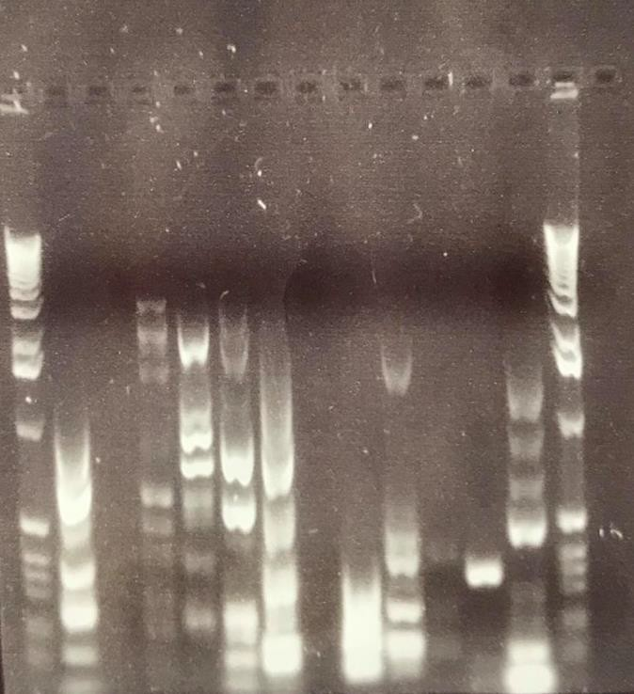

Figure 3.16– Gradient PCR for CopAu. This is a typical image of a gradient PCR using CopAu universal (u) primers (De la Iglesia et al., 2010) to CopA which is a gene encoding for CopA resistance and GoTaq master mix using a positive control sample from a previous study, the gradient was preformed using annealing temperatures ranging from 57-63 oC. Lane 1 and 14 are 1kb ladder (Promega).

3.5.2 V3/V6

Out of 63 Kenyan fish 3 samples were PCR positive using primers for V3/V6 (Chakravorty et al., 2007) (samples 3 (FT, site 1), 6 (WNP, site 1) and 23 (FT, site 10)). Out of the 19 Vietnamese samples 6 samples were positive for V3/V6 (47, 48, 49 (prawns, supermarket A) 57, 58 and 59 (Basa, supermarket A).

CopA

Primers to CopA (Altimira et al., 2012) were used to determine the presence of this gene in the bacterial DNA from fishery products in this study. Two were positive for CopA WT 4 (site 1) FT 23 (site 10).

CopAU

Universal primers to CopA (CopAU) (De la Iglesia et al., 2010) were also used to analyse for the presence of this gene, with 4 samples testing positive these were WT samples 4 (site 1), 26 (Site 10) and WNP 6 (site 1). Vietnamese sample 48 was also positive (prawn).

DMerA

Primers DMerA (de Luca Rebello et al., 2013) were used to determine the presence of the MerA gene in the bacterial DNA from fishery product in this study. None of the samples were positive.

TetB

Primers TetB (Van et al., 2008) were used to assess the presence of this gene in the bacterial DNA of the fishery product samples. WT 28 (site 10) was the only positive sample.

TetD

Primers TetD (Schmidt et al., 2001)were used to analyse the presence of this gene in the bacterial DNA of the fishery products sampled, FT sample 12 (Site 3) was the only sample positive.

3.5.8 TetDo

Primers TetDo (Ryu et al., 2012) were used to determine the presence of the TetD gene in the bacterial DNA of the fishery products sampled, Vietnamese sample 48 (prawn, supermarket A ) and 53 (prawn, supermarket B) were positive.

3.5.9 Results for PCR

An overview of the PCR results from the Kenyan samples are shown in table 3.17 and from the Vietnamese samples in table 3.18.

Sample | V3/v6 | CopA | CopAu | DMerA | TetB | TetD | TetDof
1 | N.D |  | N.D | N.D
2 | N.D |  | N.D | N.D
3 | + |  | N.D | N.D |  | N.D
4 | + | + | + | N.D |  | N.D
5 | N.D |  |  | N.D |  | N.D
6 | + |  | + | N.D |  | N.D
7 | N.D |  | N.D | N.D |  | N.D
8 | N.D |  |  | N.D |  | +
9 | N.D
10 | N.D |  |  | N.D |  | +
11 | N.D |  |  | N.D |  | N.D
12 | N.D |  |  | N.D |  | +
13 | N.D |  | N.D
14 | N.D |  |  | N.D |  | N.D
15 | N.D |  | N.D | N.D |  | N.D
16 | N.D |  | N.D | N.D |  | N.D
17 | N.D |  |  |  |  | N.D
18 | N.D |  |  | N.D | + | N.D | N.D
19 | N.D |  |  | N.D
20 | N.D |  |  | N.D
21 | N.D |  |  | N.D | + |  | +
22 | N.D |  |  | N.D |  | N.D
23 | N.D | + |  | N.D
24 | N.D |  |  | N.D
25 | N.D |  |  | N.D
26 | N.D |  | +
27 | N.D
28 | N.D |  |  |  | N.D |  | N.D

29 | N.D
30 | N.D |  |  |  |  | N.D
31 | N.D |  |  |  |  | N.D
32 | N.D |  |  |  |  | N.D
33 | N.D |  |  |  |  | N.D
34 | N.D |  |  |  |  | +
35 | N.D |  |  |  |  | N.D
36 | N.D |  |  |  |  | N.D
37 | N.D |  |  |  |  | +
38 | N.D |  |  |  |  | N.D
39 | N.D |  |  |  |  | N.D
40 | N.D |  |  |  |  | +
41 | N.D
42 | N.D |  |  |  |  | +
43 | N.D
44 | N.D
45 | N.D |  |  |  |  | +
46 | N.D |  |  |  |  | +
47 | N.D |  |  |  |  | +
48 | N.D
49 | N.D |  |  |  |  | +
50 | N.D |  |  |  |  | N.D
51 | N.D |  |  |  |  | N.D
52 | N.D |  |  |  |  | N.D
53 | N.D |  |  |  |  | N.D
54 | N.D |  |  |  |  | N.D
55 | N.D |  |  |  |  | N.D
56 | N.D |  |  |  |  | N.D
57 | N.D |  |  |  |  | N.D
58 | N.D |  |  |  |  | N.D
59 | N.D |  |  |  |  | N.D
60 | N.D |  |  |  |  | +
61 | N.D |  |  |  |  | +
62 | N.D |  |  |  |  | +
63 | N.D |  |  |  |  | +

Table 3.17 –Overview of PCR results from fish (Kenya (May and November 2018)). This table shows all PCR results for V3/V6, CopA, CopAu, DMerA, TetB, TetD and TetDof. PCR product was not detected (N.D) when the PCR was negative. When N.D is in italics and bold in the table it is due to not having a positive control.

Sample | V3/v6 | CopA | CopAu | MerA | TetB | TetD | TetDof
47 | N.D |  | N.D | N.D
48 | + |  | + | N.D | + |  | N.D
49 | + |  | N.D | N.D
50 | N.D
51 | N.D |  |  | N.D
52 | N.D |  | N.D | N.D
53 | N.D |  |  | N.D | + |  | N.D
54 | N.D |  | N.D | N.D
55 | N.D |  | N.D
56 | + |  | N.D
57 | + |  | N.D |  |  | N.D
58 | + |  | N.D |  |  | N.D
59 | + |  | + |  |  | +
60 | N.D
61 | N.D
62 | N.D
63 | N.D
64 | N.D
65 | N.D

Table 3.18 Table of PCR results from Vietnamese aquaculture product. This table shows the PCR results for V3/V6, CopA, CopAu, DMerA, TetB, TetD and TetDof. PCR product was not detected (N.D) when the PCR was negative. When N.D is in italics and bold in the table it is due to not having a positive control.

Did any of the fish have antibiotic residues present?

The results for the antibiotic resistance residues are shown in table 3.19 are from Kenya fish sampled in May (samples 1-30) and November (samples 31-63). Overall 76% percent were positive for antibiotic residues, 70% of the fish sampled in May were positive and 82% of the fish sampled in November were positive. The results shown in table 3.20 are from aquaculture product farmed in Vietnam but purchased in the UK, 55% of the Vietnamese samples were positive.

Fish ID | Premi test results (+/-) | Fish ID | Premi test results (+/-)
1 | - | 34 | +
2 | + | 35 | +
3 | + | 36 | +
4 | - | 37 | +
5 | - | 38 | +
6 | + | 39 | +
7 | + | 40 | +
8 | - | 41 | +
9 | + | 42 | +
10 | + | 43 | +
11 | + | 44 | +
12 | + | 45 | +
13 | + | 46 | +
14 | + | 47 | +
15 | - | 48 | +
16 | + | 49 | +
17 | + | 50 | +
18 | + | 51 | +
19 | + | 52 | -
20 | + | 53 | -
21 | - | 54 | -
22 | - | 55 | +
23 | + | 56 | -
24 | + | 57 | +
25 | + | 58 | +
26 | + | 59 | +
27 | + | 60 | +
28 | + | 61 | +
29 | - | 62 | -
30 | - | 63 | -
31 | +
32 | +
33 | +

Table 3.19- Antibiotic residues detected in Kenyan fish. This table shows the results (+/-) following analysis of antibiotic residues (β-lactams, Cephalosporines, Macrolides, Tetracyclines, Sulphonamides, Aminoglycosides, Quinolones, Amphenicoles and Polypeptides) tested using the PremiTest 25, for all 63 Kenyan fish samples in May 2018 (samples 1-30) and November (samples 31-62). The + denotes those that were found to contain residues from one or more antibiotics within the groups covered by the test and the – highlights those that were free from the antibiotics tested.

Fish number | Premi test results (+/-)
47 | -
48 | +
49 | +
50 | +
51 | -
52 | -
53 | -
54 | -
55 | +
56 | +
57 | +
58 | -
59 | -
60 | -
61 | -
62 | +
63 | +
64 | +
65 | +
66 | +

Table 3.20- Antibiotic residues detected in Vietnamese aquaculture product. This table shows the results (+/-) following analysis of antibiotic residues (β-lactams, Cephalosporines, Macrolides, Tetracyclines, Sulphonamides, Aminoglycosides, Quinolones, Amphenicoles and Polypeptides), tested using the PremiTest 25, for all 20 samples purchased in the UK but farmed in Vietnam. The + denotes those that were found to contain residues from one or more antibiotics within the groups covered by the test and the – highlights those that were free from the antibiotics tested.

There were no results for the antibiotic residue testing using bacterial plates, so the antibiotics residues could not be identified.

Element concentrations from ICP analysis Fish

57 elements were analysed by ICP analysis for each aquaculture product and aquaculture feed samples. In this study; levels of Antimony (Sb), Beryllium (Be), Bismuth (Bi), Bismuth (Bi), Boron (B), Cadmium (Cd), Cerium (Ce), Cobalt (Co), Dysprosium (Dy), Erbium (Er), Europium (Eu), Gadolinium (Gd), Gallium (Ga), Hafnium (Hf), Holmium (Ho), Lanthanum (La), Lead (Pb), Lithium (Li), Lutetium (Lu), Manganese (Mn), Molybdenum (Mo), Neodymium (Nd), Niobium (Nb), Phosphorous (P), Praseodymium(Pr), Samarium (Sm), Silicon (Si), Silver (Ag), Sulfur (S), Tantalum (Ta), Terbium (Tb), Thallium (Tl), Thorium (Th), Thulium

(Tm), Tungsten (W), Uranium (U), Vanadium (V), Ytterbium (Yb), Yttrium (Y) and Zirconium (Zr) were below levels of detection.
The heavy metals were Aluminium (Al), Arsenic (As), Barium (Ba), Caesium (Cs), Nickel (Ni), Chromium (Cr), Rubidium (Rb), Strontium (Sr), Tin (Sn) and Titanium (Ti). The essential elements were Calcium (Ca), Copper (Cu), Iron (Fe), Magnesium (Mg), Potassium (K), Selenium (Se) , Sodium (Na) and Zinc (Zn). Mercury (Hg) was measured by ICP for the Vietnamese aquaculture product but was measured using a Hg analyser for Kenyan product.

3.8.1 Heavy metals

Of the 57 elements analysed by ICP data from the following heavy metals were analysed further; Al, As, Ba, Cs, Cr, Co, Hg, Ni, Rb, Sr, Sn, Ti, and Zn. The summary of the Kenyan fish across the different sites can be seen in figure 3.21 Hg was measured using a Hg analyser.

86
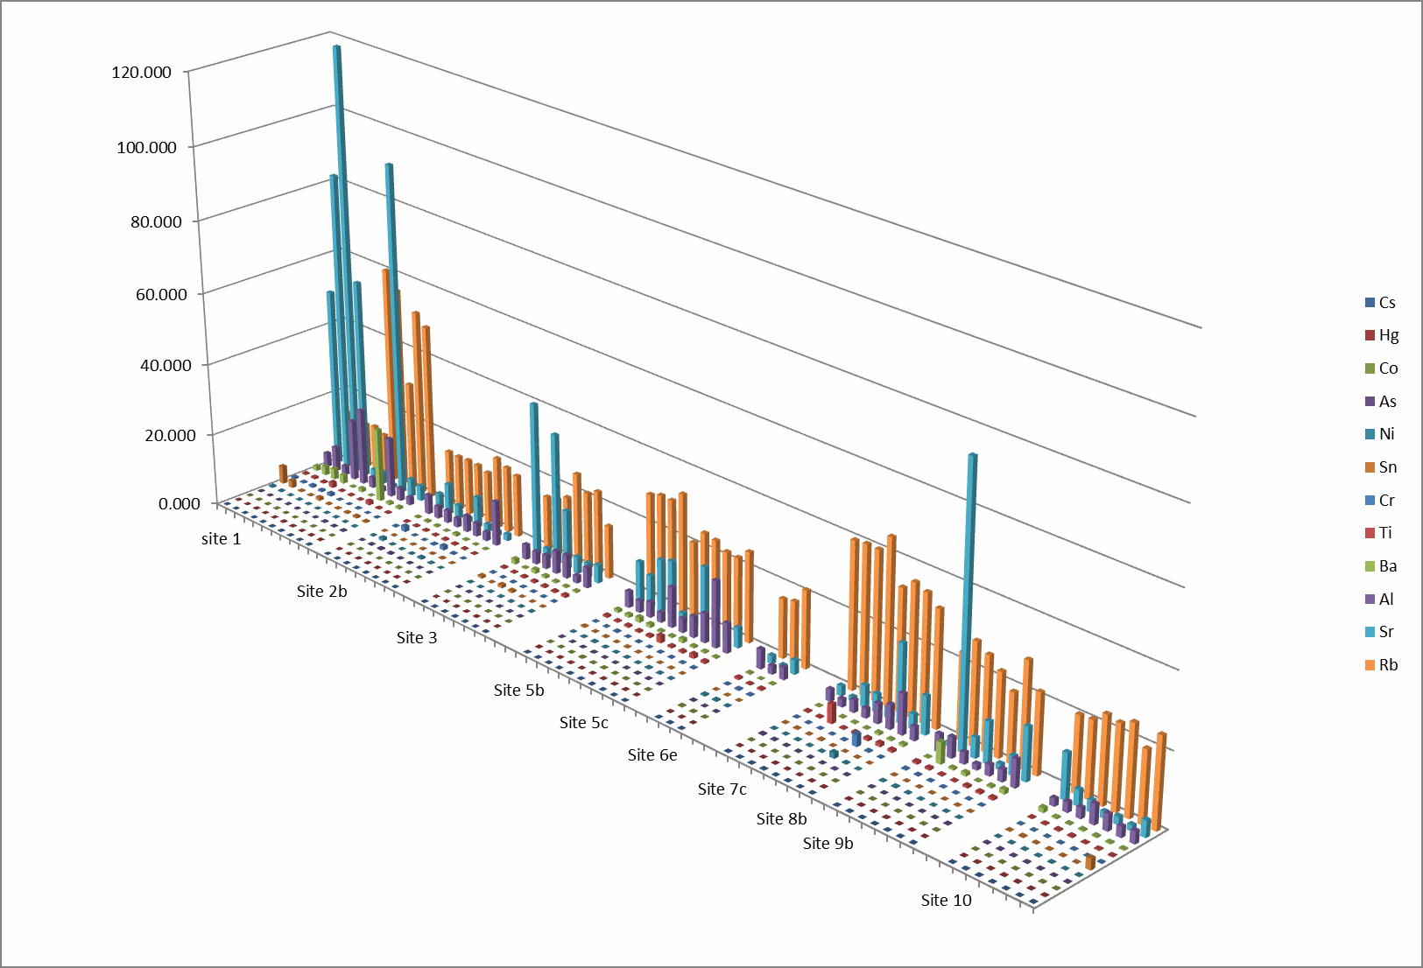
Figure 3.21 – Summary of the heavy metals across the sites. This graph shows the Aluminium (Al), Arsenic (As), Barium (Ba), Caesium (Cs), Chromium (Cr), Cobalt (Co), Mercury (Hg), Nickel (Ni), Rubidium (Rb), Strontium (Sr) , Tin (Sn), Titanium (Ti), Zinc (Zn) concentrations at the different sites. At site 1,10 samples; site 2b, 8 samples; site 3, 3 samples; site 5b, 6 samples; site 5c, 4 samples; site 6e, 3 samples; site 7c, 4 samples; site 8b, 4 samples; site 9b, 7 samples; site 10, 7 samples. The graph was made on Microsoft excel.

Aluminium

Across all Kenyan fish samples (n=67) the Al concentrations ranged from 1- 43mg/kg with a mean of 6mg/kg (Figure 3.22); sample 7 (WNP) had the lowest (1mg/kg) and sample 49 (PT) had the highest (43mg/kg). In the FT (n=29), concentrations ranged from 2-11mg/kg and the mean of 4mg/kg; samples 19, 22 and 34 had the lowest (2mg/kg) and sample 55 had the greatest (11mg/kg). The concentration range in the WT (n=26) was 2-21mg/kg with the mean of 7mg/kg; samples 33, 37 and 48 had the lowest (2mg/kg) and sample 5 had the highest (21mg/kg). The concentration range within the PT (n=6) was 8-43mg/kg with a mean of 21mg/kg; the lowest concentration was found in sample 50 (8mg/kg) and the highest in sample 49 (43mg/kg). The concentration range within the WNP (n=6) was 1-17mg/kg with a mean of 5mg/kg; with the lowest found in sample 7 (1mg/kg) and the greatest in sample S1WN3 (17mg/kg). The concentrations in the PT were significantly higher than the concentrations in the FT (P<0.001).

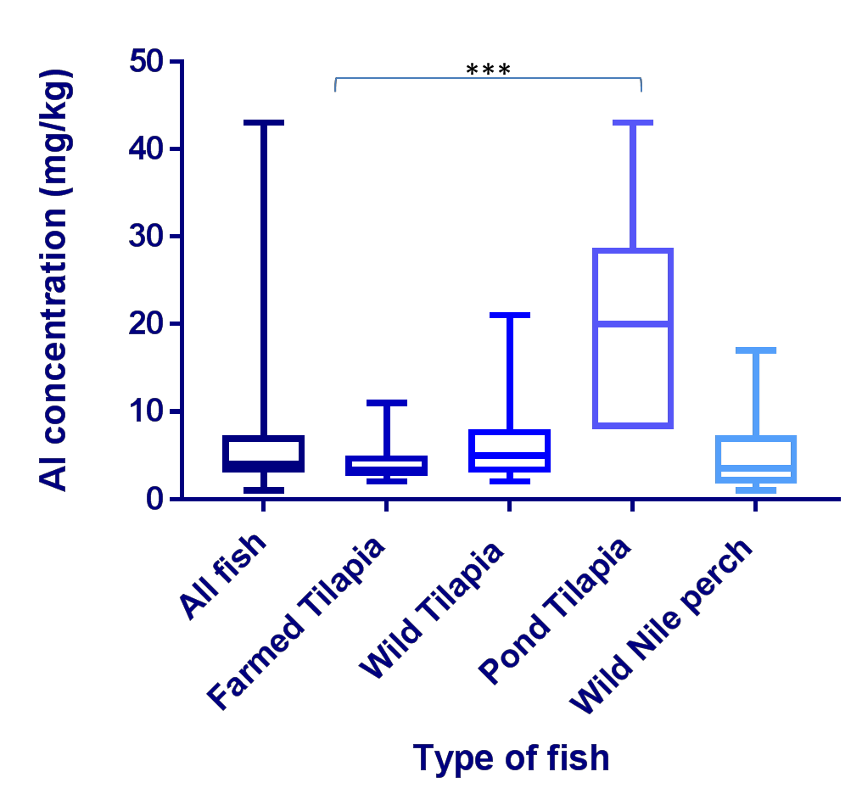

Figure 3.22- Aluminium concentrations across the fish analysed. This box and whisker plot illustrates Aluminium (Al) concentrations (in milligram/kilogram dry weight; mg/kg) in all fish muscle samples (n=67), farmed Tilapia/FT (n=29), wild Tilapia/WT (n=26), Pond Tilapia/PT (n=6) and wild Nile perch/WNP (n=6). Al was measured by Inductively Coupled Plasma Atomic Emission Spectroscopy analysis conducted by British Geological Survey) and data was analysed using GraphPad Prism. The concentrations in the PT were significantly higher than the concentrations in the FT (P<0.001).

Cross site comparison of Aluminium content

A cross site comparison of 63 fish samples (excluding PT) was performed (Figure 3.23) from across the 11 sample sites (Site 1, 10 samples; Site 2b, 8 samples; site 3, 4 samples; site 3c, 3 samples; site 5b, 6 samples; site 5c, 4 samples; site

6e, 3 samples; site 7c, 4 samples; site 8b, 4 samples; site 9b, 7 samples; site 10, 7 samples). The greatest range was found at site 1 (1-21mg/kg) and the smallest at site 7c (2-3mg/kg).There were no statistical differences in Al content

2 5
A l c o n c e n tra tio n ( m g / k g )

2 0

1 5

1 0

5

0

S ite n u m b e r

Figure 3.23 – Cross site Aluminium concentration comparison. This box and whisker plot shows the Aluminium (Al) concentrations across the fish from all sites (n=61) (excluding pond Tilapia), (Site 1, 10 samples; Site 2b, 8 samples; site 3, 4 samples; site 3c, 3 samples; site 5b , 6 samples; site 5c, 4 samples; site 6e, 3 samples; site 7c, 4 samples; site 8b, 4 samples; site 9b, 7 samples; site 10, 7 samples), with site 1 and site 5c being the only sites to include Wild Nile Perch (WNP). Al was measured by Inductively Coupled Plasma Atomic Emission Spectroscopy (analysis conducted by British Geological Survey) and data was analysed using GraphPad Prism. The greatest range was found at site 1 (1-21mg/kg) and the smallest at site 7c (2-3mg/kg). There were no statistical differences in Al content.

The Al content of the FT ranged from 2-11mg/kg whereas the WF ranged from 1- 21mg/kg, the mean of the FF was 4mg/kg whereas the mean for the WF was 6mg/kg (Figure 3.24).

A

2 5
A l c o n c e n tra tio n (m g / k g )

2 0

1 5

1 0

5

0

S ite n u m b e r

B

2 5
A l c o n c e n tra tio n ( m g / k g )

2 0

1 5

1 0

5

0

S ite n u m b e r

Figure 3.24 –Aluminium concentration comparison across the sites in farmed and wild fish. This box and whisker plot shows both the farmed Tilapia/FT (A) and the wild fish/WF (B) comparison across the 6 sites, (site 1, 3FT, 7 WF; site 2b, 4FT, 4WF; site 3, 4FT; site 5b 3FT, 3WF; site 5C, 4WT; Site 6e, 3WT; site 7c, 4FF; site 8b, 4FT, site 9b,4FT,3WT; site 10 3FT,4WF) with site 1 and site 5c being the only sites to include Wild Nile Perch (WNP). There were no wild fish from site 3, 7c and 8b; there were no farmed fish from 3c, 5c and 6e. Al was measured by Inductively Coupled Plasma Atomic Emission Spectroscopy (analysis conducted by British Geological Survey) and data was analysed using GraphPad Prism.

Arsenic

Across all Kenyan fish samples (n=67) the As concentrations ranged from 0.02- 0.33mg/kg (Figure 3.25) with a mean of 0.07mg/kg; sample 13 (FT) and 16 (WT) had the lowest (0.02mg/kg) and sample 33 (FT) had the highest (0.33mg/kg). In the FT (n=29), concentrations ranged from 0.02-0.33mg/kg; with a mean of 0.08mg/kg; sample 13 had the lowest (0.02mg/kg) and sample 33 had the greatest concentration (0.33mg/kg). The concentration range in the WT (n=26) was 0.02-0.12mg/kg, with a mean of 0.05mg/kg; sample 16 had the lowest (0.02mg/kg) and sample 46 had the highest (0.12mg/kg). The concertation range within the PT (n=6) was 0.04-0.06mg/kg with a mean of 0.04mg/kg; the lowest concentration was found in samples 49, 50, 51 and 52 (0.04mg/kg) and the highest in sample 30 (0.06mg/kg). The concentration range within the WNP (n=6) was 0.03-0.19mg/kg with a mean of 0.12mg/kg; the lowest concentration found in sample 7 (0.03mg/kg) and the highest in sample S1WN5 (0.19mg/kg). There were no significant differences between the different samples.

0 . 4
A s c o n c e n tra t io n ( m g / k g )

0 . 3

0 . 2

0 . 1

0 . 0

T y p e o f fis h

Figure 3.25- Arsenic concentrations across the fish analysed. This box and whisker plot illustrates Arsenic (As) concentrations (in milligram/kilogram dry weight; mg/kg) in all fish muscle samples (n=67), farmed Tilapia/FT (n=29), wild Tilapia/WT (n=26), Pond Tilapia/PT (n=6) and wild Nile perch/WNP (n=6). As was measured by Inductively Coupled Plasma Atomic Emission Spectroscopy analysis conducted by British Geological Survey) and data was analysed using GraphPad Prism. There were no significant differences between the different samples.

Cross site comparison of Arsenic content

A cross site comparison of 61 fish samples (excluding PT) in this study was preformed (Figure 3.26) from across the 11 sample sites (Site 1, 10 samples; Site 2b, 8 samples; site 3, 4 samples; site 3c, 3 samples; site 5b, 6 samples; site 5c,

- samples; site 6e, 3 samples; site 7c, 4 samples; site 8b, 4 samples; site 9b, 7 samples; site 10, 7 samples). The greatest range was found at site 2b (0.03- 0.33mg/kg) and the smallest at site 3C (0.05-0.07mg/kg). The concentrations at 7c were significantly higher than those at 5b (P<0.05).

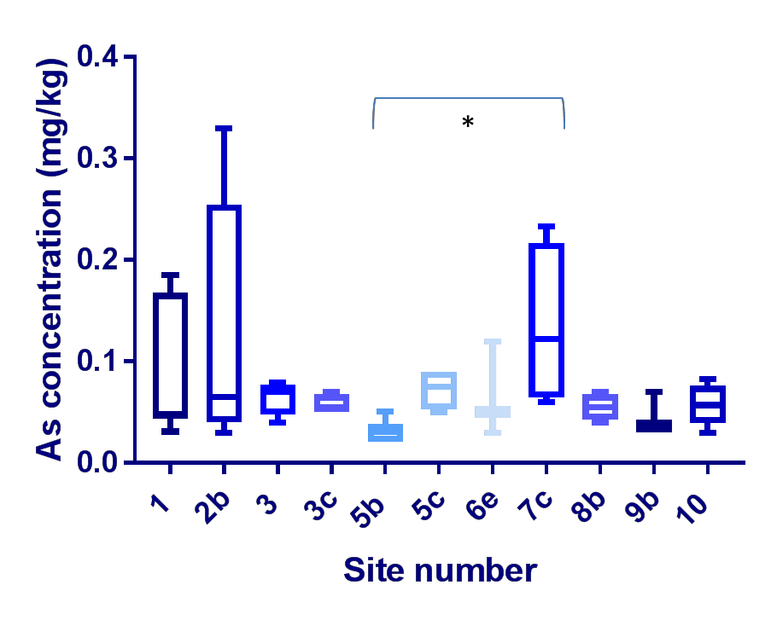

Figure 3.26 – Cross site Arsenic concentration comparison. This box and whisker plot shows the Arsenic (As) concentrations across the fish from all sites(n=67) (excluding pond Tilapia), (Site 1, 10 samples; Site 2b, 8 samples; site 3, 4 samples; site 3c, 3 samples; site 5b , 6 samples; site 5c, 4 samples; site 6e, 3 samples; site 7c, 4 samples; site 8b, 4 samples; site 9b, 7 samples; site 10, 7 samples), with site 1 and site 5c being the only sites to include Wild Nile Perch (WNP). As was measured by Inductively Coupled Plasma Atomic Emission Spectroscopy (analysis conducted by British Geological Survey) and data was analysed using GraphPad Prism. The concentrations at site 7c were significantly higher than those at 5b (P<0.05) using a Kruskal-Wallis test.

The FT ranged from 0.02-0.33mg/kg whereas the WF ranged from 0.02- 0.19mg/kg, the mean of the FT was 0.08mg/kg and the mean of the WF was 0.06mg/kg (Figure 3.27). There are no significant differences between the sites.

A

0 . 4
A s c o n c e n tra t io n ( m g / k g )

0 . 3

0 . 2

0 . 1

0 . 0

S i te n u m b e r
B

0 . 2 0
A s c o n c e n tra t io n ( m g / k g )

0 . 1 5

0 . 1 0

0 . 0 5

0 . 0 0

S i te n u m b e r

Figure 3.27 –Arsenic concentration comparison across the sites in farmed and wild fish. This box and whisker plot shows both the farmed Tilapia/FT (A) and the wild fish/WF (B) comparison across the 6 sites, (site 1, 3FT, 7 WF; site 2b, 4FT, 4WF; site 3, 4FT; site 5b 3FT, 3WF; site 5C, 4WT; Site 6e, 3WT; site 7c, 4FF; site 8b, 4FT, site 9b,4FT,3WT; site 10 3FT,4WF) with site 1 and site 5c being the only sites to include Wild Nile Perch (WNP). There were no wild fish from site 3, 7c and 8b; there were no farmed fish from 3c, 5c and 6e. As was measured by Inductively Coupled Plasma Atomic Emission Spectroscopy (analysis conducted by British Geological Survey) and data was analysed using GraphPad Prism.

Barium

Across all Kenyan fish samples (n=67), the Ba concentrations ranged from 0.07- 20.58mg/kg (Figure 3.28), with a mean of 1.23mg/kg; sample 7 (WNP) had the lowest (0.07mg/kg) and sample S1WN3 had the highest (20.58mg/kg). In the FT (n=29), concentrations ranged from 0.09-5.75mg/kg, with a mean of 0.89mg/kg; samples 19 had the lowest (0.09mg/kg) and sample 58 had the greatest (5.75mg/kg). The concentration range in the WT (n=26) was 0.08-2.32mg/kg, with a mean of 0.49mg/kg; sample 47 had the lowest (0.08mg/kg) and sample 6 had the highest (2.32mg/kg). The concertation range within the PT (n=6) was 0.46-3.64mg/kg with a mean of 2.23mg/kg; the lowest concentration was found in sample 29 (0.46mg/kg) and the highest in sample 52 (3.64mg/kg). The range within the WNP (n=6) was 0.07-20.58mg/kg, with a mean of 4.16mg/kg; the lowest concentration was found in sample 7 (0.07mg/kg) and the greatest in sample S1WN3 (20.58mg/kg).

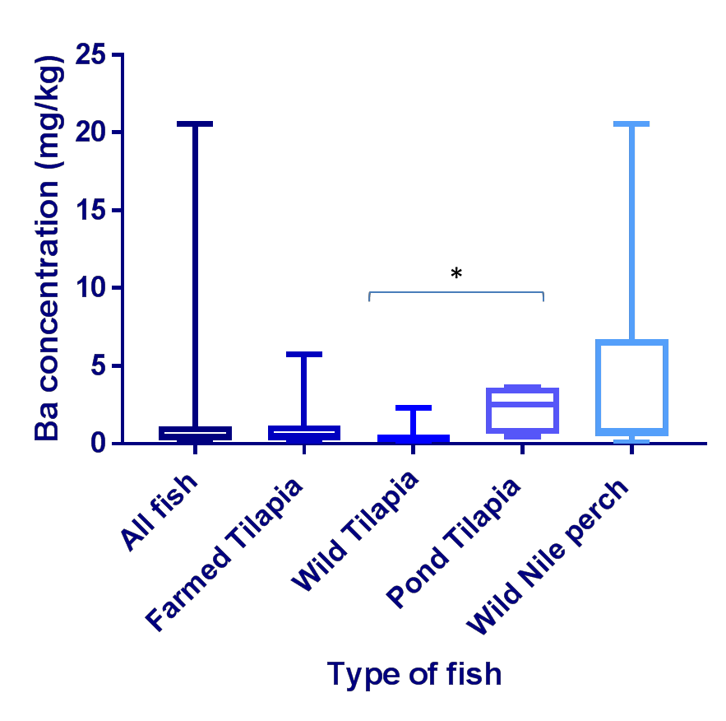

Figure 3.28- Barium concentrations across the fish analysed. This box and whisker plot illustrates Barium (Ba) concentrations (in milligram/kilogram dry weight; mg/kg) in all fish muscle samples (n=67), farmed Tilapia/FT (n=29), wild Tilapia/WT (n=26), Pond Tilapia/PT (n=6) and wild Nile perch/WNP (n=6). Ba was measured by Inductively Coupled Plasma Atomic Emission Spectroscopy analysis conducted by British Geological Survey) and data was analysed using GraphPad Prism.

Cross site comparison of Barium content

A cross site comparison of all 63 fish samples (excluding PT) in this study was preformed (Figure 3.29) from across the 11 sample sites (Site 1, 10 samples; Site 2b, 8 samples; site 3, 4 samples; site 3c, 3 samples; site 5b , 6 samples; site 5c, 4 samples; site 6e, 3 samples; site 7c, 4 samples; site 8b, 4 samples; site 9b, 7

samples; site 10, 7 samples). The greatest range was found at site 1 (0.07- 20.58mg/kg) and the smallest at site 7c (0.09-0.24mg/kg).

2 5
B a c o n c e n tr a t io n ( m g / k g )

2 0

1 5

1 0

5

0

S i te n u m b e r

Figure 3.29 - Cross site Barium concentration comparison. This box and whisker plot shows Barium (Ba) concentrations across the fish from all sites(n=67) (excluding pond Tilapia), (Site 1, 10 samples; Site 2b, 8 samples; site 3, 4 samples; site 3c, 3 samples; site 5b , 6 samples; site 5c, 4 samples; site 6e, 3 samples; site 7c, 4 samples; site 8b, 4 samples; site 9b, 7 samples; site 10, 7 samples), with site 1 and site 5c being the only sites to include Wild Nile Perch (WNP). Ba was measured by Inductively Coupled Plasma Atomic Emission Spectroscopy (analysis conducted by British Geological Survey) and data was analysed using GraphPad Prism.

The FT ranged from 0.09-5.75mg/kg whereas the WF ranged from 0.07- 20.58mg/kg, the mean of the FT was 0.89mg/kg the mean of the WF was 1.18mg/kg (Figure 3.30).

A

2 5
B a c o n c e n tr a t io n ( m g / k g )

2 0

1 5

1 0

5

0

S i te n u m b e r
B

2 5
B a c o n c e n tr a t io n ( m g / k g )

2 0

1 5

1 0

5

0

S i te n u m b e r

Figure 3.30 – Barium concentration comparison across the sites in farmed and wild fish. This box and whisker plot shows both the farmed Tilapia/FT (A) and the wild fish/WF (B) comparison across the 6 sites, (site 1, 3FT, 7 WF; site 2b, 4FT, 4WF; site 3, 4FT; site 5b 3FT, 3WF; site 5C, 4WT; Site 6e, 3WT; site 7c, 4FF; site 8b, 4FT, site 9b,4FT,3WT; site 10 3FT,4WF) with site 1 and site 5c being the only sites to include Wild Nile Perch (WNP). There were no wild fish from site 3, 7c and 8b, there were no farmed fish from 3c, 5c and 6e. Barium (Ba) was measured by Inductively Coupled Plasma Atomic Emission Spectroscopy (analysis conducted by British Geological Survey) and data was analysed using GraphPad Prism.

Caesium

Across all Kenyan fish samples (n=67), the Cs concentrations ranged from 0.01- 0.08mg/kg (Figure 3.31), with a mean of 0.03mg/kg; sample 32 (FT), 39 (WT), (49, 50, 51, 52 (PT)) had the lowest (0.01mg/kg) and sample 7 (WNP) had the highest (0.08mg/kg). In the FT (n=29), concentrations ranged from 0.01- 0.06mg/kg, with a mean of 0.03mg/kg; sample 32 had the lowest (0.01mg/kg) and sample 21 had the greatest (0.06mg/kg). The concentration range in the WT (n=26) was 0.01-0.07mg/kg, with a mean of 0.23mg/kg; sample 39 had the lowest (0.01mg/kg) and sample 16 had the highest (0.07mg/kg). The concertation range within the PT (n=6) was 0.01-0.03mg/kg with a mean of 0.02mg/kg; the lowest concentration was found in sample 49, 50, 51 and 52 (0.01mg/kg) and the highest in sample 29 (0.03mg/kg). The Cs range within the WNP (n=6) was 0.04- 0.08mg/kg, with a mean of 0.061mg/kg; with the lowest concentration found in S1WN3 (0.035mg/kg) and the greatest in sample 7 (0.08mg/kg). The Cs in the WNP was significantly greater than in the PT (P<0.001), WT (P<0.01), FT (P<0.05) and all fish (P<0.5).

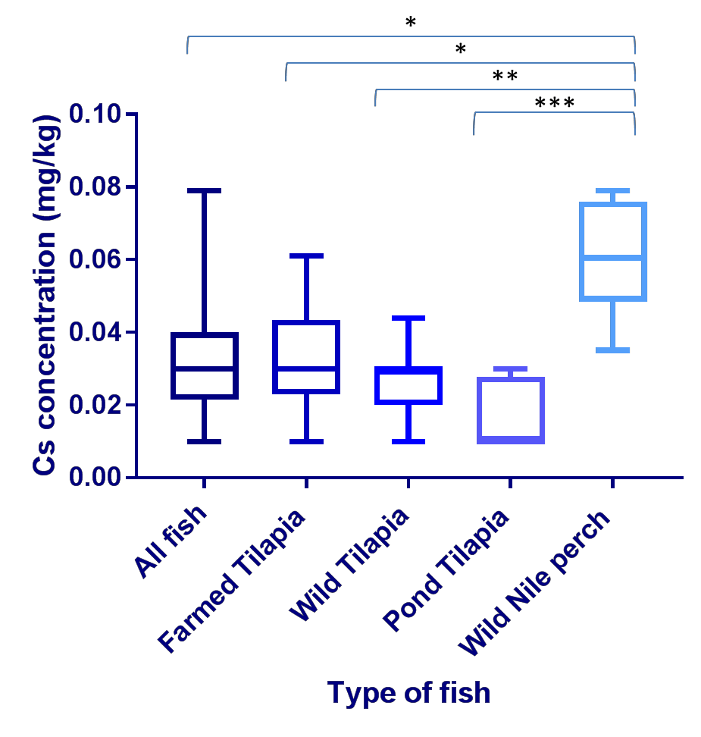

Figure 3.31- Caesium concentrations across the fish analysed. This box and whisker plot illustrates Caesium (Cs) concentrations (in milligram/kilogram dry weight; mg/kg) in all fish muscle samples (n=67), farmed Tilapia/FT (n=29), wild Tilapia/WT (n=26), Pond Tilapia/PT (n=6) and wild Nile perch/WNP (n=6). Cs was measured by Inductively Coupled Plasma Atomic Emission Spectroscopy analysis conducted by British Geological Survey) and data was analysed using GraphPad Prism. The Cs in the WNP was significantly greater than in the PT (P<0.001), WT (P<0.01), FT (P<0.05) and all fish (P<0.5).

Cross site comparison of Caesium content

A cross site comparison of all 63 fish samples (excluding PT) in this study was preformed (Figure 3.32) from across the 11 sample sites (Site 1, 10 samples; Site

2b, 8 samples; site 3, 4 samples; site 3c, 3 samples; site 5b , 6 samples; site 5c, 4 samples; site 6e, 3 samples; site 7c, 4 samples; site 8b, 4 samples; site 9b, 7 samples; site 10, 7 samples). The greatest range was found at site 1 (0.02- 0.08mg/kg) and the smallest at site 3c 0.02-0.04mg/kg. The concentrations found at site 7c were significantly higher than those found at site 3c (P<0.01).

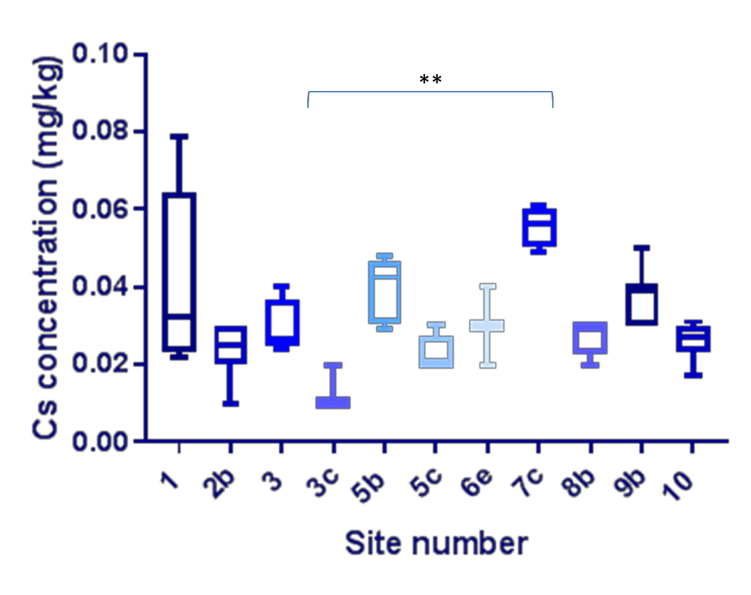

Figure 3.32 – Cross site Caesium concentration comparison. This box and whisker plot shows Caesium (Cs)concentrations across the fish from all sites(n=61) (excluding pond Tilapia), (Site 1, 10 samples; Site 2b, 8 samples; site 3, 4 samples; site 3c, 3 samples; site 5b , 6 samples; site 5c, 4 samples; site 6e, 3 samples; site 7c, 4 samples; site 8b, 4 samples; site 9b, 7 samples; site 10, 7 samples), with site 1 and site 5c being the only sites to include Wild Nile Perch (WNP). Cs was measured by Inductively Coupled Plasma Atomic Emission Spectroscopy (analysis conducted by British Geological Survey) and data was analysed using GraphPad Prism
.The concentrations found at site 7c were significantly higher than those found at site 3c (P<0.01), using a Kruskal-Wallis test.

The FT ranged from 0.01-0.06mg/kg whereas the WF ranged from 0.01- 0.08mg/kg, the mean of the FT was 0.03mg/kg the mean of the WF was the same (Figure 3.33).

A

0 . 1 0
C s c o n c e n tr a t io n ( m g / k g )

0 . 0 8

0 . 0 6

0 . 0 4

0 . 0 2

0 . 0 0

S i te n u m b e r

B

0 . 1 0
C s c o n c e n tr a t io n ( m g / k g )

0 . 0 8

0 . 0 6

0 . 0 4

0 . 0 2

0 . 0 0

S i te n u m b e r

Figure 3.33 – Caesium concentration comparison across the sites in farmed and wild fish. This box and whisker plot shows both the farmed Tilapia/FT (A) and the wild fish/WF (B) comparison across the 6 sites, (site 1, 3FT, 7 WF; site 2b, 4FT, 4WF; site 3, 4FT; site 5b 3FT, 3WF; site 5C, 4WT; Site 6e, 3WT; site 7c, 4FF; site 8b, 4FT, site 9b,4FT,3WT; site 10 3FT,4WF) with site 1 and site 5c being the only sites to include Wild Nile Perch (WNP). There were no wild fish from site 3, 7c and 8b and there were no farmed fish from 3c, 5c and 6e. Caesium (Cs) was measured by Inductively Coupled Plasma Atomic Emission Spectroscopy (analysis conducted by British Geological Survey) and data was analysed using GraphPad Prism.

Chromium

Across all Kenyan fish samples (n=67), the Cr concentrations ranged from 0.00- 3.3mg/kg (Figure 3.34), with a mean of 0.3mg/kg; sample 38 (WT) and 60(FT) had the lowest (0.00mg/kg) and sample 54 (FT) had the highest (3.3mg/kg). In the FT (n=29), concentrations ranged from 0.00-3.3mg/kg, with a mean of 0.3mg/kg; sample 60 had the lowest (0.00mg/kg) and sample 54 had the greatest concentration (3.3mg/kg). The concentration range in the WT (n=26) was 0.00- 1.10mg/kg, with a mean of 0.20mg/kg; sample 38 had the lowest (0.00mg/kg) and sample 36 had the highest (1.10mg/kg). The concertation range within the PT (n=6) was 0.10-3.20mg/kg with a mean of 0.70mg/kg; the lowest concentration was found in samples 50 (0.10mg/kg) and the highest in sample 51 (3.20mg/kg). The range within the WNP (n=6) was 0.04-2.60mg/kg, with a mean of 0.25mg/kg; the lowest concentration found in sample S1WN4 (0.04mg/kg) and the greatest in sample 45 (2.60mg/kg). There were no significant differences between the types of fish.

4
C r c o n c e n tr a t io n ( m g / k g )

3

2

1

0

T y p e o f fis h

Figure 3.34- Chromium concentrations across the fish analysed. This box and whisker plot illustrates Chromium (Cr) concentrations (in milligram/kilogram dry weight; mg/kg) in all fish muscle samples (n=67), farmed Tilapia/FT (n=29), wild Tilapia/WT (n=26), Pond Tilapia/PT (n=6) and wild Nile perch/WNP (n=6). Cr was measured by Inductively Coupled Plasma Atomic Emission Spectroscopy analysis conducted by British Geological Survey and data was analysed using GraphPad Prism. There were no significant differences between the types of fish.

Cross comparison of Chromium content

A cross site comparison of all 63 fish samples (excluding PT) in this study was preformed (Figure 3.35) from across the 11 sample sites (Site 1, 10 samples; Site 2b, 8 samples; site 3, 4 samples; site 3c, 3 samples; site 5b, 6 samples; site 5c, 4 samples; site 6e, 3 samples; site 7c, 4 samples; site 8b, 4 samples; site 9b, 7

samples; site 10, 7 samples). The greatest range was found at site 8b (0.1- 3.3mg/kg) and the smallest at site 3c (0.08-0.10mg/kg).

4
C r c o n c e n tr a t io n ( m g / k g )

3

2

1

0

S ite n u m b e r

Figure 3.35 - Cross site Chromium concentration comparison. This box and whisker plot shows the Chromium (Cr) concentrations across the fish from all sites(n=61) (excluding pond Tilapia), (Site 1, 10 samples; Site 2b, 8 samples; site 3, 4 samples; site 3c, 3 samples; site 5b , 6 samples; site 5c, 4 samples; site 6e, 3 samples; site 7c, 4 samples; site 8b, 4 samples; site 9b, 7 samples; site 10, 7 samples), with site 1 and site 5c being the only sites to include Wild Nile Perch (WNP). Cr was measured by Inductively Coupled Plasma Atomic Emission Spectroscopy (analysis conducted by British Geological Survey) and data was analysed using GraphPad Prism.

The FT ranged from 0.00-3.30mg/kg whereas the WF ranged from 0.00-2.6mg/kg, the mean of the FT was 0.3mg/kg the mean of the WF was the same (Figure 3.36).

A

4
C r c o n c e n tr a t io n ( m g / k g )

3

2

1

0

S i te n u m b e r
B

4
C r c o n c e n tr a t io n ( m g / k g )

3

2

1

0

S i te n u m b e r

Figure 3.36 – Chromium concentration comparison across the sites in farmed and wild fish. This box and whisker plot shows both the farmed Tilapia/FT (A) and the wild fish/WF (B) comparison across the 6 sites, (site 1, 3FT, 7 WF; site 2b, 4FT, 4WF; site 3, 4FT; site 5b 3FT, 3WF; site 5C, 4WT; Site 6e, 3WT; site 7c, 4FF; site 8b, 4FT, site 9b,4FT,3WT; site 10 3FT,4WF) with site 1 and site 5c being the only sites to include Wild Nile Perch (WNP). There were no wild fish from site 3, 7c and 8b; there were no farmed fish from 3c, 5c and 6e. As was measured by Inductively Coupled Plasma Atomic Emission Spectroscopy (analysis conducted by British Geological Survey) and data was analysed using GraphPad Prism.

Cobalt

Across all Kenyan fish samples (n=67), the Co concentrations ranged from 0.00- 0.18mg/kg (Figure 3.37) with a mean of 0.05mg/kg; sample 7 (WNP) had the lowest (0.00mg/kg) and sample 46 (WT) had the highest (0.171mg/kg). In the FT (n=29), Co concentrations ranged from 0.02-0.07mg/kg, with a mean of 0.04mg/kg; samples 34 and 56 had the lowest (0.02mg/kg) and sample 2 had the greatest concentration (0.071mg/kg). The concentration range in the WT (n=26) was 0.03-0.18mg/kg, with a mean of 0.07mg/kg; sample 25 had the lowest (0.03mg/kg) and sample 46 had the highest (0.18mg/kg). The concertation range within the PT (n=6) was 0.02-0.08mg/kg with a mean of 0.04mg/kg; the lowest concentration was found in samples 29 (0.02mg/kg) and the highest in sample 51 (0.08mg/kg). The Co range within the WNP (n=6) was 0.00- 0.02mg/kg, with a mean of 0.01mg/kg; the lowest found in sample 7 (0.00mg/kg) and the greatest in sample S1WN3 (0.02mg/kg). The concentrations in the WT were significantly higher than those found in the FT (P<0.01).

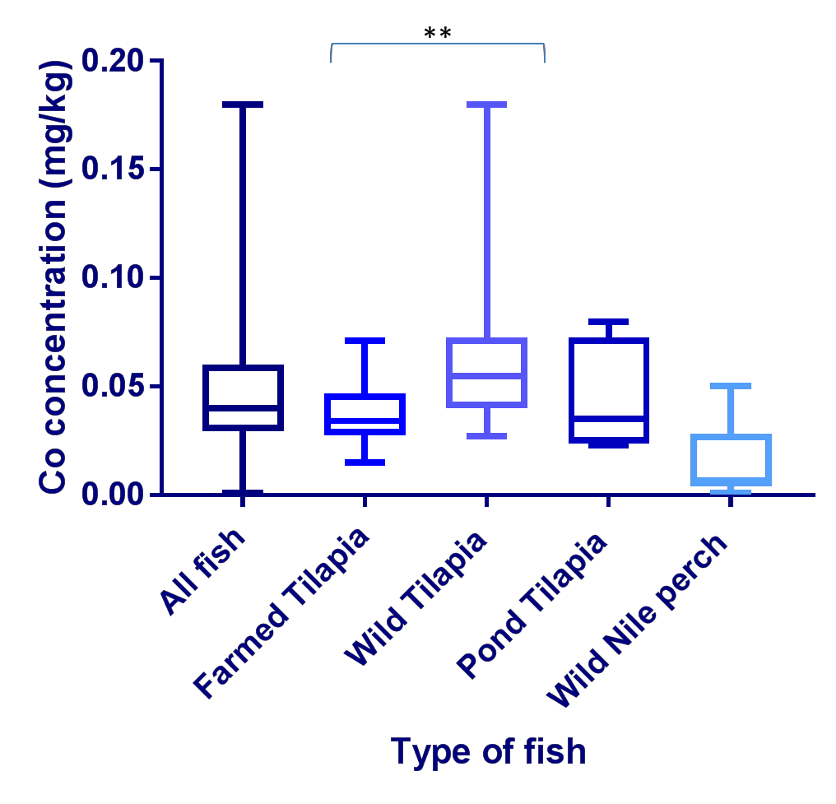

Figure 3.37- Cobalt concentrations across the fish analysed. This box and whisker plot illustrates Cobalt (Co) concentrations (in milligram/kilogram dry weight; mg/kg) in all fish muscle samples (n=67), farmed Tilapia/FT (n=29), wild Tilapia/WT (n=26), Pond Tilapia/PT (n=6) and wild Nile perch/WNP (n=6). Co was measured by Inductively Coupled Plasma Atomic Emission Spectroscopy analysis conducted by British Geological Survey and data was analysed using GraphPad Prism. The concentrations in the WT were significantly higher than those found in the FT (P<0.01) using a Kruskal-Wallis test.

Cross site comparison of Cobalt content

A cross site comparison of all 63 fish samples (excluding PT) in this study was preformed (Figure 3.38) across the 11 sample sites (Site 1, 10 samples; Site 2b, 8 samples; site 3, 4 samples; site 3c, 3 samples; site 5b, 6 samples; site 5c, 4 samples; site 6e, 3 samples; site 7c, 4 samples; site 8b, 4 samples; site 9b, 7 samples; site 10, 7 samples). The greatest range was found at site 5b (0.03-

0.17mg/kg) and the smallest at site 3 (0.03-0.05mg/kg). The concentrations from site 6e were significantly higher than those found at site 7c (P>0.05).
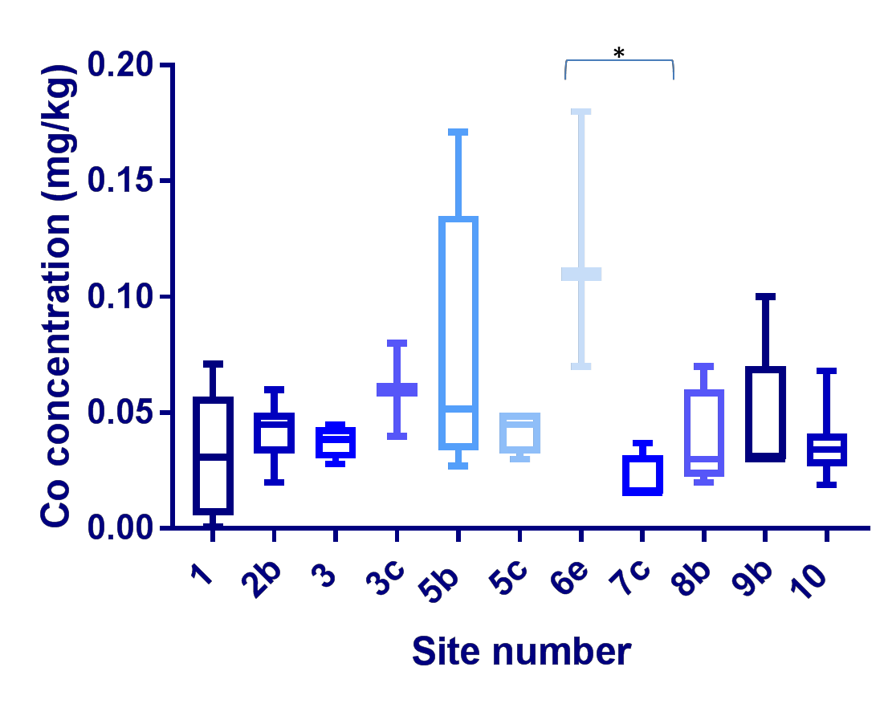

Figure 3.38– Cross site Cobalt concentration comparison. This box and whisker plot shows the Cobalt (Co) concentrations across the fish from all sites(n=61) (excluding pond Tilapia), (Site 1, 10 samples; Site 2b, 8 samples; site 3, 4 samples; site 3c, 3 samples; site 5b , 6 samples; site 5c, 4 samples; site 6e, 3 samples; site 7c, 4 samples; site 8b, 4 samples; site 9b, 7 samples; site 10, 7 samples), with site 1 and site 5c being the only sites to include Wild Nile Perch (WNP). Co was measured by Inductively Coupled Plasma Atomic Emission Spectroscopy (analysis conducted by British Geological Survey) and data was analysed using GraphPad Prism. The concentrations from site 6e were significantly higher than those found at site 7c (P>0.05), using a Kruskall- Wallis test.
The FT ranged from 0.02-0.07mg/kg whereas the WF ranged from 0.00- 0.18mg/kg, the mean of the FF was 0.04mg/kg whereas the mean for the WF was 0.06mg/kg. In the FT concentrations at site 1 were significantly higher than those found at site 7c (P<0.05). In the WF concentrations at site 6e were significantly higher than those at site 1 (P<0.05) (Figure 3.39).

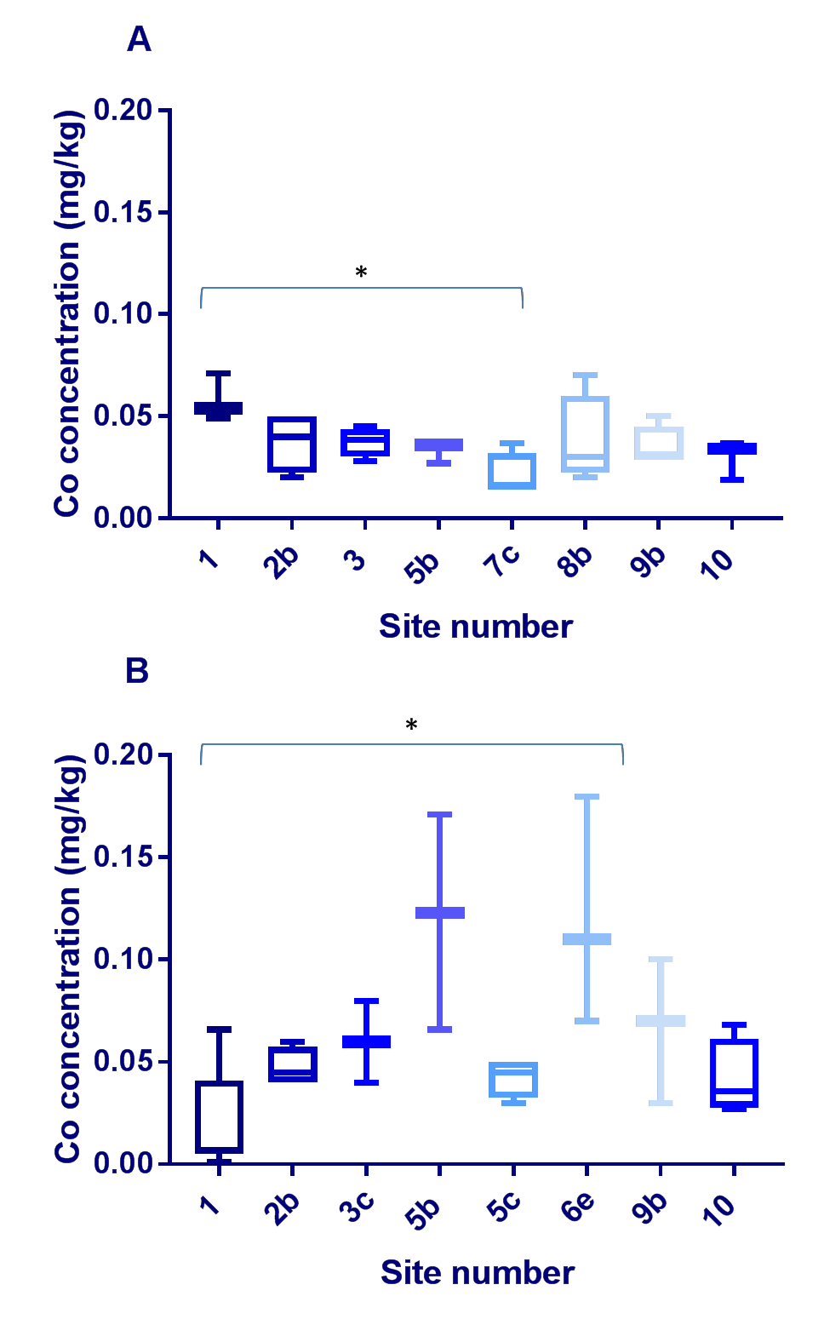

Figure 3.39 – Cobalt concentration comparison across the sites in farmed and wild fish. This box and whisker plot shows both the farmed Tilapia/FT (A) and the wild fish/WF (B) comparison across the 6 sites, (site 1, 3FT, 7 WF; site 2b, 4FT, 4WF; site 3, 4FT; site 5b 3FT, 3WF; site 5C, 4WT; Site 6e, 3WT; site 7c, 4FF; site 8b, 4FT, site 9b,4FT,3WT; site 10 3FT,4WF) with site 1 and site 5c being the only sites to include Wild Nile Perch (WNP).There were no wild fish from site 3, 7c and 8b, there were no farmed fish from 3c, 5c and 6e. Cobalt (Co) was measured by Inductively Coupled Plasma Atomic Emission Spectroscopy (analysis conducted by British Geological Survey) and data was analysed using GraphPad Prism. In the FT concentrations at site 1 were significantly higher than those found at site 7c (P<0.05). In the WF concentrations at site 6e were significantly higher than those at site 1 (P<0.05).

Nickel

Across all Kenyan fish samples (n=67), the Ni concentrations ranged from 0.02- 1.48mg/kg (Figure 3.40), with a mean of 0.18mg/kg; sample 27 (WT) had the lowest (0.02mg/kg) and sample 51 (PT) and 54 (FT) had the highest (1.48mg/kg). In the FT (n=29), concentrations ranged from 0.02-1.48mg/kg, with a mean of 0.17mg/kg; sample 56 had the lowest (0.02mg/kg) and sample 54 had the greatest concentration (1.48mg/kg). The concentration range in the WT (n=26) was 0.02-0.50mg/kg, with the mean of 0.12mg/kg; sample 27 had the lowest (0.02mg/kg) and sample 36 had the highest (0.50mg/kg). The concertation range within the PT (n=6) was 0.09-1.48mg/kg with a mean of 0.38mg/kg; the lowest concentration was found in sample 30 and 50 (0.09mg/kg) and the highest in sample 51 (1.48mg/kg). The range within the WNP (n=6) was 0.04-0.12mg/kg, with a mean of 0.06mg/kg; with the lowest found in sample S1WN5 (0.04mg/kg) and the greatest in sample S1WN3 (0.12mg/kg). There were no significant differences between the types of fish.

2 . 0
N i c o n c e n tr a tio n ( m g /k g )

1 . 5

1 . 0

0 . 5

0 . 0

T y p e o f fis h

Figure 3.40- Nickel concentrations across the fish analysed. This box and whisker plot illustrates Nickel (Ni) concentrations (in milligram/kilogram dry weight; mg/kg) in all fish muscle samples, farmed Tilapia/FT (n=29), wild Tilapia/WT (n=26), Pond Tilapia/PT (n=6) and wild Nile perch/WNP (n=6). As was measured by Inductively Coupled Plasma Atomic Emission Spectroscopy analysis conducted by British Geological Survey) and data was analysed using GraphPad Prism. There were no significant differences between the types of fish.

Cross site comparison of Nickel content

A cross site comparison of all 63 fish samples (excluding PT) (WF and FT) in this study was preformed (Figure 3.41) from across the 11 sample sites (Site 1, 10 samples; Site 2b, 8 samples; site 3, 4 samples; site 3c, 3 samples; site 5b , 6

samples; site 5c, 4 samples; site 6e, 3 samples; site 7c, 4 samples; site 8b, 4 samples; site 9b, 7 samples; site 10, 7 samples). There were not significant differences between the sites.
The greatest range was found at site 8b (0.02-1.48mg/kg) and the smallest at site 3c (0.04-0.08mg/kg) and site 10 (0.02-0.06mg/kg).

2 . 0
N i c o n c e n tr a tio n ( m g /k g )

1 . 5

1 . 0

0 . 5

0 . 0

S i te n u m b e r

Figure 3.41 – Cross site Nickel concentration comparison. This box and whisker plot shows the Nickel (Ni) concentrations across the fish from all sites(n=61) (excluding pond Tilapia), (Site 1, 10 samples; Site 2b, 8 samples; site 3, 4 samples; site 3c, 3 samples; site 5b , 6 samples; site 5c, 4 samples; site 6e, 3 samples; site 7c, 4 samples; site 8b, 4 samples; site 9b, 7 samples; site 10, 7 samples), with site 1 and site 5c being the only sites to include Wild Nile Perch (WNP). Ni was measured by Inductively Coupled Plasma Atomic Emission Spectroscopy (analysis conducted by British Geological Survey) and data was analysed using GraphPad Prism. There were no significant differences between the sites.
The FT ranged from 0.02-1.48mg/kg whereas the WF ranged from 0.02- 0.50mg/kg, the mean of the FT was 0.17mg/kg the mean of the WF was 0.15mg/kg (Figure 3.42)

A

2 . 0
N i c o n c e n tr a tio n ( m g /k g )

1 . 5

1 . 0

0 . 5

0 . 0

S ite n u m b e r
B

2 . 0
N i c o n c e n tr a tio n ( m g /k g )

1 . 5

1 . 0

0 . 5

0 . 0

S i te n u m b e r

Figure 3.42 –Nickel concentration comparison across the sites in farmed and wild fish. This box and whisker plot shows both the farmed Tilapia/FT (A) and the wild fish/WF (B) comparison across the 6 sites, (site 1, 3FT, 7 WF; site 2b, 4FT, 4WF; site 3, 4FT; site 5b 3FT, 3WF; site 5C, 4WT; Site 6e, 3WT; site 7c, 4FF; site 8b, 4FT, site 9b,4FT,3WT; site 10 3FT,4WF) with site 1 and site 5c being the only sites to include Wild Nile Perch (WNP). There were no wild fish from site 3, 7c and 8b; there were no farmed fish from 3c, 5c and 6e. Nickel (Ni) was measured by Inductively Coupled Plasma Atomic Emission Spectroscopy (analysis conducted by British Geological Survey) and data was analysed using GraphPad Prism.

Rubidium

Across all Kenyan fish samples (n=67), the Rb concentrations ranged from 11.71- 60.26mg/kg (Figure 3.43), with a mean of 25.98mg/kg; sample 5 (WT) had the lowest (11.71mg/kg) and sample 6 (WNP) had the highest (60.26mg/kg). In the FT (n=29), concentrations ranged from 12.03-44.66mg/kg, with a mean of 24.93mg/kg; sample 2 had the lowest (12.03mg/kg) and sample 21 had the greatest concentration (44.66mg/kg).The concentration range in the WT (n=26) was 11.71-32.47mg/kg, with a mean of 20.65mg/kg; sample 5 had the lowest concentration (11.71mg/kg) and sample 15 had the highest (32.47mg/kg). The concertation range within the PT (n=6) was 19.50-24.47mg/kg with a mean of 21.67mg/kg; the lowest concentration was found in sample 52 (19.50mg/kg) and the highest in sample 29 (24.47mg/kg). The range within the WNP (n=5) was 29.98-60.26mg/kg, with a mean of 21.47mg/kg with the lowest concentration in sample S1WN3 (29.98mg/kg) and the greatest in sample 6 (60.26mg/kg). All fish samples had significantly lower concentrations than the WNP (P<0.01). The WNP also had significantly higher concentrations than the FT (P<0.05), the WT (P<0.001) and the PT (P<0.05).

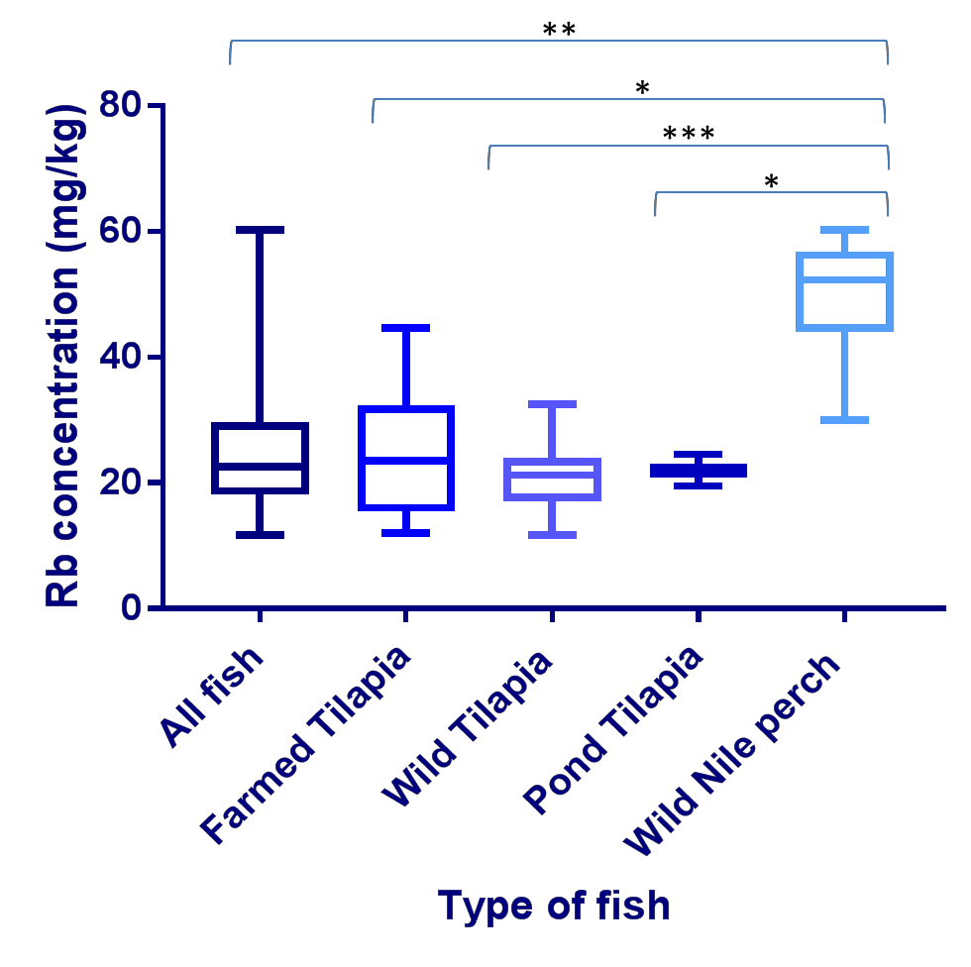

Figure 3.43- Rubidium concentrations across the fish analysed. This box and whisker plot illustrates Rubidium (Rb) concentrations (in milligram/kilogram dry weight; mg/kg) in all fish muscle samples (n=67), farmed Tilapia/FT (n=29), wild Tilapia/WT (n=26), Pond Tilapia/PT (n=6) and wild Nile perch/WNP (n=6). As was measured by Inductively Coupled Plasma Atomic Emission Spectroscopy analysis conducted by British Geological Survey) and data was analysed using GraphPad Prism. All fish samples had significantly lower concentrations than the WNP (P<0.01). The WNP also had significantly higher concentrations than the FT (P<0.05), the WT (P<0.001) and the PT (P<0.05) using a Kruskal-Wallis test.

Cross site comparison of Rubidium content

A cross site comparison of all 63 fish samples (excluding PT) in this study was preformed (Figure 3.44) from across the 11 sample sites (Site 1, 10 samples; Site

2b, 8 samples; site 3, 4 samples; site 3c, 3 samples; site 5b , 6 samples; site 5c, 4 samples; site 6e, 3 samples; site 7c, 4 samples; site 8b, 4 samples; site 9b, 7 samples; site 10, 7 samples). The greatest range was found at site 1 (11.71- 60.26mg/kg) and the smallest at site 5c (21.86-24.72mg/kg). Site 7c had significantly higher concentrations than site 2b (P<0.01) as did site 8b (P<0.05).
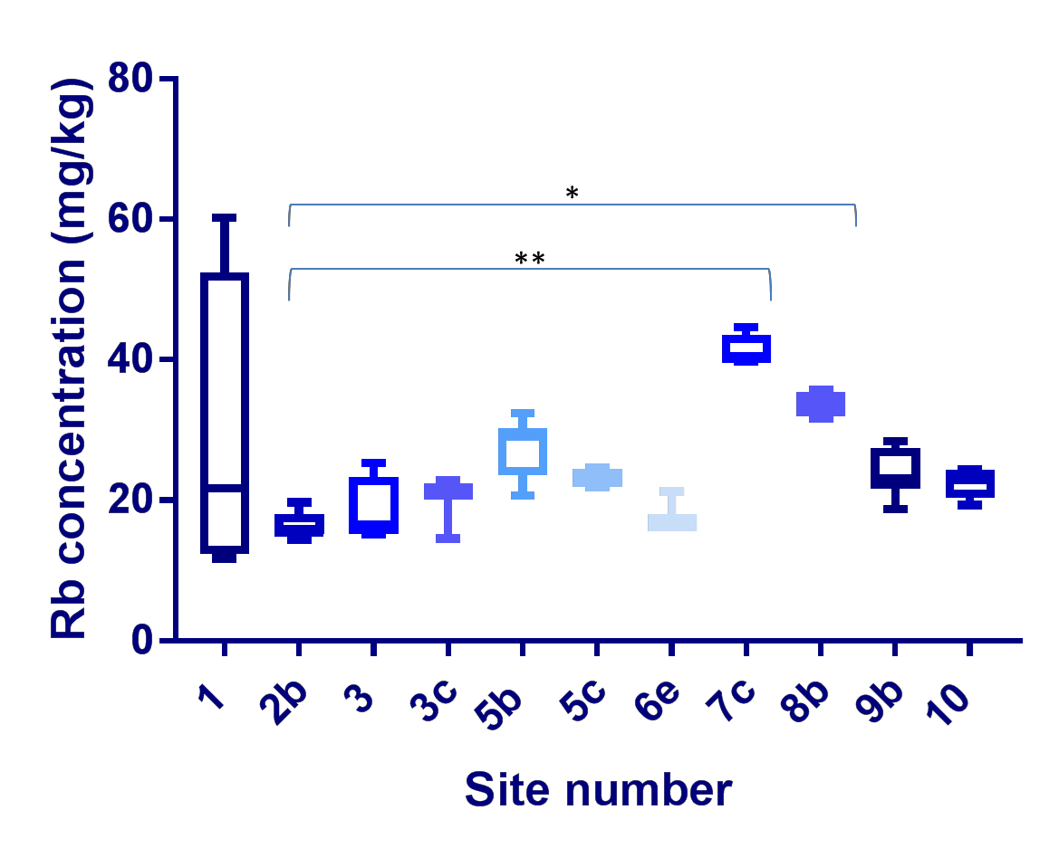

Figure 3.44 – Cross site Rubidium concentration comparison. This box and whisker plot shows the Rubidium (Rb) concentrations across the fish from all sites(n=61) (excluding pond Tilapia), (Site 1, 10 samples; Site 2b, 8 samples; site 3, 4 samples; site 3c, 3 samples; site 5b , 6 samples; site 5c, 4 samples; site 6e, 3 samples; site 7c, 4 samples; site 8b, 4 samples; site 9b, 7 samples; site 10, 7 samples), with site 1 and site 5c being the only sites to include Wild Nile Perch (WNP). Rubidium (Rb) was measured by Inductively Coupled Plasma Atomic Emission Spectroscopy (analysis conducted by British Geological Survey) and data was analysed using GraphPad Prism. Site 7c had significantly higher concentrations than site 2b (P<0.01) as did site 8b (P<0.05), using a Kruskel-wallis test.
The FT ranged from 12.03-44.66mg/kg whereas the wild ranged from 11.71- 60.26mg/kg. The mean of the FT was 25.14mg/kg and the mean of the WF was 26.12mg/kg. Site 8b has significantly higher concentrations than site 1 (P<0.05),

as does site 7c (P<0.01). Site 7c has significantly higher concentrations than site 2b (P>0.05) (Figure 3.45).

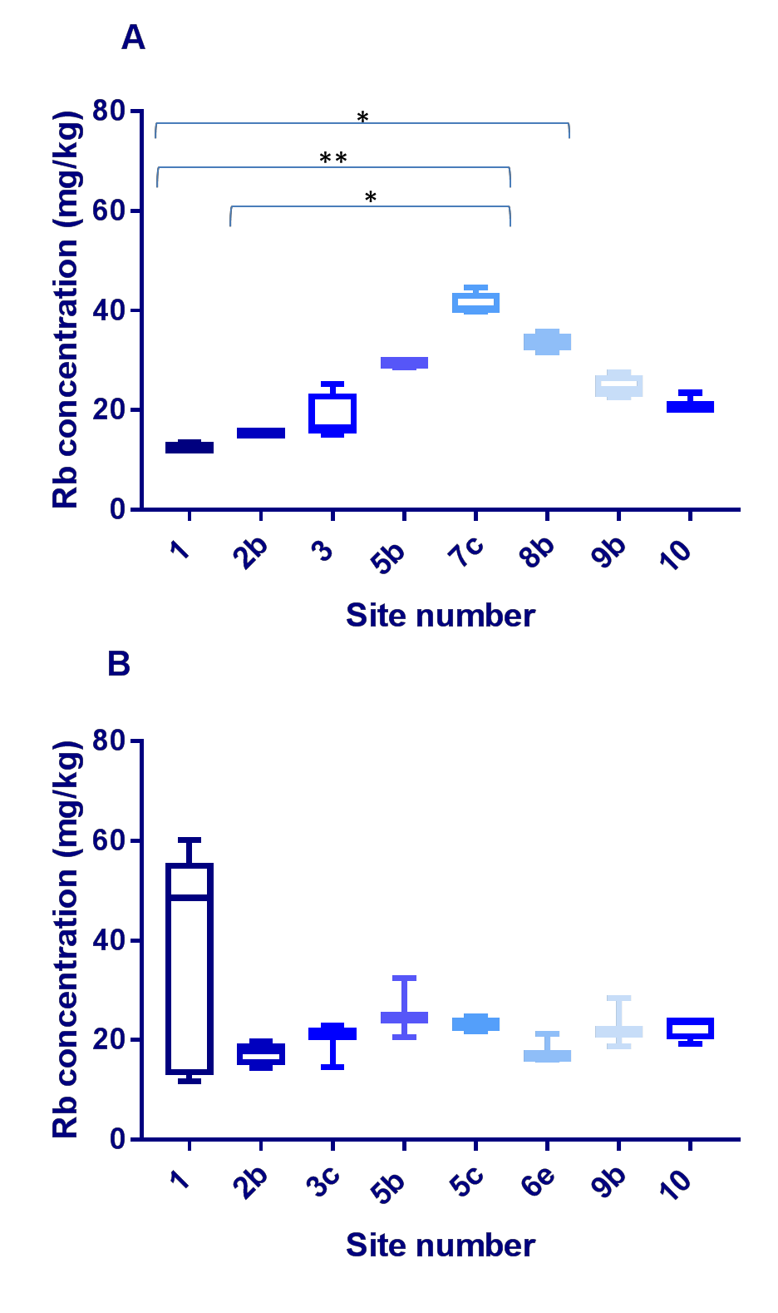

Figure 3.45 – Rubidium concentration comparison across the sites in farmed and wild fish. This box and whisker plot shows both the farmed Tilapia/FT (A) and the wild fish/WF (B) comparison across the 6 sites, (site 1, 3FT, 7 WF; site 2b, 4FT, 4WF; site 3, 4FT; site 5b 3FT, 3WF; site 5C, 4WT; Site 6e, 3WT; site 7c, 4FF; site 8b, 4FT, site 9b,4FT,3WT; site 10 3FT,4WF) with site 1 and site 5c being the only sites to include Wild Nile Perch (WNP). There were no wild fish from site 3, 7c and 8b; there were no farmed fish from 3c, 5c and 6e. Rubidium (Rb) was measured by Inductively Coupled Plasma Atomic Emission Spectroscopy (analysis conducted by British Geological Survey) and data was analysed using GraphPad Prism. Site 8b has significantly higher concentrations than site 1 (P<0.05), as does site 7c (P<0.01). Site 7c has significantly higher concentrations than site 2b (P>0.05), using a Kruskal-Wallis test.

Strontium

Across all Kenyan fish samples (n=67), the Sr concentrations ranged from 0.86- 119.67mg/kg (Figure 3.46), with a mean of 15.7mg/kg; sample 7 (WNP) had the lowest (0.86mg/kg) and sample 3 (FT) had the highest (119.67mg/kg). In the FT (n=29), concentrations ranged from 1.24-119.67mg/kg, with a mean of 19.6mg/kg; sample 19 had the lowest (1.24mg/kg) and sample 3 had the greatest (119.67mg/kg). The concentration range in the WT (n=26) was 1.62-55.65mg/kg, with a mean of 21.13mg/kg; sample 27 had the lowest (1.62mg/kg) and sample 4 had the highest level (55.65mg/kg). The range within the PT (n=6) was 4.30- 51.30mg/kg with a mean of 14.10mg/kg; the lowest concentration was found in sample 49 (4.30mg/kg) and the highest in sample 51 (51.30mg/kg). The range within the WNP (n=6) was 0.86-92.50mg/kg, with a mean of 9.96mg/kg; with the lowest concentration found in sample 7 (0.86mg/kg) and the greatest in sample S1WN3 (92.50mg/kg). There were no significant differences between the types of fish.

1 5 0
S r c o n c e n tr a t io n ( m g / k g )

1 0 0

5 0

0

T y p e o f fis h

Figure 3.46- Strontium concentrations across the fish analysed. This box and whisker plot illustrates Strontium (Sr) concentrations (in milligram/kilogram dry weight; mg/kg) in all fish muscle samples (n=67), farmed Tilapia/FT (n=29), wild Tilapia/WT (n=26), Pond Tilapia/PT (n=6) and wild Nile perch/WNP (n=6). Sr was measured by Inductively Coupled Plasma Atomic Emission Spectroscopy analysis conducted by British Geological Survey) and data was analysed using GraphPad Prism. There were no significant differences between the types of fish.

Cross site comparison of Strontium content

A cross site comparison of all 63 fish samples (excluding PT) in this study was preformed (Figure 3.47) from across the 11 sample sites (Site 1, 10 samples; Site 2b, 8 samples; site 3, 4 samples; site 3c, 3 samples; site 5b , 6 samples; site 5c, 4 samples; site 6e, 3 samples; site 7c, 4 samples; site 8b, 4 samples; site 9b, 7 samples; site 10, 7 samples). There were no significant differences between the sites.

The greatest range was found at site 1 (0.89-119.67mg/kg) and the smallest at site 3c (4.20-5.00mg/kg).

1 5 0
S r c o n c e n tr a t io n s ( m g / k g )

1 0 0

5 0

0

S i te n u m b e r

Figure 3.47 – Cross site Strontium concentration comparison. This box and whisker plot shows the Strontium (Sr) concentrations across the fish from all sites(n=61) (excluding pond Tilapia), (Site 1, 10 samples; Site 2b, 8 samples; site 3, 4 samples; site 3c, 3 samples; site 5b , 6 samples; site 5c, 4 samples; site 6e, 3 samples; site 7c, 4 samples; site 8b, 4 samples; site 9b, 7 samples; site 10, 7 samples), with site 1 and site 5c being the only sites to include Wild Nile Perch (WNP). Sr was measured by Inductively Coupled Plasma Atomic Emission Spectroscopy (analysis conducted by British Geological Survey) and data was analysed using GraphPad Prism. There were no significant differences between the sites.

The FT ranged from 1.24-119.67mg/kg whereas the WF ranged from 0.86- 92.50mg/kg, the mean of the FT was 19.60mg/kg the mean of the WF was 7.7mg/kg (Figure 3.48).

A

1 5 0
S r c o n c e n tr a t io n s ( m g / k g )

1 0 0

5 0

0

S i te n u m b e r

B

1 5 0
S r c o n c e n tr a t io n s ( m g / k g )

1 0 0

5 0

0

S i te n u m b e r

Figure 3.48 – Strontium concentration comparison across the sites in farmed and wild fish. This box and whisker plot shows both the farmed Tilapia/FT (A) and the wild fish/WF (B) comparison across the 6 sites, (site 1, 3FT, 7 WF; site 2b, 4FT, 4WF; site 3, 4FT; site 5b 3FT, 3WF; site 5C, 4WT; Site 6e, 3WT; site 7c, 4FF; site 8b, 4FT, site 9b,4FT,3WT; site 10 3FT,4WF) with site 1 and site 5c being the only sites to include Wild Nile Perch (WNP). There were no wild fish from site 3, 7c and 8b; there were no farmed fish from 3c, 5c and 6e. Strontium (Sr) was measured by Inductively Coupled Plasma Atomic Emission Spectroscopy (analysis conducted by British Geological Survey) and data was analysed using GraphPad Prism.

Titanium

Across all Kenyan fish samples (n=67), the Ti concentrations ranged from 0.17- 5.29mg/kg (Figure 3.49), with a mean of 0.51mg/kg; sample 38 (WT) had the lowest (0.17mg/kg) and sample 20 (FT) and 28 (WT) had the highest (5.29mg/kg). In the FT (n=29), concentrations ranged from 0.18-5.29mg/kg, with a mean of 0.57mg/kg; sample 23 had the lowest (0.18mg/kg) and sample 20 had the greatest (5.29mg/kg). The concentration range in the WT (n=26) was 0.17- 5.29mg/kg, with a mean of 0.29mg/kg; sample 38 had the lowest (0.17mg/kg) and sample 28 had the highest (5.29mg/kg) . The concertation range within the PT (n=6) was 0.68-4.92mg/kg with a mean of 14.10mg/kg; the lowest concentration was found in sample 30 (0.68mg/kg) and the highest in sample 49 (4.92mg/kg). The range within the WNP (n=6) was 0.20-1.09mg/kg, with a mean of 0.40mg/kg; the lowest concentration was found in sample 7 (0.20mg/kg) and the greatest in sample S1WN3 (1.09mg/kg). The concentration in the PT was significantly higher than all fish (P<0.05), FT (P<0.01), WF (P<0.05) and the WNP (P<0.01).

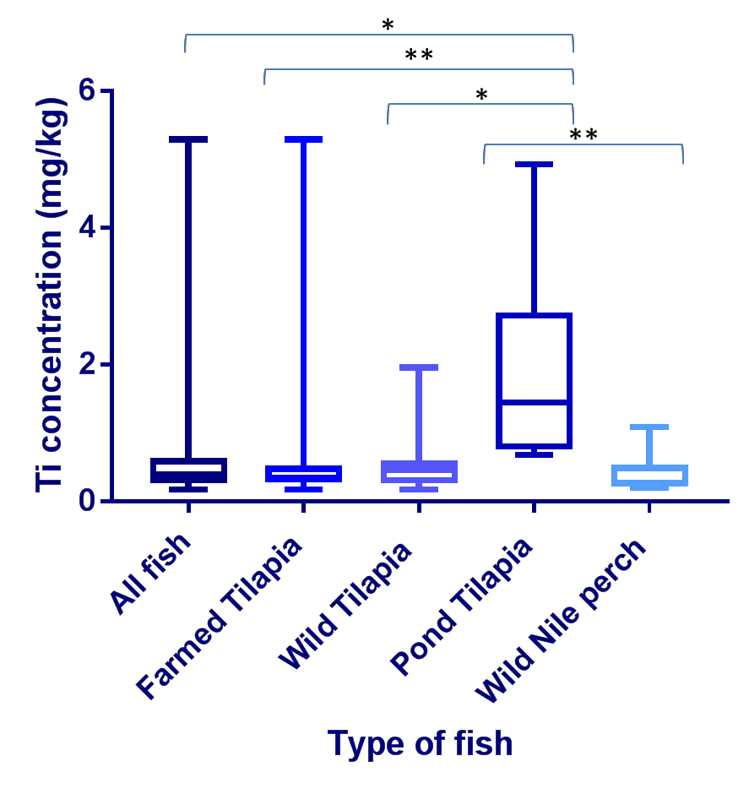

Figure 3.49- Titanium concentrations across the fish analysed. This box and whisker plot illustrates Titanium (Ti) concentrations (in milligram/kilogram dry weight; mg/kg) in all fish muscle samples (n=67), farmed Tilapia/FT (n=29), wild Tilapia/WT (n=26), Pond Tilapia/PT (n=6) and wild Nile perch/WNP (n=6). Ti was measured by Inductively Coupled Plasma Atomic Emission Spectroscopy analysis conducted by British Geological Survey) and data was analysed using GraphPad Prism. The concentration in the PT was significantly higher than all fish (P<0.05), FT (P<0.01), WF (P<0.05) and the WNP (P<0.01).

Cross site comparison of Titanium content

A cross site comparison of all 63 fish samples (excluding PT) in this study was preformed (Figure 3.50) from across the 11 sample sites (Site 1, 10 samples; Site 2b, 8 samples; site 3, 4 samples; site 3c, 3 samples; site 5b , 6 samples; site 5c,

4 samples; site 6e, 3 samples; site 7c, 4 samples; site 8b, 4 samples; site 9b, 7 samples; site 10, 7 samples). The greatest range was found at site 7c (0.25- 5.29mg/kg) and the smallest at site 10 (0.18-0.34mg/kg). The concentrations at 8b were significantly higher than those found at site 10 (P<0.01).
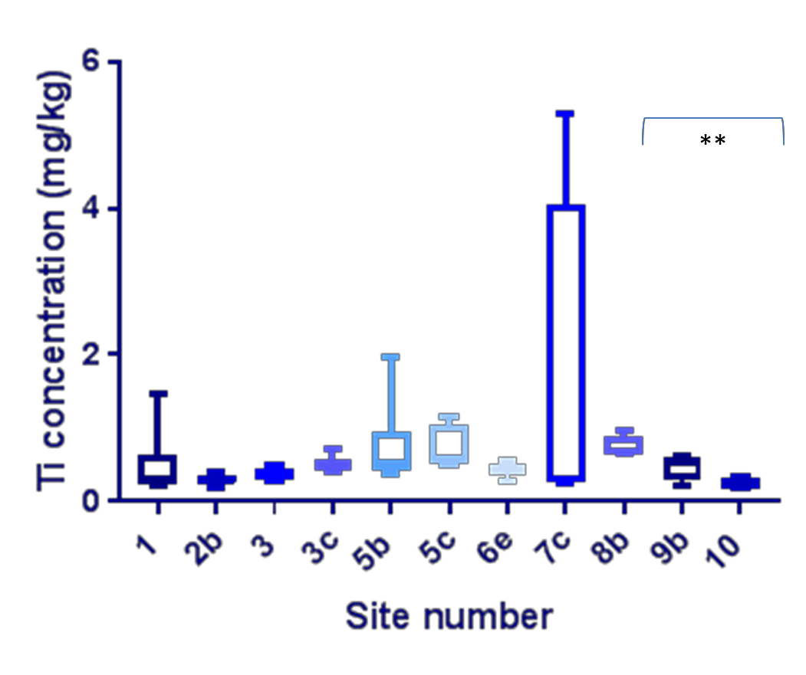

Figure 3.50 – Cross site Titanium concentration comparison. This box and whisker plot shows Titanium (Ti) concentrations across the fish from all sites (n=61) (excluding pond Tilapia), (Site 1, 10 samples; Site 2b, 8 samples; site 3, 4 samples; site 3c, 3 samples; site 5b , 6 samples; site 5c, 4 samples; site 6e, 3 samples; site 7c, 4 samples; site 8b, 4 samples; site 9b, 7 samples; site 10, 7 samples), with site 1 and site 5c being the only sites to include Wild Nile Perch (WNP). Ti was measured by Inductively Coupled Plasma Atomic Emission Spectroscopy (analysis conducted by British Geological Survey) and data was analysed using GraphPad Prism. The concentrations at 8b were significantly higher than those found at site 10 (P<0.01).
The FT ranged from 0.18-5.29mg/kg whereas the WF ranged from 0.17- 5.29mg/kg, the mean of the FT was 0.57mg/kg the mean of the WF was 0.52mg/kg (Figure 3.51)

A

6
T i c o n c e n tr a t io n ( m g / k g )

4

2

0

S i te n u m b e r

B

6
T i c o n c e n tr a t io n ( m g / k g )

4

2

0

S i te n u m b e r

Figure 3.51 – Titanium concentration comparison across the sites in farmed and wild fish. This box and whisker plot shows both the farmed Tilapia/FT (A) and the wild fish/WF (B) comparison across the 6 sites, (site 1, 3FT, 7 WF; site 2b, 4FT, 4WF; site 3, 4FT; site 5b 3FT, 3WF; site 5C, 4WT; Site 6e, 3WT; site 7c, 4FF; site 8b, 4FT, site 9b,4FT,3WT; site 10 3FT,4WF) with site 1 and site 5c being the only sites to include Wild Nile Perch (WNP). There were no wild fish from site 3, 7c and 8b; there were no farmed fish from 3c, 5c and 6e. Titanium (Ti) was measured by Inductively Coupled Plasma Atomic Emission Spectroscopy (analysis conducted by British Geological Survey) and data was analysed using GraphPad Prism.

Tin

Across all Kenyan fish samples (n=67), the Sn concentrations ranged from 0.00- 4.92mg/kg (Figure 3.52), with a mean of 0.24mg/kg; sample 44 (WT) had the lowest (0.00mg/kg) and 1 (FT) had the highest (4.92mg/kg). In the FT (n=29) concentrations ranged from 0.01-4.92mg/kg, with a mean of 0.38mg/kg; sample 56 had the lowest (0.01mg/kg) and 1 had the highest concentration (4.92mg/kg). The concentration range in the WT (n=26) was 0.00-2.95mg/kg, with a mean of 0.50mg/kg; sample 44 had the lowest (0.00mg/kg) and 28 had the highest (2.95mg/kg). The concertation range within the PT (n=6) was 0.01-0.20mg/kg with a mean of 0.07mg/kg; the lowest concentration was found in sample 52 (0.01mg/kg) and the highest in sample 30 (0.20mg/kg). The Sn range within the WNP (n=6) was 0.16-0.54mg/kg, with a mean of 0.29mg/kg; the lowest concentration found in 7 (0.16mg/kg) and the greatest in S1WN4 (0.54mg/kg). There were no significant differences between the types of fish.

6
S n c o n c e n tr a t io n ( m g / k g )

4

2

0

T y p e o f fis h

Figure 3.52- Tin concentrations across the fish analysed. This box and whisker plot illustrates Tin (Sn) concentrations (in milligram/kilogram dry weight; mg/kg) in all fish muscle samples (n=67), farmed Tilapia/FT (n=29), wild Tilapia/WT (n=26), Pond Tilapia/PT (n=6) and wild Nile perch/WNP (n=6). Sn was measured by Inductively Coupled Plasma Atomic Emission Spectroscopy analysis conducted by British Geological Survey) and data was analysed using GraphPad Prism. There were no significant differences between the types of fish.

Cross site comparison of Tin content

A cross site comparison of all 63 fish samples (excluding PT) in this study was preformed (Figure 3.53) from across the 11 sample sites (Site 1, 10 samples; Site 2b, 8 samples; site 3, 4 samples; site 3c, 3 samples; site 5b , 6 samples; site 5c, 4 samples; site 6e, 3 samples; site 7c, 4 samples; site 8b, 4 samples; site 9b, 7 samples; site 10, 7 samples).

The greatest range was found at site 1 (0.16-4.92mg/kg) and the smallest at site 8b and 9b (0.01-0.01mg/kg).

6
S n c o n c e n tr a t io n ( m g / k g )

4

2

0

S ite n u m b e r

Figure 3.53 – Cross site Tin concentration comparison. This box and whisker plot shows Tin (Sn) concentrations across the fish from all sites(n=61) (excluding pond Tilapia), (Site 1, 10 samples; Site 2b, 8 samples; site 3, 4 samples; site 3c, 3 samples; site 5b , 6 samples; site 5c, 4 samples; site 6e, 3 samples; site 7c, 4 samples; site 8b, 4 samples; site 9b, 7 samples; site 10, 7 samples), with site 1 and site 5c being the only sites to include Wild Nile Perch (WNP). Ba was measured by Inductively Coupled Plasma Atomic Emission Spectroscopy (analysis conducted by British Geological Survey) and data was analysed using GraphPad Prism.
The FT ranged from 0.01-4.92mg/kg whereas the WF ranged from 0.00- 2.97mg/kg, the mean of the FT was 0.38mg/kg the mean of the WF was 0.20mg/kg (Figure 3.54).

A

6
S n c o n c e n tr a t io n ( m g / k g )

4

2

0

S i te n u m b e r

B

6
S n c o n c e n tr a t io n ( m g / k g )

4

2

0

S i te n u m b e r

Figure 3.54 – Tin concentration comparison across the sites in farmed and wild fish. This box and whisker plot shows both the farmed Tilapia/FT (A) and the wild fish/WF (B) comparison across the 6 sites, (site 1, 3FT, 7 WF; site 2b, 4FT, 4WF; site 3, 4FT; site 5b 3FT, 3WF; site 5C, 4WT; Site 6e, 3WT; site 7c, 4FF; site 8b, 4FT, site 9b,4FT,3WT; site 10 3FT,4WF) with site 1 and site 5c being the only sites to include Wild Nile Perch (WNP). There were no wild fish from site 3, 7c and 8b; there were no farmed fish from 3c, 5c and 6e. Tin (Sn) was measured by Inductively Coupled Plasma Atomic Emission Spectroscopy (analysis conducted by British Geological Survey) and data was analysed using GraphPad Prism.

Mercury

The Hg concentrations across all fish (n=67) ranged from 0.01-0.12mg/kg with a mean of 0.03mg/kg; sample 20 (FT) having the lowest concentration (0.01mg/kg) and sample 6 (WT) (Figure 3.55) having the highest concentration (0.12mg/kg).In the FT (n=29), concentrations ranged from 0.01-0.07mg/kg and the mean of 0.025mg/kg; samples 20 had the lowest (0.01mg/kg) and sample 13 had the greatest (0.07mg/kg). The concentration range in the WT (n=26) was 0.01- 0.09mg/kg with the mean of 0.03mg/kg; with samples 61 had the lowest (0.01mg/kg) and sample 37 had the highest (0.09mg/kg). The concentration range in the PT (n=6) was 0.00-0.06mg/kg, with a mean of 0.02mg/kg; sample 49 had the lowest (0.02mg/kg) and the highest was sample 30 (0.06mg/kg).The concentration range within the WNP (n=6) was 0.06-0.12mg/kg with a mean of 0.10mg/kg; with the found in sample S1WN3 (0.056mg/kg) and the greatest in 7 (0.124mg/kg). The WNP concentrations were significantly higher than all fish (P<0.01), FT (P<0.01), WT (P<0.05) and PT (P<0.01).

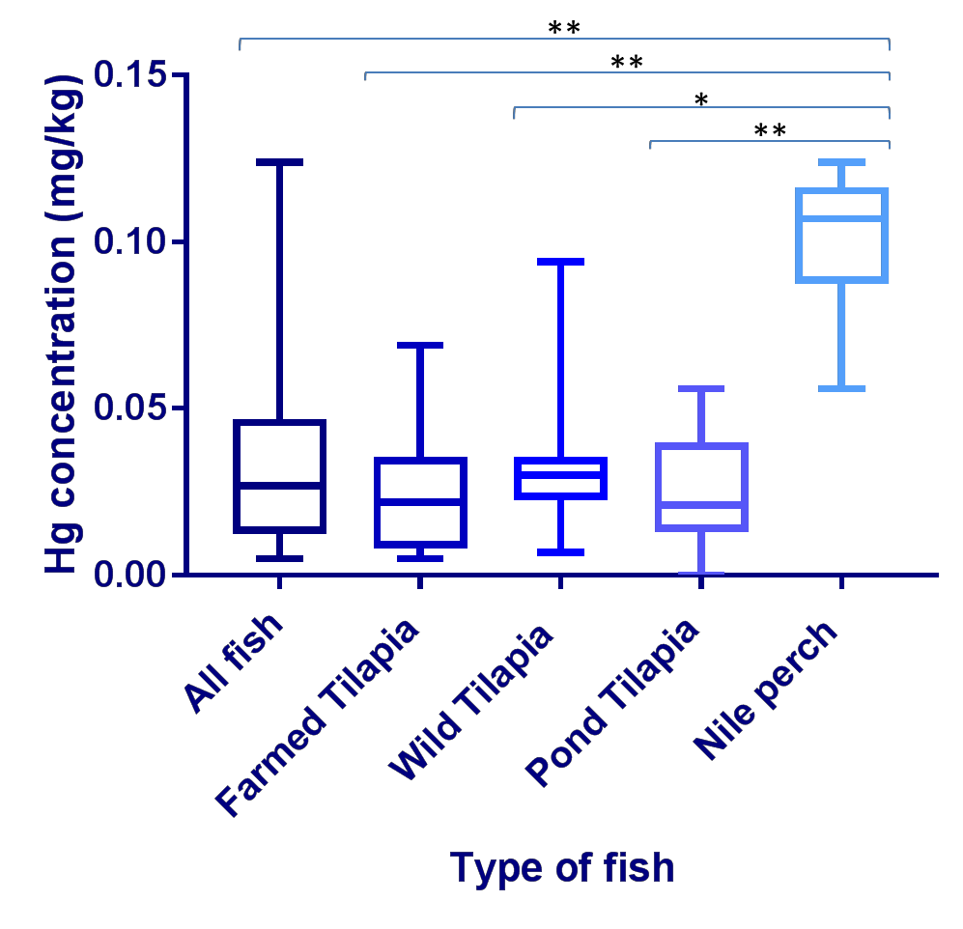

Figure 3.55- Mercury concentrations across the fish analysed. This box and whisker plot illustrates Mercury (Hg) concentrations (in milligram/kilogram dry weight; mg/kg) in all fish muscle samples, farmed Tilapia/FT (n=29), wild Tilapia/WT (n=26), Pond Tilapia/PT (n=6) and wild Nile perch/WNP (n=6). Hg was measured by direct Mercury analysis system (DMA-80Analitix) conducted by British Geological Survey and data was analysed using GraphPad Prism. The Nile perch was significantly higher than the pond Tilapia (P<0.01), the wild Tilapia (P<0.05), the farmed Tilapia (P<0.01) and all fish (P<0.01). The WNP concentrations were significantly higher than all fish (P<0.01), FT (P<0.01), WT (P<0.05) and PT (P<0.01).

Cross site comparison of Mercury content

A cross site comparison of all 61 fish samples (excluding PT) in this study was preformed (Figure 3.56) from across the 11 sample sites (Site 1, 10 samples; Site 2b, 8 samples; site 3, 4 samples; site 3c, 3 samples; site 5b, 6 samples; site 5c,

4 samples; site 6e, 3 samples; site 7c, 4 samples; site 8b, 4 samples; site 9b, 7 samples; site 10, 7 samples).
The greatest range was found at site 1 (0.02-0.12mg/kg) and the smallest at site 3 (0.01-0.01mg/kg). Site 1 was significantly higher than site 3 (P<0.05), site 7 (P<0.01) and site 8b (P<0.05).
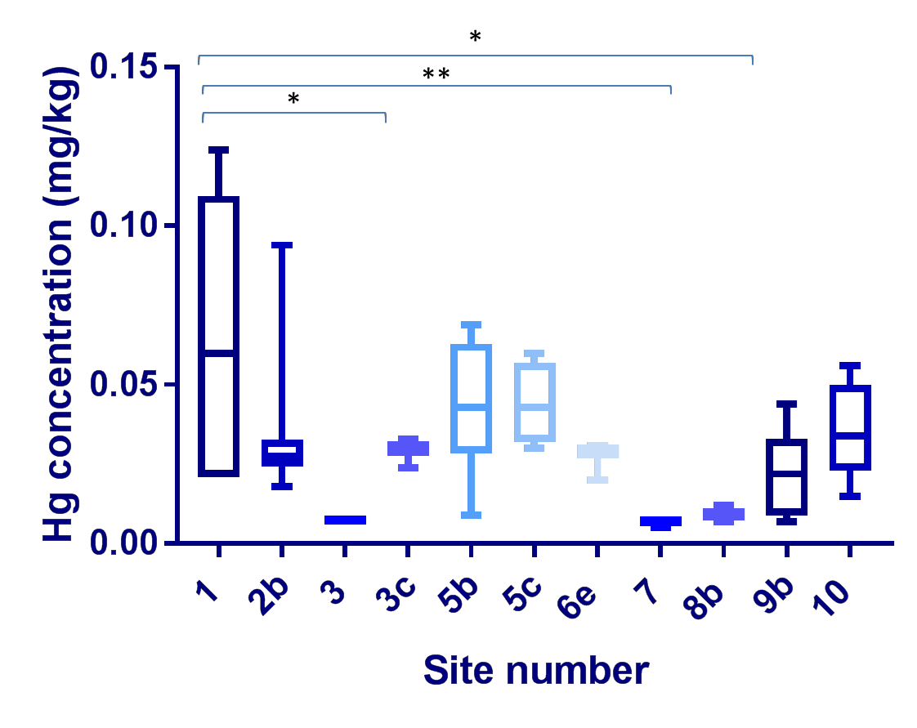

Figure 3.56 – Cross site Mercury concentration comparison. This box and whisker plot shows Mercury (Hg) concentrations across the fish from all sites (n=61) (excluding PT), (Site 1, 10 samples; Site 2b, 8 samples; site 3, 4 samples; site 3c, 3 samples; site 5b , 6 samples; site 5c, 4 samples; site 6e, 3 samples; site 7c, 4 samples; site 8b, 4 samples; site 9b, 7 samples; site 10, 7 samples), with site 1 and site 5c being the only sites to include Wild Nile Perch (WNP). Hg was measured by direct Mercury analysis system (DMA-80Analitix) conducted by British Geological Survey and data was analysed using GraphPad Prism. Site 1 was significantly higher than site 3 (P<0.05), site 7 (P<0.01) and site 8b (P<0.05).

The FT ranged from 0.01-0.07mg/kg whereas the WF ranged from 0.01- 0.09mg/kg, the mean of the FT was 0.02mg/kg the mean of the WF was

0.03mg/kg. In the farmed fish site 5b was significantly higher than site 3 (P<0.05) and site 7 (P<0.05) (Figure 3.57).

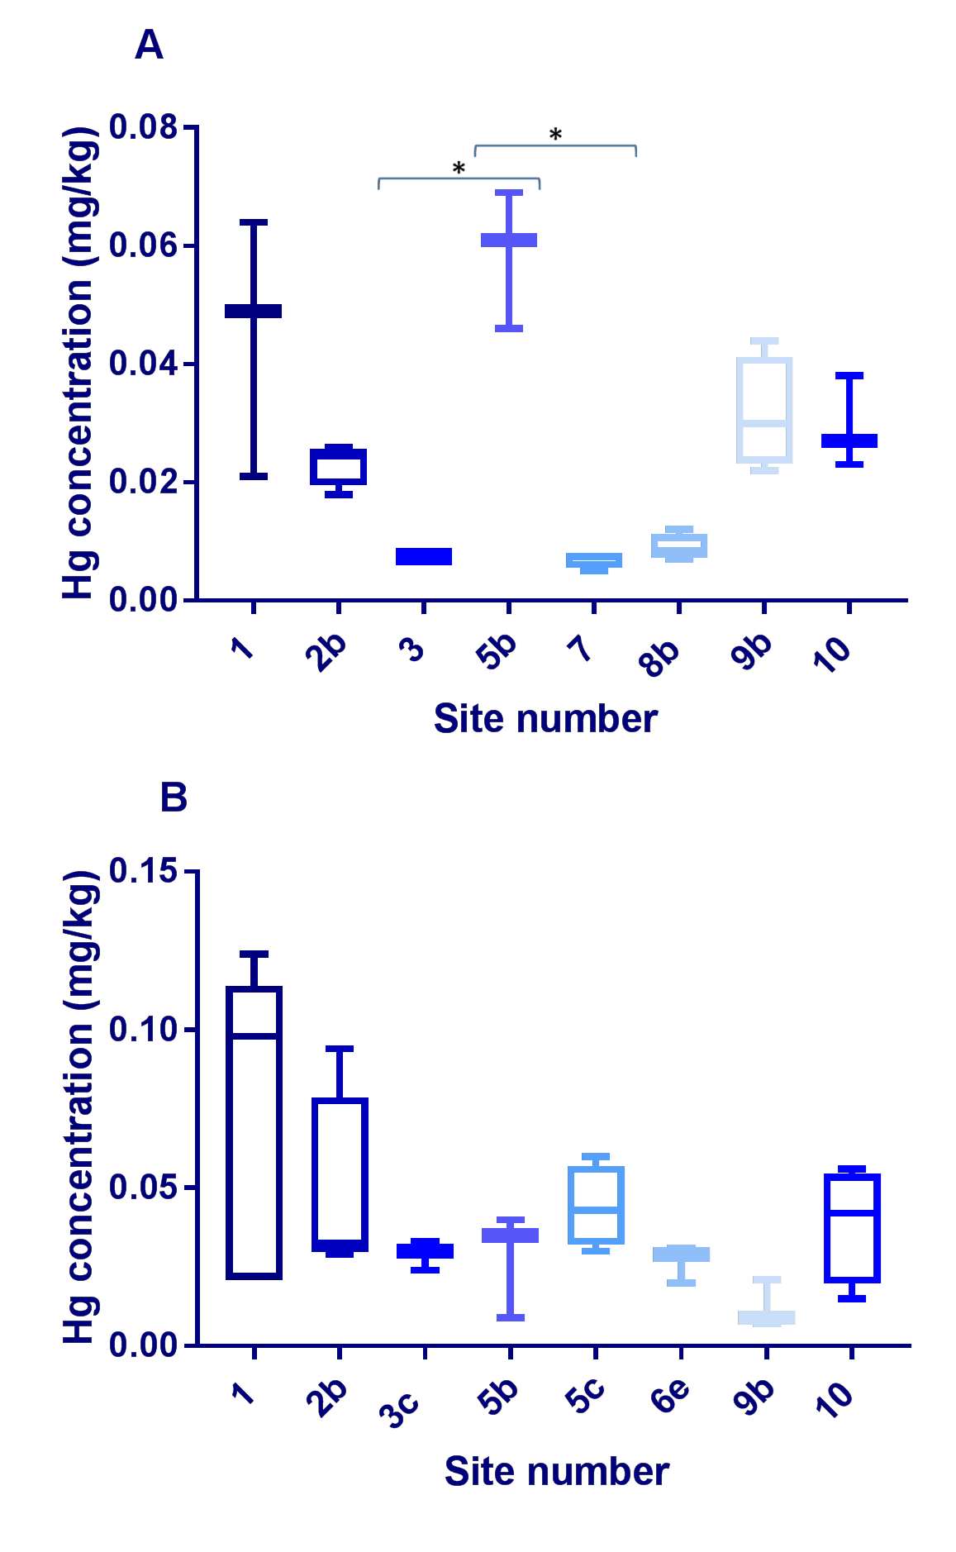

Figure 3.57 –Mercury concentration comparison across the sites in farmed and wild fish. This box and whisker plot shows both the farmed Tilapia/FT (A) and the wild fish/WF (B) comparison across the 6 sites, (site 1, 3FT, 7 WF; site 2b, 4FT, 4WF; site 3, 4FT; site 5b 3FT, 3WF; site 5C, 4WT; Site 6e, 3WT; site 7c, 4FF; site 8b, 4FT, site 9b,4FT,3WT; site 10 3FT,4WF) with site 1 and site 5c being the only sites to include Wild Nile Perch (WNP). There were no wild fish from site 3, 7c and 8b; there were no farmed fish from 3c, 5c and 6e Mercury (Hg) was measured by direct Mercury analysis system (DMA-80Analitix) conducted by British Geological Survey). and data was analysed using GraphPad Prism. In the FT site 5b was significantly higher than site 3 (P<0.05) and site 7 (P<0.05).

Essential elements

Of the 57 elements analysed by ICP, the following were classed as essential elements in fish: Ca, Cu, Fe, Mg, Potassium (K), Se, Na and Zn. The summary of the essential elements can be seen in figure 3.58

138
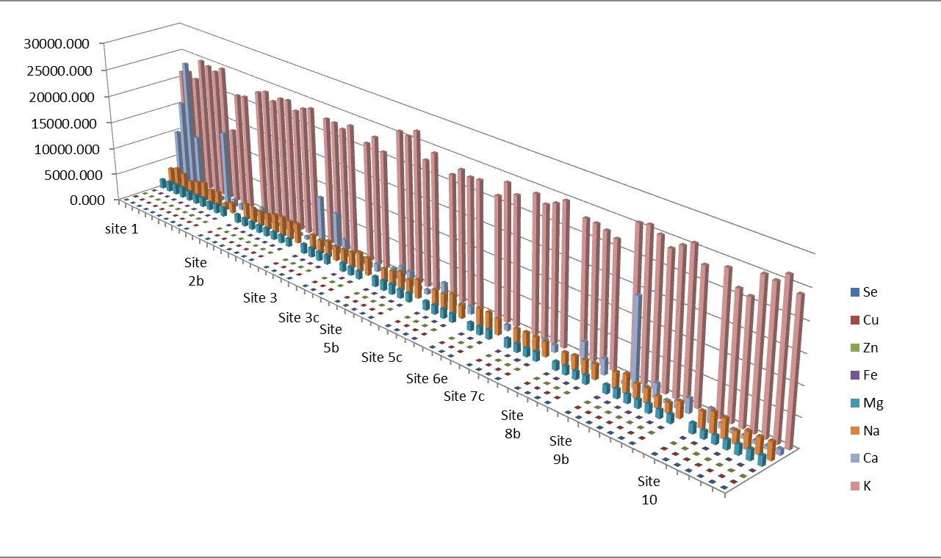

Figure 3.58- Summary graph of the essential elements at the different sites. This graph shows the Calcium (Ca), Copper (Cu), Iron (Fe), Magnesium (Mg), Potassium (K), Selenium (Se), Sodium (Na) and Zinc (Zn) concentrations at the 11 different sites. At site 1,10 samples; site 2b, 8 samples; site 3, 3 samples; site 5b, 6 samples; site 5c, 4 samples; site 6e, 3 samples; site 7c, 4 samples; site 8b, 4 samples; site 9b, 7 samples; site 10, 7 samples. The graph was made on Microsoft excel.

Calcium

Across all Kenyan fish samples (n=67), the Ca concentrations ranged from 430- 24246mg/kg (Figure 3.59), with a mean of 3159mg/kg; sample 57 (FT) had the lowest (430mg/kg) and 3 (FT) had the highest (24246mg/kg). In the FT (n=29), concentrations ranged from 430-24246mg/kg, with a mean of 4138mg/kg; 57 had the lowest (430mg/kg) and 3 had the greatest (24246mg/kg). The concentration range in the WT (n=26) was 502-10543mg/kg, with a mean of 1504mg/kg; 61 had the lowest (579mg/kg) and 4 had the highest (10543mg/kg). The concertation range within the PT (n=6) was 904-8398mg/kg with a mean of 3169mg/kg; the lowest concentration was found in sample 49 (904mg/kg) and the highest in sample 51 (8398mg/kg). The range within the WNP (n=6) was 680- 13627mg/kg, with the mean of 4137mg/kg, with the lowest found in 7 (680mg/kg) and the greatest in S1WN3 (13627mg/kg).

3 0 0 0 0
C a c o n c e n tr a t io n ( m g / k g )

2 0 0 0 0

1 0 0 0 0

0

T y p e o f fis h

Figure 3.59- Calcium concentrations across the fish analysed. This box and whisker plot illustrates Calcium (Ca) concentrations (in milligram/kilogram dry weight; mg/kg) in all fish muscle samples (n=67), farmed Tilapia/FT (n=29), wild Tilapia/WT (n=26), Pond Tilapia/PT (n=6) and wild Nile perch/WNP (n=6). Ca was measured by Inductively Coupled Plasma Atomic Emission Spectroscopy (analysis conducted by British Geological Survey) and data was analysed using GraphPad Prism.

Cross site comparison of Calcium content

A cross site comparison of all 61 fish samples (excluding PT) in this study was preformed (Figure 3.60) from across the 11 sample sites (Site 1, 10 samples; Site 2b, 8 samples; site 3, 4 samples; site 3c, 3 samples; site 5b, 6 samples; site 5c, 4 samples; site 6e, 3 samples; site 7c, 4 samples; site 8b, 4 samples; site 9b, 7 samples; site 10, 7 samples).

The greatest range was found at site 1 (680-24246mg/kg) and the smallest at site 3c (1011-1388mg/kg).

3 0 0 0 0
C a c o n c e n tr a t io n ( m g / k g )

2 0 0 0 0

1 0 0 0 0

0

S i te n u m b e r

Figure 3.60 – Cross site Calcium concentration comparison. This box and whisker plot shows Tin (Sn) concentrations across the fish from all sites (n=61) (excluding PT) (Site 1, 10 samples; Site 2b, 8 samples; site 3, 4 samples; site 3c, 3 samples; site 5b , 6 samples; site 5c, 4 samples; site 6e, 3 samples; site 7c, 4 samples; site 8b, 4 samples; site 9b, 7 samples; site 10, 7 samples), with site 1 and site 5c being the only sites to include Wild Nile Perch (WNP). Calcium (Ca) was measured by Inductively Coupled Plasma Atomic Emission Spectroscopy (analysis conducted by British Geological Survey) and data was analysed using GraphPad Prism.
The FT ranged from 430-24246mg/kg whereas the WF ranged from 502- 13627mg/kg, the mean of the FT was 4138mg/kg the mean of the WF was 1998mg/kg (Figure 3.61).

A

3 0 0 0 0
C a c o n c e n tr a t io n ( m g / k g )

2 0 0 0 0

1 0 0 0 0

0

S ite n u m b e r

B

3 0 0 0 0
C a c o n c e n tr a t io n ( m g / k g )

2 0 0 0 0

1 0 0 0 0

0

S ite n u m b e r

Figure 3.61 – Calcium concentration comparison across the sites in farmed and wild fish. This box and whisker plot shows both the farmed Tilapia/FT (A) and the wild fish/WF (B) comparison across the 6 sites, (site 1, 3FT, 7 WF; site 2b, 4FT, 4WF; site 3, 4FT; site 5b 3FT, 3WF; site 5C, 4WT; Site 6e, 3WT; site 7c, 4FF; site 8b, 4FT, site 9b,4FT,3WT; site 10 3FT,4WF) with site 1 and site 5c being the only sites to include Wild Nile Perch (WNP). There were no wild fish from site 3, 7c and 8b; there were no farmed fish from 3c, 5c and 6e. Calcium (Ca) was measured by Inductively Coupled Plasma Atomic Emission Spectroscopy (analysis conducted by British Geological Survey) and data was analysed using GraphPad Prism.

Copper
Across all Kenyan fish samples (n=67), the Cu concentrations ranged from 1.00- 51.03mg/kg (Figure 3.62), with a mean of 3.60mg/kg; sample 31 (FT) had the lowest (1.00mg/kg) and sample 1 (FT) had the highest (51.03mg/kg). In the FT (n=29), concentrations ranged from 1.00-51.03mg/kg, with a mean of 4.75mg/kg; sample 31 had the lowest (1.00mg/kg) and sample 1 had the greatest (51.03mg/kg). The concentration range in the WT (n=26) was 1.04-24.58mg/kg, with a mean of 3.08mg/kg; sample 48 had the lowest (1.04mg/kg) and sample 28 had the highest (24.58mg/kg). The range within the WNP (n=6) was 1.43- 5.17mg/kg, with a mean of 3.59mg/kg; the lowest concentration found in 45 (1.43mg/kg) and the greatest in sample S1WN3 (5.17mg/kg). The concertation range within the PT (n=6) was 904-8398mg/kg with a mean of 3169mg/kg; the lowest concentration was found in sample 49 (904mg/kg) and the highest in sample 51 (8398mg/kg). The concertation range within the PT (n=6) was 1.52- 3.37mg/kg with a mean of 2.19mg/kg; the lowest concentration was found in sample 50 (1.52mg/kg) and the highest in sample 29 (3.37mg/kg). The concentrations in the FT were significantly higher than those found in the WT (P<0.05).

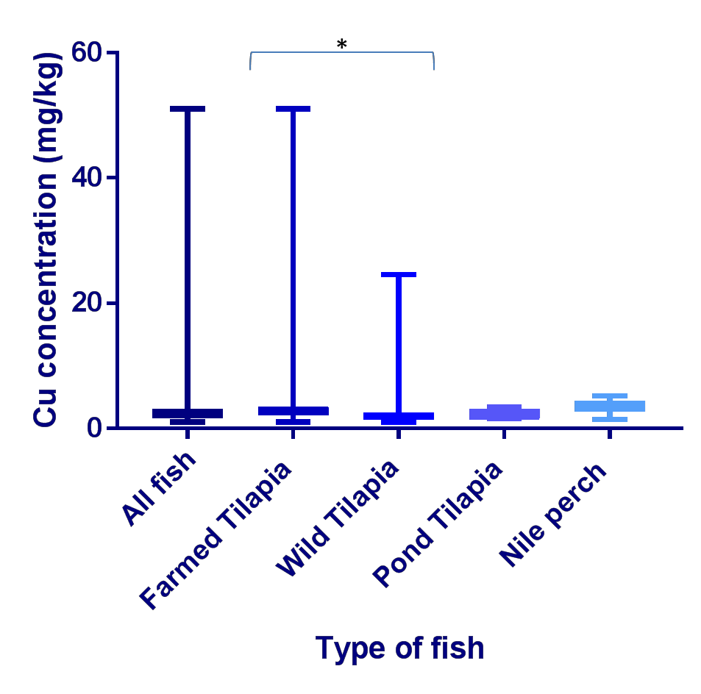

Figure 3.62- Copper concentrations across the fish analysed. This box and whisker plot illustrates Copper (Cu) concentrations (in milligram/kilogram dry weight; mg/kg) in all fish muscle samples (n=67), farmed Tilapia/FT (n=29), wild Tilapia/WT (n=26), Pond Tilapia/PT (n=6) and wild Nile perch/WNP (n=6). Cu was measured by Inductively Coupled Plasma Atomic Emission Spectroscopy analysis conducted by British Geological Survey) and data was analysed using GraphPad Prism. The concentrations in the FT were significantly higher than those found in the WT (P<0.05).

Cross site comparison of Copper content

A cross site comparison of all 63 fish samples (excluding PT) in this study was preformed (Figure 3.63) from across the 11 sample sites (Site 1, 10 samples; Site 2b, 8 samples; site 3, 4 samples; site 3c, 3 samples; site 5b , 6 samples; site 5c, 4 samples; site 6e, 3 samples; site 7c, 4 samples; site 8b, 4 samples; site 9b, 7 samples; site 10, 7 samples).

The greatest range was found at site 1 (2.84-51.03mg/kg) and the smallest at site 3c (1.31-1.41mg/kg).Site 1 had significantly higher concentrations than site 3, 5c, 6e, 7c and 8b (p<0.05).
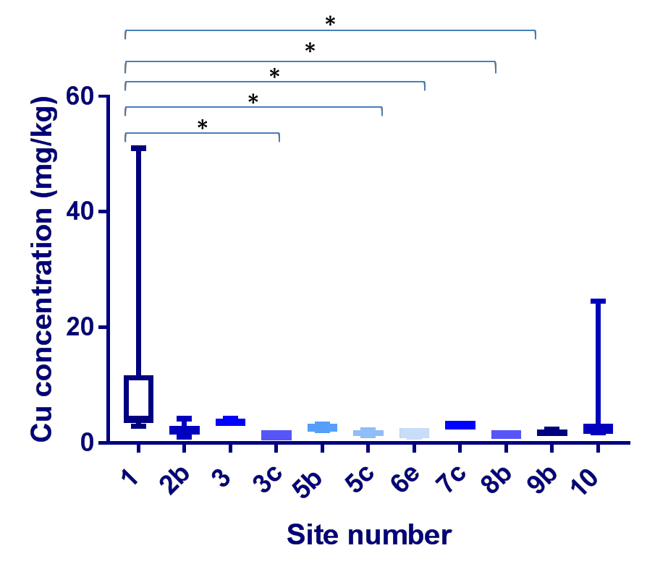

Figure 3.63 – Cross site Copper concentration comparison. This box and whisker plot shows Copper (Cu) concentrations across the fish from all sites (n=61) (excluding pond Tilapia), (Site 1, 10 samples; Site 2b, 8 samples; site 3, 4 samples; site 3c, 3 samples; site 5b , 6 samples; site 5c, 4 samples; site 6e, 3 samples; site 7c, 4 samples; site 8b, 4 samples; site 9b, 7 samples; site 10, 7 samples), with site 1 and site 5c being the only sites to include Wild Nile Perch (WNP). Cu was measured by Inductively Coupled Plasma Atomic Emission Spectroscopy (analysis conducted by British Geological Survey) and data was analysed using GraphPad Prism. Site 1 had significantly higher concentrations than site 3, 5c, 6e, 7c and 8b (p<0.05).
The (FT) ranged from 1.00-51.03mg/kg whereas the WF ranged from 1.04- 24.58mg/kg, the mean of the FT was 4.75mg/kg the mean of the WF was 3.17mg/kg. FT at site 1 had significantly higher concentrations of Cu than FT at site 9b (P<0.05). WF at site 1 had significantly higher Cu concentrations than WF at site 3c (P<0.05) (Figure 3.64).

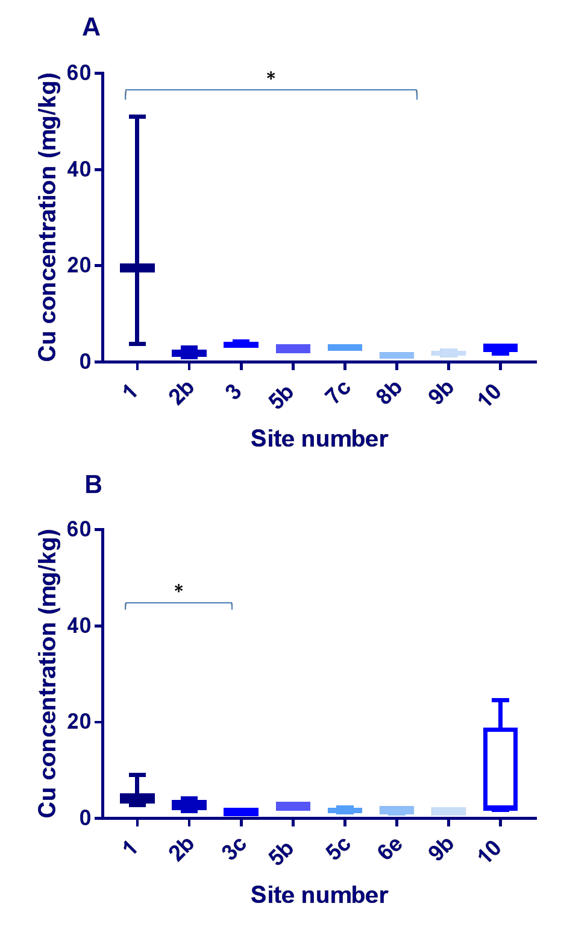

Figure 3.64 – Copper concentration comparison across the sites in farmed and wild fish. This box and whisker plot shows both the farmed Tilapia/FT (A) and the wild fish/WF (B) comparison across the 6 sites, (site 1, 3FT, 7 WF; site 2b, 4FT, 4WF; site 3, 4FT; site 5b 3FT, 3WF; site 5C, 4WT; Site 6e, 3WT; site 7c, 4FF; site 8b, 4FT, site 9b,4FT,3WT; site 10 3FT,4WF) with site 1 and site 5c being the only sites to include Wild Nile Perch (WNP). There were no wild fish from site 3, 7c and 8b; there were no farmed fish from 3c, 5c and 6e. Copper (Cu) was measured by Inductively Coupled Plasma Atomic Emission Spectroscopy (analysis conducted by British Geological Survey) and data was analysed using GraphPad Prism. FT at site 1 had significantly higher concentrations of Cu than those at site 9b (P<0.05). WF at site 1 had significantly higher Cu concentrations than those at site 3c (P<0.05).

3.8.2.3 Iron

Across all Kenyan fish samples (n=67), the Fe concentrations ranged from 11- 108mg/kg (Figure 3.65), with a mean of 27mg/kg; sample 7 (WNP) had the lowest (11mg/kg) and sample 49 (PT) had the highest (108mg/kg). In the FT (n=29), concentrations ranged from 16-84mg/kg, with a mean of 26mg/kg; sample 55 had the lowest (16mg/kg) and 20 had the greatest concentration (84mg/kg). The concentration range in the WT (n=26) was 14-40mg/kg, with a mean of 27mg/kg; sample 40 had the lowest (14mg/kg) and sample 17 had the highest (40mg/kg). The concertation range within the PT (n=6) was 26-108mg/kg with a mean of 52mg/kg; the lowest concentration was found in sample 49 (26mg/kg) and the highest in sample 50 (108mg/kg). The range within the WNP (n=6) was 11- 31mg/kg, with a mean of 18mg/kg; the lowest concentration found in 7 (11mg/kg) and the greatest in sample S1WN3 (3mg/kg). The concentrations in the PT were significantly higher than those across all fish (P<0.01), FT (P<0.05), WT (P<0.05) and the WNP (P<0.01).

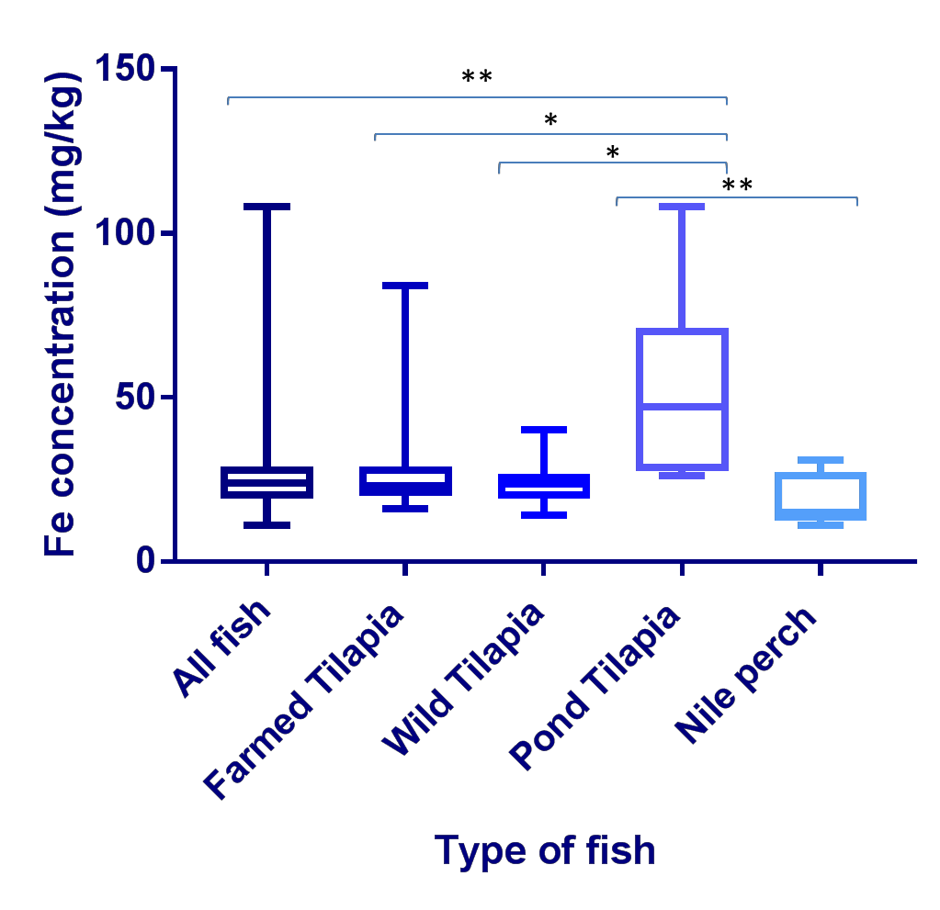

Figure 3.65- Iron concentrations across the fish analysed. This box and whisker plot illustrates Iron (Fe) concentrations (in milligram/kilogram dry weight; mg/kg) in all fish muscle samples, farmed Tilapia/FT (n=29), wild Tilapia/WT (n=26), Pond Tilapia/PT (n=6) and wild Nile perch/WNP (n=6). Fe was measured by Inductively Coupled Plasma Atomic Emission Spectroscopy analysis conducted by British Geological Survey) and data was analysed using GraphPad Prism. The concentrations in the pond Tilapia were significantly higher than those across all fish (P<0.01), FT (P<0.05), WT (P<0.05) and the WNP (P<0.01).

3.8.2.3.1 Cross site comparison of Iron content

A cross site comparison of all 63 fish samples (excluding PT) in this study was preformed (Figure 3.66) from across the 11 sample sites (Site 1, 10 samples; Site 2b, 8 samples; site 3, 4 samples; site 3c, 3 samples; site 5b , 6 samples; site 5c, 4 samples; site 6e, 3 samples; site 7c, 4 samples; site 8b, 4 samples; site 9b, 7 samples; site 10, 7 samples).

The greatest range was found at site 7c (22-84mg/kg) and the smallest at site 3 (20-25mg/kg) and site 3c (16-21mg/kg).

1 0 0
F e c o n c e n tr a t io n ( m g / k g )

8 0

6 0

4 0

2 0

0

T y p e o f fis h

Figure 3.66 – Cross site Iron concentration comparison. This box and whisker plot shows Iron (Fe) concentrations across the fish from all sites (n=61) (excluding PT), (Site 1, 10 samples; Site 2b, 8 samples; site 3, 4 samples; site 3c, 3 samples; site 5b , 6 samples; site 5c, 4 samples; site 6e, 3 samples; site 7c, 4 samples; site 8b, 4 samples; site 9b, 7 samples; site 10, 7 samples), with site 1 and site 5c being the only sites to include Wild Nile Perch (WNP). Fe was measured by Inductively Coupled Plasma Atomic Emission Spectroscopy (analysis conducted by British Geological Survey) and data was analysed using GraphPad Prism.

The FT ranged from 16-84mg/kg whereas the WF ranged from 11-40mg/kg, the mean of the FT was 26mg/kg the mean of the WF was 23mg/kg (Figure 3.67).

A

1 0 0
F e c o n c e n tr a t io n ( m g / k g )

8 0

6 0

4 0

2 0

0

S i te n u m b e r

B

1 0 0
F e c o n c e n tr a t io n ( m g / k g )

8 0

6 0

4 0

2 0

0

S i te n u m b e r

Figure 3.67 –Iron concentration comparison across the sites in farmed and wild fish. This box and whisker plot shows both the farmed Tilapia/FT (A) and the wild fish/WF (B) comparison across the 6 sites, (site 1, 3FT, 7 WF; site 2b, 4FT, 4WF; site 3, 4FT; site 5b 3FT, 3WF; site 5C, 4WT; Site 6e, 3WT; site 7c, 4FF; site 8b, 4FT, site 9b,4FT,3WT; site 10 3FT,4WF) with site 1 and site 5c being the only sites to include Wild Nile Perch (WNP). There were no wild fish from site 3, 7c and 8b; there were no farmed fish from 3c, 5c and 6e. Iron (Fe) was measured by Inductively Coupled Plasma Atomic Emission Spectroscopy (analysis conducted by British Geological Survey) and data was analysed using GraphPad Prism.

3.8.2.4 Magnesium

Across all Kenyan fish samples (n=67), the Mg concentrations ranged from 1384- 1957mg/kg (Figure 3.68) with 23 (FT) having the lowest (1384mg/kg) and sample 4 (WT) having the highest (1957mg/kg), and a mean of 1589mg/kg. In the FT (n=29), Fe concentrations ranged from 1384-1908mg/kg, with a mean of 1592mg/kg; sample 23 had the lowest (1384mg/kg) and sample 3 had the greatest concentration (1908mg/kg).The concentration range in the WT (n=26) was 1407-1957mg/kg, with a mean concentration of 1589mg/kg; sample 46 had the lowest (1407mg/kg) and sample 4 having the highest (1957mg/kg). The concertation range within the PT (n=6) was 1486-1647mg/kg with a mean of 1532mg/kg; the lowest concentration was found in sample 29 (1486mg/kg) and the highest in sample 50 (1647mg/kg). The Mg range within the WNP (n=6) was 1474-1732mg/kg with the lowest concentration found in sample 45 (1474mg/kg) and the greatest in sample 7 (1732mg/kg); the mean was 1620mg/kg.

2 2 0 0
M g c o n c e n tr a t io n ( m g / k g )

2 0 0 0

1 8 0 0

1 6 0 0

1 4 0 0

1 2 0 0

T y p e o f fis h

Figure 3.68- Magnesium concentrations across the fish analysed. This box and whisker plot illustrates Magnesium (Mg) concentrations (in milligram/kilogram dry weight; mg/kg) in all fish muscle samples (n=67), farmed Tilapia/FT (n=29), wild Tilapia/WT (n=26), Pond Tilapia/PT (n=6) and wild Nile perch/WNP (n=6). Mg was measured by Inductively Coupled Plasma Atomic Emission Spectroscopy analysis conducted by British Geological Survey and data was analysed using GraphPad Prism.

3.8.2.4.1 Cross site comparison of Magnesium content

A cross site comparison of all 63 fish samples (excluding PT) in this study was preformed (Figure 3.69) from across the 11 sample sites (Site 1, 10 samples; Site 2b, 8 samples; site 3, 4 samples; site 3c, 3 samples; site 5b , 6 samples; site 5c, 4 samples; site 6e, 3 samples; site 7c, 4 samples; site 8b, 4 samples; site 9b, 7 samples; site 10, 7 samples).

The greatest range was found at site 10 (1384-1843mg/kg) and the smallest at site 5c (1637-1536mg/kg). Site 1 has significant higher concentrations than site 2b (P<0.001), site 5b had significantly higher concentrations than site 2b (P<0.05).
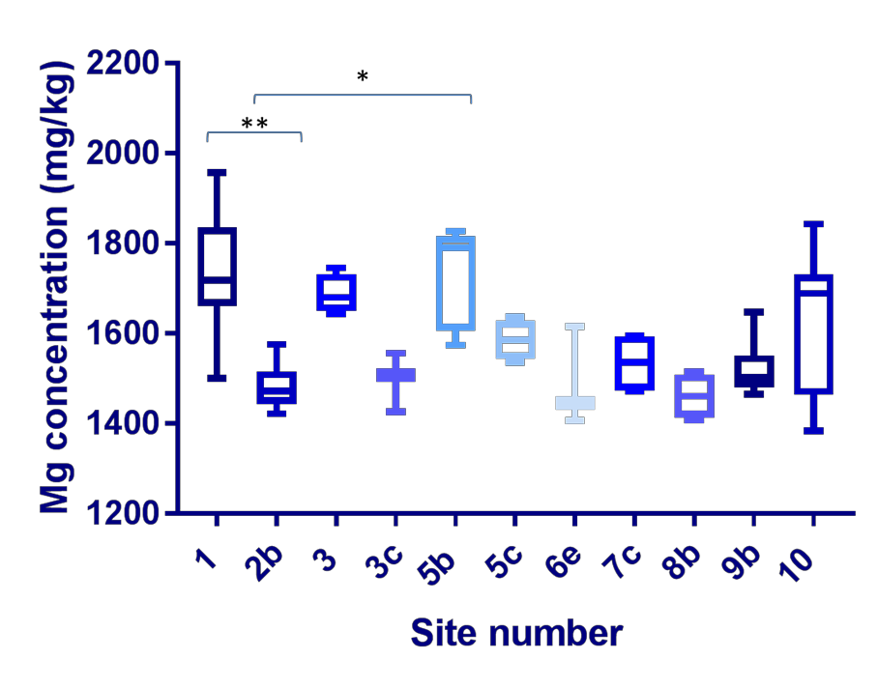

Figure 3.69 – Cross site Magnesium concentration comparison. This box and whisker plot shows Magnesium (Mg) concentrations across the fish from all sites (n=61) (excluding pond Tilapia), (Site 1, 10 samples; Site 2b, 8 samples; site 3, 4 samples; site 3c, 3 samples; site 5b , 6 samples; site 5c, 4 samples; site 6e, 3 samples; site 7c, 4 samples; site 8b, 4 samples; site 9b, 7 samples; site 10, 7 samples), with site 1 and site 5c being the only sites to include Wild Nile Perch (WNP). Mg was measured by Inductively Coupled Plasma Atomic Emission Spectroscopy (analysis conducted by British Geological Survey) and data was analysed using GraphPad Prism. Site 1 has significant higher concentrations than site 2b (P<0.001), site 5b had significantly higher concentrations than site 2b (P<0.05).
The FT ranged from 1384-1908mg/kg whereas the WF ranged from 1407- 1957mg/kg, the mean of the FT was 1592mg/kg the mean of the WF was 1595mg/kg (Figure 3.70).

A

2 2 0 0
M g c o n c e n tr a t io n ( m g / k g )

2 0 0 0

1 8 0 0

1 6 0 0

1 4 0 0

1 2 0 0

S i te n u m b e r
B

2 2 0 0
M g c o n c e n tr a t io n ( m g / k g )

2 0 0 0

1 8 0 0

1 6 0 0

1 4 0 0

1 2 0 0

S i te n u m b e r

Figure 3.70 – Magnesium concentration comparison across the sites in farmed and wild fish. This box and whisker plot shows both the farmed Tilapia/FT (A) and the wild fish/WF (B) comparison across the 6 sites, (site 1, 3FT, 7 WF; site 2b, 4FT, 4WF; site 3, 4FT; site 5b 3FT, 3WF; site 5C, 4WT; Site 6e, 3WT; site 7c, 4FF; site 8b, 4FT, site 9b,4FT,3WT; site 10 3FT,4WF) with site 1 and site 5c being the only sites to include Wild Nile Perch (WNP). There were no wild fish from site 3, 7c and 8b; there were no farmed fish from 3c, 5c and 6e. Magnesium (Mg) was measured by Inductively Coupled Plasma Atomic Emission Spectroscopy (analysis conducted by British Geological Survey) and data was analysed using GraphPad Prism.

3.8.2.5 Potassium

Across all Kenyan fish samples (n=67), the K concentrations ranged from 13601- 27945mg/kg (Figure 3.71), with a mean of 23052mg/kg; sample S1WN3 and sample 8 (FT) had the lowest (13601mg/kg) and sample 30 (PT) had the highest (27945mg/kg). In the FT (n=29), K concentrations ranged from 13601- 25973mg/kg, with a mean of 23312mg/kg; sample 8 had the lowest (13601mg/kg) and sample 58 had the greatest (25973mg/kg). The concentration range in the WT (n=26) was 21004-26864mg/kg, with a mean of 23560mg/kg; sample 10 had the lowest (21004mg/kg) and sample 15 had the highest (26864mg/kg). The concertation range within the PT (n=6) was 20373- 27945mg/kg with a mean of 23090mg/kg; the lowest concentration was found in sample 51 (20373mg/kg) and the highest in sample 30 (27945mg/kg). The range within the WNP (n=6) was 13601-24804mg/kg, with a mean of 20890mg/kg; the lowest concentration was found in sample S1WN3 (13601mg/kg) and the greatest in sample 7 (24804mg/kg).

3 0 0 0 0

2 0 0 0 0
K c o n c e n tr a io n ( m g /k g )

1 0 0 0 0

0

T y p e o f fis h

Figure 3.71- Potassium concentrations across the fish analysed. This box and whisker plot illustrates Potassium (K) concentrations (in milligram/kilogram dry weight; mg/kg) in all fish muscle samples (n=67), farmed Tilapia/FT (n=29), wild Tilapia/WT (n=26), Pond Tilapia/PT (n=6) and wild Nile perch/WNP (n=6). K was measured by Inductively Coupled Plasma Atomic Emission Spectroscopy analysis conducted by British Geological Survey and data was analysed using GraphPad Prism.

3.8.2.5.1 Cross site comparison of Potassium content

A cross site comparison of all 63 fish samples (excluding PT) in this study was preformed (Figure 3.72) from across the 11 sample sites (Site 1, 10 samples; Site 2b, 8 samples; site 3, 4 samples; site 3c, 3 samples; site 5b , 6 samples; site 5c, 4 samples; site 6e, 3 samples; site 7c, 4 samples; site 8b, 4 samples; site 9b, 7 samples; site 10, 7 samples).

The greatest range was found at site 1 (13601-24804mg/kg) and the smallest at site 3 (22200-23374mg/kg).

3 0 0 0 0

2 0 0 0 0
K c o n c e n tr a io n ( m g /k g )

1 0 0 0 0

0

S ite n u m b e r

Figure 3.72 – Cross site Potassium concentration comparison. This box and whisker plot shows Iron (Fe) concentrations across the fish from all sites (n=61) (excluding pond Tilapia), (Site 1, 10 samples; Site 2b, 8 samples; site 3, 4 samples; site 3c, 3 samples; site 5b , 6 samples; site 5c, 4 samples; site 6e, 3 samples; site 7c, 4 samples; site 8b, 4 samples; site 9b, 7 samples; site 10, 7 samples), with site 1 and site 5c being the only sites to include Wild Nile Perch (WNP). Potassium (K) was measured by Inductively Coupled Plasma Atomic Emission Spectroscopy (analysis conducted by British Geological Survey) and data was analysed using GraphPad Prism.

The FT ranged from 13601-25973mg/kg whereas the WF ranged from 13601- 26864mg/kg, the mean of the FT was 23312mg/kg the mean of the WF was 23060mg/kg. In the FT concentrations were significantly higher at site 9b than site 1 (P<0.05) (Figure 3.73).

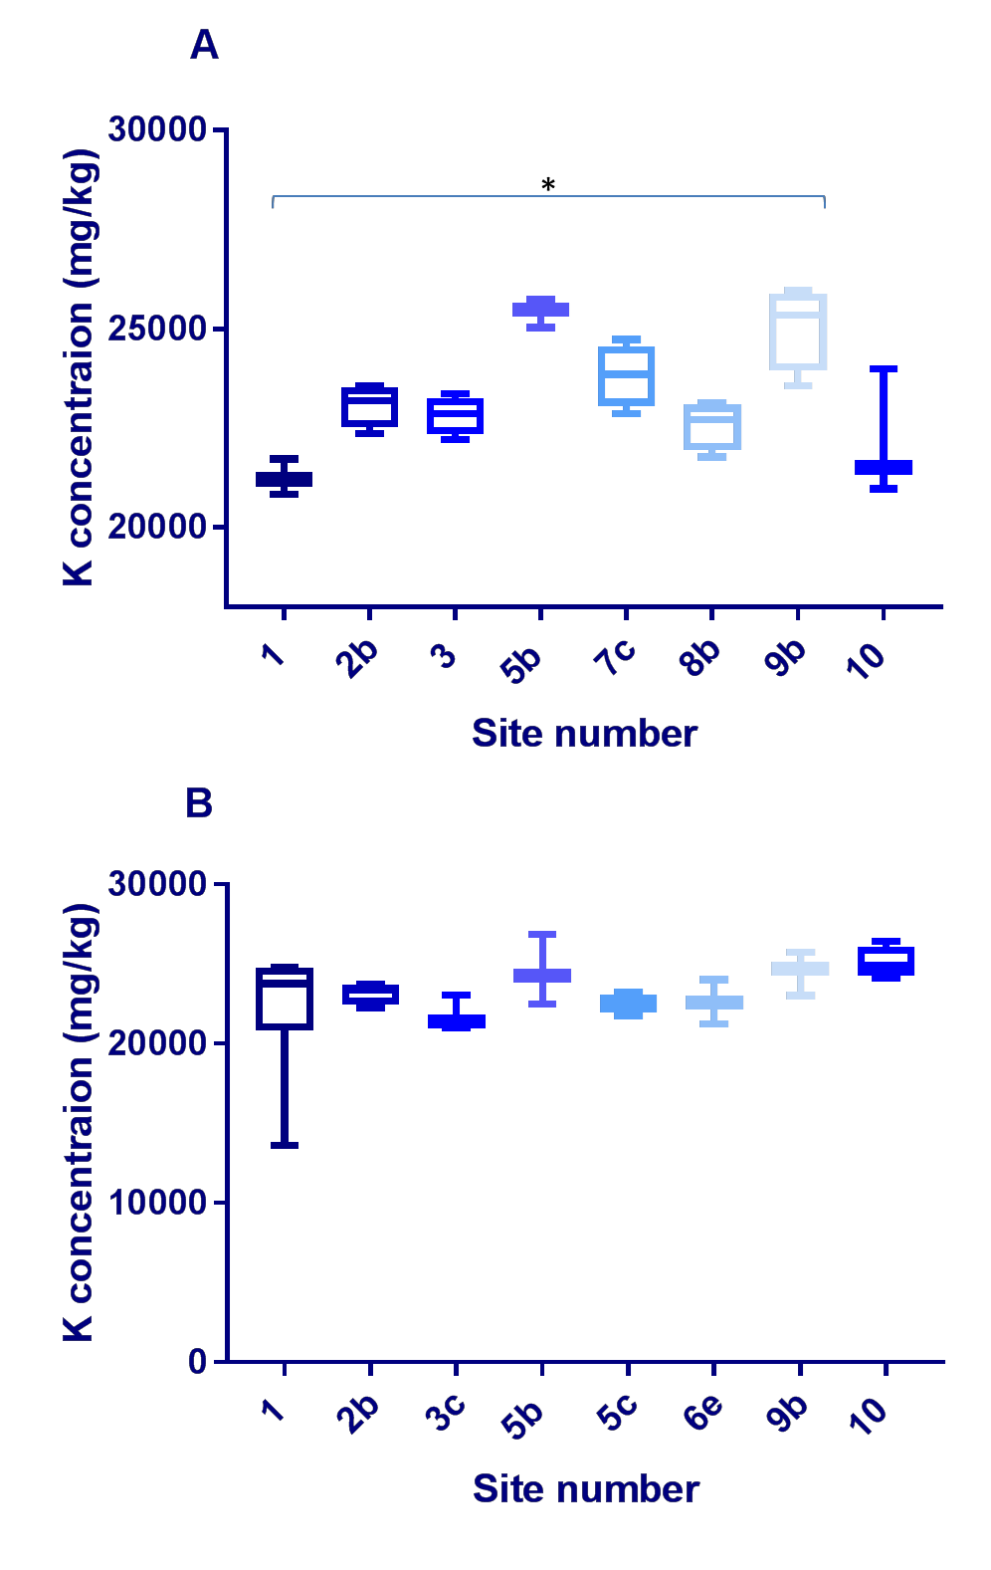

Figure 3.73 –Iron concentration comparison across the sites in farmed and wild fish. This box and whisker plot shows both the farmed Tilapia/FT (A) and the wild fish/WF (B) comparison across the 6 sites, (site 1, 3FT, 7 WF; site 2b, 4FT, 4WF; site 3, 4FT; site 5b 3FT, 3WF; site 5C, 4WT; Site 6e, 3WT; site 7c, 4FF; site 8b, 4FT, site 9b,4FT,3WT; site 10 3FT,4WF) with site 1 and site 5c being the only sites to include Wild Nile Perch (WNP). There were no wild fish from site 3, 7c and 8b; there were no farmed fish from 3c, 5c and 6e. Iron (Fe) was measured by Inductively Coupled Plasma Atomic Emission Spectroscopy (analysis conducted by British Geological Survey) and data was analysed using GraphPad Prism. In the FT concentrations were significantly higher at site 9b than site 1 (P<0.05).

3.8.2.6 Selenium

Across all Kenyan fish samples (n=67), the Se concentrations ranged from 0.27- 1.50mg/kg (Figure 3.74), with a mean of 0.69mg/kg; sample 27 had the lowest (0.27mg/kg) and sample S1WN5 had the highest (1.50mg/kg). In the FT (n=29), concentrations ranged from 0.45-0.84mg/kg, with a mean of 0.58mg/kg; sample
55 and 56 had the lowest (0.45mg/kg) and sample 58 had the greatest (0.84mg/kg). The concentration range in the WT (n=26) was 0.27-1.35mg/kg, with a mean of 0.74mg/kg; sample 27 had the lowest (0.27mg/kg) and sample 46 had the highest (1.35mg/kg). The concertation range within the PT (n=6) was 0.39-0.93mg/kg with a mean of 0.58mg/kg; the lowest concentration was found in sample 49 (0.39mg/kg) and the highest in sample 29 (0.93mg/kg). The range within the WNP (n=6) was 1.06-1.50mg/k, with a mean of 1.23mg/kg; the lowest concentration found in sample 7 (1.06mg/kg) and the greatest in sample S1WN5 (1.50mg/kg). The concentrations In the WNP was significantly higher than in the PT (P<0.01), the WT (P<0.05), FT (P<0.0001) and all fish (P<0.01).

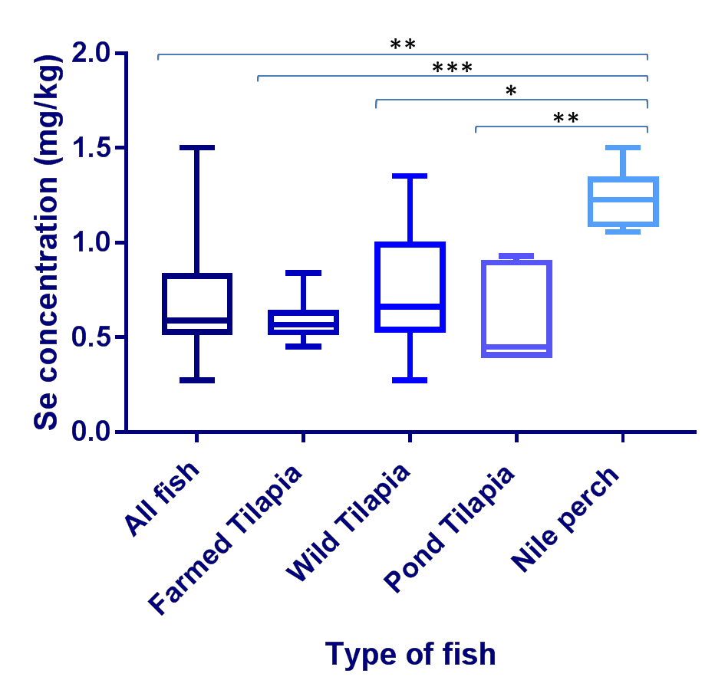

Figure 3.74-Selenium concentrations across the fish analysed. This box and whisker plot illustrates Selenium (Se) concentrations (in milligram/kilogram dry weight; mg/kg) in all fish muscle samples (n=67), farmed Tilapia/FT (n=29), wild Tilapia/WT (n=26), Pond Tilapia/PT (n=6) and wild Nile perch/WNP (n=6). Se was measured by Inductively Coupled Plasma Atomic Emission Spectroscopy analysis conducted by British Geological Survey) and data was analysed using GraphPad Prism. The concentrations in the WNP was significantly higher than in the PT (P<0.01), the WT (P<0.05), FT (P<0.0001) and all fish (P<0.01).

3.8.2.6.1 Cross site comparison of Selenium

A cross site comparison of all 63 fish samples (excluding PT) in this study was preformed (Figure 3.75) from across the 11 sample sites (Site 1, 10 samples; Site 2b, 8 samples; site 3, 4 samples; site 3c, 3 samples; site 5b , 6 samples; site 5c, 4 samples; site 6e, 3 samples; site 7c, 4 samples; site 8b, 4 samples; site 9b, 7 samples; site 10, 7 samples).

The greatest range was found at site 1 (0.48-1.50mg/kg) and the smallest at site 8b (0.45-0.52mg/kg).The concentrations in the fish at site 3c were significantly higher than those found at site 8b (P<0.05).

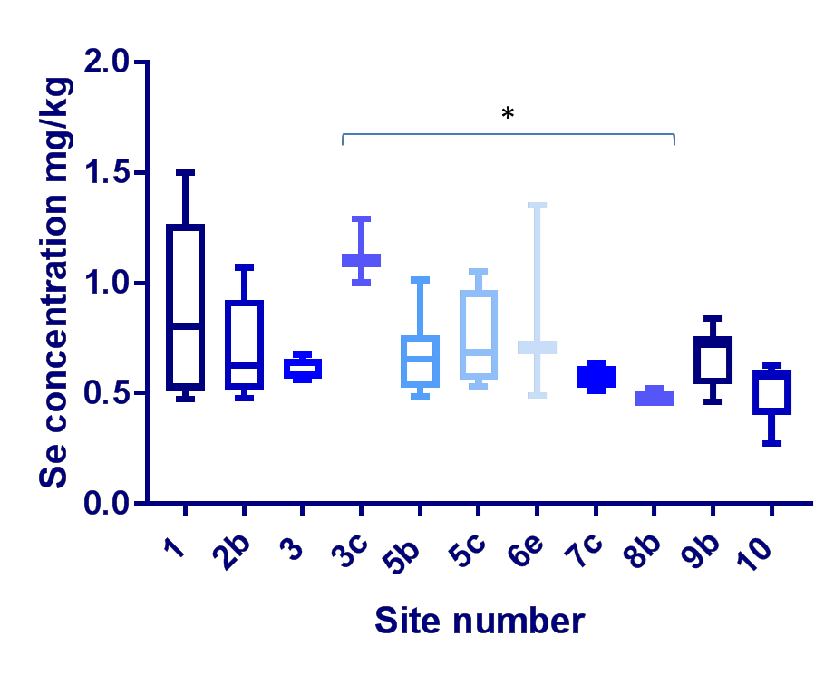

Figure 3.75 – Cross site Selenium concentration comparison. This box and whisker plot shows Selenium (Se) concentrations across the fish from all sites (n=61) (excluding pond Tilapia), (Site 1, 10 samples; Site 2b, 8 samples; site 3, 4 samples; site 3c, 3 samples; site 5b , 6 samples; site 5c, 4 samples; site 6e, 3 samples; site 7c, 4 samples; site 8b, 4 samples; site 9b, 7 samples; site 10, 7 samples), with site 1 and site 5c being the only sites to include Wild Nile Perch (WNP). Se was measured by Inductively Coupled Plasma Atomic Emission Spectroscopy (analysis conducted by British Geological Survey) and data was analysed using GraphPad Prism. The concentrations in the fish at site 3c were significantly higher than those found at site 8b (P<0.05).

The FT ranged from 0.45-0.84mg/kg whereas the WF ranged from 0.27- 1.50mg/kg, the mean of the FT was 0.58mg/kg the mean of the WF was 0.83mg/kg. In the farmed fish the concentrations at site 9b were significantly higher than those found at 8b (P<0.01) (Figure 3.76).

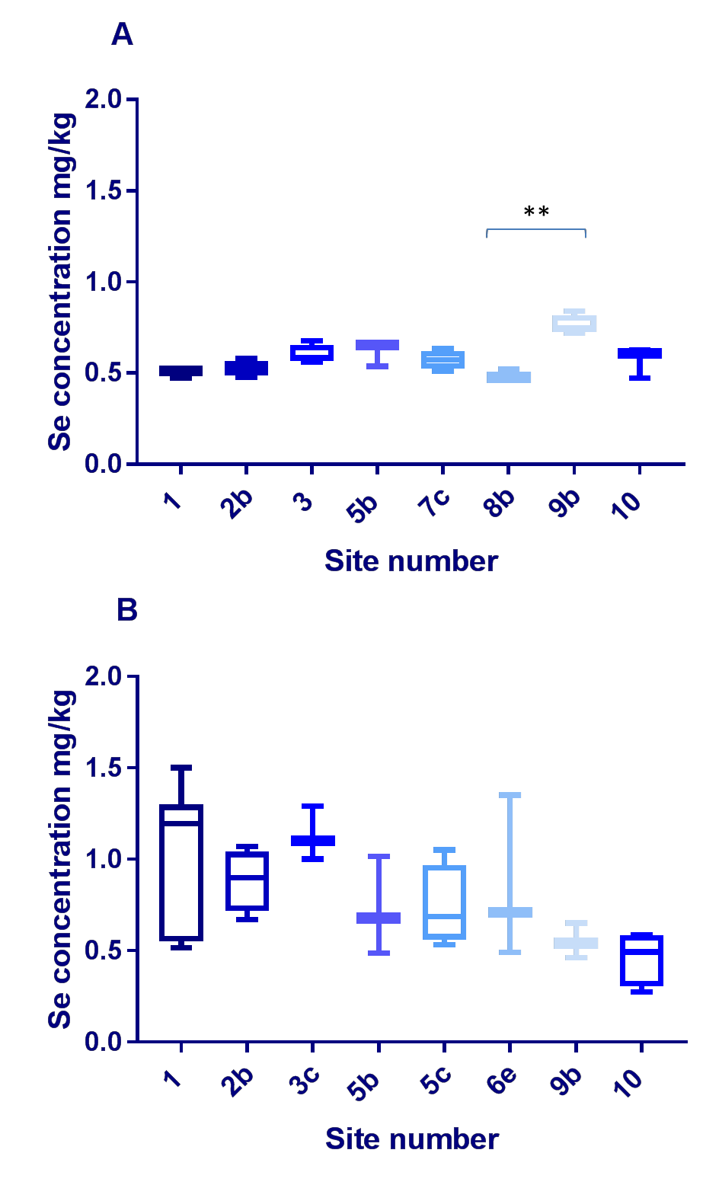

Figure 3.76 – Selenium concentration comparison across the sites in farmed and wild fish. This box and whisker plot shows both the farmed Tilapia /FT (A) and the wild fish/WF (B) comparison across the 6 sites, (site 1, 3FT, 7 WF; site 2b, 4FT, 4WF; site 3, 4FT; site 5b 3FT, 3WF; site 5C, 4WT; Site 6e, 3WT; site 7c, 4FF; site 8b, 4FT, site 9b,4FT,3WT; site 10 3FT,4WF) with site 1 and site 5c being the only sites to include Wild Nile Perch (WNP). There were no wild fish from site 3, 7c and 8b; there were no farmed fish from 3c, 5c and 6e. Selenium (Se) was measured by Inductively Coupled Plasma Atomic Emission Spectroscopy (analysis conducted by British Geological Survey) and data was analysed using GraphPad Prism. In the FT the concentrations at site 9b were significantly higher than those found at 8b (P<0.01).

3.8.2.7 Sodium

Across all Kenyan fish samples (n=67), the Na concentrations ranged from 1246- 3909mg/kg (Figure 3.77), with a mean of 2819mg/kg; S1WN4 had the lowest (1246mg/kg) and sample 2 (FT) had the highest (3909mg/kg). In the FT (n=29), Na concentrations ranged from 2287-3909mg/kg, with a mean of 2880mg/kg; sample 53 had the lowest (2274mg/kg) and sample 2 had the greatest (3909mg/kg).The concentration range in the WT (n=26) was 1797-3619mg/kg, with a mean of 2896mg/kg; sample 62 had the lowest (1797mg/kg) and sample 38 had the highest (3619mg/kg). The concertation range within the PT (n=6) was 2148-2658mg/kg with a mean of 2391mg/kg; the lowest concentration was found in sample 52 (2148mg/kg) and the highest in sample 50 (2658mg/kg). The range within the WNP (n=6) was 1246-3402mg/kg, with a mean of 2464mg/kg, lowest concentration found in SNWN4 (1246mg/kg) and the greatest in 6 (3402mg/kg). The concentrations of the WT were significantly higher than those of the PT (P<0.05).

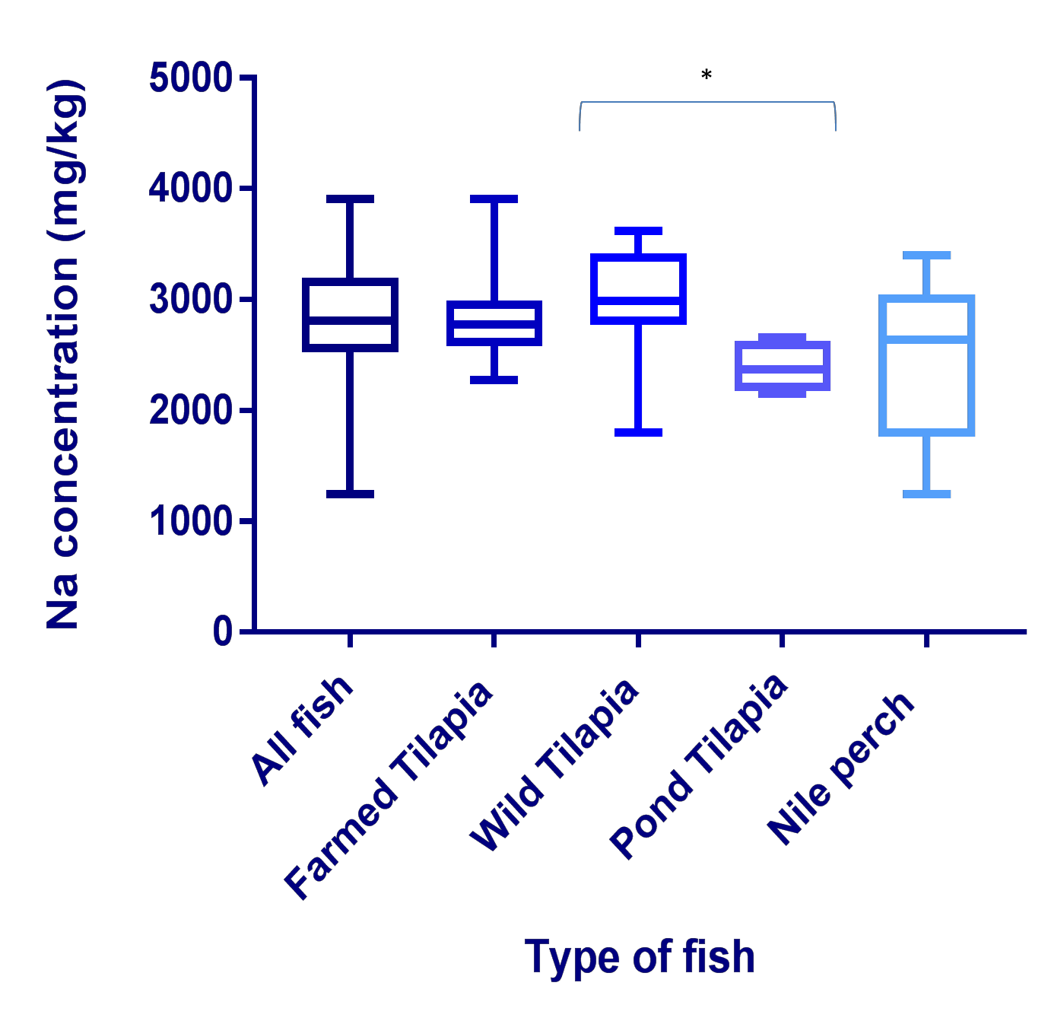

Figure 3.77- Sodium concentrations across the fish analysed. This box and whisker plot illustrates Sodium (Na) concentrations (in milligram/kilogram dry weight; mg/kg) in all fish muscle samples (n=67), farmed Tilapia/FT (n=29), wild Tilapia/WT (n=26), Pond Tilapia/PT (n=6) and wild Nile perch/WNP (n=6). Na was measured by Inductively Coupled Plasma Atomic Emission Spectroscopy analysis conducted by British Geological Survey and data was analysed using GraphPad Prism. The concentrations of the WT were significantly higher than those of the PT (P<0.05).

3.8.2.7.1 Cross site comparison of Sodium content

A cross site comparison of all 63 fish samples (excluding PT) in this study was preformed (Figure 3.78) from across the 11 sample sites (Site 1, 10 samples; Site 2b, 8 samples; site 3, 4 samples; site 3c, 3 samples; site 5b , 6 samples; site 5c,

4 samples; site 6e, 3 samples; site 7c, 4 samples; site 8b, 4 samples; site 9b, 7 samples; site 10, 7 samples).
The greatest range was found at site 1 (1246-3909mg/kg) and the smallest at site 3c (2593-2706mg/kg).

5 0 0 0
N a c o n c e n tr a t io n ( m g / k g )

4 0 0 0

3 0 0 0

2 0 0 0

1 0 0 0

0

S ite n u m b e r

Figure 3.78 – Cross site Sodium concentration comparison. This box and whisker plot shows Sodium (Na) concentrations across the fish from all sites (n=61) (excluding Pond Tilapia), (Site 1, 10 samples; Site 2b, 8 samples; site 3, 4 samples; site 3c, 3 samples; site 5b , 6 samples; site 5c, 4 samples; site 6e, 3 samples; site 7c, 4 samples; site 8b, 4 samples; site 9b, 7 samples; site 10, 7 samples), with site 1 and site 5c being the only sites to include Wild Nile Perch (WNP). Sodium (Na) was measured by Inductively Coupled Plasma Atomic Emission Spectroscopy (analysis conducted by British Geological Survey) and data was analysed using GraphPad Prism.
The FT ranged from 2287-3909mg/kg whereas the WF ranged from 1246- 3619mg/kg, the mean of the FT was 2880mg/kg the mean of the WF was 2883mg/kg. The FT Na concentrations at site 1 were significantly higher than the FT at site 8b (P<0.05). The WF concentrations at site 2b were also significantly higher than the WF at site 9b (P<0.05) (Figure 3.79).

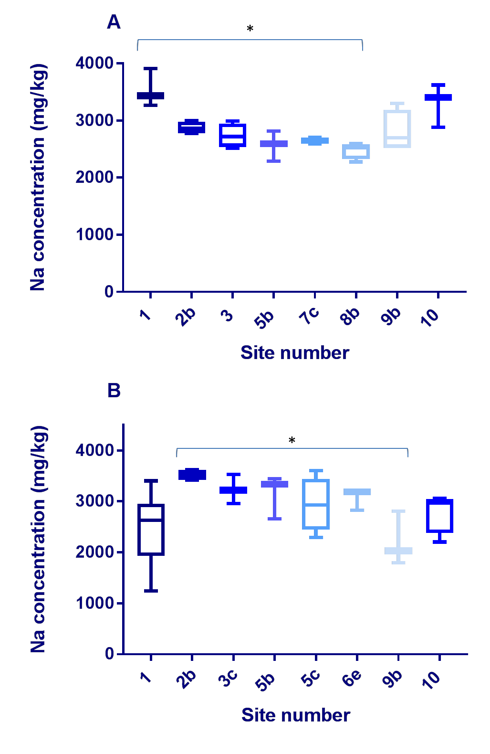

Figure 3.79 – Sodium concentration comparison across the sites in farmed and wild fish. This box and whisker plot shows both the farmed Tilapia/FT (A) and the wild fish/WF (B) comparison across the 6 sites, (site 1, 3FT, 7 WF; site 2b, 4FT, 4WF; site 3, 4FT; site 5b 3FT, 3WF; site 5C, 4WT; Site 6e, 3WT; site 7c, 4FF; site 8b, 4FT, site 9b,4FT,3WT; site 10 3FT,4WF) with site 1 and site 5c being the only sites to include Wild Nile Perch (WNP). There were no wild fish from site 3, 7c and 8b; there were no farmed fish from 3c, 5c and 6e. Sodium (Na) was measured by Inductively Coupled Plasma Atomic Emission Spectroscopy (analysis conducted by British Geological Survey) and data was analysed using GraphPad Prism. The FT Na concentrations at site 1 were significantly higher than the FT at site 8b (P<0.05). The WF concentrations at site 2b were also significantly higher than the WFat site 9b (P<0.05)

3.8.2.8 Zinc

Across all Kenyan fish samples (n=67), the Zn concentrations ranged from 20.05- 75.66mg/kg (Figure 3.80), with a mean of 30.4mg/kg, 47 (WT) had the lowest (22.02mg/kg) and 30 (PT) had the highest (75.66mg/kg). In the FT (n=29), concentrations ranged from 23.91-35.86mg/kg, with the mean of 29.60mg/kg; sample 1 had the lowest (23.91mg/kg) and sample 9 had the greatest concentration (35.86mg/kg). The concentration range in the WT (n=26) was 20.50-41.00mg/kg, with a mean of 28.70mg/kg 47 had the lowest (20.50mg/kg) and 44 had the highest (41.00mg/kg). The range in the PT was 34.50-75.70mg/kg with a mean of 50.60mg/kg; the lowest concentration was found in sample 49 (34.50mg/kg) and the highest was found in sample 30 (75.70mg/kg). The range within the WNP (n=6) was 22.38-65.79mg/kg, with a mean of 31.43mg/kg; the lowest concentration was found in 7 (22.38mg/kg) and the greatest in S1WN3 (65.78mg/kg). The PT concentrations were significantly higher than those of all fish (P<0.01), the FT (P<0.05), the WT (P<0.01) and the WNP (P<0.05).

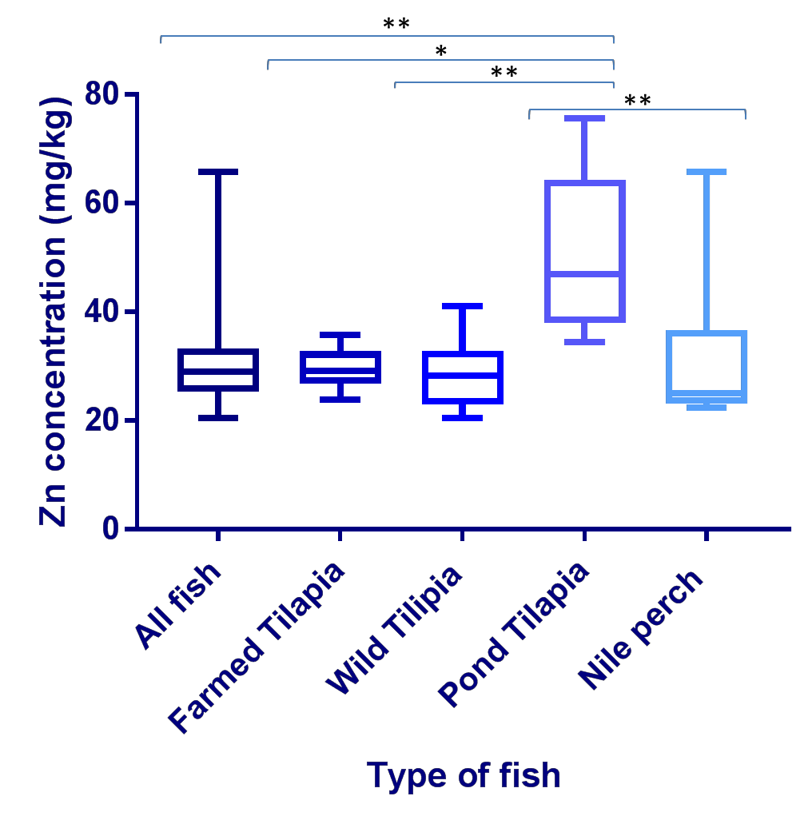

Figure 3.80- Zinc concentrations across the fish analysed. This box and whisker plot illustrates Zinc (Zn) concentrations (in milligram/kilogram dry weight; mg/kg) in all fish muscle samples (n=67), farmed Tilapia/FT (n=29), wild Tilapia/WT (n=26), Pond Tilapia/PT (n=6) and wild Nile perch/WNP (n=6). Zn was measured by Inductively Coupled Plasma Atomic Emission Spectroscopy analysis conducted by British Geological Survey and data was analysed using GraphPad Prism. The PT concentrations were significantly higher than those of all fish (P<0.01), the FT (P<0.05), the WT (P<0.01) and the WNP (P<0.05).

3.8.2.8.1 Cross site comparison of zinc concentrations

A cross site comparison of all 63 fish samples (excluding PT) in this study was preformed (Figure 3.81) from across the 11 sample sites (Site 1, 10 samples; Site

2b, 8 samples; site 3, 4 samples; site 3c, 3 samples; site 5b , 6 samples; site 5c, 4 samples; site 6e, 3 samples; site 7c, 4 samples; site 8b, 4 samples; site 9b, 7 samples; site 10, 7 samples). The greatest range was found at site 1 (22.21- 65.79mg/kg) and the smallest at site 8b (29.0-32.20mg/kg).

8 0
Z n c o n c e n tra t io n ( m g / k g )

6 0

4 0

2 0

0

S ite n u m b e r

Figure 3.81 – Cross site Zinc concentration comparison. This box and whisker plot shows Zinc (Zn) concentrations across the fish from all sites (n=61) (excluding pond Tilapia), (Site 1, 10 samples; Site 2b, 8 samples; site 3, 4 samples; site 3c, 3 samples; site 5b , 6 samples; site 5c, 4 samples; site 6e, 3 samples; site 7c, 4 samples; site 8b, 4 samples; site 9b, 7 samples; site 10, 7 samples), with site 1 and site 5c being the only sites to include Wild Nile Perch (WNP). Zinc (Zn) was measured by Inductively Coupled Plasma Atomic Emission Spectroscopy (analysis conducted by British Geological Survey) and data was analysed using GraphPad Prism.
The FT ranged from 23.91-35.86mg/kg whereas the WF ranged from 20.50- 65.79mg/kg, the mean of the FT was 29.60mg/kg the mean of the WF was 29.70mg/kg (Figure 3.82).

A

8 0
Z n c o n c e n tra t io n ( m g / k g )

6 0

4 0

2 0

0

S ite n u m b e r

B

8 0
Z n c o n c e n tra t io n ( m g / k g )

6 0

4 0

2 0

0

S i te n u m b e r

Figure 3.82 –Zinc concentration comparison across the sites in farmed and wild fish. This box and whisker plot shows both the farmed Tilapia/FT (A) and the wild fish/WF (B) comparison across the 6 sites, (site 1, 3FT, 7 WF; site 2b, 4FT, 4WF; site 3, 4FT; site 5b 3FT, 3WF; site 5C, 4WT; Site 6e, 3WT; site 7c, 4FF; site 8b 4FT; site 9b,4FT,3WT; site 10 3FT,4WF) with site 1 and site 5c being the only sites to include Wild Nile Perch (WNP). There were no wild fish from site 3, 7c and 8b; there were no farmed fish from 3c, 5c and 6e. Zinc (Zn) was measured by Inductively Coupled Plasma Atomic Emission Spectroscopy (analysis conducted by British Geological Survey) and data was analysed using GraphPad Prism.

3.8.3 Vietnamese aquaculture ICP

Aquaculture samples in Vietnam but purchased in the UK were also analysed for heavy metal and essential element content Table 3.83 and 3.84.
The concentrations between the two sets of prawns purchased in different supermarkets were significantly different for Ca, Cu and Na (Figure 3.85, 3.86 and 3.87).

Sample number | Al | As | Cs | Cr | Co | Hg | Ni | Rb | Sr | Sn | Ti
47 | 3 | 1.43 | 0.00 | 0.29 | 0.01 | 0.06 | 0.16 | 0.58 | 16.6 | 0.62 | 0.2
48 | 3 | 0.80 | 0.00 | 0.47 | 0.01 | 0.03 | 0.28 | 0.58 | 13.2 | 0.86 | 0.1
49 | 1 | 0.77 | 0.00 | 0.15 | 0.01 | 0.07 | 0.08 | 0.73 | 8.17 | 0.31 | 0.1
50 | 6 | 1.57 | 0.00 | 0.31 | 0.01 | 0.07 | 0.16 | 0.56 | 14.3 | 0.60 | 0.2
51 | 7 | 1.21 | 0.01 | 0.29 | 0.01 | 0.05 | 0.14 | 0.60 | 24.2 | 1.42 | 0.3
52 | 2 | 0.77 | 0.00 | 0.29 | 0.01 | 0.07 | 0.45 | 0.96 | 22.0 | 0.18 | 0.1
53 | 6 | 0.89 | 0.01 | 0.13 | 0.01 | 0.05 | 0.05 | 1.12 | 15.1 | 0.59 | 0.2
54 | 5 | 0.83 | 0.00 | 0.89 | 0.02 | 0.04 | 0.11 | 1.07 | 24.0 | 0.18 | 0.2
55 | 1 | 0.68 | 0.01 | 0.39 | 0.02 | 0.05 | 0.09 | 1.14 | 23.7 | 0.77 | 0.4
57 | 1 | 0.07 | 0.07 | 0.32 | 0.01 | 0.02 | 0.16 | 18.8 | 2.45 | 0.21 | 0.1
58 | 1 | 0.06 | 0.07 | 0.32 | 0.01 | 0.02 | 0.11 | 21.6 | 2.30 | 0.13 | 0.1
59 | 1 | 0.11 | 0.07 | 2.01 | 0.02 | 0.02 | 0.15 | 20.3 | 2.21 | 0.26 | 0.1
60 | 1 | 0.07 | 0.07 | 0.16 | 0.01 | 0.02 | 0.07 | 20.2 | 2.19 | 0.12 | 0.1
61 | 2 | 0.06 | 0.07 | 0.42 | 0.01 | 0.02 | 0.15 | 21.4 | 2.16 | 0.46 | 0.2

Table 3.83-Heavy metal analysis of aquaculture products from Vietnam. Fourteen aquaculture products, farmed in Vietnam and purchased in the UK, were analysed by Inductively coupled plasma mass spectrometry 37 elements (including heavy metals) were bellow detection; this table shows the results for the following : Aluminium (Al), Arsenic (As), Barium (Ba) , Caesium (Cs) ,Chromium (Cr), Cobalt (Co), Mercury (Hg), Nickel (Ni), Rubidium (Rb), Strontium (Sr), Tin (Sn) and Titanium (Ti). Samples 47-51 were prawns from supermarket A, samples 52-55 were prawn from supermarket B and samples 57-61 were Basa from supermarket A.

Sample number | Ca | Cu | Fe | Mg | K | Na | Se | Zn
47 | 2247 | 14.4 | 7.4 | 1204 | 2813 | 32044 | 1.26 | 49.6
48 | 1786 | 14.9 | 8.0 | 906 | 2317 | 27313 | 0.50 | 46.0
49 | 1163 | 10.1 | 4.7 | 1225 | 3122 | 24986 | 0.60 | 50.0
50 | 1997 | 12.7 | 14.2 | 1125 | 2570 | 29788 | 1.56 | 50.1
51 | 2826 | 18.5 | 12.9 | 1156 | 2762 | 30650 | 1.28 | 50.3
52 | 3312 | 5.87 | 7.1 | 1163 | 2897 | 14977 | 0.72 | 51.3
53 | 2533 | 11.1 | 8.3 | 1294 | 3882 | 20204 | 0.75 | 46.4
54 | 3085 | 5.18 | 18.6 | 1081 | 3313 | 21633 | 0.89 | 47.6
55 | 4058 | 9.15 | 8.7 | 1185 | 3677 | 25273 | 0.96 | 48.3
57 | 531 | 2.59 | 8.1 | 930 | 8163 | 880 | 0.62 | 16.8
58 | 529 | 1.86 | 7.9 | 1098 | 9450 | 958 | 0.70 | 14.6
59 | 493 | 3.42 | 29.9 | 1043 | 8783 | 1033 | 0.68 | 16.6
60 | 509 | 2.50 | 6.8 | 1062 | 8639 | 926 | 0.79 | 14.9
61 | 481 | 10.1 | 15.0 | 1038 | 9325 | 1086 | 0.69 | 15.7

Table 3.84 -Essential element analysis of aquaculture product from Vietnam. Fourteen aquaculture products, farmed in Vietnam and purchased in the UK, were analysed by Inductively coupled plasma mass spectrometry 37 elements (including heavy metals) were bellow detection; this table shows the results for the following : Calcium (Ca), Copper (Cu), Iron (Fe), Magnesium (Mg), Potassium (K), Selenium (Se), Sodium (Na) and Zinc (Zn). Samples 47-51 were prawns from supermarket A, samples 52-55 were prawn from supermarket B and samples 57-61 were Basa from supermarket A.

3.8.3.1 Were there any differences in the nutritional content of the prawns?
Ca concentrations were significantly higher in prawns purchased from supermarket B than supermarket A (P<0.05) with a mean of 3247mg/kg versus 2004mg/kg respectively (Figure 3.85).

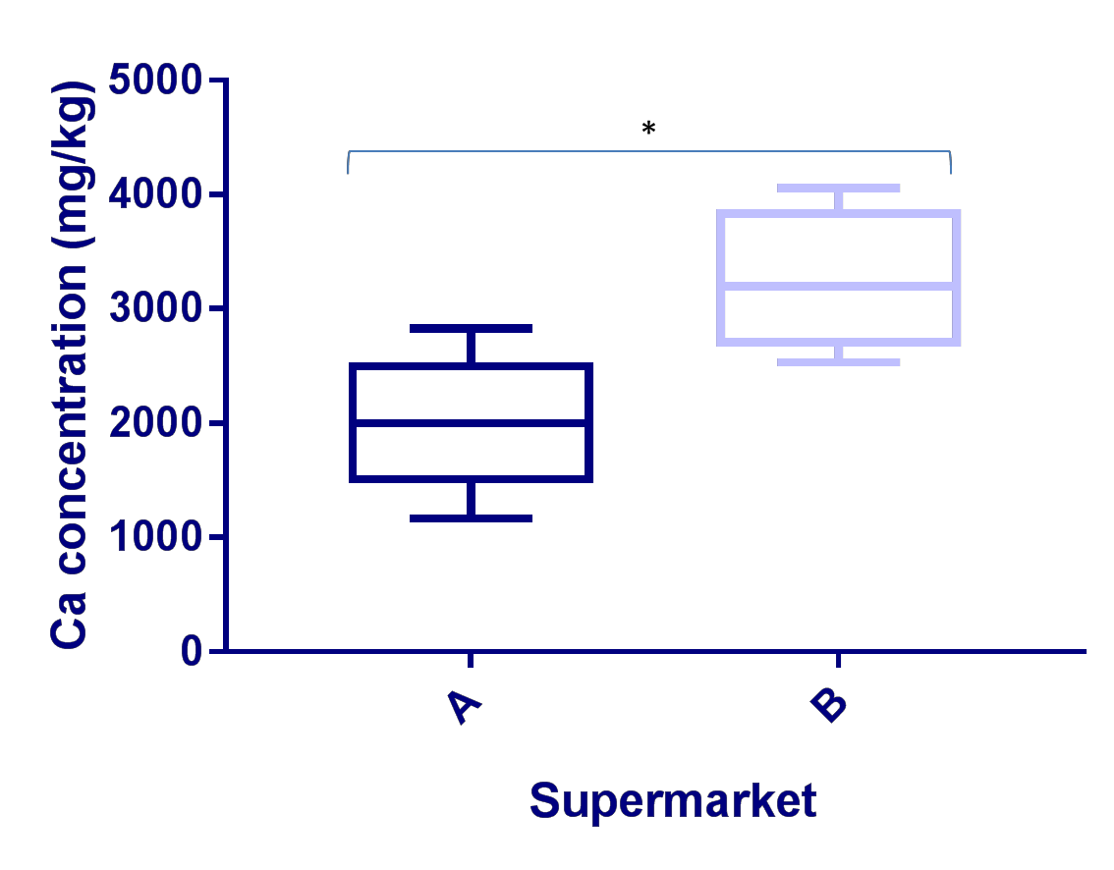

Figure 3.85 – Comparison of Calcium concentrations in prawns purchased. This box and whisker plot illustrates Calcium (Ca) concentrations (in milligram/kilogram dry weight; mg/kg) in prawn muscle samples, Prawn from supermarket A (n=5) and Prawn from supermarket B (n=4). Ca was measured by Inductively Coupled Plasma Atomic Emission Spectroscopy conducted by British Geological Survey and data was analysed using GraphPad Prism. Ca concentrations were significantly higher in prawns purchased from supermarket B than supermarket A (P<0.05) using Mann-Whitney test.
Cu concentrations were significantly higher in prawns purchased from supermarket A than supermarket B (P<0.05) with means of 14.12mg/kg and 7.83mg/kg respectively (Figure 3.86).

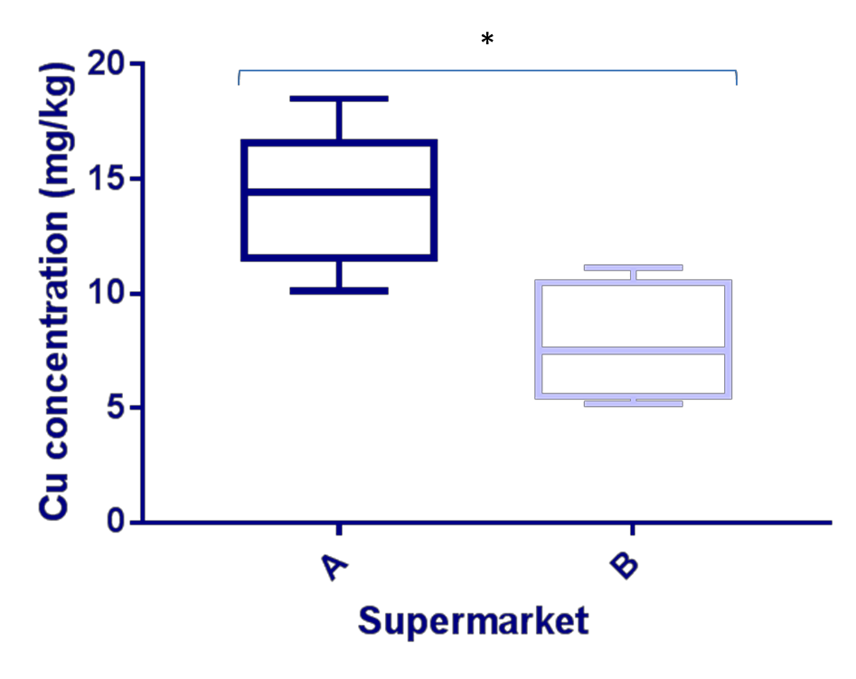

Figure 3.86 –Comparisons of the Copper concentrations in prawns. This box and whisker plot illustrates Copper (Cu) concentrations (in milligram/kilogram dry weight; mg/kg) in prawn muscle samples, Prawn from supermarket A (n=5) and Prawn from supermarket B (n=4). Ca was measured by Inductively Coupled Plasma Atomic Emission Spectroscopy analysis conducted by British Geological Survey and data was analysed using GraphPad Prism. Cu concentrations were significantly higher in prawns purchased from supermarket A than supermarket B (P<0.05) using Mann-Whitney test.

Na concentrations were significantly higher in prawns purchased from supermarket A than supermarket B (P<0.05), with means of 28956mg/kg and 20521.8mg/kg respectively (Figure 3.87).

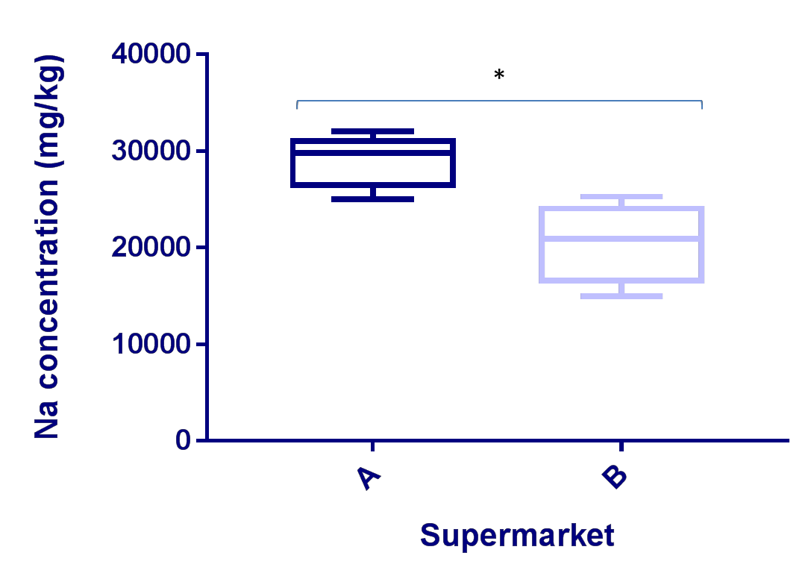

Figure 3.87 –Comparison of the Sodium concentrations in prawns. This box and whisker plot illustrates Sodium (Na) concentrations (in milligram/kilogram dry weight; mg/kg) in prawn muscle samples, Prawn from supermarket A (n=5) and Prawn from supermarket B (n=4). Na was measured by Inductively Coupled Plasma Atomic Emission Spectroscopy analysis conducted by British Geological Survey and data was analysed using GraphPad Prism. Cu concentrations were significantly higher in prawns purchased from supermarket A than supermarket B (P<0.05) using Mann-Whitney test.

Fish food

- samples of fish food were collected and analysed by ICP analysis and by mercury analysis, 37 elements were either below detection levels (Table 3.88).

Element | Fish meal 1  concentration (mg/kg) | Fish meal 2a  concentration (mg/kg) | Fish meal 2b  concentration (mg/kg)
Al | 240 | 108 | 858
As | 0.53 | 0.70 | 0.56
Ba | 49.76 | 8.45 | 87.18
Ca | 22143 | 20572 | 12804
Co | 0.75 | 1.18 | 1.07
Cr | 5.39 | 2.06 | 30.59
Cu | 33.86 | 34.47 | 26.57
Fe | 383 | 432 | 2103
Hg | 0.01 | 0.01 | 0.01
K | 14066 | 13404 | 14477
Mg | 759 | 3345 | 4019
Na | 2949 | 5171 | 759
Ni | 5.46 | 4.25 | 15.11
Rb | 19.79 | 12.97 | 18.45
Se | 0.65 | 1.63 | 0.43
Sn | 0.35 | 0.37 | 0.10
Sr | 110.78 | 26.21 | 145.54
Ti | 8.71 | 3.42 | 43.69
Zn | 158.23 | 341.60 | 74.57

Table 3.88 – Table showing elemental concentrations of fish food samples. This table shows the Aluminium (Al), Arsenic (As), Barium (Ba), Calcium (Ca), Cobalt (Co), Chromium (Cr), Copper (Cu), Iron (Fe), Mercury (Hg), Potassium(K), Magnesium (Mg), Sodium (Na), Nickel (Ni), Rubidium (Rb) Selenium (Se), Tin (Sn), Strontium (Sr), Titanium (Ti) and Zinc (Zn), concentrations in the three fish meal samples. Elements were measured by Inductively Coupled Plasma Atomic Emission Spectroscopy analysis conducted by British Geological Survey, 37 elements were below levels of detection.

Do elemental concentrations vary between seasons?

A comparison of the data from the elemental analyses was made between the Kenyan fish sampled in May and November 2018.
The means of Fe, Rb, Sr and Zn were not significantly different in the fish between the May and November 2018 sampling periods (see figure 3.89).

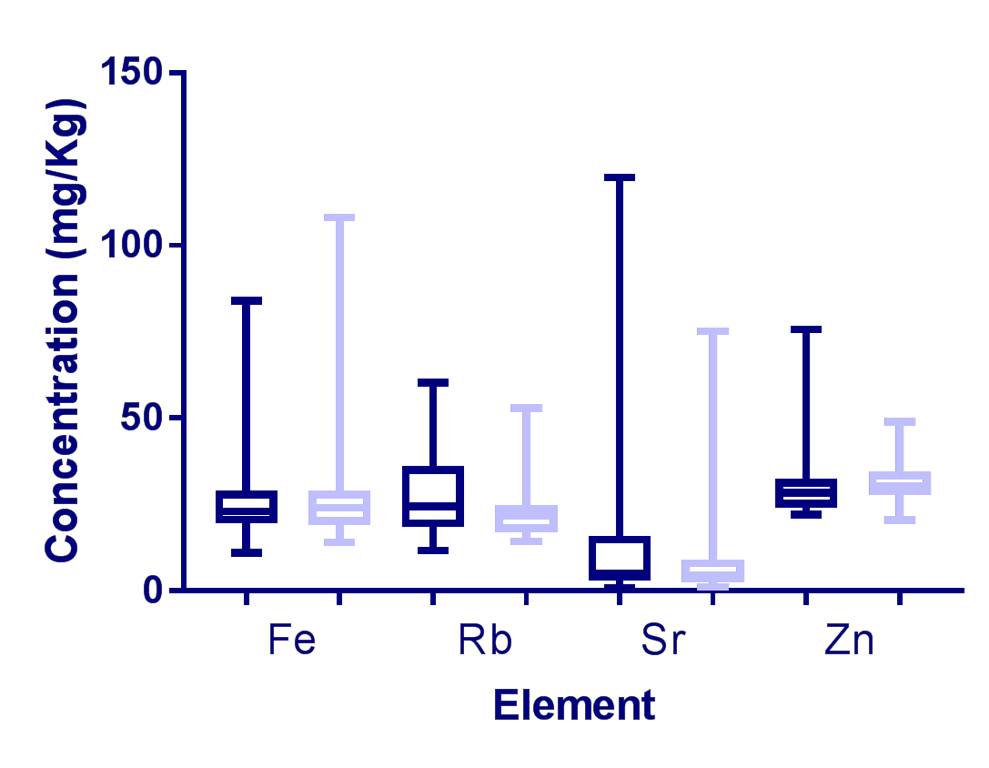

Figure 3.89 – Comparison of Iron, Rubidium, Strontium and Zinc concentrations in fish muscle tissue from May and November 2018. This shows a comparison between the Iron (Fe) Rubidium (Rb) Strontium (Sr) and Zinc (Zn) concentrations (milligram/kilogram; mg/kg dry weight) in fish muscle tissues from May 2018 (dark blue) and November 2018 (light blue). Elements were measured by Inductively Coupled Plasma Atomic Emission Spectroscopy analysis (analysis conducted by British Geological Survey) and data was analysed using GraphPad Prism; the levels of the elements found in the fish were not statistically different between the two sampling time frames using unpaired t test.

The means of Na between the different groups of fish were not significantly different between the seasons. However, the means of the Mg were significantly different (<0.0001) in the fish between the May and November 2018 sampling periods (see figure 3.90).

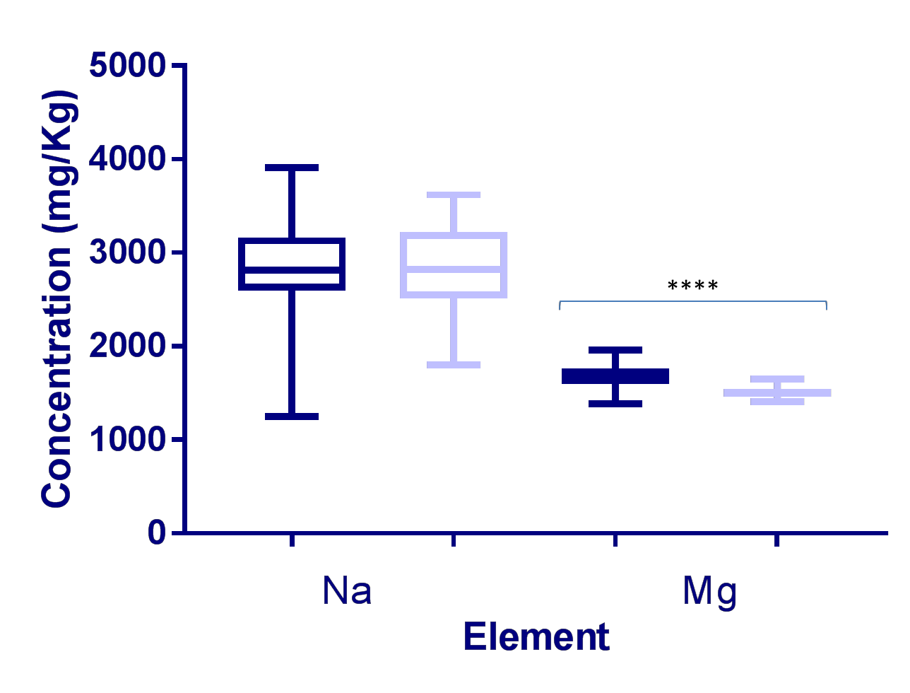

Figure 3.90 – Comparison of sodium and magnesium concentrations in fish muscle tissue from May and November 2018. This shows a comparison between the Sodium (Na) and magnesium (Mg) concentrations (milligram/kilogram; mg/kg dry weight) in fish muscle tissues from May 2018 (dark blue) and November 2018 (light blue). Elements were measured by Inductively Coupled Plasma Atomic Emission Spectroscopy analysis (analysis conducted by British Geological Survey) and data was analysed using GraphPad Prism; the levels of the elements found in the fish were not statistically different for Na but were for Mg (P<0.0001) using an unpaired t test.

The means of Ca and K were not significantly different in the fish between the May and November 2018 sampling periods (see figure 3.91).

3 0 0 0 0

2 0 0 0 0
C o n c e n tr a t io n ( m g / K g )

1 0 0 0 0

0
C a K
E le m e n t

Figure 3.91 – Comparison of Calcium and Potassium in fish muscle tissue from May and November 2018. This shows a comparison between the Calcium (Ca) and Potassium (K) concentrations (milligram/kilogram; mg/kg dry weight) in fish muscle tissues from May 2018 (dark blue) and November 2018 (light blue). Elements were measured by Inductively Coupled Plasma Atomic Emission Spectroscopy analysis (analysis conducted by British Geological Survey) and data was analysed using GraphPad Prism; the levels of the elements found in the fish were not statistically different between the two sampling time frames using unpaired t test.

The means of Al concentrations were not significantly different but the means of Cu were (P<0.05) in the fish between the May and November 2018 sampling periods (see figure 3.92).

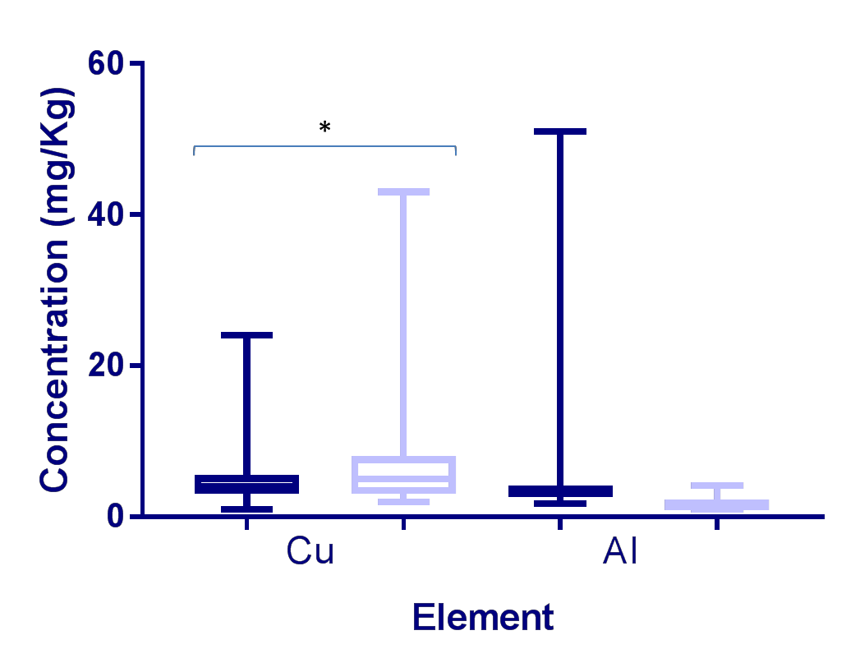

Figure 3.92 – Comparison of Copper and Aluminium in fish muscle tissue from May and November 2018. This shows a comparison between the Copper (Cu) and Aluminium (Al) concentrations (milligram/kilogram; mg/kg dry weight) in fish muscle tissues from May 2018 (dark blue) and November 2018 (light blue). Elements were measured by Inductively Coupled Plasma Atomic Emission Spectroscopy analysis (analysis conducted by British Geological Survey) and data was analysed using GraphPad Prism; means of Al concentrations were not significantly different but the means of Cu were (P<0.05) using an unpaired t test.

The means of Ni were not significantly different but the means of Se were (P<0.05) in the fish between the May and November 2018 sampling periods (see figure 3.93).

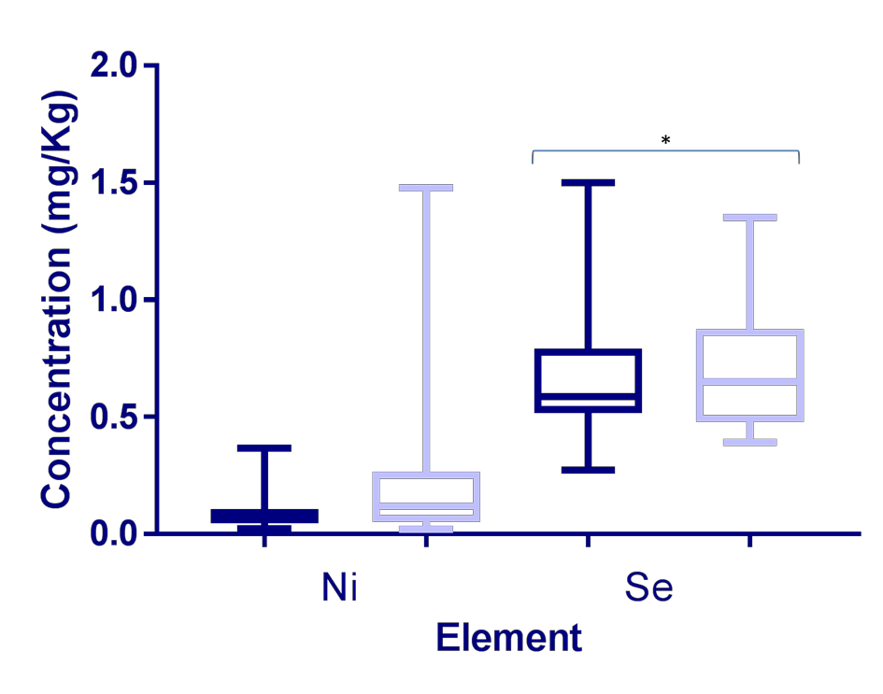

Figure 3.93 – Comparison of Nickel and Selenium in fish muscle tissue from May and November 2018. This shows a comparison between the Nickel (Ni) and Selenium (Se) concentrations (milligram/kilogram; mg/kg dry weight) in fish muscle tissues from May 2018 (dark blue) and November 2018 (light blue). Elements were measured by Inductively Coupled Plasma Atomic Emission Spectroscopy analysis (analysis conducted by British Geological Survey) and data was analysed using GraphPad Prism; the means of Ni were not significantly different but the means of Se were (P<0.05) using an unpaired t test.

The means of Hg ,Co and As were not significantly different in the fish between the May and November 2018 sampling periods (see figure 3.94).

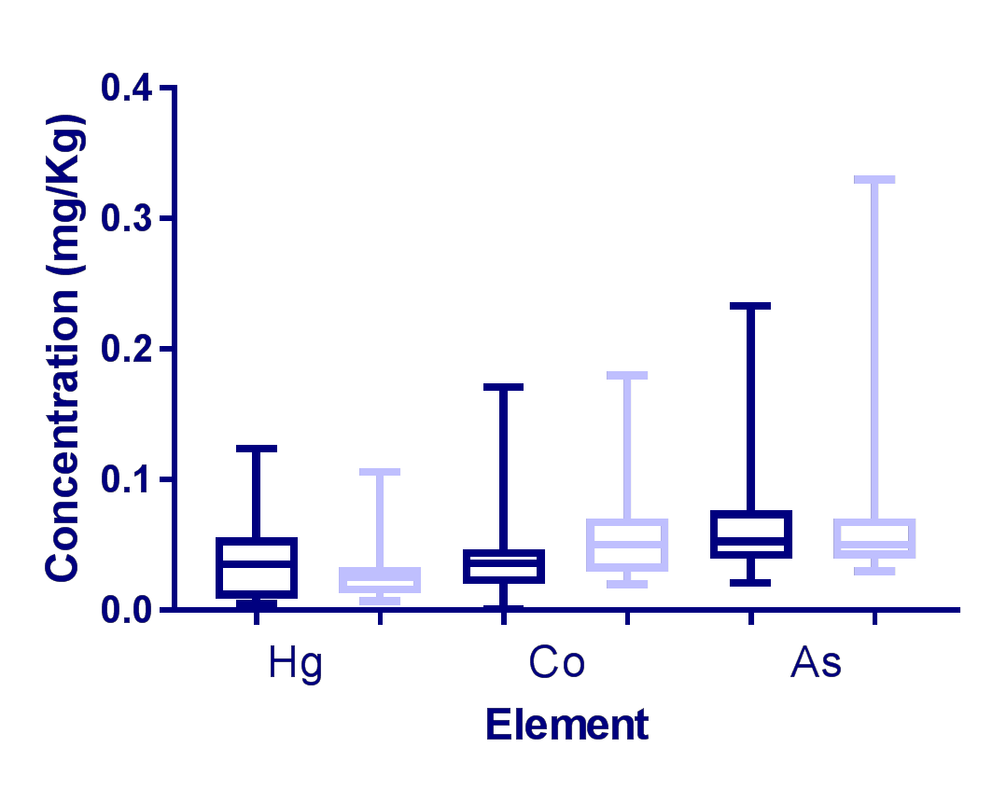

Figure 3.94 – Comparison of Mercury, Cobalt, and Arsenic in fish muscle tissue from May and November 2018. This shows a comparison between the Mercury (Hg), Cobalt (Co) and Arsenic (As) concentrations (milligram/kilogram; mg/kg dry weight) in fish muscle tissues from May 2018 (dark blue) and November 2018 (light blue). Elements were measured by Inductively Coupled Plasma Atomic Emission Spectroscopy analysis (analysis conducted by British Geological Survey) and data was analysed using GraphPad Prism; the levels of the elements found in the fish were not statistically different between the two sampling time frames using an unpaired t test.
The means of Ti were not significantly different but the means of Cr (P<0.05) and Sn (P<0.01) were in the fish between the May and November 2018 sampling periods (see figure 3.95).

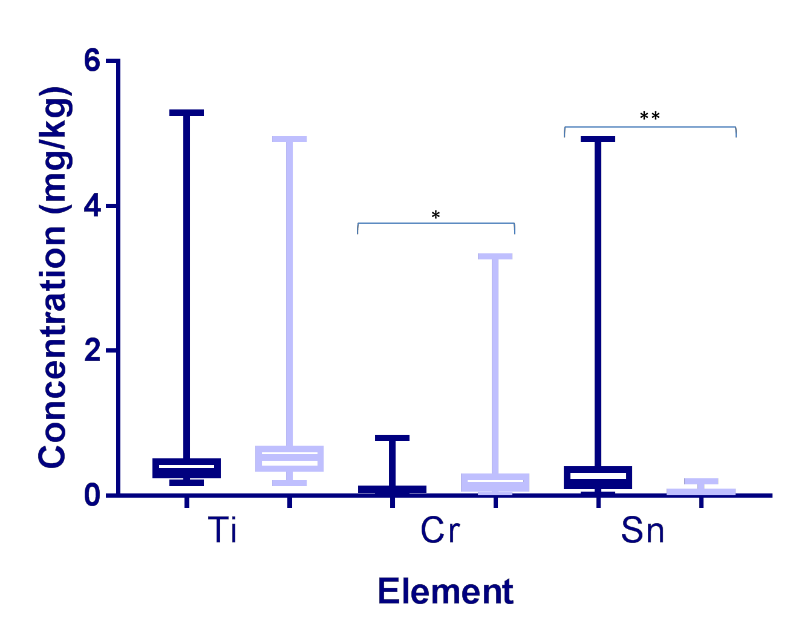

Figure 3.95 – Comparison of Titatinium , Chromium and Tin in fish muscle tissue from May and November 2018. This shows a comparison between the Titanium (Ti), Chromium (Cr) and Tin (Sn) concentrations (milligram/kilogram; mg/kg dry weight) in fish muscle tissues from May 2018 (dark blue) and November 2018 (light blue). Elements were measured by Inductively Coupled Plasma Atomic Emission Spectroscopy analysis (analysis conducted by British Geological Survey) and data was analysed using GraphPad Prism; the levels of the elements found in the fish were not statistically different between the two sampling time frames. The means of Ti were not significantly different but the means of Cr (P<0.05) and Sn (P<0.01) were using an unpaired t test.

The means of Ba were not significantly different in the fish between the May and November 2018 sampling periods (see figure 3.96).

2 5

2 0
C o n c e n tra t io n ( m g / k g )

1 5

1 0

5

0
B a

E le m e n t

Figure 3.96 – Comparison of Barium in fish muscle tissue from May and November 2018. This shows a comparison between the Barium (Ba) concentrations (milligram/kilogram; mg/kg dry weight) in fish muscle tissues from May 2018 (dark blue) and November 2018 (light blue). Elements were measured by Inductively Coupled Plasma Atomic Emission Spectroscopy analysis (analysis conducted by British Geological Survey) and data was analysed using GraphPad Prism; the levels of the elements found in the fish were not statistically different between the two sampling time frames using an unpaired t test.

Does the fish weight impact on the elemental concentration?

The Tilapia samples from Kenya were spilt into pre-harvest (<250g), harvest (250-300g) and post-harvest size (>300g), this was done for both WT and FT. The elemental concentrations of Al,(Figure 3.97) As (Figure 3.98), Rb (Figure 3.99)
, (Ti figure 3.100) Fe (Figure 3.101) and Zn (Figure 3.102) were statistically different between weight categories and there were compared.

Aluminium
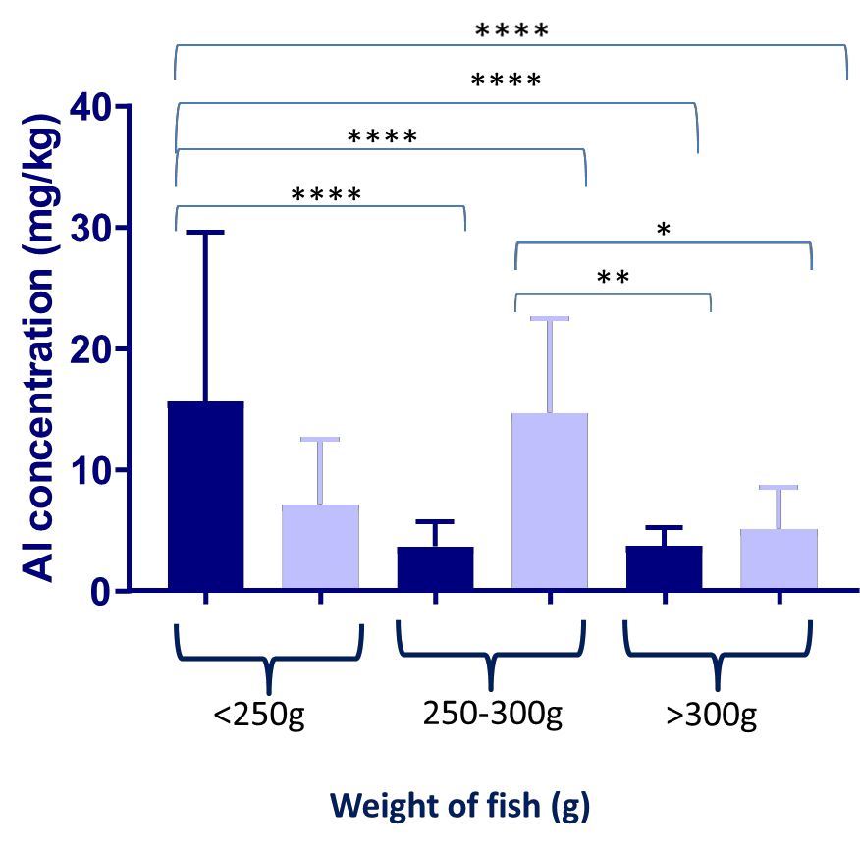

Figure 3.97- Comparison of Al concentrations across wild and farmed Tilapia of different weights. The graph shows Aluminium (Al) concentrations (in milligram/kilogram dry weight; mg/kg) in all fish muscle samples, farmed Tilapia (FT) (n=31, dark blue) and wild Tilapia (WT) (n=26, light blue). The fish are split by weights (g, grams); <250g pre-harvest (FT n=5, WT n=10), 250-300g optimal harvest size (FT n=3, WT n=3) and >300g larger than harvest size (FT n=20, WT n=16) (Ngugi et al., 2007). Al was measured by Inductively Coupled Plasma Atomic Emission Spectroscopy analysis (analysis conducted by British Geological Survey) and data was analysed using GraphPad Prism. Between <250g and 250-300g FT, <250g FT and 250-300g WT, between <200g and >300g FT, and between <250g FT and >300g WT, there was a highly significant difference between the Al concentrations within the fish muscle (P < 0.0001). There were also statistical differences between the 250-300g WT and >300g FT (P<0.01) and the 250-300g WT and >300g WT (P>0.05).

Arsenic
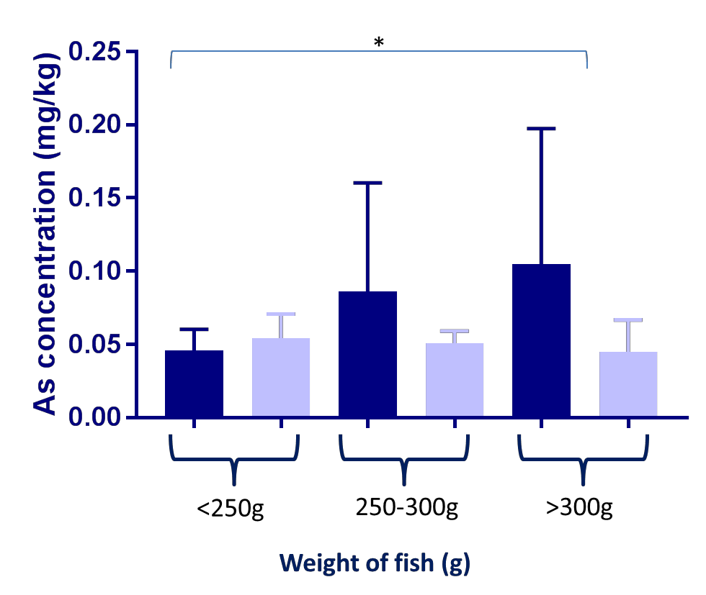

Figure 3.98- Comparison of As concentrations across wild and farmed Tilapia of different weights. The graph shows Arsenic (As) concentrations (in milligram/kilogram dry weight; mg/kg) in all fish muscle samples, farmed Tilapia (FT) (n=31, dark blue) and wild Tilapia (WT) (n=26, light blue). The fish are split by weights (g, grams); <250g pre-harvest (FT n=5, WT n=10), 250-300g optimal harvest size (FT n=3, WT n=3) and >300g larger than harvest size (FT n=20, WT n=16) (Ngugi et al., 2007). As was measured by Inductively Coupled Plasma Atomic Emission Spectroscopy analysis (analysis conducted by British Geological Survey) and data was analysed using GraphPad Prism. Between <250g and >300g FT there was a statistical difference (P<0.01).

Rubidium
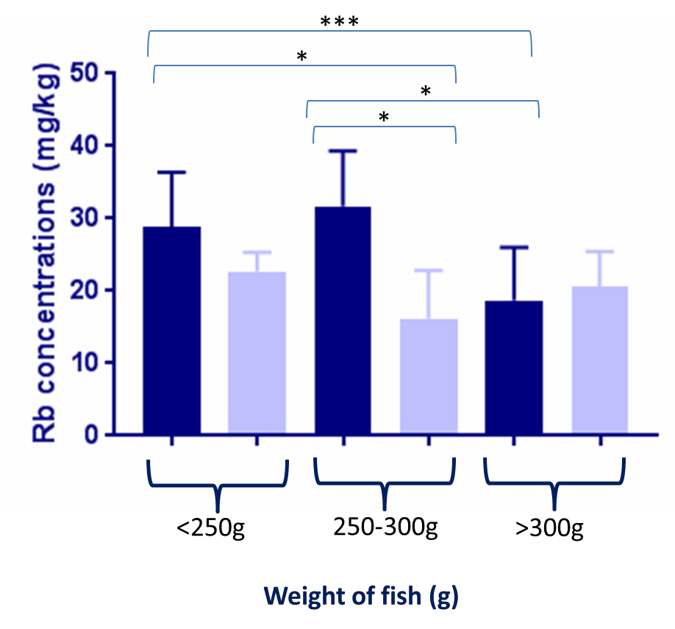

Figure 3.99- Comparison of Rb concentrations across wild and farmed Tilapia of different weights. The graph shows Rubidium (Rb) concentrations (in milligram/kilogram dry weight; mg/kg) in all fish muscle samples, farmed Tilapia (FT) (n=31, dark blue) and wild Tilapia (WT) (n=26, light blue). The fish are split by weights (g, grams); <250g pre-harvest (FT n=5, WT n=10), 250-300g optimal harvest size (FT n=3, WT n=3) and >300g larger than harvest size (FT n=20, WT n=16) (Ngugi et al., 2007). Rb was measured by Inductively Coupled Plasma Atomic Emission Spectroscopy analysis (analysis conducted by British Geological Survey) and data was analysed using GraphPad Prism. Between <250g and >300g FT there was a significant difference (P<0.001). And between the 250-500g and >300g FT , the <200g FT and the 250-300g WT and between the 250-300g FT and WT there was a statistical difference (P<0.01).

Titanium
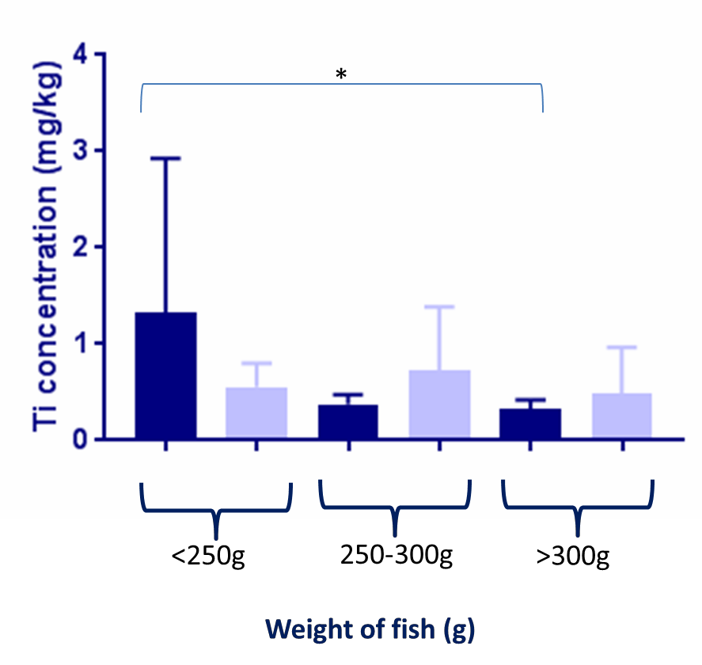

Figure 3.100- Comparison of Ti concentrations across wild and farmed Tilapia of different weights. The graph shows Titanium (Ti) concentrations (in milligram/kilogram dry weight; mg/kg) in all fish muscle samples, farmed Tilapia (FT) (n=31, dark blue) and wild Tilapia (WT) (n=26, light blue). The fish are split by weights (g, grams); <250g pre-harvest (FT n=5, WT n=10), 250-300g optimal harvest size (FT n=3, WT n=3) and >300g larger than harvest size (FT n=20, WT n=16) (Ngugi et al., 2007). As was measured by Inductively Coupled Plasma Atomic Emission Spectroscopy analysis (analysis conducted by British Geological Survey) and data was analysed using GraphPad Prism. Between <250g and >300g FT there is a statistical difference (P<0.01).

3.8.6.6 Iron
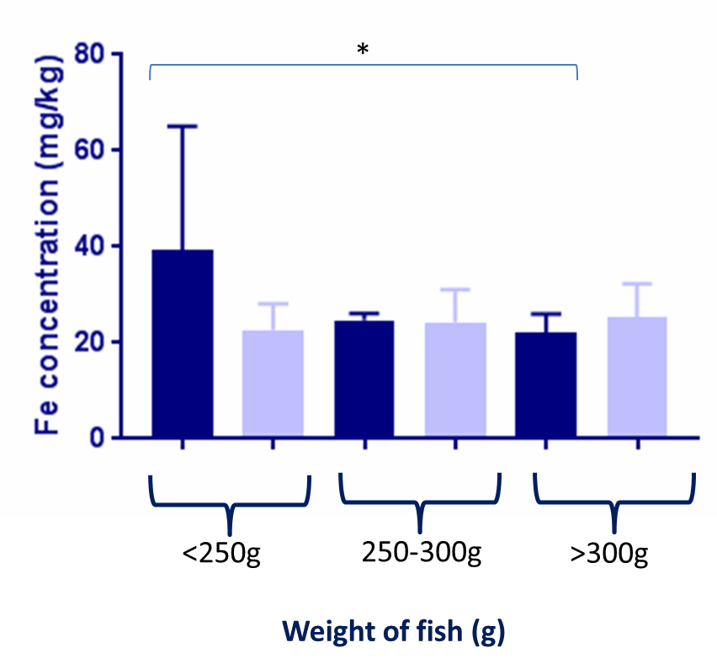

Figure 3.101- Comparison of Fe concentrations across wild and farmed Tilapia of different weights. The graph shows Iron (Fe) concentrations (in milligram/kilogram dry weight; mg/kg) in all fish muscle samples, farmed Tilapia (FT) (n=31, dark blue) and wild Tilapia (WT) (n=26, light blue). The fish are split by weights (g, grams); <250g pre-harvest (FT n=5, WT n=10), 250-300g optimal harvest size (FT n=3, WT n=3) and >300g larger than harvest size (FT n=20, WT n=16) (Ngugi et al., 2007). Fe was measured by Inductively Coupled Plasma Atomic Emission Spectroscopy analysis (analysis conducted by British Geological Survey) and data was analysed using GraphPad Prism. Between the <250g and >300g FT there was a significant difference in concentrations (P< 0.05).

3.8.6.5 Zinc
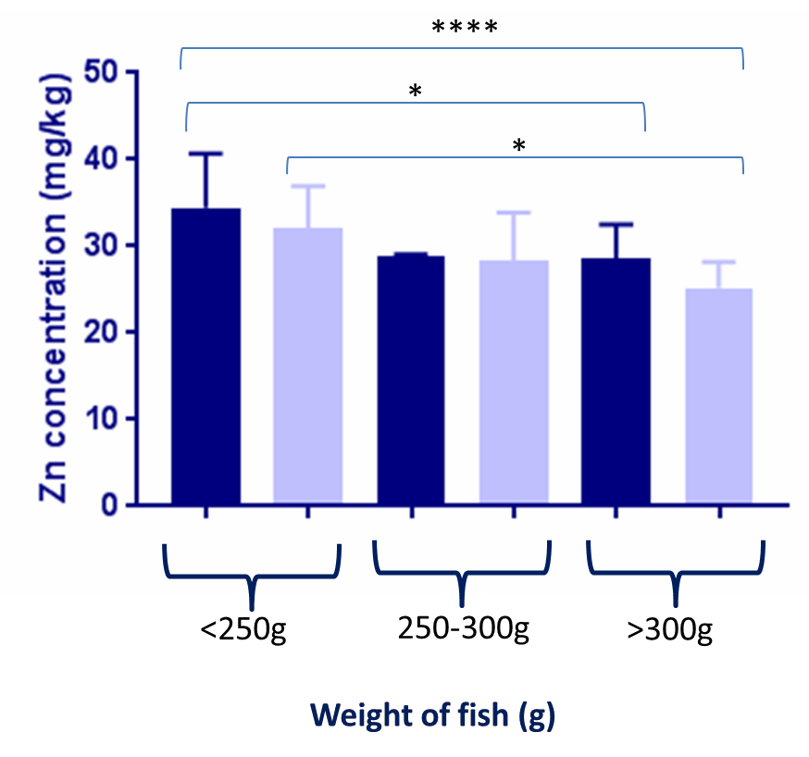

Figure 3.102- Comparison of Zn concentrations across wild and farmed Tilapia of different weights. The graph shows Zinc (Zn) concentrations (in milligram/kilogram dry weight; mg/kg) in all fish muscle samples, farmed Tilapia (FT) (n=31, dark blue) and wild Tilapia (WT) (n=26, light blue). The fish are split by weights (g, grams); <250g pre-harvest (FT n=5, WT n=10), 250-300g optimal harvest size (FT n=3, WT n=3) and >300g larger than harvest size (FT n=20, WT n=16) (Ngugi et al., 2007). Zn was measured by Inductively Coupled Plasma Atomic Emission Spectroscopy analysis (analysis conducted by British Geological Survey) and data was analysed using GraphPad Prism. Between <250g and >300g FT and between <250g and >300g WT there was a significant difference in concentrations (P>0.05). Between <250g FT and >300g WT there was also a significant difference (P < 0.0001).

Discussion
Aquaculture is the fastest growing food sector worldwide (Subasinghe et al., 2009) with 76% of the top 10 global exporters being situated in developing countries (FAO, 2018b). Therefore it is important that the sector grows in a safe and sustainable manner, especially within the leading exporters.
Anthropogenic pollutants, including antibiotics, plastics and heavy metals, can all contaminate the aquatic environment (Christensen et al., 2006, Moore, 2008, Jezierska and Witeska, 2006) and potentially end up within aquaculture products destined for human consumption. These pollutants pose a threat to the aquatic organisms and also the consumers.
This study looked at two aquaculture global producers. Kenya, a growing aquaculture producer who are looking to increase both their local and export market, and focussed focussing their freshwater production which is predominantly farmed in Lake Victoria. This study aimed to investigate the quality of the fish, both farmed and wild, within Lake Victoria, and the impact of aquaculture on the ecosystem. Vietnam is also a growing aquaculture producer and is already the fourth largest aquaculture producer globally, with the UK being one of the largest importers of Vietnamese aquaculture products. This study aimed to investigate the quality and safety of the aquaculture product farmed in Vietnam available for purchase in the UK.

4.1 How does the environment impact on fish?

Temperature, pH and presence of elements in the water have all been shown to have an effect on fish elemental concentrations (Sissener and Bjørndal, 2005, Sokolova and Lannig, 2008, Guinotte and Fabry, 2008). This study included both WF and FT from Kenya, However, when investigating correlations between the

water parameters and effects on fish only FT were used. As WF are able to migrate and are not constricted like FT, they may not give a true representation of how the local environment at the sites studied can affect the fish. In addition, the WF analysed as part of this study are larger (on average) than the farmed fish analysed suggesting they may be older, which would mean they may have had more exposure to pollutants. The Vietnamese fish were not included in this part of the study

4.1.1 How does water temperature effect fish size?

Changes in water temperature have been shown to impact the marine environment, fish productivity including growth, fish migration patterns and to have effect on predator prey relationships (Sissener and Bjørndal, 2005). Changes in the aquatic temperature are more likely to affect the fish in farms rather than their wild counterparts, due to farmed fish being more susceptible to stressors as a result of the highly intense nature of the farming (Brander, 2007). The fixed nature of the farms means it is important to monitor the effects of temperature change on the fish.
The present study found no correlation between fish weights and the water temperature at the site they were farmed. This may be due to fish at different sites being different ages; the weights of the farmed fish used in this study ranged from 155-653g, supporting the probability that they were of various ages. In addition, other factors including food availability, space and oxygen content of the water also affect fish growth. However, it is important to note that this study did not measure growth over time and did not encompass fish age, therefore in further studies it would be important to age fish and take repeat measurements to assess if variations in water temperatures at different sites have an effect on fish growth.

4.1.1.2 Does water temperature affect the elemental concentrations in the fish?

Aquatic temperature plays a key role in the maintenance of not only normal physiological processes of fish, but can also have an effect on the toxicity of metals to these organisms, with increases in temperatures shown to increase solubility and the bioavailability of metals, including Hg and Cu (Sokolova and Lannig, 2008). Higher water temperatures have been shown to correlate with the accumulation of Hg in Salmo gairdneri and Cu in Lepomis macrochirus across the whole body of the fish (Sokolova and Lannig, 2008). In contrast, higher temperatures have been shown to increase Cs elimination in Salmo trutta (Sokolova and Lannig, 2008). A study in small Nile Tilapia (4-6g) concluded that MeHg uptake was increased with high temperatures, low oxygen levels and in fast water flow systems (Wang et al., 2011).
In this study, it was observed that at sites where the water temperature was higher the concentration of Hg and Cu in the fish farmed there was lower than those farmed at sites with lower water temperature, which is opposite to what previous studies had found (Sokolova and Lannig, 2008) . In the present study this was also observed for Ba, Ca, Co, Cs, Fe, Mg, Na, Ni, Sr, Sn and Ti. Interestingly, at those sites with higher temperatures there was a correlation with higher levels of As, Al, Cr, Se and Zn in the fish muscle tissue, which is what previous studies have suggested for Cu and Hg (Sokolova and Lannig, 2008). Although the few studies conducted (Wang et al., 2011) suggest that higher water temperatures would increase the accumulative concentrations of Hg, this appears to not be the case in this study. This could be due to numerous factors, including that the fish species in some of the previous studies were not the same as analysed here and the only study in Tilapia analysed MeHg and in much smaller fish. In addition, the
published studies analysed element concentrations across the whole fish whereas this study focused on concentrations in the muscle.
The Cs concentrations observed in this study follow the same trend as previous studies (Sokolova and Lannig, 2008). This could suggest that at sites with higher temperatures Cs elimination increased, resulting in lower concentration of Cs in the muscle than observed in fish farmed at sites with lower water temperatures. This increased excretion may also have led to the trends observed for Ba, Ca, Co, Cs, Fe, Mg, Na, Ni, Sr, Sn and Ti.
It was observed in this study that at the majority of sites with lower water temperatures the Cu concentrations in the fish muscle were also lower when compared to sites with higher water temperatures. However, the greatest range and concentration of Cu was observed at the site with the lowest mean temperature. This difference could also be due to the diet, as at different sites they may be fed different diets; for example in the fish meal tested the range of Cu is 27-34mg/kg. Fish could also be fed or consume different quantities of feed, which may result in more Cu being incorporated into the fish. Conversely, a study in salmon found that higher water temperature correlated with lower Cu concentrations (Mance, 2012).
A limitation in this study is that we do not know the oxygen content or the rate of water flow; these variables could be impacting on element uptake and bioaccumulation. Water temperatures are only available for some sites (1, 2b, 3, 5b, 8b, 9b and 10) and there are varying depths, time of sampling and sample numbers per site.

How do changes in pH affect the fish?

Although a lot of work has been done on how temperature change will affect marine environments, little has been done on how climate change will affect aquatic biochemistry. While it has been seen that marine organisms can adapt to changes in temperatures, the expected changes in pH due to climate change are higher than any other pH change that has been recorded (Guinotte and Fabry, 2008).
The increase in hydrogen ions which lowers the pH causes a reduction in carbonate ions including calcium carbonate, which can significantly impact the Ca concentrations available (Guinotte and Fabry, 2008). In the present study, there is a positive trend between the pH of the water at the sites and the Ca concentrations, which correlates to previous literature (Guinotte and Fabry, 2008).
At the sites where pH was greater, there were higher concentrations of Cu in the muscle from fish harvested at that site. This contradicts one study in Nile Tilapia which found that Cu accumulation in fish liver gills and muscle increased when the pH was lower (Çoǧun and Kargın, 2004). This difference may be due to the size of the Tilapia used (13.7 ± 1.74g) which were a lot smaller than the fish used in the present study. This may suggest that pH affects Cu concentrations in the fish tissue relative to fish size.
Overall, there was no correlation between Ni concentrations in fish tissue and the pH of the water at the site, However, it is worth noting that fish from site 1 (pH 7.92) had a larger range (0.11-0.37mg/kg Ni) in comparison to the other sites and the highest concentration (0.37mg/kg).
One study in carp fingerlings found the concentrations of Ni in fish to be significantly higher at higher pHs (Karthikeyan et al., 2007). The lack of correlation observed within this study could be due to species and age differences. Further

limitations of this study are that water pH was not measured for all the sites and fingerlings from the different hatcheries in Kenya were not included in the study. In addition, actual depths of each of the fish cages at the farms used in this study were not measured.

Does water elemental concentration have an effect on the fish?

Generally higher elemental concentrations in the aquatic environment lead to higher concentrations in the organisms living in that environment (Jezierska and Witeska, 2006). However, it should be noted that the water is unlikely to be the only source of any element. Potential other sources include feed and sediment. In farmed fish, which exhibit inquisitive behaviour towards parts of their cages, there is the potential to ingest pollutants, including metals, through such behaviour. The accumulation of these elements would also vary depending on fish species, age, size and how long they had been exposed to these elements (Jezierska and Witeska, 2006).
In the present study, as the elemental concentrations in the water increased for Ba, K, Rb, Se and Zn the concentrations in the fish muscle were generally lower. The opposite was seen for As, Co, Cr, Cu, Pb, Sn and Ti.
Contrary to findings for most other elements, one study has shown Rb concentrations in the muscle to be higher than that of the liver (Agusa et al., 2005), suggesting that Rb bioaccumulates in muscle. The Rb concentrations of the water were lowest at site 7c However, muscle from fish at this site had the highest concentrations of Rb observed, which were substantially higher than levels in the water. This could indicate that the accumulation of Rb in the tissue is chronic and has increased over time, however this cannot be concluded as the sampling for

this study was only conducted at each site once. In order to confirm this finding, we would need to assess the concentration of Rb in the fish muscle tissue during fish growth.
One study in Tilapia showed that the liver accumulated high concentration of Co, Cu and Zn, the stomach had higher levels of Fe and Mn than other tissues and that the muscles contained the lowest of Co, Cr, Cu, Fe, Mn, Ni, Sr and Zn (Rashed, 2001). From this it could be concluded that the concentrations of these elements in the muscle are not representative of the whole fish as levels will vary depending on the tissue sites sampled. However, the muscle is the main source of food when consumers are eating fish, therefore although the concentrations of these elements are likely to be lower in the muscle than in any other part of the fish from a human health perspective it is important to consider these concentrations. In addition any further use of the fish waste, including the liver, is important given the bioaccumulation of certain elements. For example, in those counties where fish waste is used in other livestock industries (Shabani et al., 2018) or for pet food manufacturing there is the potential to introduce pollutants such as heavy metals into the diet (Davies et al., 2017).
It can be concluded that the As, Co, Cr, Cu, Pb, Sn and Ti concentrations in the fish muscle are potentially due to the concentrations of these elements in the environment. However, there could be several other factors affecting this; for example different foods may be used at the different sites which could have varying elemental concentrations. It would be worth noting that the food is also likely to impact the water elemental concentrations as food not ingested would break down over time. It could also be concluded that the sites with lower concentrations of these elements could be suitable for fish farming, as other than
Cu the rest of these elements are heavy metals which have no or little biological

role in fish and in humans. However, further investigation would be needed involving measuring elemental concentrations and fish muscle concentrations over time at the same site.
However, there are multiple limitations as this study was only conducted at each of the sites once and therefore trends for the sites cannot be predicted, as the elemental concentration is only seen at one point in time. Also the fish age will have an effect on elemental concentrations as those exposed to environmental conditions for a longer period of time will exhibit more bioaccumulation. There are also several factors that affect the bioaccumulation in fish including the feeding patterns, the ages of the fish and the lipid content of the fish (Eneji et al., 2011).

Does water quality have an effect on antibiotic concentrations?

In aquaculture, antibiotics are usually incorporated into the food pellets, and are used prophylactically. Higher rates of antibiotics are used in aquaculture than other agricultural industries due to a higher pathogenic load in the aquatic environment, potentially leading to higher levels of antibiotic resistance (Naylor and Burke, 2005). In this study we tested for the following antibiotic residues; β- lactams, Cephalosporines, Macrolides, Tetracyclines, Sulphonamides, Aminoglycosides, Quinolones, Amphenicoles and Polypeptides.
A study in Rainbow trout investigated the absorption of oxytetracyline at different water temperatures and concluded that there were higher absorption and elimination rates at increased water temperatures. The concentrations were highest in the bile and liver followed by serum and then muscle (Björklund and Bylund, 1990). However, in this study at sites with higher water temperatures the percentage of fish positive for antibiotic residues decreased; this may be because

of species differences between Tilapia and Rainbow trout or because the muscle was analysed rather than the bile or liver. This could indicate that antibiotics could be present in other parts of the fish that were not tested, for example the liver.
General hydrolysis rates for tetracycline have been shown to increase as the pH and temperature of the water increased which follows Arrhenius relationships (Loftin et al., 2008). This may imply that if the hydrolysis increases in the water there would be less antibiotic available for uptake. With regards to pH, this trend can be seen in the present study; in general at sites with higher pH there was a greater percentage of fish positive for antibiotics. However, the published study (Loftin et al., 2008) was lab based, and does not take into consideration the biological processes occurring in fish, making a direct comparison between the two studies more difficult.

Do the water conditions affect the fish quality?

With regards to water conditions, fish farmed in water of a higher pH had more fish positive for antibiotic residues. This could indicate that fish farmed in water of lower pH are healthier, requiring less antibiotic treatment, and that there are therefore less chances of antibiotic residues being present. However, at sites where the water was a higher pH, there were also greater concentrations of Cu in the fish muscle tissues at the sites, which is an essential element in both fish and humans. However, there are multiple other factors involved as the pH was only measured once at each site, in further studies it would be recommended to measure the pH over time at the different sites and test the fish over time for antibiotic residues and Cu concentrations.
As temperature increased across the sites in this study the concentration of Hg, Cu Ca, Co, Cs, Fe, Mg, Ti, Ni, Sr, Ba, Na and Sn decreased. With five of these Cu,

Ca, Fe, Mg and Na are essential elements, certain levels present within the fish would represent optimal levels for the fish but also a good source of these elements for the consumer. However, Hg, Co, Cs, Ti, Ni, Sr, Ba and Sn are non- essential elements, and all can be toxic so you would not want these present in fish.

Variability in fish size

Fish growth can be dependent on various factors including water temperature, food availability, photoperiod and dissolved oxygen content. Tilapia are very tolerant to low dissolved oxygen concentrations which makes them very resilient for farming However, hypoxia can result in growth reduction (Richards, 2011).
In this study there was a positive correlation between the length and the weight of the fish (R2= 0.69), both farmed and wild. When analysing the FT and WF separately, the correlation was lost for the FT (R2= 0.37) but not the WF (R2= 0.91). This reflect the WF are likely to be older, whilst FT are reared for one growing season and then culled and sent to market.

Does fish size have an impact on the elemental levels?

As the FT increased in weight there was significantly lower Al content within their muscle tissue, particularly between the pre-harvest size (<200g) and the harvest size (200-300g) and between the pre-harvest size and the post-harvest size (>300g). This is similar to the Rb concentrations as there is a significant difference between pre- and post-harvest size fish, and between harvest and post-harvest size fish. A similar trend is also seen for Ti, Zn and Fe as there were significantly lower concentrations between the pre-harvest and the post-harvest size FT.

Contradictory to this, as the FT weight increased the concentration of As increases; this is statistically significant between the pre-harvest and the post-harvest fish.
In the WF, there was no significant difference between the As, Ti, Rb and Fe concentrations between the different sized fish. However, there is a significant decrease in Al concentration between the harvest and post-harvest size WF, and a significant decrease between the pre- and post-harvest size fish with respect to Zn, which is similar to their farmed counterparts. From this it could be concluded that the decrease could be due to their size as the WF and the FT would be subject to different environmental factors.
There are no significant differences between the wild and farmed fish in each weight category apart from Al; there is a significantly more Al in the FT pre-harvest than the WF.
The differences between the increase of weight and decrease of Al, Fe, Rb, Ti, and Zn concentrations could be due to several factors, including that younger Tilapia have lower excretion rates of these elements. It could also be that at different growth stages the Tilapia are fed different feeds as there is large variance in some of the elements in the food samples collected in this study. For example, the Al, Fe, Ti, and Zn concentrations of the different fish foods ranged from 108- 858mg/kg, 3.42-43.69mg/kg, 341.59-74.57mg/kg and 383-2103mg/kg respectively. In addition, fingerlings sourced from different hatcheries could have been exposed to different water conditions resulting in the fish arriving to the farms with higher concentrations of these elements. You would also expect the fingerlings to be fed a specific diet which could also have varying elemental concentrations. The difference between the FT and WF with respect to Al could also be due to environmental factors such as their diets, the water Al concentration

and if there are any major sources of Al in the farm environment such as rods to keep nets in place.
Studies have shown that Al exposure alters haematology parameters in Tilapia, which is thought to be due to the Al precipitating on the mucous of the gills (Alwan et al., 2009). Another study in Tilapia showed that Rb was also precipitated on the gills (Furukawa et al., 2012). While there are no published studies on Tilapia regarding the effects of Ti on the gills, a study in Zebra fish showed that TiO2 nanoparticles damaged the gills; there were minor alterations to the gills of fish kept in lower concentrations of Ti (1/2/4 mg/L) but more severe damage at higher concentrations (5/7mg/L). Damage to the gill and precipitation of Ti would lead to an increased diffusion barrier, thus having an effect on the ion uptake in the fish and also on the rate of respiration. Both of these factors could limit the fish growth and therefore potentially explain why the fish with higher levels Ti were a lower weight. There have also been studies in Tilapia linking TiO2 and the production of reactive oxygen species, which can cause disruptions to physiological process, generate mutations and change fish growth patterns (Varela-Valencia et al., 2014). The fish in this study were also pre-harvest weight (90–100 g), therefore this only shows the effect TiO2 has in pre-harvest fish, however if the Ti is inhibiting growth it could explain why the Ti concentrations are significantly higher in the pre-harvest fish compared to the post-harvest fish.
One study in Tilapia fingerlings (Abdel-Tawwab, 2016) investigated the effects of Zn on well fed and starved fingerlings, and found fish growth was significantly decreased when the feed ration was decreased and when the Zn exposure increased. Fish fed up to satiation with no Zn exposure grew the most, followed by fish fed up to satiation with Zn exposure, then starved fish with no Zn exposure
then starved fish with Zn exposure. It was also shown that the fish that were fed

up to satiation and were not exposed to Zn consumed more food than those who were exposed. The retarded fish growth may be due to the Zn toxicity impairing physiological functions and therefore impairing growth. However, it may also be concluded from this study that high Zn exposure leads to decreased appetite in fish, which subsequently would reduce growth rates. The Zn concentrations were significantly lower in the post-harvest fish which could mean that the pre-harvest fish are smaller due to the effects of Zn toxicity effects. However, there are many other reasons why the pre-harvest fish are smaller, for example they may just be younger. There are also limitations to using this study as it is on fingerlings and the present study is on older Tilapia; the physiological processes and rate of growth will vary between the ages.
Fe is an essential element for fish and can therefore impact fish growth. It is considered to be primarily up taken from the diet (Council, 1993). The significant difference between the Fe concentrations in the pre-harvest and post-harvest fish in this study may be due to the different size fish having different diets; the Fe in the fish food samples for this study ranged from 383-2103mg/kg. One study concluded that the Fe requirement for Tilapia is approximately 150-160mg/kg, however, the requirement does vary depending on the source of Fe; if ferric citrate the requirement is 85 mg/kg. Some of the food in this study therefore contains over the required amount of Fe, and is more likely to cause toxicity and potentially harmful effects.
In contrast to other trace elements, Zn and Rb have been shown to be higher in fish muscle tissue than the liver (Agusa et al., 2005), which may indicate that Rb bioaccumulates in the muscle and that the muscle concentrations are a good representation of the overall Rb concentration in the fish. However, this published
study only looked at several species of marine fish in Malaysia.

There was a significantly higher concentration of As in fish of higher weights, which could be due to increased bioaccumulation of As over time leading to higher concentrations in the muscle. In addition, changes to the source of the food during the growth phase could result in differing As concentrations, However, little variation in As concentrations was observed in the fish food sampled for this study (0.525-0.697mg/kg). There could also be slower excretion as fish get larger or there could be other factors slowing the excretion, for example changes in water temperature.
One study in Tilapia showed that the As uptake in the fish was proportional to the concentration of As in the surrounding environment (Ohki et al., 2002). This may indicate that the larger fish are in an environment where there is higher As in the water. It could also indicate that the levels of As are lower in the fingerling hatcheries than the fish farms, as the smaller fish have lower concentrations but the larger ones, that are usually older and therefore have spent more time in the fish farms, have higher concentrations. Fish from site 1, 3 and 7c all have fish with high As content having concentrations of 0.06mg/kg, 0.08mg/kg and 0.23mg/kg respectively and all of which were post-harvest weight. The only water element data available for these sites was for site 1 which had the highest concentration of As out of all the May sites (0.04mg/kg). This could indicate that the As present in the fish from this site could be due to the environmental As.

Are some sizes of fish healthier than others?

From this study it could be concluded that generally the larger FT have potential concerns for human health regarding toxicity of Al, Rb, Ti, Fe and Zn, with the larger WF raising less of a concern regarding Al and Zn However, still being a concern for Rb and TI. The opposite is seen with As, with the larger fish having

higher concentrations in general and therefore the smaller fish are less of a concern with regards to toxicity or continued consumption over time leading to health issues. However, it is worth noting that Fe and Zn are essential elements in humans and are therefore required but can also have toxic effects. Zn toxicity is rare and there are more concerns regarding Zn deficiency and toxic (Plum et al., 2010) effects of Fe are not usually seen until there has been ingestion of
>20mg/kg of body weight (Prieto et al., 2019).

What effects does seasonality have on fish quality?

Kenya is close to the equator so the climate is rather stable However, there are two rainy seasons the first “season of long rains” is from April-June and the other is the “season of short showers” which is between October-December (https://seasonsyear.com/Kenya). Therefore, the first period of sampling (May) for this study falls into the first rainy season ‘wet’ and the second period (November) falls into the less rainy or ‘dry’ season.
The differences in the wet and dry seasons affect several biological events including algal bloom, fish spawning and zooplankton production. The wind speed also differs through the seasons with the maximum speed found during the dry season, which leads to maximum evaporation. There is also increased run off from the land in the wet season and water volume (and pollutants contained within) flowing down the rivers that feed the Lake, which can contribute to more pollutants entering the Lake. The wind also enhances mixing in the water column (Ochumba, 1996), which should theoretical stabilise the temperatures and pH between the different depths of water in the dry season. There has also been found to be some spatial distribution of the fish between the seasons in Lake Victoria (Getabu et al.,

2003) however, this cannot be the case for the FT due to their restricted movement within the fish cages.

Does seasonality impact growth?

The oxygen content of the water has been shown to differ between the seasons in Lake Victoria (Getabu et al., 2003), potentially resulting in different growth rates as oxygen content of the water is one of the factors affecting growth.
In this study, both FT and WF weighed more in the wet season that in the dry season, with the means in the wet season being 366.3g and 500.6g and the means in the dry season being 266.9g and 372.1g respectively. While this could be due to differences in oxygen content between the seasons, there are multiple factors that could affect the fish weight including fish age at time of harvest, stocking densities in the cages, genetics and food availability. It is also important to note that growth was not measured in this study, it was only the weight at time of harvest that was recorded and therefore although the fish are on average heavier in the wet season it cannot be concluded that they grew quicker. Further investigations would be required, involving measurements of the fish weight over time during both seasons to determine if seasonality affects growth.

Does seasonality affect elemental concentrations in fish?

We found significantly higher mean concentrations of Cu, Fe and Zn in the muscle of Tilapia and Nile perch from the Winam Gulf in Lake Victoria in the wet season compared to fish harvested in the dry season, showing that the wash off into the Lake, either from the land or the rivers feeding the Lake, in the rainy season could be having an impact on Cu, Fe and Zn levels in the fish. The reverse was seen for

Pb which could be due to lower solubility of its salts in water in the rainy season (Ongeri et al., 2012).
In the present study, only Cu was significantly higher in the wet season than the dry season. This could suggest that the seasons affect the availability of certain elements in different ways, however the sites sampled in the two different seasons were not the same and therefore comparisons are not direct. There also may be other factors affecting the elemental concentrations in the fish, including the food that the fish were fed and food availability.
In the Winam Gulf, run off of soil particles from both agricultural and urban soils contributes to increased heavy metal concentrations (Omwoma et al., 2010). This run off is more prevalent in the rainy seasons due to the rain contributing to soil erosion (Omwoma et al., 2010). The industrialisation and urbanisation has also led to increased emissions being released into the atmosphere, which in turn causes acidic rainfall, which would also pollute the lake (Juma et al., 2014). This would be more prevalent in the rainy season, which could lead to higher elemental concentrations in the Lake. The run off of water from urbanised land would also be higher in the rainy season, which could be another source of anthropogenic pollution. The Winam Gulf has some areas of high industrialisation including mining activity
The concentrations of Co, Ni, As, Sr and Ba were all higher in the water sampled in the dry season than the wet season whilst Ti, Cr, Rb and Cs were higher in the wet season than the dry seasons; concentrations of Al and Sn were the same. This may indicate that some elements are higher in the soils, rain or more of these elements are being used in industrialised areas in this season, However, further work would be needed to investigate this.

Does seasonality affect antibiotic contamination in the fish?

In aquaculture, temperature is a major factor in withdrawal periods for antibiotics as they are stated in degree days, meaning that the fish have to spend a certain amount of time at a certain temperature for the drug to be eliminated. For example, a comparison of the water temperatures between the two seasons in Kenya found they were significantly different with the dry season having significantly higher water temperatures than the wet season. However, it is worth noting that the temperatures were not taken at the same sites and therefore not directly comparable. Interestingly in the area of the Mekong Delta in Vietnam, there are also two seasons, a dry season from October-November and a rainy season April-May and this is true for many of the leading global aquaculture producers. Given the potential for temperature to affect antibiotic elimination this highlights the need to monitor fish products for pollutants such as antibiotics across the seasons.
There was no significant difference between the percentages of Kenyan fish positive for antibiotic residues between the seasons. Although different farms were sampled, it does indicate that farms were using similar levels of antibiotics or being exposed to similar levels of antibiotics/antibiotic residues throughout the year. This may be due to the food the farms were using containing antibiotics; therefore the fish would receive similar concentrations if the same food is being used across the farms and seasons.
This also suggests that the farms are using antibiotics prophylactically rather than as treatment, as if they were using antibiotics as treatment you would expect only

farms that had been subject to disease to have fish positive for antibiotic residues. It is unlikely that all the farms would be subject to disease at the same time.
You would also expect to see more human and agricultural waste run off into the lake in the wet season, which could lead to more antibiotics/antibiotic residues and bacteria being present in the Lake. DNA samples from these fish have been sent for sequencing as part of the project that has funded this work, However, results will not be known in time for inclusion within this dissertation; it will be interesting to compare the bacterial load and species of bacteria present in fish harvested in the different seasons.
Although there was no difference in the overall percentage of fish testing positive for antibiotic residues between the seasons, we also tested the bacterial DNA recovered from the fish for the presence of genes that conferred resistance to antibiotics, focussing primarily on tetracycline which is commonly used in aquaculture. Several different tetracycline resistance genes were analysed as part of this study, including tetD, tetE and tetM which represent some of the tetracycline resistance determinants (Van et al., 2008, Schmidt et al., 2001, Ryu et al., 2012).
The only Kenyan fish to have bacteria with Tetracycline resistant genes were farmed in the rainy season. This could be due to antibiotic resistance bacteria being inputted into the Lake from agricultural and human waste run off into the lake. However, the species of bacteria from which this tetracycline resistance determinant originated is not known and further work would need to be done.

Does the season impact on trace element content of fish?

With regards to seasonality only Cu was significantly higher in the wet season than the dry season, which could imply that fish harvested in the wet season are providing more dietary requirements for consumers as Cu is an essential element for both fish and humans. However, the sites sampled were not the same in these seasons and therefore more work needs to be done.
The average Cu concentration was 5.80mg/kg in the wet season and 1.75mg/kg in the dry season. Using the average consumption daily in the wet season Kenyans on average would be ingesting 382.80µg/week and 115µg/ week in the dry season. The RDA for adults is 900 μg/day, therefore meaning that Kenyans would not be meeting their daily requirements if there major Cu source was from the fish.

Does the type of fish have any effect on the fish quality?

Different species of fish have different elemental requirements, and therefore will have different elemental concentrations.

Does the aquatic environment affect fish quality?

The PT had significantly higher concentrations of Al, Ti, Ba, Ca and Fe than all the other types of fish farmed in the lake. This could mean that PT have higher rates of bioaccumulation potentially as their aquatic environment contained greater concentrations of these elements than the Lake water; equally they were grown in still water and smaller volumes. Al Ti and Ba are non-essential and could threaten fish health and. While Ca and Fe are essential elements they but still be toxic in high quantities. The PT included in this study were not for human consumption, and were included as an example of an alternative aquaculture

system. However, given the low numbers (n=6) of PT analysed, further research comparing pond to cage reared tilapia is required.
The WNP had significantly higher concentrations of Se, Rb and Cs than all other types of fish. This could be due to species differences; however, there is limited literature on species specific requirements and metabolism of Se, Rb and Cs. This could be due to the WNP being wild and potentially older and therefore more bioaccumulation with age.
The WT Ba concentrations were significantly higher than the PT, However, given the low numbers of PT analysed further investigations would be needed to determine the relevance, if any, of this. Ba exists in spark plugs, vacuum tubes, lamps, fireworks, medicine, paint, bricks glass and rubber (Martin and Griswold, 2009). This may suggest that the Ba in the fish could result from such waste products entering the lake. Levels in the FT were lower than in the FT, suggesting that either they are less exposed to Ba in the environment; this may be their location or the shorter duration of time of FT compared to WT spent in the aquatic environment.
The PT in this study had significantly higher concentrations of Al, Ti, Ba, Ca and Fe than all the other types of fish. This could indicate that the water conditions in ponds make the fish more likely to bioacumulate some elements, however, this part of the project was very limited, and more work is required to compare pond to cage systems.
The Nile perch had significantly higher concentrations of Se, Rb and Cs than all other types of fish. This could be due to species differences as all other types of fish were Tilapia. The relevance of this requires greater numbers of WNP to be analysed.

Variation among identical aquaculture products originating from the same country

Vietnam is the fourth largest aquaculture producer globally, with the major products being exported including jumbo king prawns. As part of this study we compared two sources (different leading supermarkets and their suppliers) of Jumbo king prawns, originally farmed in Vietnam in the Mekong delta. Elemental analysis of the prawn tissue found that Na, Ca and Cu concentrations were significantly different between the two. As a consumer, you might expect the concentrations of these three essential elements to be similar between what is essentially the same product, and may rely on such products to supplement your diet.
A study in prawns (Bello, 2013) concluded that different processing methods (fresh, sundried, boiled and smoked) led to varying Na and Ca contents of the prawn. In the present studies both prawns had been frozen fresh, however different storage and handling methods may affect the elemental content and these prawns may have been stored and handled differently.
Another reason these prawns may have different concentrations of these elements could be that they are likely to have been sourced from different farms supplying the two supermarkets; different farm/farm environments can lead to elemental variation from the feed, water environment and any anthropogenic sources of elements that may only be present on one farm.

Are wild fish healthier?

Concerns from consumption of farmed fish to the public include that these fish may contain antibiotic residues, which can be carcinogenic and can lead to antibiotic resistance in the consumer (Cole et al., 2009). Due to an increase in

growth in aquaculture, there has been an increase in the use of prophylactic antibiotics, especially in developing countries where there use is less restricted and regulated. These antibiotics are usually given in the food, and whatever is not ingested by the farmed fish is excreted, which then leaches out into the environment potentially being taken up by wild fish (Cabello, 2006).
In this study, 74% of the WF were positive for antibiotic residues. The source of these antibiotics is likely to be either from the WF eating the food of the FT that contains antibiotics, WF eating escaped farmed fish that contained antibiotics or potentially from human or animal waste containing antibiotics running into the Lake. It is therefore both a human and animal health concern if there is no monitoring of antibiotic use, given the potential for the development of antibiotic resistance, and potential contamination of aquaculture products destined for human consumption.
Analysis of the bacterial DNA isolated from the fish muscle for the presence of genetic determinants that confer resistance to copper (CopA) found them in found of the fish sampled at site 1 and site 10, there were WNP and WT from site 1 and FT and WT from site 10. Interestingly analysis of the Cu content of the fish tissue found variable levels (22nd, 7th, 13th and 12th highest copper concentrations out of all the samples). Three of these were WF, which could suggest resistance has developed through chronic exposure to Cu.

Do sites make a difference?

The pollution sources in Lake Victoria include those from numerous industries such as agro-processing factories, pharmaceutical industries, fisheries themselves, mining, shipping and tanning. Studies have also found that metal pollutants are highest nearest the towns (O Ogoyi et al., 2011), implying that increased

urbanisation causes increased pollutant run off into the Lake. This pollution not only encompasses industrial waste but also agricultural and human waste both of which may contain antimicrobial compounds as well as bacteria. This could indicate that sites that are near areas of higher urbanisation would be less suitable for farming.
In the muscle tissue from fish harvested at Site 7c, concentrations of As, Al, Rb, Ti and Cs were significantly higher that observed in fish from the other sites. This could indicate that this site is particularly high in these elements which could be due to water concentrations and potentially a nearby anthropogenic source. Although no water data was available for site 7c there is water data available for nearby sites (7a and 7b), however the concentrations of all these metals were among the lowest observed. This may indicate that the water is not the major origin of these elements at this site, suggesting an alternative primary source such as the food used. There is also limited literature on this site and the sources of metals here. None of these metals are essential for humans or fish, and some have the potential to be harmful even at low levels following chronic exposure. For example, chronic low level exposure of As in adolescents has shown to impair neurobehavioral development (Tsai et al., 2003). It could suggest that the consumption of fish from this site has potential human health implications.
Genetic elements conferring copper resistance were found in bacterial DNA isolated from two fish, originating at site 1 and site 10. Site 1 was at Dunga, and the closest site to Kisumu the third largest city in Kenya. It has been previously reported that the water at Dunga) had been contaminated with Cu (Ongeri et al., 2009), which could account for the presence of copper-resistant. In addition, the river Nyamasaria runs into the Lake at Dunga, and this, and its close proximity to
Kisumu, could be potential sources of heavy metals due to multiple waste waters

into the river and directly into the Lake from the site. The river passes through a developed area and one with industrial activities which could be the sources of the heavy metals contaminating the water. Also weathering that leads to soil erosion from the land, for example flooding could be also contribute to the higher concentrations of heavy metals as more run off from the contaminated land results in more contamination into the water. Bacterial DNA conferring resistance to copper was also detected in fish from site 10. While there are no previous studies on this site (Kadimo Bay), this could indicate that neither of these sites are suitable for fish farming. The work to identify the bacteria that were the source of these genetic elements within the fish is still ongoing; it will be interesting to compare the main bacterial species present and those bacteria associated with copper resistance.

Comparison of fish quality from the two aquaculture producers

This study also analysed Basa or the Mekong catfish is one of the major aquaculture products exported by Vietnam; The fish were farmed in cages in the Mekong River.A comparison of the element content of the FT and the Basa was also made to demonstrate the different concerns of individual aquaculture producing countries with regards to the quality of their product.
When comparing heavy metal content, the Kenyan fish were found to contain significantly higher concentrations of Al (P<0.0001), Ti (P<0.0001), Co (P<0.0001) and Sr (P<0.01) in their muscle, whereas the Basa contained significantly higher concentrations of Cr (P<0.05) and Cs (P<0.0001). This may indicate that neither fish is healthier than the other as none of these metals are essential and therefore you would not want high quantities of any of them in consumable fish.

The FT contained significantly higher concentrations of some essential elements, Mg (P<0.0001), K (P<0.0001), Zn (P<0.0001), Ca (P<0.01) and Fe (P<0.05),
while the Basa were found to contain significantly higher concentrations of Se (P<0.05). As the FT is higher in more essential elements than the Basa you could conclude that the FT is healthier for consumers. However, it should be highlighting that different fish will have different nutritional composition and you would not expect different types of fish to have the same concentrations of essential elements.

Interaction between elements

Se is known to have a protective effect against Hg and, while the mechanism of protection is still unclear, it has been suggested that the two form a biologically
inactive compound (Burger et al., 2001). While more work is needed to investigate the effects of Se and Hg interaction in different species of fish, a study in Tilapia has suggested that although the complexes may be formed to protect against the toxic effects of Hg, the complexes themselves could cause biological change including increasing erythropoiesis and leukopoiesis (Seriani et al., 2015). In the FT analysed in this study, there was a positive trend between Hg and Se, with higher concentrations of one associated with higher concentrations of the other; however from this study it is hard to conclude if the Se was having a protective effect as complex formation between Se and Hg was not measured.
It has also been highlighted that Ca enriched-water can reduce the amount of Cu accumulation at the gills (Baldisserotto et al., 2005), which could also lead to a reduction in Cu accumulation in the muscles. Interestingly this study found that at sites (site 1 (KSM Pier) and 5b (Naya Cages)) which are on Lake Victoria with higher concentrations of Ca in the water, there was lower concentrations of Cu in the muscle of fish harvested at these sites.

How does cooking the fish affect element content?

Mercury can be unaffected by cooking

Hg is the most well documented heavy metal with regards to its contamination in fish. MeHg is of particular importance as it is not removed when the tissue is cooked, with approximately 95% absorbed on average when the tissue is consumed. It is absorbed into the blood stream and taken up by all the tissues, with an initial phase of distribution of 1-2 days after one dose (Clarkson, 1997, Mahaffey and Rice, 1998, Hightower and Moore, 2003). In pregnant women, MeHg can pass through to the foetal blood compartments and bind to the foetal red

blood cells alongside other foetal tissues. At parturition the foetal MeHg blood levels can be twice that of the maternal concentrations, with some studies even stating it can be higher than a 2-1 ratio (Bjerregaard and Hansen, 2000, Hightower and Moore, 2003).
In recent studies, toxic effects have been documented at MeHg levels as low as 0.5-1.0 μg Hg g- 1(ww) in the muscle of fish; at this level it has been reported that there were changes in the biochemical processes, reduced reproduction and damage to the tissues and cells (Sandheinrich and Wiener, 2011). This therefore could impact fish and human health. In dry weight this would be equivalent to 0.1-0.2mg/kg; some fish in this study had muscle concentrations of 0.124g which is within this range. However, this study measured total Hg, and it is unlikely that all the Hg present in the fish tissue would be MeHg, However, measuring this is something to consider for future studies with regards to human health as MeHg is not removed when cooking and can be toxic at very low concentrations.

Cooking can cause calcium increase

The mean concentration of Ca in the FT is 315.9mg/100g. With nutritional guidelines (https:nutritiondata.self.com) suggesting the typical Ca content of Tilapia is 14.mg/100g when cooked, the amount of Ca in the FT is substantially higher. However, it has been indicated that that the stability of minerals vary during cooking some have been reported to increase and some decrease (Campo et al., 2013). This could therefore lead to more Ca in diets of people eating the FT. A study in rainbow trout investigated the microelement changes with different cooking methods, and showed that Ca doubled when the fish was baked, boiled and fried and increased slightly when microwaved (Karimian-Khosroshahi et al., 2016). This may indicate that eating these FT cooked by such methods could, over

time, cause hypercalcemia. One study suggests that excess Ca can inhibit Zn absorption and therefore increased Ca in the diet could cause Zn deficiency, which can lead to generalised impairment of metabolic functions, cases of severe deficiency have been shown to effect several body systems including; the nervous, gastrointestinal, skeletal and the reproductive system.

4.8 What effect could the heavy metals in these fish have on humans?

Acute As toxicity can cause cardiomyopathy and hypertension as it affects the vascular system, while chronic exposure can also affect the vascular system causing hypertension and cardiovascular disease. Chronic exposure also leads to neurological effects and gastrointestinal effects (Jomova et al., 2011). Arsenic exposure has been linked with various types of cancer (Miller et al., 2002), diabetes (Díaz-Villaseñor et al., 2007) and dermal disease (Cohen et al., 2006). It has been demonstrated that >90% of total dietary As is coming from fish, However, most of the As in fish is in a non-toxic form, arsenobetaine (Ysart et al., 2000). As total As and no individual forms was measured in this study, future studies should assess the type of As was present to determine any potential risks for fish and consumer health
Al has no role in the human body and has been shown to have effects on the bioavailability of essential elements, including Ca, Cu, Fe and Zn (Pérez-Granados and Vaquero, 2002). Al is thought to promote the progression of Alzheimer’s disease, and to be involved in accelerating aging of the brain which leads to increased prevalence of neurological disease (Bondy, 2014). It has also been linked to breast cancer (Klotz et al., 2017). Interestingly a study in Kenya concluded that the prevalence of dementias low in comparison to other developing

regions (Kalaria et al., 2008). Further studies into the long term health of those who consume FT as their primary source of protein is needed to determine if there are links between pollutant content and consumer health.
There is limited literature on Ba toxicity in humans However, in rats acute or chronic exposure to Ba salts has resulted in cardiac malfunction, hypertension and renal intoxication (Oskarsson, 2015). There have been cases of Ba poisoning in humans when soluble Ba compounds have been ingested due to surgical ingestion for contrast medium for x-ray. In these cases there has been cardiac, gastrointestinal and skeletal muscle stimulation followed by paralysis. However, these concentrations are likely to be much higher than those found in the fish muscle in this study. Ba can act as an antagonist of K, resulting in K channels in the Na-K pump in cell membranes being blocked which would result in an increase in influx of K; therefore Ba poisoning is accompanied by hypokalaemia (Oskarsson, 2015). Consumption of large amounts can cause changes in blood pressure, cardiac rhythm and possibly death (Martin and Griswold, 2009).
Co is essential in the formation of the vitamin B12, However, inorganic Co is not required in human diets and Co deficiency has never been reported (Simonsen et al., 2012). Co can be toxic in large doses or can have more chronic toxic effects at low levels, affecting the thyroid gland, lungs, skin and the immune system and is potentially carcinogenic (Simonsen et al., 2012).
Cs is relatively safe and is used in humans as a cancer treatment, However, intake of 6g/day have been reported to have caused severe hypokalaemia, hypomagnesemia, episodes of polymorphic ventricular tachycardia and even acute heart arrest (Melnikov and Zanoni, 2010). However, there is limited literature with regards to ingestion from contaminated food. There is also limited literature on the toxicity

of Cr when ingested with food, however, it is a group 1 human carcinogen (Jaishankar et al., 2014).
Hg has no known physiological role in the human body, which has no mechanism of active excretion. Hg toxicity can cause hypertension, coronary heart disease, vascular disease and cerebral vascular disease (Houston, 2011), and affect neurological, hormonal, reproductive systems and the persons behaviour (Scheuhammer et al., 2012). MeHG is a particularly dangerous neurotoxicant, which can cross the placenta and accumulate in the foetus, impacting neurological development; therefore MeHg is a particular concern in pregnant women (Daniels et al., 2004).
There is limited literature on the effects of Rb toxicity in humans, However, it is of biological interest due to its close physiochemical relationship to K; it has previously been observed that Rb has a similar effect to K on the isolated frog heart (Mertz, 2012). This could imply that Rb may have the potential to act as K in biological processes in the body.
Sn has low toxicity in humans, with some studies suggesting it may be an essential trace element. It is assumed that in humans the daily intake is 0.2-1mg on average per day (Rüdel, 2003). Ti toxicity can have negative impacts on human health such as inflammatory responses in the lungs and can also cause malignancy (Heinrich et al., 1995). TiO2 is said to be potentially carcinogenic to humans” but studies in rodents showed that acute exposure did not increase risk (Baan et al., 2006). Therefore it may be suggested that the ingestion of Ti poses little health threat to humans, however little is known about chronic exposure and the long term effects.

Ni is not an essential element in humans, and the mental can have adverse effects on human health. Acute exposure can lead to dermatitis, whereas more chronic exposure can cause lung fibrosis, kidney and cardiovascular diseases and can be carcinogenic (Denkhaus and Salnikow, 2002).

4.8.1 Would any of the heavy metals in this study cause toxicity?
The average yearly consumption of fish in Kenya is 3.7kg per person, which equates to 66g a week, and the average body weight of an African adult is 60.7kg (FAO, 2019c).
The highest concentration of Al, Hg, Ba Cs, Rb, Sr and Sn were all found at site 1 and the highest concentration of As was found at site 2b, Co site 6e, Ni site 8b and Ti site 7c. The fish found at these sites would not cause acute toxicity of any of these elements, however, there is opportunity for bioaccumulation and therefore these elements could cause chronic toxicity for consumers constantly purchasing from this site. It is also likely that people living near Lake Victoria would eat more fish, relying on it as their only source of animal protein. Therefore more work would need to be carried out to determine if chronic exposure to one or more of the elements found could pose health concerns.
There is limited literature on the effects of Rb toxicity in humans and its biological purpose. However, one study suggested that the requirement in humans may be
<400µg/day (Anke et al., 2005). As the highest concentration found in fish analysed in this study was 44.6mg/kg, you would only require 8.9g of this fish to reach the suggested daily requirement. This suggests that further research on Rb and the potential effects on human and fish health is needed.

4.9 The importance of trace elements
Cu is a trace metal that is vital to human health, being part of several enzymes, bone marrow and the nervous system. Cu deficiency causes anaemia and has

been associated with myelopathy (Jaiser and Winston, 2010). Although a few Cu toxicities have been reported in people, the major public health concern is regarding deficiency (Soetan et al., 2010).
Ca is important in the regulation of bones, teeth, muscle and nerve function, and also has a part in blood clotting and enzyme activation. Ca deficiency causes rickets in children and in adults can cause osteomalacia which is generalised demineralization of bones. It can also contribute to osteoporosis, where Ca withdraws from the bones causing them to weaken. Toxicity can cause a depression in cardiac activity and cause respiratory and cardiac failure (Soetan et al., 2010).
Mg contributes to enzyme system and is a constituent of bones, teeth and enzyme cofactors. Acute Mg deficiency can result in vasodilation and neuromuscular hyperirritability and can be followed by cardiac arrhythmias and general tremors. In Mg toxicity the symptoms include depressed respiration and tendon reflexes (Soetan et al., 2010).
Fe forms part of haemoglobin and used in the transportation of oxygen and is part of several essential enzymes. Fe deficiency can cause anaemia and toxicity signs can include accumulation in the liver, heart, lungs and other tissues which can cause haemosiderosis (Soetan et al., 2010).
K is the main cation in intracellular fluid and its functions include regulation of acid-base and osmotic pressure, conduction of nerve impulses, regulation of muscle contraction, in particular the cardiac muscle and function of cell membranes; it is also required in glycogenesis. Toxicity symptoms include cardiac arrest and ulcers in the small bowel; deficiency usually occurs secondary to illness

and can affect the function of all muscles, lead to paralysis and mental confusion (Soetan et al., 2010).
Na, like K, regulates acid-base balance, osmotic pressure, conduction of nerves and muscle function, and is important in the absorption of amino acids and bile salts. Effects of toxicity varies depending on the water available in the person, with toxicity symptoms including hypertension, with Na deficiency usually secondary to other illnesses such as Addison’s (Ceacero et al., 2015, Soetan et al., 2010).
Zn is important in cell replication and gene expression and needed for wound healing and tissue repair. In Zn deficiency, the symptoms include impaired wound healing, stunted growth and hypogonadism (Soetan et al., 2010).
Se is a trace element of particular importance as it has been proposed to be a nutrient that is key in people living with HIV, with approximately 5% of Kenya’s population having HIV (UNIAIDS, 2017). Deficiency of Se has been associated with increased mortality rates of people infected with HIV. Se also plays an important role in immunity and therefore is important not only in populations with high prevalence of HIV but also in communities where there is high prevalence of disease (Otieno et al., 2013).

4.9.1 Trace element content of the fish

In adults and children (>14 years of age), the recommended Se intake is 55 µg/day. The highest concentration in this study, found in WNP, was 1.5mg/kg, which would mean 36.6g of this fish would have to be consumed daily for the recommended amount of Se to be consumed. As the average yearly intake of fish in Kenya is 3.7kg, this means the daily intake is approximately 10g, which would

result in only 35% of the daily recommended Se intake being met from exclusively fish.
If consumers were to eat 3.7kg of the fish in this study annually, the 0.61-35% of the daily Ca intake would be met, depending on the site purchased from, 0.8-43% of the Cu, 1.26-12.4% of the male Fe and 0.74-7.3% of the recommended daily Fe concentration for women. 0.46-0.65% and 0.5-0.73% of the men and women’s daily recommended amount of Mg would be consumed respectively and 2.47-5% of the daily K. The percent of daily Zn intake that would be met for men and women would be 2.11-7.4% and 2.86-10% respectively. However, it is likely that people living near to the lake would eat more fish than the average Kenyan as fish would be their main source of protein.
Although you would expect none of the essential element recommendations to be met by one food source, more work would need to be done to investigate the other sources to evaluate if the consumers are facing deficiencies. None of the fish sampled in this study would cause acute toxicity with regards to essential elements.

Potential for co-resistance to antibiotics

There is growing concern regarding the development of co-resistance to antibiotics in bacteria through exposure to heavy metals (Baker-Austin et al., 2006a). This could result in the development of antibiotic resistance in the aquatic ecosystem due to high concentrations of heavy metals; this could subsequently lead to farmers needing to increase the concentrations of antibiotics given to the fish and therefore leading to higher concentrations of antibiotics in the fish muscle.

Interestingly there were four aquaculture product samples that tested positive for bacteria containing antibiotic resistance genetic elements, and all were for tetracycline resistance these were WT from site 10, WT from site 3 and two Vietnamese prawns from supermarket A and supermarket B.
The WT from site 3 and site 10 and the Vietnamese prawn from supermarket A were all positive for antibiotic residues, suggesting these fish/prawns had been treated or exposed to antibiotics, one or more of β-lactams, Cephalosporines, Macrolides, Tetracyclines, Sulphonamides, Aminoglycosides, Quinolones, Amphenicoles and Polypeptide. However, prawn from supermarket B did not test positive for antibiotic residues, However, we were still able to isolate bacterial DNA that tested positive for the antibiotic (tetracycline) resistance determinant TetB. This may be because the antibiotics have been eliminated from the prawn before harvest, or it could imply that the antibiotic resistance is not due to antibiotic exposure itself but is due to co-resistance through exposure to heavy metals. It has been found that genes associated with resistance to tetracyclines have been co-located with CopA (Wales and Davies, 2015).
One study in pigs using TetA primers concluded that there was a significant rise in the presence of tetracycline resistant genes found in the stomachs of pigs, when they were fed with high dietary Zn (Vahjen et al., 2015). The concentration of Zn in sample 53 was one of the lowest in the prawns. Further work is ongoing to determine the bacteria from which the TetB originated.
Bacterial DNA isolated from a Vietnamese Jumbo King prawn (supermarket A) was found to contain CopA, which confers resistance to copper, and also TetB. It has been found that genes associated with tetracyclines are co-located with CopA,

and therefore the TetB resistance gene could be present due to CopA resistance (Wales and Davies, 2015) or vice versa.
It could be expected that high concentrations of Cu in the environment could lead to Cu resistance However, this prawn sample had the lowest Cu concentration found in all the prawns. This could indicate that Cu resistance genes were not present due to high Cu concentrations in the prawn or it could be that the Cu concentrations were high but have decreased. Interestingly, the sample was positive for antibiotic residues, which could indicate that the tetracycline resistance was due to high concentrations of Tetracycline present in the prawn and that this resulted in the development of copper resistance. However, further studies are needed to clarify this.

Conclusions

This study highlights the importance of monitoring the quality of fish farmed or caught for human consumption and the monitoring of their environment. It also highlights the importance of monitoring the aquaculture industry in Kenya, to ensure the growth is done in a sustainable manor that does not threaten the consumers.

Bibliography

ABDEL-TAWWAB, M. 2016. Effect of feed availability on susceptibility of Nile tilapia, Oreochromis niloticus (L.) to environmental zinc toxicity: Growth performance, biochemical response, and zinc bioaccumulation. Aquaculture, 464, 309-315.
ABEDINI, S., NAMDARI, R. & LAW, F. 1998. Comparative pharmacokinetics and bioavailability of oxytetracycline in rainbow trout and chinook salmon.
Aquaculture, 162, 23-32.
ABOLLO, E., RAMILO, A., CASAS, S. M., COMESAÑA, P., CAO, A., CARBALLAL, M. J. &
VILLALBA, A. 2008. First detection of the protozoan parasite Bonamia exitiosa (Haplosporidia) infecting flat oyster Ostrea edulis grown in European waters. Aquaculture, 274, 201-207.
AGUSA, T., KUNITO, T., YASUNAGA, G., IWATA, H., SUBRAMANIAN, A., ISMAIL, A. &
TANABE, S. 2005. Concentrations of trace elements in marine fish and its risk assessment in Malaysia. Marine pollution bulletin, 51, 896-911.
AHMED, N. 2013. Linking prawn and shrimp farming towards a green economy in Bangladesh: confronting climate change. Ocean & coastal management, 75, 33- 42.
AHMED, N. & AHMED, S. 2009. Development of tilapia marketing systems in Bangladesh: potential for food supply. Final report CF, 8.
ALAM, M. F., KHAN, M. A. & HUQ, A. A. 2012. Technical efficiency in tilapia farming of Bangladesh: a stochastic frontier production approach. Aquaculture International, 20, 619-634.
ALASALVAR, C., TAYLOR, K., ZUBCOV, E., SHAHIDI, F. & ALEXIS, M. 2002.
Differentiation of cultured and wild sea bass (Dicentrarchus labrax): total lipid content, fatty acid and trace mineral composition. Food chemistry, 79, 145-150.
ALI, H., HAQUE, M. M. & BELTON, B. 2013. Striped catfish (Pangasianodon hypophthalmus, Sauvage, 1878) aquaculture in Bangladesh: an overview. Aquaculture research, 44, 950-965.
ALTIMIRA, F., YÁÑEZ, C., BRAVO, G., GONZÁLEZ, M., ROJAS, L. A. & SEEGER, M. 2012.
Characterization of copper-resistant bacteria and bacterial communities from copper-polluted agricultural soils of central Chile. BMC microbiology, 12.
ANKE, M., ANGELOW, L., MÜLLER, R. & ANKE, S. 2005. Recent progress in exploring the essentiality of the ultratrace element rubidium to the nutrition of animals and man. Biomedical Research on Trace Elements, 16, 203-207.
ASCHE, F., BELLEMARE, M. F., ROHEIM, C., SMITH, M. D. & TVETERAS, S. 2015. Fair
enough? Food security and the international trade of seafood. World Development, 67, 151-160.
AWANGE, J. L., OGALO, L., BAE, K.-H., WERE, P., OMONDI, P., OMUTE, P. & OMULLO, M.
2008. Falling Lake Victoria water levels: Is climate a contributing factor? Climatic Change, 89, 281-297.
AZIM, M., VERDEGEM, M., MANTINGH, I., VAN DAM, A. & BEVERIDGE, M. 2003.
Ingestion and utilization of periphyton grown on artificial substrates by Nile tilapia, Oreochromis niloticus L. Aquaculture research, 34, 85-92.
BAAN, R., STRAIF, K., GROSSE, Y., SECRETAN, B., EL GHISSASSI, F. & COGLIANO, V.
2006. Carcinogenicity of carbon black, titanium dioxide, and talc. The lancet oncology, 7, 295-296.
BAKER-AUSTIN, C., WRIGHT, M. S., STEPANAUSKAS, R. & MCARTHUR, J. 2006a. Co-
selection of antibiotic and metal resistance. Trends in microbiology, 14, 176-182. BAKER-AUSTIN, C., WRIGHT, M. S., STEPANAUSKAS, R. & MCARTHUR, J. V. 2006c. Co-
selection of antibiotic and metal resistance. Trends in Microbiology, 14, 176-182.

BALDISSEROTTO, B., CHOWDHURY, M. & WOOD, C. M. 2005. Effects of dietary calcium and cadmium on cadmium accumulation, calcium and cadmium uptake from the water, and their interactions in juvenile rainbow trout. Aquatic Toxicology, 72, 99-117.
BALIRWA, J. S., CHAPMAN, C. A., CHAPMAN, L. J., COWX, I. G., GEHEB, K., KAUFMAN, L., LOWE-MCCONNELL, R. H., SEEHAUSEN, O., WANINK, J. H. & WELCOMME, R.
L. 2003. Biodiversity and fishery sustainability in the Lake Victoria basin: an unexpected marriage? AIBS Bulletin, 53, 703-715.
BARBOZA, L. G. A., VETHAAK, A. D., LAVORANTE, B. R., LUNDEBYE, A.-K. &
GUILHERMINO, L. 2018. Marine microplastic debris: An emerging issue for food security, food safety and human health. Marine pollution bulletin, 133, 336-348.
BARTON, B. A. & IWAMA, G. K. 1991. Physiological changes in fish from stress in aquaculture with emphasis on the response and effects of corticosteroids. Annual Review of Fish Diseases, 1, 3-26.
BELLO, B. 2013. Effect of processing method on the proximate and mineral composition of prawn (Penaeus notialis). Journal Global Biosci, 2, 42-46.
BÉNÉ, C. & HECK, S. 2005. Fish and food security in Africa. NAGA, WorldFish Center Quarterly, 28, 8-13.
BERG, M., STENGEL, C., TRANG, P. T. K., VIET, P. H., SAMPSON, M. L., LENG, M.,
SAMRETH, S. & FREDERICKS, D. 2007. Magnitude of arsenic pollution in the Mekong and Red River Deltas—Cambodia and Vietnam. Science of the Total Environment, 372, 413-425.
BJERREGAARD, P. & HANSEN, J. C. 2000. Organochlorines and heavy metals in pregnant women from the Disko Bay area in Greenland. Science of the total environment, 245, 195-202.
BJÖRKLUND, H., BONDESTAM, J. & BYLUND, G. 1990. Residues of oxytetracycline in wild fish and sediments from fish farms. Aquaculture, 86, 359-367.
BJÖRKLUND, H. & BYLUND, G. 1990. Temperature-related absorption and excretion of oxytetracycline in rainbow trout (Salmo gairdneri R.). Aquaculture, 84, 363-372.
BOERLAGE, A., NGUYEN, K., DAVIDSON, J., PHAN, V., BUI, T., DANG, L., STRYHN, H. &
HAMMELL, K. 2017. Finfish marine aquaculture in Northern Vietnam: Factors related to pathogen introduction and spread. Aquaculture, 466, 1-8.
BONDY, S. C. 2014. Prolonged exposure to low levels of aluminum leads to changes associated with brain aging and neurodegeneration. Toxicology, 315, 1-7.
BOSTOCK, J., MCANDREW, B., RICHARDS, R., JAUNCEY, K., TELFER, T., LORENZEN, K., LITTLE, D., ROSS, L., HANDISYDE, N. & GATWARD, I. 2010. Aquaculture: global
status and trends. Philosophical Transactions of the Royal Society B: Biological Sciences, 365, 2897-2912.
BOUSQUET, P. J., DEMOLY, P. & ROMANO, A. 2009. Drug allergy and hypersensitivity: still a hot topic. Allergy, 64, 179-182.
BRANDER, K. M. 2007. Global fish production and climate change. Proceedings of the National Academy of Sciences, 104, 19709-19714.
BRAZ-MOTA, S., CAMPOS, D. F., MACCORMACK, T. J., DUARTE, R. M., VAL, A. L. &
ALMEIDA-VAL, V. M. F. 2018. Mechanisms of toxic action of copper and copper nanoparticles in two Amazon fish species: Dwarf cichlid (Apistogramma agassizii) and cardinal tetra (Paracheirodon axelrodi). Science of The Total Environment, 630, 1168-1180.
BRIONES, M., DEY, M. & AHMED, M. 2004. The future for fish in the food and livelihoods of the poor in Asia. NAGA, worldfish center quarterly, 27, 48-50.
BRUMMETT, R. E., LAZARD, J. & MOEHL, J. 2008. African aquaculture: realizing the potential. Food policy, 33, 371-385.
BURGER, J., GAINES, K. F., BORING, C. S., STEPHENS JR, W. L., SNODGRASS, J. &
GOCHFELD, M. 2001. Mercury and selenium in fish from the Savannah River: species, trophic level, and locational differences. Environmental Research, 87, 108-118.

CABELLO, F. C. 2006. Heavy use of prophylactic antibiotics in aquaculture: a growing problem for human and animal health and for the environment. Environmental microbiology, 8, 1137-1144.
CEACERO, F., LANDETE-CASTILLEJOS, T., OLGUÍN, A., MIRANDA, M., GARCÍA, A., MARTÍNEZ, A., CASSINELLO, J., MIGUEL, V. & GALLEGO, L. 2015. Avoiding Toxic
Levels of Essential Minerals: A Forgotten Factor in Deer Diet Preferences. PLOS ONE, 10, e0115814.
CHAKRAVORTY, S., HELB, D., BURDAY, M., CONNELL, N. & ALLAND, D. 2007. A detailed
analysis of 16S ribosomal RNA gene segments for the diagnosis of pathogenic bacteria. Journal of microbiological methods, 69, 330-339.
CHANGADEYA, W., MALEKANO, L. & AMBALI, A. 2003. Potential of genetics for aquaculture development in Africa. Naga, Worldfish Center Quarterly, 26, 31-35.
CHAPMAN, J. S. 2003. Disinfectant resistance mechanisms, cross-resistance, and co- resistance. International Biodeterioration & Biodegradation, 51, 271-276.
CHEN, H., LIU, S., XU, X.-R., DIAO, Z.-H., SUN, K.-F., HAO, Q.-W., LIU, S.-S. & YING,
G.-G. 2018. Tissue distribution, bioaccumulation characteristics and health risk of antibiotics in cultured fish from a typical aquaculture area. Journal of Hazardous Materials, 343, 140-148.
CHOPRA, I. & ROBERTS, M. 2001. Tetracycline antibiotics: mode of action, applications, molecular biology, and epidemiology of bacterial resistance. Microbiology and molecular biology reviews, 65, 232-260.
CHRISTENSEN, A. M., INGERSLEV, F. & BAUN, A. 2006. Ecotoxicity of mixtures of antibiotics used in aquacultures. Environmental Toxicology and Chemistry: An International Journal, 25, 2208-2215.
CLARKSON, T. W. 1997. The toxicology of mercury. Critical reviews in clinical laboratory sciences, 34, 369-403.
ÇOǦUN, H. Y. & KARGıN, F. 2004. Effects of pH on the mortality and accumulation of copper in tissues of Oreochromis niloticus. Chemosphere, 55, 277-282.
COHEN, S. M., ARNOLD, L. L., ELDAN, M., LEWIS, A. S. & BECK, B. D. 2006. Methylated
arsenicals: the implications of metabolism and carcinogenicity studies in rodents to human risk assessment. Critical reviews in toxicology, 36, 99-133.
COLE, D. W., COLE, R., GAYDOS, S. J., GRAY, J., HYLAND, G., JACQUES, M. L., POWELL-
DUNFORD, N., SAWHNEY, C. & AU, W. W. 2009. Aquaculture: Environmental, toxicological, and health issues. International journal of hygiene and environmental health, 212, 369-377.
COMMISSION, A.-P. F. 2014. Regional overview of aquaculture trends in the Asia-Pacific Region 2014. RAP Publication, 26, 45.
COUNCIL, N. R. 1993. Nutrient requirements of fish, National Academies Press.
CRAIG, S., HELFRICH, L. A., KUHN, D. & SCHWARZ, M. H. 2017. Understanding fish
nutrition, feeds, and feeding.
DALLAGO, B. S. L., LIMA, B. A. F., BRAZ, S. V., DA SILVA MUSTAFA, V., MCMANUS, C., DO PRADO PAIM, T., CAMPECHE, A., GOMES, E. F. & LOUVANDINI, H. 2016.
Tissue accumulation and urinary excretion of Cr in chromium picolinate (CrPic)- supplemented lambs. Journal of Trace Elements in Medicine and Biology, 35, 30- 35.
DANIELS, J. L., LONGNECKER, M. P., ROWLAND, A. S., GOLDING, J. & HEALTH, A. S. T.-
U. O. B. I. O. C. 2004. Fish intake during pregnancy and early cognitive development of offspring. Epidemiology, 394-402.
DE LA IGLESIA, R., VALENZUELA‐HEREDIA, D., PAVISSICH, J., FREYHOFFER, S.,
ANDRADE, S., CORREA, J. & GONZÁLEZ, B. 2010. Novel polymerase chain reaction primers for the specific detection of bacterial copper P‐type ATPases gene sequences in environmental isolates and metagenomic DNA. Letters in applied microbiology, 50, 552-562.
DE LUCA REBELLO, R. C., MACHADO GOMES, K., DUARTE, R. S., TAVORA COELHO DA COSTA RACHID, C., ROSADO, A. S. & REGUA-MANGIA, A. H. 2013. Diversity of
mercury resistant Escherichia coli strains isolated from aquatic systems in Rio de Janeiro, Brazil. International Journal of Biodiversity, 2013.

DE SOUZA MACHADO, A. A., SPENCER, K., KLOAS, W., TOFFOLON, M. & ZARFL, C.
2016. Metal fate and effects in estuaries: a review and conceptual model for better understanding of toxicity. Science of the Total Environment, 541, 268-281.
DEFOIRDT, T., SORGELOOS, P. & BOSSIER, P. 2011. Alternatives to antibiotics for the control of bacterial disease in aquaculture. Current opinion in microbiology, 14, 251-258.
DEN, D. T., ANCEV, T. & HARRIS, M. 2007. Technical efficiency of prawn farms in the Mekong Delta, Vietnam.
DENKHAUS, E. & SALNIKOW, K. 2002. Nickel essentiality, toxicity, and carcinogenicity.
Critical reviews in oncology/hematology, 42, 35-56.
DESA, U. 2013. World population prospects: the 2012 revision. Population division of the department of economic and social affairs of the United Nations Secretariat, New York.
DÍAZ-VILLASEÑOR, A., BURNS, A. L., HIRIART, M., CEBRIÁN, M. E. & OSTROSKY-
WEGMAN, P. 2007. Arsenic-induced alteration in the expression of genes related to type 2 diabetes mellitus. Toxicology and applied pharmacology, 225, 123-133.
DOMINGO, J. L., BOCIO, A., FALCÓ, G. & LLOBET, J. M. 2007. Benefits and risks of fish consumption: Part I. A quantitative analysis of the intake of omega-3 fatty acids and chemical contaminants. Toxicology, 230, 219-226.
DOWNING, A. S., VAN NES, E. H., VAN DE WOLFSHAAR, K. E., SCHEFFER, M. & MOOIJ,
W. M. 2013. Effects of resources and mortality on the growth and reproduction of Nile perch in Lake Victoria. Freshwater Biology, 58, 828-840.
EASTHAM, J., MPELASOKA, F., MAINUDDIN, M., TICEHURST, C., DYCE, P., HODGSON,
G., ALI, R. & KIRBY, M. 2008. Mekong river basin water resources assessment: Impacts of climate change. Citeseer.
EDWARDS, P. 2000. Aquaculture, poverty impacts and livelihoods, Overseas Development Institute.
EKNATH, A., DEY, M., RYE, M., GJERDE, B., ABELLA, T., SEVILLEJA, R., TAYAMEN, M.,
REYES, R. & BENTSEN, H. Selective breeding of Nile tilapia for Asia. 6th World Congress on Genetics Applied to Livestock Production, 1998. University of New England Armidale, Australia, 89-96.
ENEJI, I. S., SHA’ATO, R. & ANNUNE, P. 2011. Bioaccumulation of Heavy Metals in Fish (Tilapia Zilli and Clarias Gariepinus) Organs from River Benue, North–Central Nigeria. Pak. J. anal. environ. Chem, 12.
FALAISE, C., FRANÇOIS, C., TRAVERS, M.-A., MORGA, B., HAURE, J., TREMBLAY, R., TURCOTTE, F., PASETTO, P., GASTINEAU, R. & HARDIVILLIER, Y. 2016.
Antimicrobial compounds from eukaryotic microalgae against human pathogens and diseases in aquaculture. Marine drugs, 14, 159.
FAO 2008 Lack of investment in agriculture hinders overall economic growth in developing countries.
FAO 2014a. Nile Perch - June 2014. GLOBEFISH - Information and Analysis on World Fish Trade.
FAO 2014c. The state of food insecurity in the world 2014: Strengthening the enabling environment for food security and nutrition, Food and Agriculture Organization.
FAO 2014 The State of World Fisheries and Aquaculture FAO 2017 The Global Aquaculture Summit 2017.
FAO 2018a. Animal production
FAO 2018b. FAO yearbook. Fishery and Aquaculture Statistics 2016. FAO yearbook.
Fishery and Aquaculture Statistics 2016.
FAO 2018 Impacts of climate change on fisheries and aquaculture. FAO FISHERIES ANDAQUACULTURE TECHNICAL PAPER.
FAO 2019a. Fish trade in Africa: an update. GLOBEFISH - Information and Analysis on World Fish Trade.
FAO 2019b. National Aquaculture Sector Overview Vietnam
Geographic profiles Fishery & Aquaculture Country Profiles.

FAO. 2019c. Notes from Kenya: Eat fish for a better life [Online]. Available: http://www.fao.org/blogs/blue-growth-blog/notes-from-kenya-eat-fish-for-a- better-life/en/.
FAO 2019d. Species Fact Sheets Oreochromis niloticus FAO fish finder
FAO 2019e. Tilapia markets in Sub-Saharan Africa. GLOBEFISH - Information and Analysis on World Fish Trade.
FARRELL, A. P., WOOD, C. M. & BRAUNER, C. J. 2012. Homeostasis and toxicology of non-essential metals.
FERNANDES, M. N. 2016. Fish respiration and environment, CRC Press.
FURUKAWA, F., WATANABE, S. & KANEKO, T. 2012. Excretion of cesium and rubidium via the branchial potassium-transporting pathway in Mozambique tilapia.
Fisheries science, 78, 597-602.
GABRIEL, U., AKINROTIMI, O., BEKIBELE, D., ONUNKWO, D. & ANYANWU, P. 2007.
Locally produced fish feed: potentials for aquaculture development in subsaharan Africa. African Journal of Agricultural Research, 2, 287-295.
GETABU, A., TUMWEBAZE, R. & MACLENNAN, D. N. 2003. Spatial distribution and temporal changes in the fish populations of Lake Victoria. Aquatic Living Resources, 16, 159-165.
GODFRAY, H. C. J., BEDDINGTON, J. R., CRUTE, I. R., HADDAD, L., LAWRENCE, D., MUIR, J. F., PRETTY, J., ROBINSON, S., THOMAS, S. M. & TOULMIN, C. 2010.
Food security: the challenge of feeding 9 billion people. science, 1185383.
GRIFFITT, R. J., HYNDMAN, K., DENSLOW, N. D. & BARBER, D. S. 2009. Comparison of
Molecular and Histological Changes in Zebrafish Gills Exposed to Metallic Nanoparticles. Toxicological Sciences, 107, 404-415.
GROSELL, M., WOOD, C. M. & WALSH, P. J. 2003. Copper homeostasis and toxicity in the elasmobranch Raja erinacea and the teleost Myoxocephalus octodecemspinosus during exposure to elevated water-borne copper.
Comparative Biochemistry and Physiology Part C: Toxicology & Pharmacology,
135, 179-190.
GUINOTTE, J. M. & FABRY, V. J. 2008. Ocean acidification and its potential effects on marine ecosystems. Annals of the New York Academy of Sciences, 1134, 320- 342.
GUPTA, M. V. & ACOSTA, B. O. 2004. A review of global tilapia farming practices.
Aquaculture Asia, 9, 7-12.
GUSTIN, M. S., LINDBERG, S. E., AUSTIN, K., COOLBAUGH, M., VETTE, A. & ZHANG, H.
2000. Assessing the contribution of natural sources to regional atmospheric mercury budgets. Science of the Total Environment, 259, 61-71.
GUSTIN, M. S., LINDBERG, S. E. & WEISBERG, P. J. 2008. An update on the natural sources and sinks of atmospheric mercury. Applied Geochemistry, 23, 482-493.
HANNESSON, R. 2003. Aquaculture and fisheries. Marine policy, 27, 169-178. HEINRICH, U., FUHST, R., RITTINGHAUSEN, S., CREUTZENBERG, O., BELLMANN, B.,
KOCH, W. & LEVSEN, K. 1995. Chronic inhalation exposure of Wistar rats and two different strains of mice to diesel engine exhaust, carbon black, and titanium dioxide. Inhalation Toxicology, 7, 533-556.
HEYMANN, D. & DZENOWAGIS, J. 1998. Commentary: Emerging and other communicable diseases. Bulletin of the World Health Organization, 76, 545.
HIGHTOWER, J. M. & MOORE, D. 2003. Mercury levels in high-end consumers of fish.
Environmental health perspectives, 111, 604.
HIRSCH, R., TERNES, T., HABERER, K. & KRATZ, K.-L. 1999. Occurrence of antibiotics in the aquatic environment. Science of the Total Environment, 225, 109-118.
HOA, P. T. P., MANAGAKI, S., NAKADA, N., TAKADA, H., SHIMIZU, A., ANH, D. H., VIET,
P. H. & SUZUKI, S. 2011. Antibiotic contamination and occurrence of antibiotic- resistant bacteria in aquatic environments of northern Vietnam. Science of the Total Environment, 409, 2894-2901.
HOUSTON, M. C. 2011. Role of mercury toxicity in hypertension, cardiovascular disease, and stroke. The Journal of Clinical Hypertension, 13, 621-627.

JAISER, S. R. & WINSTON, G. P. 2010. Copper deficiency myelopathy. Journal of neurology, 257, 869-881.
JAISHANKAR, M., TSETEN, T., ANBALAGAN, N., MATHEW, B. B. & BEEREGOWDA, K. N.
2014. Toxicity, mechanism and health effects of some heavy metals.
Interdisciplinary toxicology, 7, 60-72.
JÄRUP, L. 2003. Hazards of heavy metal contamination. British medical bulletin, 68, 167- 182.
JEZIERSKA, B. & WITESKA, M. 2006. The metal uptake and accumulation in fish living in polluted waters. Soil and water pollution monitoring, protection and remediation. Springer.
JOMOVA, K., JENISOVA, Z., FESZTEROVA, M., BAROS, S., LISKA, J., HUDECOVA, D.,
RHODES, C. & VALKO, M. 2011. Arsenic: toxicity, oxidative stress and human disease. Journal of Applied Toxicology, 31, 95-107.
JOVANOVIĆ, B. 2017. Ingestion of microplastics by fish and its potential consequences from a physical perspective. Integrated environmental assessment and management, 13, 510-515.
JUMA, D. W., WANG, H. & LI, F. 2014. Impacts of population growth and economic development on water quality of a lake: case study of Lake Victoria Kenya water. Environmental Science and Pollution Research, 21, 5737-5746.
KALARIA, R. N., MAESTRE, G. E., ARIZAGA, R., FRIEDLAND, R. P., GALASKO, D., HALL, K., LUCHSINGER, J. A., OGUNNIYI, A., PERRY, E. K. & POTOCNIK, F. 2008.
Alzheimer's disease and vascular dementia in developing countries: prevalence, management, and risk factors. The Lancet Neurology, 7, 812-826.
KALFAKAKON, V. & AKRIDA-DEMERTZI, K. 2000. Transfer factors of heavy metals in aquatic organisms of different trophic level. Article available at the following adress: http://business. nol. gr/~ bio/allfile/HTML/Kalfak. htm [last view: 01.01. 2010].
KARIMIAN-KHOSROSHAHI, N., HOSSEINI, H., REZAEI, M., KHAKSAR, R. &
MAHMOUDZADEH, M. 2016. Effect of different cooking methods on minerals, vitamins, and nutritional quality indices of rainbow trout (oncorhynchus mykiss). International journal of food properties, 19, 2471-2480.
KARTHIKEYAN, S., PALANIAPPAN, P. & SABHANAYAKAM, S. 2007. Influence of pH and
water hardness upon nickel accumulation in edible fish Cirrhinus mrigala. Journal of Environmental Biology, 28, 489.
KARVONEN, A., RINTAMÄKI, P., JOKELA, J. & VALTONEN, E. T. 2010. Increasing water
temperature and disease risks in aquatic systems: climate change increases the risk of some, but not all, diseases. International journal for parasitology, 40, 1483-1488.
KAWARAZUKA, N. & BÉNÉ, C. 2011. The potential role of small fish species in improving micronutrient deficiencies in developing countries: building evidence. Public health nutrition, 14, 1927-1938.
KENNARD, C. 2018. Africa Hunger and Poverty Facts. Hunger notes
KENNISH, M. J. 2002. Environmental threats and environmental future of estuaries.
Environmental conservation, 29, 78-107.
KIM, D. P., SAEGERMAN, C., DOUNY, C., DINH, T. V., XUAN, B. H., VU, B. D., HONG, N.
P. & SCIPPO, M.-L. 2013. First survey on the use of antibiotics in pig and poultry production in the Red River Delta region of Vietnam. Food Public Health, 3, 247- 56.
KISHE, M. & MACHIWA, J. 2003. Distribution of heavy metals in sediments of Mwanza Gulf of Lake Victoria, Tanzania. Environment International, 28, 619-625.
KLOTZ, K., WEISTENHÖFER, W., NEFF, F., HARTWIG, A., VAN THRIEL, C. & DREXLER, H.
2017. The health effects of aluminum exposure. Deutsches Ärzteblatt International, 114, 653.
KLUTS, I. N., POTTING, J., BOSMA, R. H., PHONG, L. T. & UDO, H. M. 2012.
Environmental comparison of intensive and integrated agriculture–aquaculture systems for striped catfish production in the Mekong Delta, Vietnam, based on

two existing case studies using life cycle assessment. Reviews in aquaculture, 4, 195-208.
KMFRI 2017. Kenyas aquaculture brief
KOHNO, Y. 2003. Pharmacokinetics and metabolism of macrolides. Macrolide Antibiotics (Second Edition). Elsevier.
KONIKOFF, M. 2017. Introduction to the general principles of aquaculture, Routledge. KRIS-ETHERTON, P. M., HARRIS, W. S. & APPEL, L. J. 2002. Fish consumption, fish oil,
omega-3 fatty acids, and cardiovascular disease. circulation, 106, 2747-2757.
KRKOŠEK, M., LEWIS, M. A. & VOLPE, J. P. 2005. Transmission dynamics of parasitic sea lice from farm to wild salmon. Proceedings of the Royal Society of London B: Biological Sciences, 272, 689-696.
KUMAR, G. & ENGLE, C. R. 2016. Technological advances that led to growth of shrimp, salmon, and tilapia farming. Reviews in Fisheries Science & Aquaculture, 24, 136- 152.
KÜMMERER, K. 2001. Introduction: pharmaceuticals in the environment.
Pharmaceuticals in the Environment. Springer.
KÜMMERER, K. 2003. Significance of antibiotics in the environment. Journal of Antimicrobial Chemotherapy, 52, 5-7.
KÜMMERER, K. 2009a. Antibiotics in the aquatic environment–a review–part I.
Chemosphere, 75, 417-434.
KÜMMERER, K. 2009b. Antibiotics in the aquatic environment – A review – Part I.
Chemosphere, 75, 417-434.
KUTTY, M. N. 2005. Towards sustainable freshwater prawn aquaculture–lessons from shrimp farming, with special reference to India. Aquaculture Research, 36, 255- 263.
KWONG, R. W., KUMAI, Y. & PERRY, S. F. 2014. The physiology of fish at low pH: the zebrafish as a model system. Journal of Experimental Biology, 217, 651-662.
LALL, S. P. 1995. Macro and trace elements in fish and shellfish. Fish and fishery products. CAB International, 187, 213.
LARI, E., BOGART, S. J. & PYLE, G. G. 2018. Fish can smell trace metals at environmentally relevant concentrations in freshwater. Chemosphere, 203, 104- 108.
LAZARD, J. 2002. Tilapia Farming in the 21st Century: Proceedings of the International Forum on Tilapia Farming 25-27 February 2002, Los Baños, Laguna, Philippines, 21-41.
LAZARD, J., BARUTHIO, A., MATHÉ, S., REY-VALETTE, H., CHIA, E., CLÉMENT, O., AUBIN, J., MORISSENS, P., MIKOLASEK, O. & LEGENDRE, M. 2010. Aquaculture
system diversity and sustainable development: fish farms and their representation. Aquatic living resources, 23, 187-198.
LI, W., WANG, M.-Y., LIU, L.-Y., WANG, H.-F. & YU, S. 2015. Groundwater heavy metal levels and associated human health risk in the North China Plain. Arabian Journal of Geosciences, 8, 10389-10398.
LINNIK, P. M. & ZUBENKO, I. B. 2000. Role of bottom sediments in the secondary pollution of aquatic environments by heavy‐metal compounds. Lakes & Reservoirs: Research & Management, 5, 11-21.
LITTLE, D. C., BUSH, S. R., BELTON, B., PHUONG, N. T., YOUNG, J. A. & MURRAY, F. J.
2012. Whitefish wars: Pangasius, politics and consumer confusion in Europe.
Marine Policy, 36, 738-745.
LIU, J., YANG, T., CHEN, Q., LIU, F. & WANG, B. 2016. Distribution and potential ecological risk of heavy metals in the typical eco-units of Haihe River Basin. Frontiers of Environmental Science & Engineering, 10, 103-113.
LIU, S., BEKELE, T.-G., ZHAO, H., CAI, X. & CHEN, J. 2018. Bioaccumulation and tissue distribution of antibiotics in wild marine fish from Laizhou Bay, North China.
Science of The Total Environment, 631-632, 1398-1405.
LIU, X., STEELE, J. C. & MENG, X.-Z. 2017. Usage, residue, and human health risk of antibiotics in Chinese aquaculture: A review. Environmental Pollution, 223, 161- 169.

LOBELLE, D. & CUNLIFFE, M. 2011. Early microbial biofilm formation on marine plastic debris. Marine Pollution Bulletin, 62, 197-200.
LOFTIN, K. A., ADAMS, C. D., MEYER, M. T. & SURAMPALLI, R. 2008. Effects of ionic
strength, temperature, and pH on degradation of selected antibiotics. Journal of environmental quality, 37, 378-386.
LUCAS, J., SOUTHGATE, P. & BILLARD, R. 2004. Analyse d'ouvrage: Aquaculture farming aquatic animals and Plants.
LUSHER, A., HOLLMAN, P. & MENDOZA-HILL, J. 2017. Microplastics in fisheries and aquaculture: status of knowledge on their occurrence and implications for aquatic organisms and food safety. FAO Fisheries and Aquaculture Technical Paper.
LUSHER, A., MCHUGH, M. & THOMPSON, R. 2013. Occurrence of microplastics in the gastrointestinal tract of pelagic and demersal fish from the English Channel. Marine pollution bulletin, 67, 94-99.
LUTEN, J., OEHLENSCHLÄGER, J. & OLAFSDOTTIR, G. 2003. Quality of fish from catch to consumer: Labelling, monitoring and traceability, Wageningen Academic Pub.
LÜTZHØFT, H.-C. H., HALLING-SØRENSEN, B. & JØRGENSEN, S. 1999. Algal toxicity of
antibacterial agents applied in Danish fish farming. Archives of Environmental Contamination and Toxicology, 36, 1-6.
MAHAFFEY, K. & RICE, G. 1998. Environmental Protection Agency Office of Air Quality Planning and Standards. Mercury Study Report to Congress. Govt Reports Announcements and Index (GRA and I), Issue 09.
MAKUNDI, I. N. 2001. A study of heavy metal pollution in Lake Victoria sediments by energy dispersive X-ray fluorescence. Journal of Environmental Science and Health, Part A, 36, 909-921.
MALIK, N., BISWAS, A., QURESHI, T., BORANA, K. & VIRHA, R. 2010. Bioaccumulation of
heavy metals in fish tissues of a freshwater lake of Bhopal. Environmental Monitoring and Assessment, 160, 267.
MANCE, G. 2012. Pollution threat of heavy metals in aquatic environments, Springer Science & Business Media.
MARTIN, S. & GRISWOLD, W. 2009. Human health effects of heavy metals.
Environmental Science and Technology briefs for citizens, 15, 1-6.
MASON, R. P. & SHEU, G. R. 2002. Role of the ocean in the global mercury cycle. Global biogeochemical cycles, 16, 40-1-40-14.
MBUGUA, H. 2008. Aquaculture in Kenya; status, challenges and opportunities.
Aquaculture, 80, 100.
MELNIKOV, P. & ZANONI, L. Z. 2010. Clinical effects of cesium intake. Biological trace element research, 135, 1-9.
MERTZ, W. 2012. Trace elements in human and animal nutrition, Elsevier. MILLER, W. H., SCHIPPER, H. M., LEE, J. S., SINGER, J. & WAXMAN, S. 2002.
Mechanisms of action of arsenic trioxide. Cancer research, 62, 3893-3903.
MINH, N. H., MINH, T. B., KAJIWARA, N., KUNISUE, T., IWATA, H., VIET, P. H., TU, N. P.
C., TUYEN, B. C. & TANABE, S. 2007. Pollution sources and occurrences of selected persistent organic pollutants (POPs) in sediments of the Mekong River delta, South Vietnam. Chemosphere, 67, 1794-1801.
MIRANDA, C. D. & ZEMELMAN, R. 2002. Bacterial resistance to oxytetracycline in Chilean salmon farming. Aquaculture, 212, 31-47.
MITEMA, E., KIKUVI, G., WEGENER, H. C. & STOHR, K. 2001. An assessment of
antimicrobial consumption in food producing animals in Kenya. Journal of veterinary pharmacology and therapeutics, 24, 385-390.
MOORE, C. J. 2008. Synthetic polymers in the marine environment: a rapidly increasing, long-term threat. Environmental research, 108, 131-139.
MORÉT-FERGUSON, S., LAW, K. L., PROSKUROWSKI, G., MURPHY, E. K., PEACOCK, E. E.
& REDDY, C. M. 2010. The size, mass, and composition of plastic debris in the western North Atlantic Ocean. Marine Pollution Bulletin, 60, 1873-1878.
MOZAFFARIAN, D. & RIMM, E. B. 2006. Fish intake, contaminants, and human health: evaluating the risks and the benefits. Jama, 296, 1885-1899.

MSANGI, S. & BATKA, M. 2015. The rise of aquaculture: The role of fish in global food security. IFPRI book chapters, 61-72.
MUNGUTI, J. M., KIM, J.-D. & OGELLO, E. O. 2014. An overview of Kenyan aquaculture: Current status, challenges, and opportunities for future development. Fisheries and Aquatic sciences, 17, 1-11.
MURRAY, A. G., SMITH, R. J. & STAGG, R. M. 2002. Shipping and the spread of infectious salmon anemia in Scottish aquaculture. Emerging infectious diseases, 8, 1.
MWANGI, H. 2008. Aquaculture in Kenya. Status Challenges and Opportunities, Directorate of Aquaculture, Nairobi, Kenya.
MYERS, G. J., DAVIDSON, P. W., COX, C., SHAMLAYE, C. F., PALUMBO, D., CERNICHIARI, E., SLOANE-REEVES, J., WILDING, G. E., KOST, J. & HUANG, L.-S.
2003. Prenatal methylmercury exposure from ocean fish consumption in the Seychelles child development study. The lancet, 361, 1686-1692.
NAYLOR, R. & BURKE, M. 2005. Aquaculture and ocean resources: raising tigers of the sea. Annual Review of Environment and Resources, 30.
NAYLOR, R., HINDAR, K., FLEMING, I. A., GOLDBURG, R., WILLIAMS, S., VOLPE, J., WHORISKEY, F., EAGLE, J., KELSO, D. & MANGEL, M. 2005. Fugitive salmon:
assessing the risks of escaped fish from net-pen aquaculture. Bioscience, 55, 427-437.
NAYLOR, R. L., GOLDBURG, R. J., PRIMAVERA, J. H., KAUTSKY, N., BEVERIDGE, M. C., CLAY, J., FOLKE, C., LUBCHENCO, J., MOONEY, H. & TROELL, M. 2000. Effect of
aquaculture on world fish supplies. Nature, 405, 1017.
NEW, M. B. 2002. Farming freshwater prawns: a manual for the culture of the giant river prawn (Macrobrachium rosenbergii), Food & Agriculture Org.
NEW, M. B. 2005. Freshwater prawn farming: global status, recent research and a glance at the future. Aquaculture research, 36, 210-230.
NEW, M. B. 2009. History and global status of freshwater prawn farming. Freshwater prawns: biology and farming, 194, 16-40.
NEW, M. B. & NAIR, C. M. 2012. Global scale of freshwater prawn farming. Aquaculture Research, 43, 960-969.
NGHIA, N. H. & JEPSEN, M. R. 2017. Dependency on aquaculture in northern Vietnam.
Aquaculture International, 25, 881-891.
NGUGI, C. C., BOWMAN, J. R. & OMOLO, B. O. 2007. A new guide to fish farming in Kenya. USAID.
NGUYEN, H. N. K., VAN, T. T. H. & COLOE, P. J. 2016. Antibiotic resistance associated with aquaculture in Vietnam. Microbiology Australia, 37, 108-111.
NGUYEN, T. P. T., H.M 2005. National Aquaculture Sector Overview. Viet Nam. National Aquaculture Sector Overview Fact Sheets.
NHAN, D. K., PHONG, L. T., VERDEGEM, M. J., DUONG, L. T., BOSMA, R. H. & LITTLE, D.
C. 2007. Integrated freshwater aquaculture, crop and livestock production in the Mekong delta, Vietnam: determinants and the role of the pond. Agricultural systems, 94, 445-458.
NIKINMAA, M. 2014. An introduction to aquatic toxicology, Elsevier.
NJIRU, M., GETABU, A., OTHINA, A. & WAKWABI, E. 2007. Are the management
measures successful in Lake Victoria, Kenya? The case of Nile perch and Nile tilapia Fishery. Afri. J. Eco, 45, 315.
NJIRU, M., KAZUNGU, J., NGUGI, C., GICHUKI, J. & MUHOOZI, L. 2008. An overview of
the current status of Lake Victoria fishery: Opportunities, challenges and management strategies. Lakes & Reservoirs: Research & Management, 13, 1-12.
NOAA 2017. What is aquaculture? .
NOGA, E. J. 2011. Fish disease: diagnosis and treatment, John Wiley & Sons.
O OGOYI, D., J MWITA, C., K NGUU, E. & M SHIUNDU, P. 2011. Determination of heavy metal content in water, sediment and microalgae from Lake Victoria, East Africa. The Open Environmental Engineering Journal, 4.
OBEID, P. J., FARES, S. A., FARHAT, G. N., EL-KHOURY, B., NASSIF, R. M., EL-NAKAT, J.
& DHAINI, H. R. 2017. Mercury health risk assessment among a young adult

Lebanese population. Environmental Science and Pollution Research, 24, 9370- 9378.
OHKI, A., NAKAJIMA, T. & MAEDA, S. 2002. Studies on the accumulation and transformation of arsenic in freshwater organisms II. Accumulation and transformation of arsenic compounds by Tilapia mossambica. Chemosphere, 46, 325-331.
OLSSON, P.-E., KLING, P. & HOGSTRAND, C. 1998. Mechanisms of heavy metal accumulation and toxicity in fish. Metal metabolism in aquatic environments. Springer.
OMWOMA, S., LALAH, J. O., ONGERI, D. M. & WANYONYI, M. B. 2010. Impact of
fertilizers on heavy metal loads in surface soils in Nzoia Nucleus Estate sugarcane farms in Western Kenya. Bulletin of environmental contamination and toxicology, 85, 602-608.
ONGERI, D., LALAH, J., WANDIGA, S., SCHRAMM, K. & MICHALKE, B. 2009. Levels of
toxic metals in multisectoral samples from Winam Gulf of Lake Victoria. Bulletin of environmental contamination and toxicology, 82, 64-69.
ONGERI, D. M., LALAH, J. O., WANDIGA, S. O., SCHRAMM, K.-W. & MICHALKE, B. 2012.
Seasonal variability in cadmium, lead, copper, zinc and iron concentrations in the three major fish species, Oreochromis niloticus, Lates niloticus and Rastrineobola argentea in Winam Gulf, Lake Victoria: Impact of wash-off into the lake. Bulletin of environmental contamination and toxicology, 88, 166-171.
ORBAN, E., NEVIGATO, T., DI LENA, G., MASCI, M., CASINI, I., GAMBELLI, L. &
CAPRONI, R. 2008. New trends in the seafood market. Sutchi catfish (Pangasius hypophthalmus) fillets from Vietnam: nutritional quality and safety aspects. Food Chemistry, 110, 383-389.
OSKARSSON, A. 2015. Barium. Handbook on the Toxicology of Metals. Elsevier.
OTIENO, S., WERE, F., KABIRU, E. & WAZA, K. 2013. Study of selenium content in foods in a high HIV prevalence community: A case study in Pala-Bondo district, Kenya. Selenium in the Environment and Human Health, 62.
PACYNA, E. G., PACYNA, J., SUNDSETH, K., MUNTHE, J., KINDBOM, K., WILSON, S.,
STEENHUISEN, F. & MAXSON, P. 2010. Global emission of mercury to the atmosphere from anthropogenic sources in 2005 and projections to 2020. Atmospheric Environment, 44, 2487-2499.
PARK, Y., HWANG, S., HONG, M. & KWON, K. 2012. Use of antimicrobial agents in aquaculture. Revue Scientifique et Technique-OIE, 31, 189.
PÉREZ-GRANADOS, A. M. & VAQUERO, M. P. 2002. Silicon, aluminium, arsenic and lithium: essentiality and human health implications. JOURNAL OF NUTRITION HEALTH AND AGING, 6, 154-162.
PETERSEN, A., ANDERSEN, J. S., KAEWMAK, T., SOMSIRI, T. & DALSGAARD, A. 2002.
Impact of integrated fish farming on antimicrobial resistance in a pond environment. Applied and Environmental Microbiology, 68, 6036-6042.
PHAN, L. T., BUI, T. M., NGUYEN, T. T., GOOLEY, G. J., INGRAM, B. A., NGUYEN, H. V.,
NGUYEN, P. T. & DE SILVA, S. S. 2009. Current status of farming practices of striped catfish, Pangasianodon hypophthalmus in the Mekong Delta, Vietnam. Aquaculture, 296, 227-236.
PHELPS, R. P. & POPMA, T. J. 2000. Sex reversal of tilapia. Tilapia aquaculture in the Americas, 2, 34-59.
PHILLIPS, I., CASEWELL, M., COX, T., DE GROOT, B., FRIIS, C., JONES, R.,
NIGHTINGALE, C., PRESTON, R. & WADDELL, J. 2004. Does the use of antibiotics in food animals pose a risk to human health? A critical review of published data. Journal of Antimicrobial Chemotherapy, 53, 28-52.
PHOUNG, N. T., HAI, T. N., HIEN, T. T. T., BUI, T. V., HUONG, D. T. T., SON, V.,
MOROOKA, Y., FUKUDA, Y. & WILDER, M. N. Aquaculture Achievements in 2002 and Implementation Plan for 2003 Aquaculture Achievements in 2002 and Implementation Plan for 2003, 2003.
PHUONG, N. T., HAI, T. N., HIEN, T. T. T., BUI, T. V., HUONG, D. T. T., SON, V. N.,
MOROOKA, Y., FUKUDA, Y. & WILDER, M. N. 2006. Current status of freshwater

prawn culture in Vietnam and the development and transfer of seed production technology. Fisheries Science, 72, 1-12.
PRINGLE, R. M. 2005. The Nile perch in Lake Victoria: local responses and adaptations.
Africa, 75, 510-538.
RAINBOW, P. S. 2002. Trace metal concentrations in aquatic invertebrates: why and so what? Environmental pollution, 120, 497-507.
RASHED, M. 2001. Monitoring of environmental heavy metals in fish from Nasser Lake.
Environment international, 27, 27-33.
REISSER, J., SHAW, J., HALLEGRAEFF, G., PROIETTI, M., BARNES, D. K., THUMS, M.,
WILCOX, C., HARDESTY, B. D. & PATTIARATCHI, C. 2014. Millimeter-sized marine plastics: a new pelagic habitat for microorganisms and invertebrates. PLoS One, 9, e100289.
RICHARDS, J. G. 2011. Physiological, behavioral and biochemical adaptations of intertidal fishes to hypoxia. Journal of Experimental Biology, 214, 191-199.
RIGOS, G. & SMITH, P. 2015. A critical approach on pharmacokinetics, pharmacodynamics, dose optimisation and withdrawal times of oxytetracycline in aquaculture. Reviews in Aquaculture, 7, 77-106.
ROTHUIS, A., VAN DUIJN, A., RIJSINGEN, J., VAN DER PIJL, W. & RURANGWA, E. 2011.
Business opportunities for aquaculture in Kenya: with special reference to food security. LEI.
RÜDEL, H. 2003. Case study: bioavailability of tin and tin compounds. Ecotoxicology and Environmental Safety, 56, 180-189.
RYU, S.-H., PARK, S.-G., CHOI, S.-M., HWANG, Y.-O., HAM, H.-J., KIM, S.-U., LEE, Y.-K.,
KIM, M.-S., PARK, G.-Y. & KIM, K.-S. 2012. Antimicrobial resistance and resistance genes in Escherichia coli strains isolated from commercial fish and seafood. International journal of food microbiology, 152, 14-18.
SANDHEINRICH, M. & WIENER, J. 2011. Methylmercury in freshwater fish: recent advances in assessing toxicity of environmentally relevant exposures.
Environmental Contaminants in Biota: Interpreting Tissue Concentrations, 2, 169- 190.
SARMAH, A. K., MEYER, M. T. & BOXALL, A. B. 2006. A global perspective on the use, sales, exposure pathways, occurrence, fate and effects of veterinary antibiotics (VAs) in the environment. Chemosphere, 65, 725-759.
SCHEREN, P., ZANTING, H. & LEMMENS, A. 2000. Estimation of water pollution sources in Lake Victoria, East Africa: application and elaboration of the rapid assessment methodology. Journal of environmental management, 58, 235-248.
SCHEUHAMMER, A. M., BASU, N., EVERS, D. C., HEINZ, G. H., SANDHEINRICH, M. B.,
BANK, M. S. & MICHAEL, S. 2012. Ecotoxicology of mercury in fish and wildlife: Recent advances.
SCHMIDT, A. S., BRUUN, M. S., DALSGAARD, I. & LARSEN, J. L. 2001. Incidence,
distribution, and spread of tetracycline resistance determinants and integron- associated antibiotic resistance genes among motile aeromonads from a fish farming environment. Appl. Environ. Microbiol., 67, 5675-5682.
SCHWARZ, S. & CHASLUS-DANCLA, E. 2001. Use of antimicrobials in veterinary medicine and mechanisms of resistance. Veterinary research, 32, 201-225.
SEDKI, A., LEKOUCH, N., GAMON, S. & PINEAU, A. 2003. Toxic and essential trace metals in muscle, liver and kidney of bovines from a polluted area of Morocco. Science of the total environment, 317, 201-205.
SERIANI, R., FRANÇA, J. G., LOMBARDI, J. V., BRITO, J. M. & RANZANI-PAIVA, M. J. T.
2015. Hematological changes and cytogenotoxicity in the tilapia Oreochromis niloticus caused by sub-chronic exposures to mercury and selenium. Fish physiology and biochemistry, 41, 311-322.
SHELTON, W. L. Tilapia culture in the 21st century. Tilapia Farming in the 21st Century, Proc. Int. Forum on Tilapia Farming in the 21st Century, 2002. 1-20.
SHIAU, S. & NING, Y. 2003. Estimation of dietary copper requirements of juvenile tilapia, Oreochromis niloticus 5 O. aureus. Animal Science, 77, 287-292.

SIDHU, M. S., HEIR, E., SØRUM, H. & HOLCK, A. 2001. Genetic Linkage Between Resistance to Quaternary Ammonium Compounds and β-Lactam Antibiotics in Food-Related Staphylococcus spp. Microbial Drug Resistance, 7, 363-371.
SILSBE, G. & HECKY, R. 2008. Are the Lake Victoria fisheries threatened by exploitation or eutrophication? Towards an ecosystem-based approach to management. The ecosystem approach to fisheries, 309.
SIMONSEN, L. O., HARBAK, H. & BENNEKOU, P. 2012. Cobalt metabolism and toxicology—a brief update. Science of the Total Environment, 432, 210-215.
SISSENER, E. H. & BJØRNDAL, T. 2005. Climate change and the migratory pattern for Norwegian spring-spawning herring—implications for management. Marine Policy, 29, 299-309.
SNYDER, S. A., WESTERHOFF, P., YOON, Y. & SEDLAK, D. L. 2003. Pharmaceuticals,
personal care products, and endocrine disruptors in water: Implications for the water industry. Environmental Engineering Science, 20, 449-469.
SOETAN, K., OLAIYA, C. & OYEWOLE, O. 2010. The importance of mineral elements for humans, domestic animals and plants-A review. African journal of food science, 4, 200-222.
SOKOLOVA, I. M. & LANNIG, G. 2008. Interactive effects of metal pollution and temperature on metabolism in aquatic ectotherms: implications of global climate change. Climate Research, 37, 181-201.
SØRUM, H. 2006. Antimicrobial drug resistance in fish pathogens. Antimicrobial resistance in bacteria of animal origin. American Society of Microbiology.
STEPANAUSKAS, R., GLENN, T. C., JAGOE, C. H., TUCKFIELD, R. C., LINDELL, A. H. &
MCARTHUR, J. V. 2005. Elevated Microbial Tolerance to Metals and Antibiotics in Metal-Contaminated Industrial Environments. Environmental Science & Technology, 39, 3671-3678.
SUBASINGHE, R., BONDAD-REANTASO, M. & MCGLADDERY, S. 2001. Aquaculture
development, health and wealth.
SUBASINGHE, R., SOTO, D. & JIA, J. 2009. Global aquaculture and its role in sustainable development. Reviews in Aquaculture, 1, 2-9.
SUMMERS, A., WIREMAN, J., VIMY, M., LORSCHEIDER, F., MARSHALL, B., LEVY, S.,
BENNETT, S. & BILLARD, L. 1993. Mercury released from dental" silver" fillings provokes an increase in mercury-and antibiotic-resistant bacteria in oral and intestinal floras of primates. Antimicrobial agents and chemotherapy, 37, 825- 834.
SURENDRAN, P. 2003. Adverse effect of antibiotic residues in seafood.
SURENDRAN, P. 2005. Antibiotic residues in fish and fishery products. Central Institute of Fisheries Technology.
SWIFT, B. M., BENNETT, M., WALLER, K., DODD, C., MURRAY, A., GOMES, R. L., HUMPHREYS, B., HOBMAN, J. L., JONES, M. A. & WHITLOCK, S. E. 2019.
Anthropogenic environmental drivers of antimicrobial resistance in wildlife.
Science of the Total Environment, 649, 12-20.
TERNES, T. A., MEISENHEIMER, M., MCDOWELL, D., SACHER, F., BRAUCH, H. J., HAIST- GULDE, B., PREUSS, G., WILME, U. & ZULEI-SEIBERT, N. 2002. Removal of
pharmaceuticals during drinking water treatment. Environmental Science and Technology, 36, 3855-3863.
TEUTEN, E. L., SAQUING, J. M., KNAPPE, D. R., BARLAZ, M. A., JONSSON, S., BJÖRN, A., ROWLAND, S. J., THOMPSON, R. C., GALLOWAY, T. S. & YAMASHITA, R.
2009. Transport and release of chemicals from plastics to the environment and to wildlife. Philosophical Transactions of the Royal Society of London B: Biological Sciences, 364, 2027-2045.
THAKER, M., SPANOGIANNOPOULOS, P. & WRIGHT, G. D. 2010. The tetracycline
resistome. Cellular and molecular life sciences, 67, 419-431.
THE FISH SITE. 2010. Aquatic Animal Diseases And Their Economic Impact [Online]. Available: https://thefishsite.com/articles/aquatic-animal-diseases-and-their- economic-impact.
THE WORLD BANK 2019a. Aquaculture production (metric tons).

THE WORLD BANK 2019b. Poverty The world bank poverty index
TIDWELL, J. H. & ALLAN, G. L. 2001. Fish as food: aquaculture's contribution: Ecological and economic impacts and contributions of fish farming and capture fisheries.
EMBO reports, 2, 958-963.
TIERNEY, K. B., BALDWIN, D. H., HARA, T. J., ROSS, P. S., SCHOLZ, N. L. & KENNEDY,
- J. 2010. Olfactory toxicity in fishes. Aquatic toxicology, 96, 2-26.
USYDUS, Z., SZLINDER-RICHERT, J., ADAMCZYK, M. & SZATKOWSKA, U. 2011. Marine
and farmed fish in the Polish market: Comparison of the nutritional value. Food Chemistry, 126, 78-84.
VAHJEN, W., PIETRUSZYŃSKA, D., STARKE, I. C. & ZENTEK, J. 2015. High dietary zinc
supplementation increases the occurrence of tetracycline and sulfonamide resistance genes in the intestine of weaned pigs. Gut pathogens, 7, 23.
VAN, T. T. H., CHIN, J., CHAPMAN, T., TRAN, L. T. & COLOE, P. J. 2008. Safety of raw
meat and shellfish in Vietnam: an analysis of Escherichia coli isolations for antibiotic resistance and virulence genes. International journal of food microbiology, 124, 217-223.
VARELA-VALENCIA, R., GÓMEZ-ORTIZ, N., OSKAM, G., DE COSS, R., RUBIO-PIÑA, J., DEL RÍO-GARCÍA, M., ALBORES-MEDINA, A. & ZAPATA-PEREZ, O. 2014. The
effect of titanium dioxide nanoparticles on antioxidant gene expression in tilapia (Oreochromis niloticus). Journal of Nanoparticle Research, 16, 2369.
VERBEKE, W., SIOEN, I., PIENIAK, Z., VAN CAMP, J. & DE HENAUW, S. 2005. Consumer
perception versus scientific evidence about health benefits and safety risks from fish consumption. Public health nutrition, 8, 422-429.
VERSCHUERE, L., ROMBAUT, G., SORGELOOS, P. & VERSTRAETE, W. 2000. Probiotic
bacteria as biological control agents in aquaculture. Microbiology and molecular biology reviews, 64, 655-671.
WALKER, P. J. & WINTON, J. R. 2010. Emerging viral diseases of fish and shrimp.
Veterinary research, 41, 51.
WANG, M. & LU, M. 2016. Tilapia polyculture: a global review. Aquaculture research, 47, 2363-2374.
WANG, R., WONG, M. H. & WANG, W. X. 2011. Coupling of methylmercury uptake with respiration and water pumping in freshwater tilapia Oreochromis niloticus.
Environmental Toxicology and Chemistry, 30, 2142-2147.
WATANABE, T., KIRON, V. & SATOH, S. 1997. Trace minerals in fish nutrition.
Aquaculture, 151, 185-207.
WATTS, J. E., SCHREIER, H. J., LANSKA, L. & HALE, M. S. 2017. The rising tide of
antimicrobial resistance in aquaculture: sources, sinks and solutions. Marine drugs, 15, 158.
WHO 2001. WHO global strategy for containment of antimicrobial resistance. WIENER, J. G., KRABBENHOFT, D. P., HEINZ, G. H. & SCHEUHAMMER, A. M. 2003.
Ecotoxicology of mercury. Handbook of ecotoxicology, 2, 409-463.
WILDGOOSE, W. H. & ASSOCIATION, B. S. A. V. 2001. BSAVA manual of ornamental fish, British small animal veterinary association Gloucester.
WOLLENBERGER, L., HALLING-SØRENSEN, B. & KUSK, K. O. 2000. Acute and chronic
toxicity of veterinary antibiotics to Daphnia magna. Chemosphere, 40, 723-730. YANG, W., MOORE, I. F., KOTEVA, K. P., BAREICH, D. C., HUGHES, D. W. & WRIGHT, G.
- 2004. TetX is a flavin-dependent monooxygenase conferring resistance to tetracycline antibiotics. Journal of Biological Chemistry, 279, 52346-52352.
YORK, R. & GOSSARD, M. H. 2004. Cross-national meat and fish consumption: exploring the effects of modernization and ecological context. Ecological economics, 48, 293-302.
YSART, G., MILLER, P., CROASDALE, M., CREWS, H., ROBB, P., BAXTER, M., DE L'ARGY,
C. & HARRISON, N. 2000. 1997 UK Total Diet Study dietary exposures to aluminium, arsenic, cadmium, chromium, copper, lead, mercury, nickel, selenium, tin and zinc. Food additives & contaminants, 17, 775-786.

ZHAO, H., QUAN, W., BEKELE, T. G., CHEN, M., ZHANG, X. & QU, B. 2018. Effect of
copper on the accumulation and elimination kinetics of fluoroquinolones in the zebrafish (Danio rerio). Ecotoxicology and Environmental Safety, 156, 135-140.
ZHOU, X. 2017. An overview of recently published global aquaculture statistics. FAO Aquaculture Newsletter, 6.

