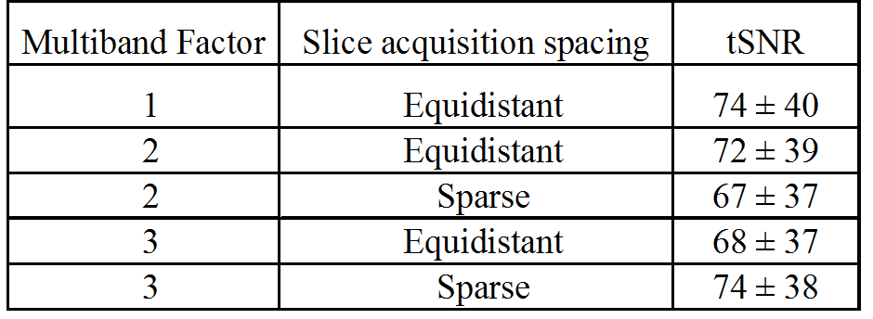
Table 1. Mean temporal SNR (tSNR) (±standard deviation) calculated over grey matter across 3 participants during five MR sequences: MB: 1-3; acquisition type = equidistant or sparse. All other parameters were constant: TR/TE=3060/40ms, SENSE=2, slices=36, FA=79°, Volumes=41.

